## PROJECT TITLE

### A PROJECT REPORT

**submitted by**

## SOURAV V

## MUT20CS111

**to**

**the APJ Abdul Kalam Technological University in partial fullfilment of the requirements for the award of the Degree**

**of**

### Bachelor of Technology

In

### Computer Science & Engineering



**Department of Computer Science & Engineering Muthoot Institute of Technology and Science Varikoli PO, Puthencruz - 682308**

**JULY 2023**

# DECLARATION

I hereby declare that this submission is my own work and that, to the best of my knowledge and belief, it contains no material previously written by another person nor material which has been accepted for the award of any other degree or diploma of the university or other institute of higher learning, except where due acknowledgment has been made in the text.

### SOURAV V

### MUT20CS111

Place:

Date:



# CERTIFICATE

*This is to certify that the report entitled* **“AI-BASED RECOMMENDATION SYSTEM”**, *submitted by* **SOURAV V** *to Muthoot Institute of Technology and Science, Varikoli for the award of the degree of Bachelor of Technology in Computer Science & Engineering is a bonafide record of the project work carried out by her, under our supervision and guidance. The content of the report, in full or parts have not been submitted to any other Institute or University for the award of any other degree or diploma.*

|  |  |  |
| --- | --- | --- |
| Ms.Dhanya Sudarsan | Ms.Steffy Livera | Dr.Anand Hareendran S |
| Project Guide | Project Coordinator | Head of the Department |

Place Date

## ACKNOWLEDGMENT

I am grateful to almighty who has blessed me with good health, committed and con- tinuous interest throughout the project work.

I express my sincere thanks to my guide, **Ms. Dhanya S**, Assistant Professor, Department of Computer Science And Engineering, Muthoot Institute of Technology and Science and **Dr. Anand Hareendran S**, Professor, Head Of the Department, Muthoot Institute of Technology and Science for their guidance and support which were instrumental in all the stages of the project work and without whom the project could not have been accomplished.

In particular, I also wish to express my sincere appreciation to **Dr. Anand Ha- reendran S**, Head Of the Department, Muthoot Institute of Technology and Science, who was willing to spend his precious time to give some ideas and suggestion towards this project.

I am grateful to my project coordinator **Ms. Steffy Livera** Assistant Professor, Department of Computer Science And Engineering, Muthoot Institute of Technology and Science, for her guidance and support.

I would like to thank **Dr. Neelakantan P.C.**, Principal, Muthoot Institute of Tech- nology and Science, Varikoli for providing us all the necessary facilities.

The last but not the least, I extend my sincere thanks to the entire teaching and non-teaching staff of Computer Science And Engineering of Muthoot Institute of Tech- nology and Science for their help and co-operation throughout our project work.

## ABSTRACT

**CONTENTS**

|  |  |
| --- | --- |
| **ACKNOWLEDGMENT** . . . . . . . . . . . . . . . . . . . . . . . . . . . | i |
| **ABSTRACT** . . . . . . . . . . . . . . . . . . . . . . . . . . . . . . . . . . | ii |
| **LIST OF FIGURES** . . . . . . . . . . . . . . . . . . . . . . . . . . . . . . | v |
| **1 INTRODUCTION** | **1** |
| 1.1 INTRODUCTION . . . . . . . . . . . . . . . . . . . . . . . . . . . . . | 1 |
| 1.2 SCOPE AND MOTIVATION . . . . . . . . . . . . . . . . . . . . . . . | 1 |
| **2 PROPOSED WORK** | **2** |
| 2.1 OBJECTIVES . . . . . . . . . . . . . . . . . . . . . . . . . . . . . . . | 2 |
| 2.2 PROBLEM STATEMENT . . . . . . . . . . . . . . . . . . . . . . . . . | 2 |
| 2.3 EXISTING SYSTEM AND PROPOSED SOLUTION . . . . . . . . . . | 2 |
| 2.3.1 EXISTING SYSTEM . . . . . . . . . . . . . . . . . . . . . . . . | 2 |
| 2.3.2 PROPOSED SYSTEM . . . . . . . . . . . . . . . . . . . . . . . | 2 |
| **3 PROJECT DESIGN** | **3** |
| 3.1 SYSTEM ARCHITECTURE . . . . . . . . . . . . . . . . . . . . . . . | 3 |
| 3.2 MODULES . . . . . . . . . . . . . . . . . . . . . . . . . . . . . . . . . | 3 |
| 3.2.1 first module . . . . . . . . . . . . . . . . . . . . . . . . . . . . . | 3 |
| 3.2.2 second module . . . . . . . . . . . . . . . . . . . . . . . . . . . | 3 |
| 3.2.3 third module . . . . . . . . . . . . . . . . . . . . . . . . . . . . | 3 |
| 3.3 DATA FLOW DIAGRAM . . . . . . . . . . . . . . . . . . . . . . . . . | 3 |
| 3.3.1 DFD LEVEL 0 . . . . . . . . . . . . . . . . . . . . . . . . . . . | 3 |
| 3.3.2 DFD LEVEL 1 . . . . . . . . . . . . . . . . . . . . . . . . . . . | 3 |
| 3.3.3 DFD LEVEL 2 . . . . . . . . . . . . . . . . . . . . . . . . . . . | 3 |
| 3.4 DATABASE TABLE DESIGN . . . . . . . . . . . . . . . . . . . . . . . | 4 |
| 3.4.1 first table in db . . . . . . . . . . . . . . . . . . . . . . . . . . . | 4 |

3.4.2 second table in db 4

* 1. GUI DESIGN 4
  2. TECHNOLOGY STACK 4
  3. SYSTEM REQUIREMENTS 4

1. IMPLEMENTATION 5
   1. CODE SNIPPETS 5
   2. SCREENSHOTS 6
2. CONCLUSION 7
   1. REFERENCES 8

## LIST OF FIGURES

4.1 figure name 6

# CHAPTER 1 INTRODUCTION

## INTRODUCTION

* 1. **SCOPE AND MOTIVATION**

# CHAPTER 2 PROPOSED WORK

## OBJECTIVES

* 1. **PROBLEM STATEMENT**

## EXISTING SYSTEM AND PROPOSED SOLUTION

* + 1. **EXISTING SYSTEM**
    2. **PROPOSED SYSTEM**

# CHAPTER 3 PROJECT DESIGN

## SYSTEM ARCHITECTURE

## 

## Designing an AI-based recommendation system architecture involves creating a structure that can efficiently generate personalized recommendations for users based on their preferences and behaviors. Here's a high-level outline of the system architecture for an AI-based recommendation system:

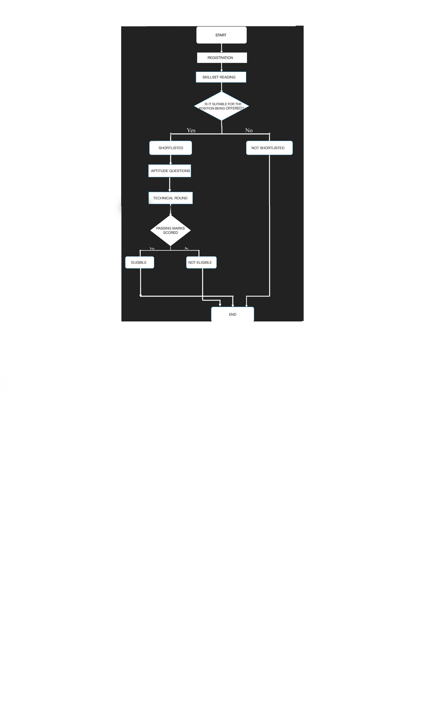

* 1. **MODULES**

## first module

The first module of the project for an AI-based recommendation system could be the "Data Collection" module. This module focuses on gathering relevant user data and item data to build a foundation for generating personalized recommendations. Here's an outline of the tasks and components involved in this module:

User Data Collection:

Identify the types of user data to collect: Determine the data points that are relevant for generating recommendations, such as user demographics, browsing history, purchase history, ratings, reviews, and preferences.

Item Data Collection:

Determine item data requirements: Identify the attributes and information about the Items or products that are essential for generating recommendations. This can include item descriptions, categories, features, images, or any other relevant metadata.

Data Storage and Management:

Design the database schema: Define the structure and relationships of the user and item data in a database. Consider the scalability and performance requirements of the system.

Data Quality and Validation:

Perform data quality checks: Establish mechanisms to validate and verify the integrity, consistency, and quality of the collected data. This can involve data profiling, outlier detection, or statistical analysis.

Data Governance and Compliance:

Establish data governance policies: Define guidelines and policies for data governance, including data access controls, data retention policies, and data usage agreements.

Data Integration:

Integrate external data sources: Explore opportunities to integrate external data sources, such as social media data, location-based data, or publicly available datasets, to enrich the recommendation process.

* + 1. **second module**

The second module of the project can be the "Data Collection and Preprocessing" module. This module focuses on gathering the necessary data for the AI-based recommendation system and preparing it for further analysis and modeling. Here's an outline of the tasks and components involved in this module:

Data Identification and Acquisition:

Identify data sources: Determine the relevant data sources for the recommendation system, such as user profiles, historical interactions, item catalogs, or external data feeds.

Data Cleaning and Preprocessing:

Data cleaning: Handle missing values, outliers, and inconsistencies in the data. This may involve techniques such as imputation, outlier detection, and data validation.

Data Integration and Aggregation:

Merge datasets: Combine multiple datasets from different sources, ensuring compatibility and resolving any data schema conflicts.

Data Sampling and Splitting:

Sample data: If the dataset is large, consider sampling techniques to work with a representative subset of the data for initial analysis and model development.

Data Privacy and Security:

Ensure data privacy: Implement measures to protect sensitive user data and ensure compliance with privacy regulations. This may involve anonymization techniques, data encryption, or access controls.

Data Documentation and Metadata:

Document data sources: Maintain documentation that describes the origin, structure, and characteristics of the collected data.

Data Exploration and Analysis:

Explore data patterns: Perform exploratory data analysis to gain insights into the data distribution, correlations, and patterns. Visualize the data using charts, graphs, or other visual techniques.

## third module

The third module of the project can be the "Model Development and Training" module. In this module, the focus is on building and training the AI-based recommendation model using the preprocessed data. Here's an outline of the tasks and components involved in this module:

Model Selection:

Identify suitable recommendation algorithms: Explore different types of recommendation algorithms, such as collaborative filtering, content-based filtering, hybrid approaches, or deep learning-based models.

Model Architecture Design:

Define the model architecture: Determine the structure and components of the recommendation model. This includes deciding on the input representation, hidden layers (if applicable), output format, and any auxiliary modules.

Training Data Preparation:

Split data for training and validation: Use the preprocessed data from the previous module and split it into training and validation datasets. The training dataset is used to optimize the model parameters, while the validation dataset helps monitor and fine-tune the model's performance.

Model Training:

Initialize model parameters: Set initial values for the model parameters.

Train the model: Use the training data to iteratively update the model parameters through optimization techniques such as gradient descent or stochastic gradient descent.

Model Evaluation:

Evaluate the model's performance: Use the validation dataset to assess the model's ability to generate accurate recommendations. Compute relevant evaluation metrics such as precision, recall, F1 score, or area under the ROC curve.

Model Validation:

Validate the model with real-world data: Use a separate test dataset or deploy the model in a controlled environment to assess its performance in real-world scenarios.

Model Optimization and Iteration:

Refine the model: Incorporate user feedback and evaluation results to enhance the model's performance. This may involve tweaking the model architecture, adjusting hyperparameters, or incorporating additional data features.

* 1. **DATA FLOW DIAGRAM**

## DFD LEVEL 0

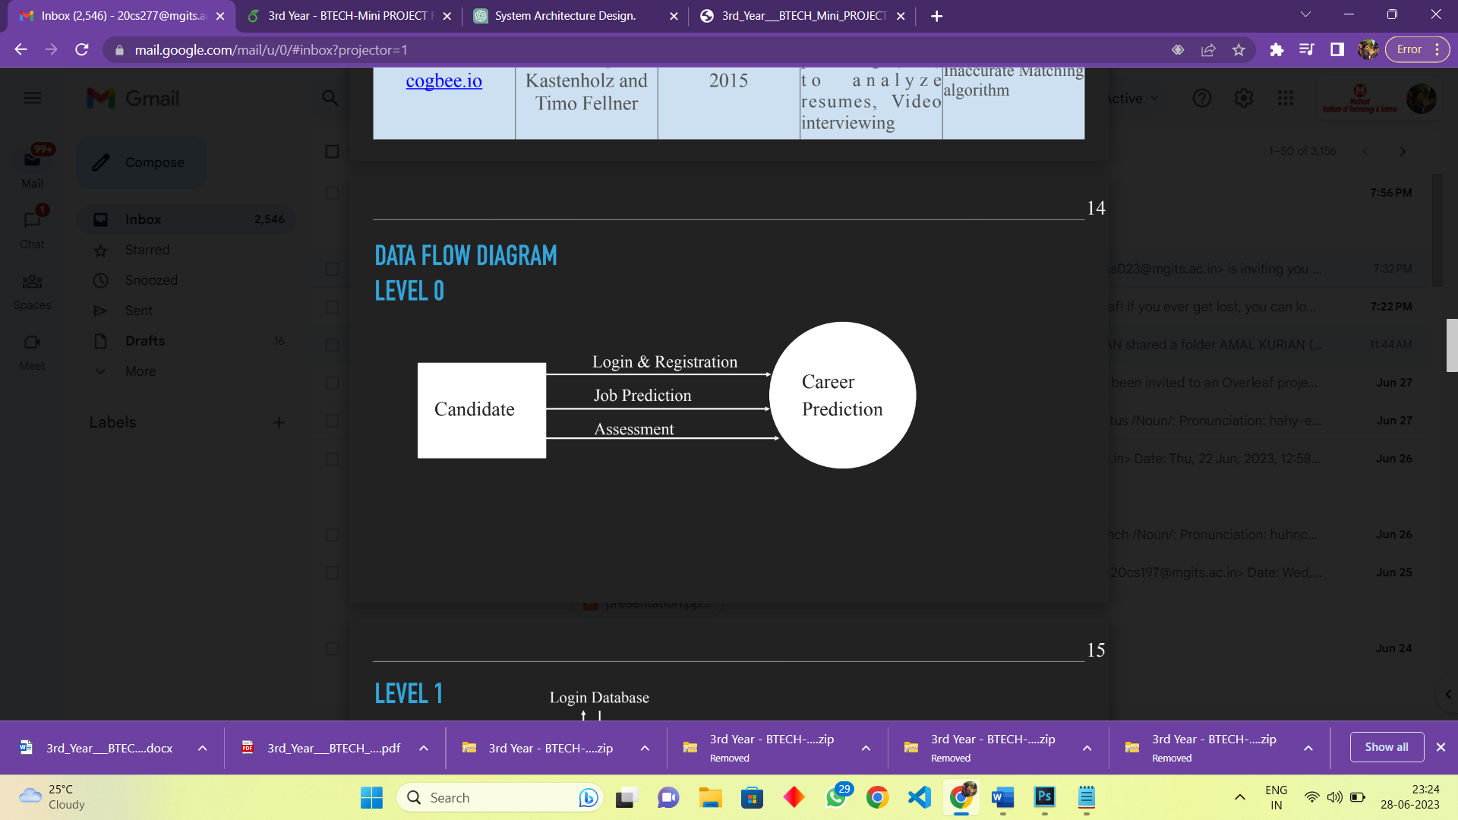

## DFD LEVEL 1

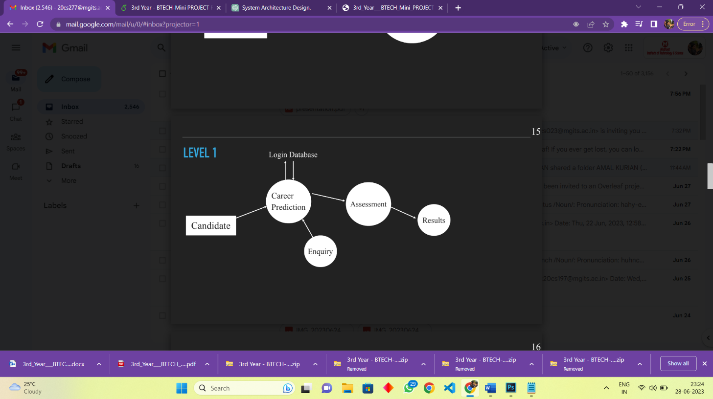

## DFD LEVEL 2

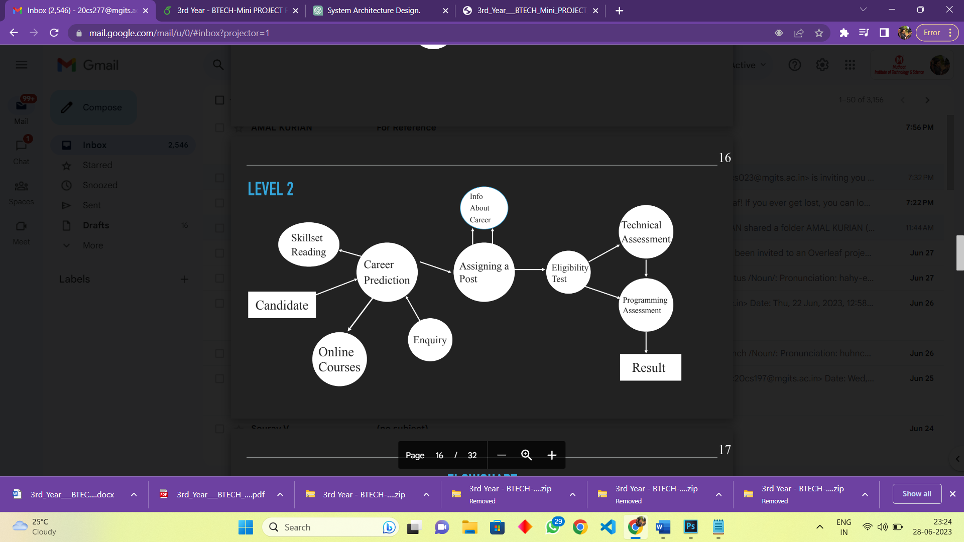

1. PROJECT DESIGN DATABASE TABLE DESIGN

## DATABASE TABLE DESIGN

* + 1. **first table in db**

## second table in db

## GUI DESIGN

## TECHNOLOGY STACK

## SYSTEM REQUIREMENTS

# CHAPTER 4 IMPLEMENTATION

## CODE SNIPPETS

1. IMPLEMENTATION SCREENSHOTS

## SCREENSHOTS



Figure 4.1: figure name

# CHAPTER 5 CONCLUSION

1. CONCLUSION REFERENCES

## REFERENCES

1.