1. Jun 19, 2013 @ 12:48 PM. Enable change tracking in OP_DEV2 (TMSDEV). Retention Period is 1 day

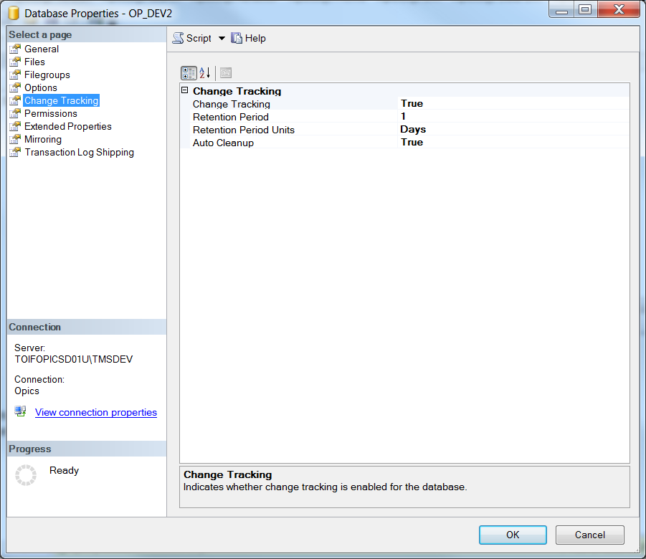

1. Enable Change tracking for CUST Table

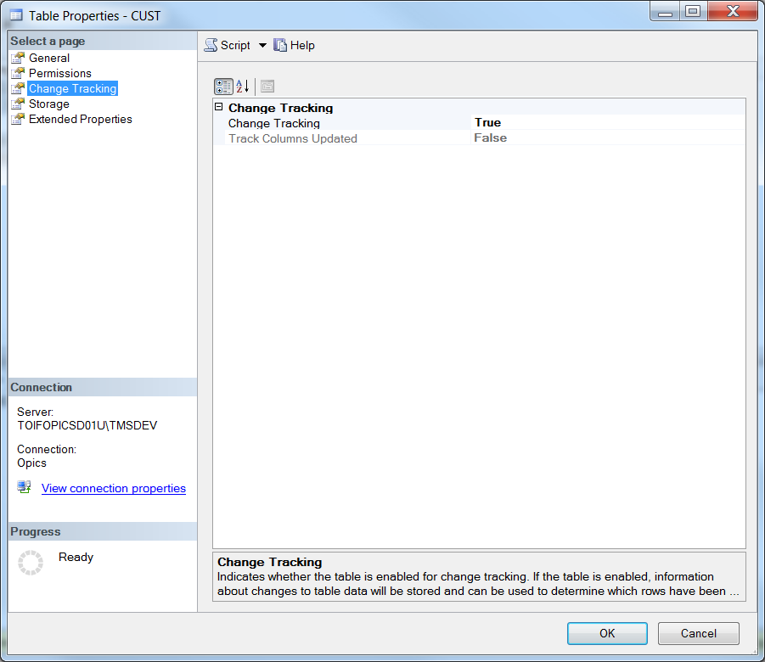

1. Query change tracking on CUST table, and no change found.

*declare @last_synchronization_version bigint*

*set @last_synchronization_version = 0*

*select CT.CNO COLLATE SQL_Latin1_General_CP1_CI_AS AS CNO from*

*CHANGETABLE(CHANGES CUST, @last_synchronization_version) AS CT*

1. Update Address1 for CNO ‘000002’

*update CUST SET CA1='12345678'*

*Where CNO='000002'*

1. Query change tracking again, and change of ‘CNO 000002’ is found
2. Back up OP_DEV2 Database from TMSDEV (Jun 19, 200 @ 1:37 PM)
3. Restore OP_DEV2 Database to local, and run the change tracking query immediately. The Changed Record CNO 000002 is found