# **CSS EXERCISES**

***(*Note: All exercises must be done with pure HTML and CSS)***



**Figure 1. Exercise 1**



**Figure 2. Exercise 2**

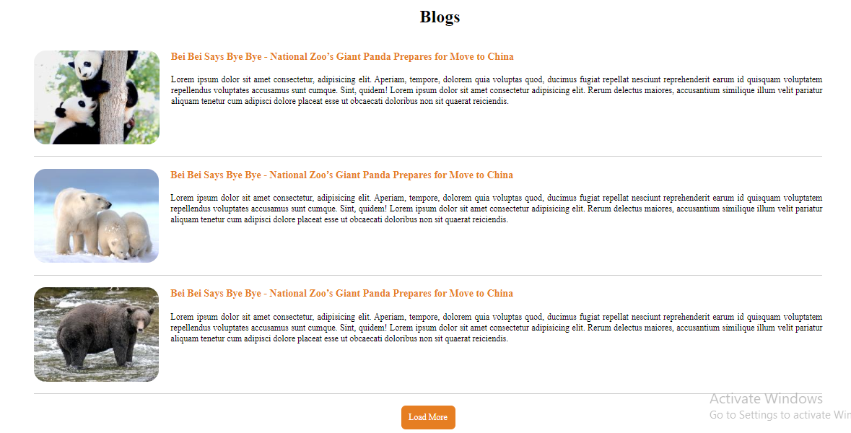

**Figure 3. Exercise 3**



**Figure 4. Exercise 4 – Desktop Mode**

***(*Note: Position of the sidebar need to be fixed when scrolling)***



**Figure 5. Exercise 4 - Tablet Mode**



**Figure 6. Exercise 4 - Mobile Mode**

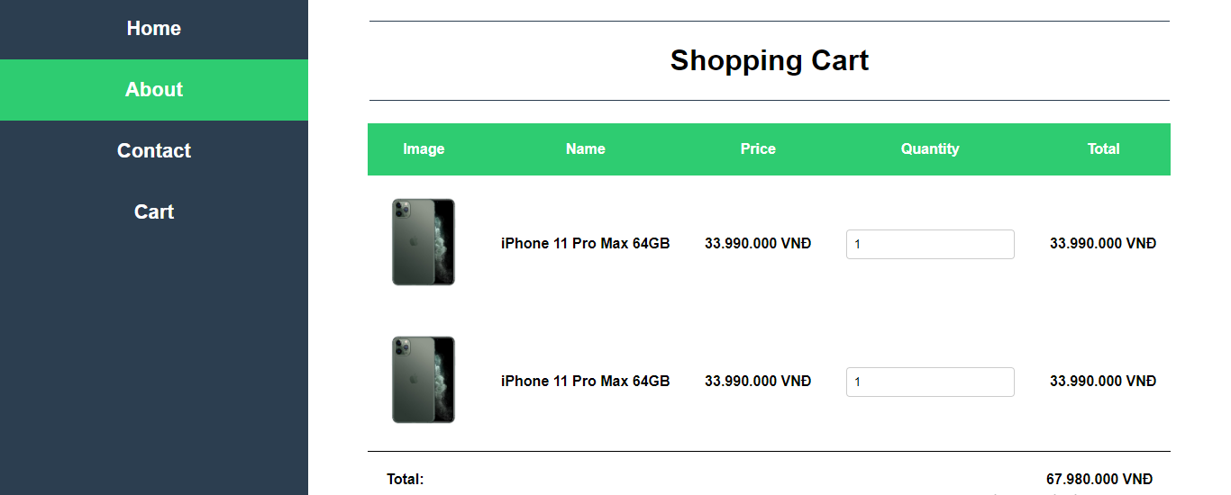

**Figure 7. Exercise 4 - Shopping Cart – Desktop Mode**

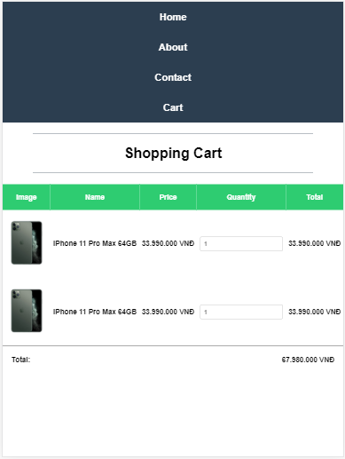

**Figure 8. Exercise 4 - Shopping Cart - Tablet Mode & Mobile Mode**