Henrique Lima

Fall 2019

**Conceptual Schema Version.3**

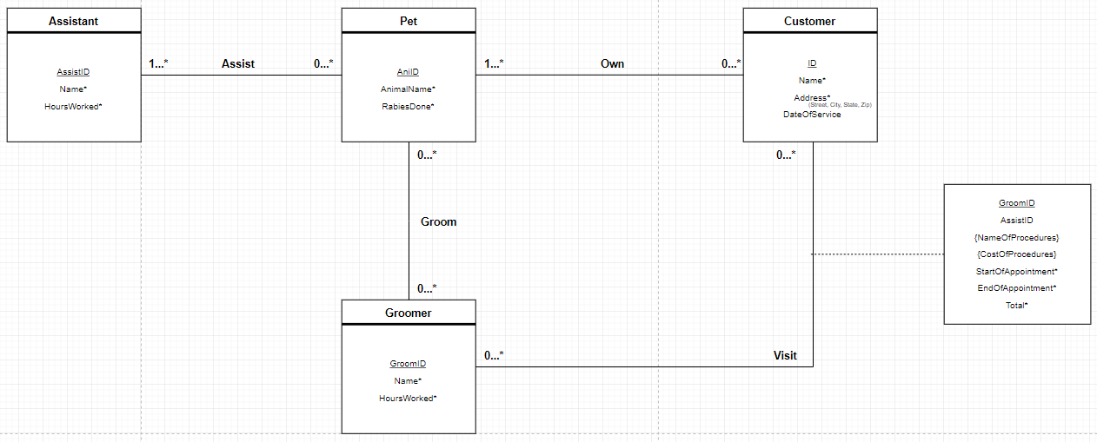

Entities

* Pet - The pet that is getting taken care of that day. It has its unique id and name. Name is not unique but required as the pet can have the same name but it is not possible to NOT have a name. It also shows if this pet has gotten its rabies shot.
* Assistant/Groomer - The only reason these are two different entities is due to the unique id that dictates whether the employee is a groomer or an assistant. Other than that, they both have name, hours worked, start of appointment, and end of appointment. Name is required but not unique as everyone has a name though there could be a multiple of the same name. HoursWorked is required as there needs to be a way to track the employee’s work time. This is done in *hours* because they get paid by the hour.
* Customer - The customer is kept track of by a unique id and a required name. Customer has an Address and DateOfService. These two attributes are there so to help any kind of billing. The only reason to keep track of any customer information is for billing reasons.

Relationships

* Groom/Assist/Own - The Groomer(s) will Groom the Pet(s). Assist works similarly to Groom, however, there is no requirement to having an Assistant. Own is different as a Customer can own one to many Pets, but a Pet isn’t required to be owned by a customer.
* Visit - The Groomer(s) can bill the Customer through a Visit. This is a many-to-many relationship as the customer can be billed as many times as possible and the Groomer(s) can bill the customer as many times as possible. The Visit has the Groomer’s ID, the Assistant’s ID, the name of the procedure(s) that were done, the time the appointment started, the time the appointment ended, the cost of the procedure(s), and the total of the bill. The Groomer ID, the appointment’s start and end times, and the total of the bill are all required because those need to be documented at all times. Both name and cost of the procedure(s) are multi-variable attributes has there can be multiple procedures done in one appointment.

Change Summary

* Version 3:
  + Renamed relationship: Bill -> Visit
  + Moved some Groomer and Assistant attributes into Visit
  + Moved some old Visit (Bill) attributes into Customer
  + Changed 1…* into 0…* except for the relationship of Assist
  + Edited the information to represent the new changes made to the schema
* Version 2:
  + Removed relationship: Register
  + Added relationships: Groom, Assist, and Own
  + Renamed relationship: Bills -> Bill
  + Added constraints to new relationships
  + Edited the information to represent the new changes made to the schema