Validation of a hierarchical business process management capability model through a tri-methodological analytical strategy: sequential integration of PLS-SEM, artificial neural networks, and fuzzy-set qualitative comparative analysis
Validación de un modelo jerárquico de capacidad de gestión por procesos mediante una estrategia analítica tri-metodológica: integración secuencial de PLS-SEM, redes neuronales artificiales y análisis cualitativo comparativo difuso
Research manuscript · Version 6
Target journals: Business Process Management Journal · International Journal of Information Management

Abstract
Business Process Management (BPM) constitutes a consolidated discipline whose effectiveness, nevertheless, continues to exhibit failure rates ranging between sixty and eighty percent (Trkman, 2010), a circumstance that has motivated sustained inquiry into its critical success factors. This study addresses three persistent limitations in the literature: the insufficient theoretical grounding of such factors, the reliance on single-method analytical approaches, and the predominant use of proprietary computational instruments. To this end, a hierarchical component model is proposed and empirically validated, consolidating five original constructs into three theoretically grounded dimensions —strategic alignment (SA), human capabilities (PEO), and governance and measurement (GOVMEAS)— integrated into a second-order formative construct termed BPM capability, whose effect on business process outcomes (BPO) is examined through a sequential tri-methodological analytical strategy. Drawing on a sample of fifty-six predominantly Costa Rican chief information officers, partial least squares structural equation modelling (PLS-SEM) evidences a positive, substantial, and statistically significant effect of BPM capability on process outcomes (β = 0.934; t = 54.2; p < 0.001; R² = 0.873). Artificial neural network analysis, implemented through a robust averaging protocol across multiple initialisations, reveals that nonlinear relative importance places governance and measurement as the dominant predictor (41.4%), ahead of strategic alignment (29.7%) and human capabilities (28.8%), a finding that corrects erroneous interpretations derived from single-run implementations. Fuzzy-set qualitative comparative analysis (fsQCA), articulated through a conservative solution refined with the PRI statistic, identifies two causally sufficient routes to high outcomes in which governance and measurement operates as a core condition (consistency = 0.968; PRI = 0.936; coverage = 0.862). A robustness analysis based on Monte Carlo simulation and on the formal robustness test protocol for QCA confirms that the central inferences are recovered stably under the available sample size and across 1,152 alternative analytical specifications. The tri-methodological convergence warrants the conclusion that governance articulates the capability system, while human capabilities and strategic alignment operate as complementary factors. The entire analysis was implemented in open-source environments (R and Python) and is distributed under the MIT licence.
Keywords: business process management; BPM; critical success factors; PLS-SEM; artificial neural networks; ANN; MLP; fsQCA; hierarchical construct; dynamic capabilities; robustness analysis; computational reproducibility.

Resumen
La gestión por procesos de negocio (Business Process Management, en adelante BPM) constituye una disciplina consolidada cuya efectividad, no obstante, continúa exhibiendo tasas de fracaso que oscilan entre el sesenta y el ochenta por ciento (Trkman, 2010), circunstancia que ha motivado una indagación sostenida en torno a sus factores críticos de éxito. El presente estudio aborda tres limitaciones persistentes en la literatura: la insuficiente fundamentación teórica de dichos factores, la dependencia de aproximaciones analíticas monométodo y el empleo predominante de instrumental computacional propietario. Con tal propósito, se propone y valida empíricamente un modelo de componente jerárquico que consolida cinco constructos originales en tres dimensiones teóricamente fundamentadas —alineación estratégica (SA), capacidades humanas (PEO) y gobernanza y medición (GOVMEAS)— integradas en un constructo formativo de segundo orden denominado capacidad de BPM, cuyo efecto sobre los resultados de proceso (Business Process Outcomes, en adelante BPO) se examina mediante una estrategia analítica tri-metodológica de carácter secuencial. A partir de una muestra de cincuenta y seis directores de tecnologías de información, predominantemente costarricenses, el modelado de ecuaciones estructurales por mínimos cuadrados parciales (PLS-SEM) evidencia un efecto positivo, sustancial y estadísticamente significativo de la capacidad de BPM sobre los resultados de proceso (β = 0.934; t = 54.2; p < 0.001; R² = 0.873). El análisis mediante redes neuronales artificiales, implementado a través de un protocolo robusto de promediado sobre múltiples inicializaciones, revela que la importancia relativa no lineal sitúa a la gobernanza y medición como predictor dominante (41.4 %), por encima de la alineación estratégica (29.7 %) y las capacidades humanas (28.8 %), hallazgo que corrige interpretaciones erróneas derivadas de implementaciones de ejecución única. El análisis cualitativo comparativo difuso (fsQCA), articulado mediante una solución conservadora depurada con el estadístico PRI, identifica dos rutas causalmente suficientes hacia los resultados elevados en las que la gobernanza y medición opera como condición central (consistencia = 0.968; PRI = 0.936; cobertura = 0.862). Un análisis de robustez basado en simulación Monte Carlo y en el protocolo formal de robustez para QCA confirma que las inferencias centrales se recuperan de manera estable bajo el tamaño muestral disponible y bajo 1 152 especificaciones analíticas alternativas. La convergencia tri-metodológica permite concluir que la gobernanza articula el sistema de capacidades, en tanto que las capacidades humanas y la alineación estratégica operan como factores complementarios. La totalidad del análisis se implementó en entornos de código abierto (R y Python) y se distribuye bajo licencia MIT.
Palabras clave: gestión por procesos de negocio; BPM; factores críticos de éxito; PLS-SEM; redes neuronales artificiales; ANN; MLP; fsQCA; constructo jerárquico; capacidades dinámicas; análisis de robustez; reproducibilidad computacional.

1. Introduction
Business process management, known in the specialised literature as BPM, constitutes a management discipline that integrates knowledge from management science and information technology in order to analyse, design, implement, control, and continuously improve organisational processes (Dumas et al., 2018; van der Aalst, 2013; vom Brocke et al., 2014). The consolidation of the field is amply documented: a bibliometric analysis of two decades of scientific production evidences sustained growth of the discipline, with an average annual rate of 16.5% and a thematic concentration around management, methodological frameworks, and performance (Lizano-Mora et al., 2021), while the contemporary agenda places it at the centre of digital transformation and the emergence of artificial intelligence (Iden et al., 2025; Rosemann et al., 2024). Despite the considerable theoretical and practical maturity the field has attained, empirical evidence repeatedly documents that between sixty and eighty percent of BPM initiatives fail to achieve their intended objectives (Beerepoot et al., 2023; Trkman, 2010), a circumstance that has stimulated a sustained line of research aimed at identifying the critical success factors that condition their results.
Trkman's (2010) seminal work established that the principal deficiency of this research stream lay in the absence of a robust theoretical foundation, which prevented systematic comparison of findings across studies and confined accumulated knowledge to a scattered set of casuistic prescriptions, a diagnosis that recent research on the success factors of process digitalisation continues to corroborate (Baier et al., 2022). To remedy this deficiency, that author proposed a tripartite theoretical framework articulating three complementary organisational theories: contingency theory (Fiedler, 1964), which posits the need for fit between the environment and organisational processes; dynamic capabilities theory (Teece, 2007), which emphasises continuous improvement as a source of sustainable competitive advantage; and task-technology fit theory (Goodhue & Thompson, 1995), which underscores the congruence between process tasks and the capabilities of information systems. This theoretical scaffolding was subsequently developed by Škrinjar and Trkman (2013), who empirically identified a set of critical practices, and by Ongena and Ravesteyn (2019), who examined the role of contextual factors in the relationship between BPM maturity and organisational performance.
Notwithstanding the advances reviewed, three substantive limitations persist in the literature which the present study sets out to address. First, a methodological limitation: prevailing research practice relies on single-method analytical approaches —typically structural equation modelling or regression techniques— that capture exclusively linear and symmetric relationships, neglecting both the possible existence of nonlinear relationships and the configurational and asymmetric nature of causality in organisational phenomena, whose capture requires the combination of symmetric and asymmetric approaches (García-Río et al., 2023; Rasoolimanesh et al., 2021). Second, a limitation concerning measurement model specification: operationalising BPM through strongly correlated first-order constructs frequently leads to violations of discriminant validity, a problem that is rarely addressed through theoretically grounded respecification. Third, an instrumental limitation: dependence on proprietary software, whose licensing cost can be very high, restricts the reproducibility of analyses and limits access for researchers with limited resources (Peng, 2011).
In light of these limitations, the study answers the following research question: to what extent, and through which configurations, does BPM capability —conceived as an integrated system of strategic alignment, human capabilities, and governance and measurement— determine business process outcomes? To answer it, four contributions are formulated. The first consists of the proposal and empirical validation of a hierarchical component model that consolidates five original constructs into three theoretically parsimonious dimensions, resolving discriminant validity violations without detriment to content validity. The second lies in the implementation of a sequential tri-methodological analytical strategy integrating partial least squares structural equation modelling (PLS-SEM), artificial neural networks (ANN) —specifically the multilayer perceptron (MLP)— and fuzzy-set qualitative comparative analysis (fsQCA), which constitutes, to the authors' knowledge, the first application of this triangulation to the study of BPM critical success factors. The third contribution, eminently methodological in nature, consists of the empirical demonstration that interpretations about the relative importance of predictors derived from single-run neural network implementations constitute artefacts of random initialisation, and the consequent proposal of a robust averaging protocol whose specificity is verified by simulation. The fourth contribution resides in the implementation of the entire analysis with open-source tools, accompanied by reproducible scripts in R and Python and by a robustness analysis that quantifies the stability of each inference with respect to sample size and analytical decisions.
The remainder of the manuscript is organised as follows. Section 2 develops the theoretical framework and literature review. Section 3 presents the methodological strategy, comprising the description of the sample, the data cleaning procedure, the tripartite analytical protocol, and the design of the robustness analysis. Section 4 reports the results of each technique, their synthesis, and the evaluation of their robustness. Section 5 discusses the theoretical, methodological, and managerial implications of the findings. Section 6 formulates the conclusions, acknowledges the limitations of the study, and outlines future research directions.

2. Theoretical framework and literature review

2.1 Business process management and process orientation
BPM is conceived, within the framework of this study, as the systematic set of efforts aimed at continuously analysing and improving the fundamental activities of an organisation (Trkman, 2010). Closely linked to this concept, business process orientation (BPO) designates the degree to which an organisation has institutionalised the process perspective in its structure, culture, and operational practices, and constitutes the most widely used surrogate indicator for evaluating BPM success (Škrinjar & Trkman, 2013). The four-level maturity model proposed by McCormack and Johnson (2001) —ad hoc, defined, linked, and integrated— has provided the conceptual foundation for the empirical measurement of BPO in numerous subsequent studies. The intellectual roots of the discipline trace back to process reengineering (Hammer, 1990; Hammer & Champy, 1993), whose synthesis with workflow management crystallised into the contemporary body of methods for discovering, analysing, redesigning, executing, and monitoring business processes (vom Brocke & Rosemann, 2015).

2.2 Tripartite theoretical grounding
The theoretical architecture of the present study rests on the integration of three organisational theories, in accordance with Trkman's (2010) proposal. Contingency theory (Fiedler, 1964) grounds the strategic alignment dimension by positing that organisational effectiveness depends on the degree of fit between the characteristics of the competitive environment and the internal configuration of processes, so that no universally optimal form of organisation exists. Dynamic capabilities theory (Teece, 2007) underpins the human capabilities dimension, insofar as it holds that the source of sustainable competitive advantage lies in the organisation's capacity to continuously reconfigure its resources and competencies in the face of changing environments, a capacity pre-eminently embedded in human capital. Finally, task-technology fit theory (Goodhue & Thompson, 1995) articulates the governance and measurement dimension by establishing that organisational performance increases to the extent that congruence is verified between the tasks composing processes, the capabilities of the information systems supporting them, and the performance measurement mechanisms governing them. The currency of this scaffolding is reinforced by recent evidence: BPM capabilities operate as dynamic capabilities enabling decision-making in digital transformation contexts (Huy & Phuc, 2025), and process-technology fit decisions continue to constitute a central problem of the discipline (Ahmad & Van Looy, 2025).

2.3 Model respecification and hypothesis formulation
The original model derived from the work of Trkman (2010) and Škrinjar and Trkman (2013) operationalised BPM through five first-order reflective constructs conceived as independent: strategic alignment, organisational changes, training and empowerment, performance measurement, and information technology support. Preliminary empirical evaluation of this specification revealed, however, heterotrait-monotrait ratio (HTMT) values above the 0.90 threshold between multiple pairs of constructs, evidencing a violation of discriminant validity and suggesting that informants did not perceive these constructs as conceptually distinguishable phenomena (Henseler et al., 2015).
In response to this diagnosis, the model was respecified on theoretical grounds. The five original constructs were consolidated into three higher-order dimensions: strategic alignment (SA), which retains the conceptual core of strategic direction; human capabilities (PEO), corresponding to staff training and empowerment; and governance and measurement (GOVMEAS), resulting from the theoretically justified merger of organisational changes, performance measurement, and technological support. This consolidation is supported by the holistic conception of BPM formulated by vom Brocke et al. (2014), according to which governance, measurement, and technology operate as interdependent facets of a unitary organisational capability. The three dimensions are, in turn, integrated into a second-order formative construct termed BPM capability. The formative specification of the higher level follows three criteria: the dimensions are not interchangeable, since each captures a conceptually distinct facet of the capability; a change in any one of them alters the construct without the others necessarily changing; and there is no theoretical expectation that they share identical antecedents and consequences (Becker et al., 2012; Sarstedt et al., 2019). The expectation of a positive effect on process outcomes is further corroborated by the accumulated empirical evidence linking BPM capabilities and maturity to organisational outcomes (Antonucci et al., 2021; Biernikowicz et al., 2025), as well as by the role of process management systems as instrumental support for such capabilities (Bhaskar, 2025; Martín Navarro et al., 2025; Zuhaira & Ahmad, 2021). Accordingly, the following hypothesis is posited:
Hypothesis: BPM capability, operationalised as a second-order hierarchical construct, exerts a positive and significant effect on business process outcomes.
Figure 1 graphically represents the structure of the respecified model, indicating the estimated coefficients reported in the results section.
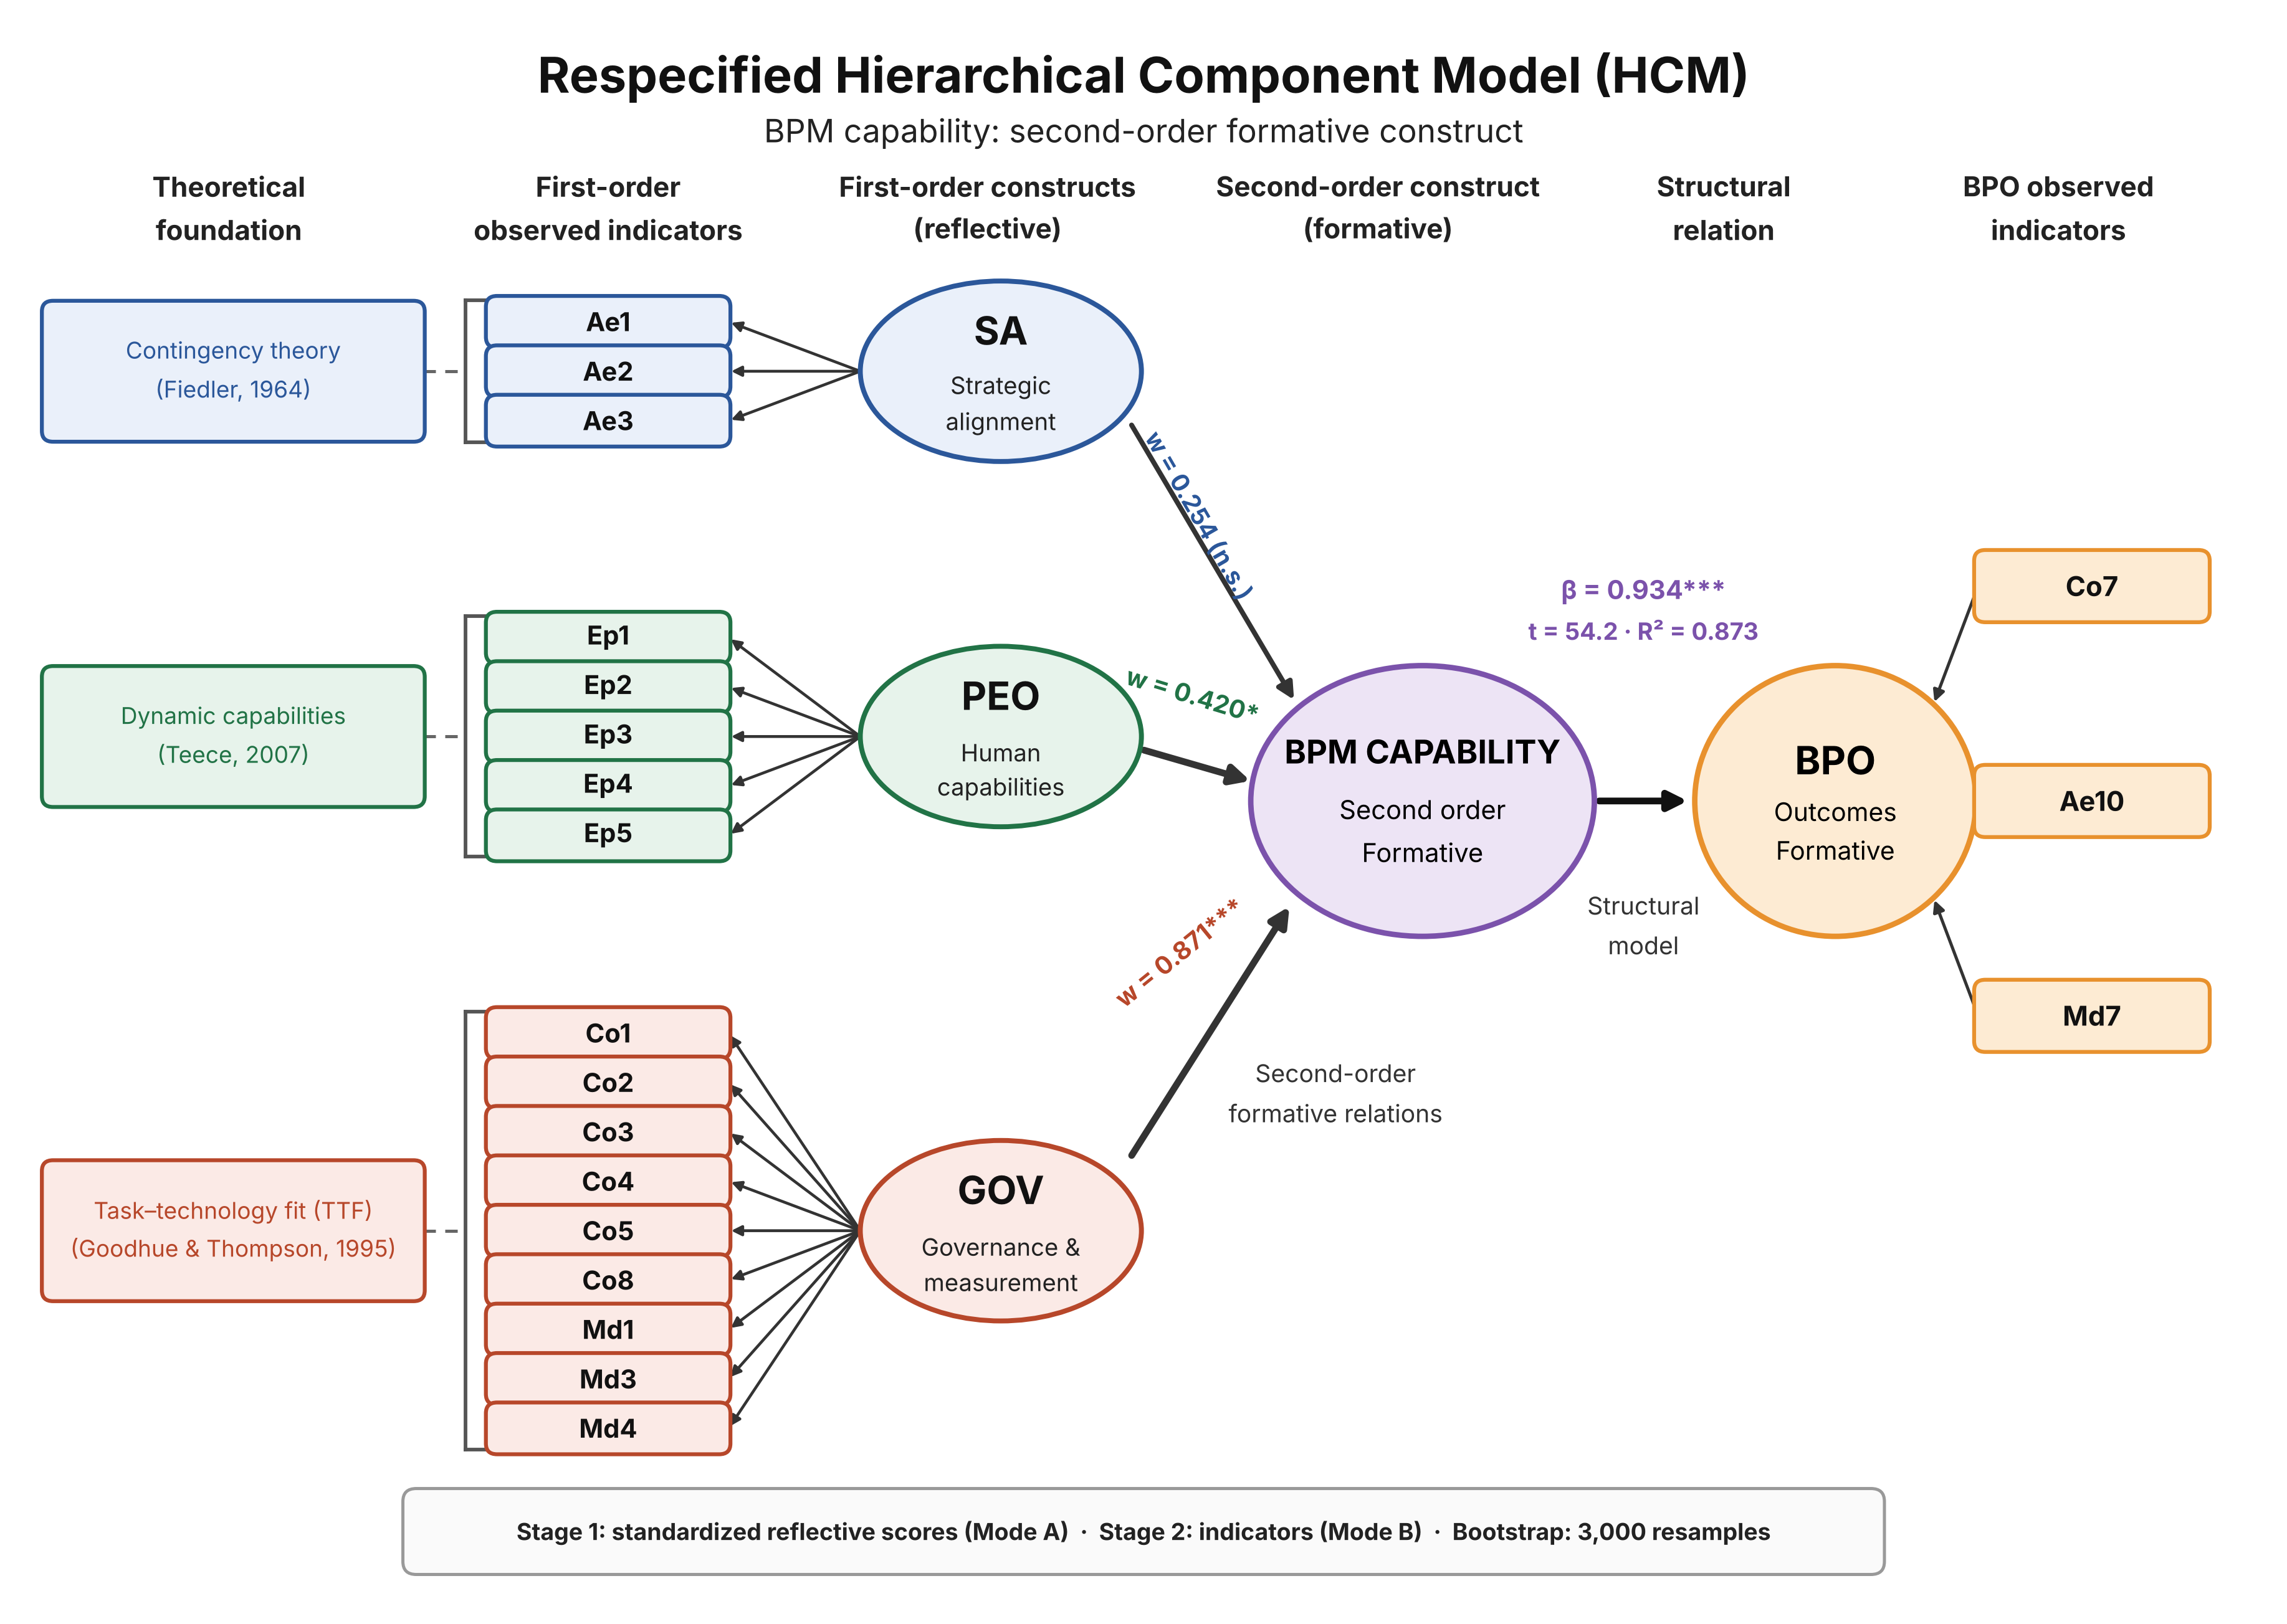
Figure 1. Respecified hierarchical component model (HCM). The three theories ground the first-order dimensions, which are integrated into the second-order formative construct BPM capability, whose effect on BPO is estimated by PLS-SEM. The formative weights correspond to the estimates reported in Table 2. Notation: * p < 0.05; *** p < 0.001; n.s. = not significant.

3. Methodology

3.1 Sample and data cleaning procedure
The data analysed derive from the administration of a structured questionnaire addressed to chief information officers, an instrument adapted from the work of Škrinjar and Trkman (2013) and Ongena and Ravesteyn (2019), comprising thirty-five items rated on a seven-point Likert scale, a format whose adoption responds to the optimal balance it offers between discriminating capacity, reliability, and respondent cognitive load, and whose psychometric properties are documented as superior to those of five-point formats (Hair et al., 2017; Joshi et al., 2015). The data cleaning procedure unfolded in four sequential phases grounded in the recommendations of Hair et al. (2017) and Little and Rubin (2019). Of the one hundred and thirty-five responses initially recorded, sixty-three entirely empty records were removed, attributable to sessions started but not completed; next, sixteen observations with missing data on the model indicators were discarded through complete-case deletion; the presence of ten cases of undifferentiated response was verified, and these were retained after confirming the absence of a universal exclusion criterion and in order to preserve statistical power; finally, the absence of out-of-range values was confirmed. The final sample comprised fifty-six valid observations, a magnitude that comfortably satisfies the ten-times heuristic rule for the complexity of the specified model (Barclay et al., 1995; Hair et al., 2017). Complementarily, the inverse square root method establishes that detecting path coefficients of at least 0.35, with a power of 0.80 and a significance level of 0.05, requires a minimum of fifty-one observations (Kock & Hadaya, 2018), a threshold the available sample satisfies; the effective adequacy of the sample size for each of the study's inferences is further examined by simulation in Section 4.6. As regards geographical composition, forty-one observations —73.2% of the sample— reported their country of origin, distributed as 95.1% (thirty-nine cases) from Costa Rica and 4.9% (two cases) from Spain; the remaining fifteen observations did not complete the sociodemographic block, so their origin remains undetermined. The available evidence therefore indicates a marked predominance of the Costa Rican context.
Analysis of distributional assumptions revealed that all twenty indicators employed exhibit significant departures from normality (Shapiro-Wilk test, p < 0.05), a circumstance that grounds the choice of PLS-SEM —a technique that imposes no distributional assumptions— and of artificial neural networks as central analytical methods (Hair et al., 2011, 2017).

3.2 Tri-methodological analytical strategy
The analytical strategy was structured in three sequential stages, each contributing an epistemologically distinctive perspective on the phenomenon under study. The first stage employed PLS-SEM through the two-stage approach for hierarchical constructs (Becker et al., 2012; Sarstedt et al., 2019). In the first stage, the standardised scores of the three dimensions were computed from their reflective indicators; in the second stage, these scores were used as formative indicators of the second-order construct BPM capability, whose effect on process outcomes was estimated using a path weighting scheme, with statistical inference based on a bootstrap resampling procedure of three thousand subsamples, in accordance with contemporary PLS-SEM reporting standards (Hair et al., 2019). Predictive relevance was assessed through the PLSpredict procedure, contrasting the prediction error of the PLS model against that of a linear model benchmark (LM) under cross-validation and reporting the Q²predict statistic (Shmueli et al., 2016, 2019).
The second stage employed artificial neural networks under the multilayer perceptron architecture, with the purpose of detecting nonlinear relationships that the linear structural model does not capture. Unlike conventional practice, which derives relative importance measures from a single run of the network (Leong et al., 2020; Luyao et al., 2022), the present study adopted a robust protocol consisting of training ten independent networks, each subjected to ten-fold cross-validation, with subsequent averaging of the importance measures. This methodological decision, whose justification is developed in detail in the results section, responds to the need to mitigate the influence of random initialisation of synaptic weights on conclusions regarding predictor importance. Sensitivity analysis was performed using Garson's (1991) algorithm.
The third stage employed fsQCA in order to identify the combinations of conditions sufficient and necessary for achieving high process outcomes (Pappas & Woodside, 2021; Ragin, 2008). Calibration of the fuzzy sets was performed using the direct method with a logistic function, setting the anchors for full membership, maximum ambiguity, and non-membership at the 95th, 50th, and 5th percentiles, respectively. The necessity analysis was accompanied by the Relevance of Necessity (RoN) parameter, which discriminates substantively necessary conditions from those trivially necessary owing to their ubiquity in the sample (Schneider & Wagemann, 2012). The sufficiency analysis was enriched with the PRI (Proportional Reduction in Inconsistency) consistency statistic, whose incorporation makes it possible to discriminate genuinely sufficient configurations from those maintaining simultaneous subset relations with the outcome and its negation (Schneider & Wagemann, 2012), a methodological refinement of relevance for the validity of configurational inferences. Boolean minimisation was performed using the conservative solution, without incorporating logical remainders. The combination of PLS-SEM with fsQCA on the same dataset follows the methodological recommendation to integrate symmetric and asymmetric approaches (García-Río et al., 2023; Rasoolimanesh et al., 2021), while the incorporation of neural networks falls within the tradition of hybrid SEM-ANN designs (Sharma et al., 2021).
Design of the robustness analysis. In order to quantify the stability of the inferences with respect to sample size and analytical decisions, the design incorporates a three-component robustness analysis. The first is a Monte Carlo parameter recovery study (Paxton et al., 2001) in which the data-generating process is fixed at the observed mean vector and covariance matrix of the second-stage indicators, one thousand multivariate replications are drawn for each sample size between thirty and two hundred observations, and the PLS-SEM model is re-estimated in each, reporting bias, root mean squared error, coverage of the bootstrap intervals, and the proportion of replications in which the significance of the structural effect and the hierarchy of formative weights are recovered; the procedure follows the logic with which Kock and Hadaya (2018) validated their own minimum sample size methods. The second component is a specificity test of the robust neural network protocol, which verifies whether that protocol returns equidistributed importance when the three dimensions contribute equally to the outcome —a null hypothesis constructed with identical conditional coefficients and preserved explained variance— and whether it recovers the observed hierarchy when the data-generating process is the real one. The third component applies to the fsQCA the formal robustness test protocol of Oana and Schneider (2024), comprising sensitivity ranges for each analytical parameter, fit-oriented robustness over a test set of plausible specifications, and case-oriented robustness. Simulated data are used exclusively to characterise the properties of the estimators under the conditions of the study and are in no case incorporated into the substantive inference, whose sole input is the observed sample (Decruyenaere et al., 2024). The results are presented in Section 4.6 and the complete detail in Appendix C.

3.3 Computational environment and reproducibility
The entire analysis was implemented using open-source tools, whose algorithms were published under the MIT licence (Lizano-Mora, 2026), in keeping with the principles of open science and computational reproducibility (Peng, 2011). Two programming environments were used in parallel: the R language, with the SEMinR package for PLS-SEM, QCA for configurational analysis, and nnet together with NeuralNetTools for neural networks; and the Python language, with the NumPy, SciPy, Scikit-learn, and Pandas libraries. The availability of equivalent implementations in both languages enables cross-verification of results and maximises accessibility for different research communities. The total cost of the computational environment amounts to zero, in contrast to the annual licensing of equivalent proprietary instruments such as SmartPLS, Stata, or IBM SPSS. The complete reproduction scripts are attached as Appendices A and B, and those of the robustness analysis as Appendix C.

4. Results

4.1 Measurement model assessment
The assessment of the reflective measurement model, corresponding to the first stage of the two-stage procedure, confirmed the psychometric adequacy of the three first-order constructs. All standardised outer loadings exceeded the recommended threshold of 0.708 (Hair et al., 2017), with values ranging between 0.836 and 0.955, as represented in Figure 2. The reliability and convergent validity indicators, summarised in Table 1, comfortably satisfy the criteria established in the literature: Cronbach's alpha and composite reliability exceed the 0.70 threshold, while the average variance extracted exceeds the 0.50 reference value (Fornell & Larcker, 1981).
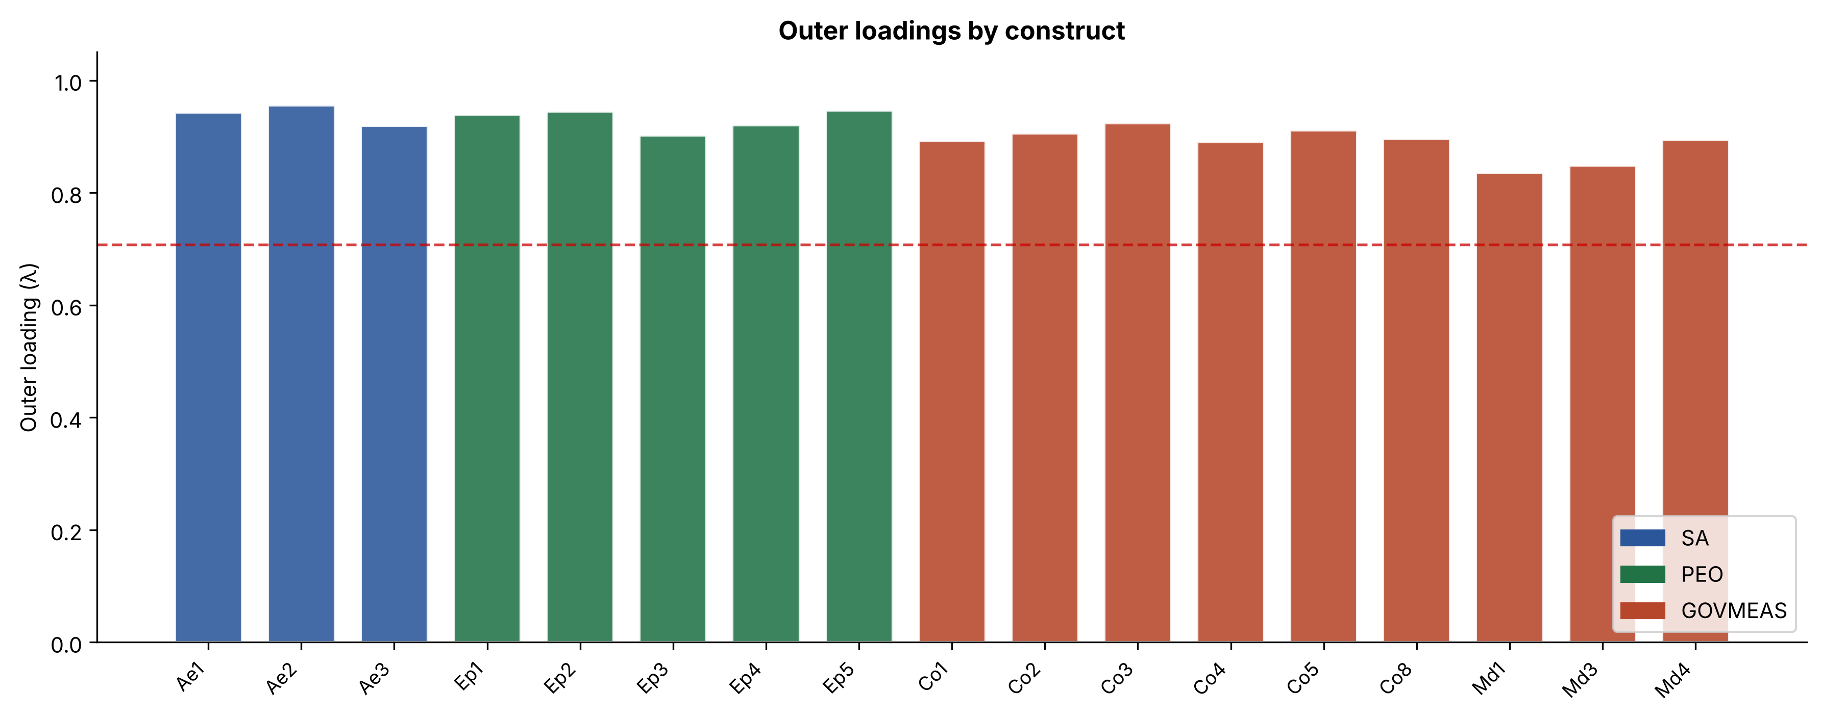
Figure 2. Standardised outer loadings of the reflective indicators, grouped by construct. The dashed line marks the minimum threshold of 0.708.
Table 1. Reliability and convergent validity indicators of the first-order reflective constructs. Thresholds: α ≥ 0.70; CR ≥ 0.70; AVE ≥ 0.50.
Construct | Cronbach's α | CR | AVE | √AVE | Items | Criterion
SA | 0.932 | 0.957 | 0.881 | 0.939 | 3 | Met
PEO | 0.961 | 0.970 | 0.866 | 0.930 | 5 | Met
GOVMEAS | 0.966 | 0.971 | 0.790 | 0.889 | 9 | Met

The respecification of the model comprehensively resolved the discriminant validity problem that affected the original specification. The resulting HTMT values —0.775 for the SA-PEO pair, 0.894 for the SA-GOVMEAS pair, and 0.859 for the PEO-GOVMEAS pair— all fall below the 0.90 threshold (Figure 3), confirming that the three consolidated dimensions represent empirically distinguishable phenomena.
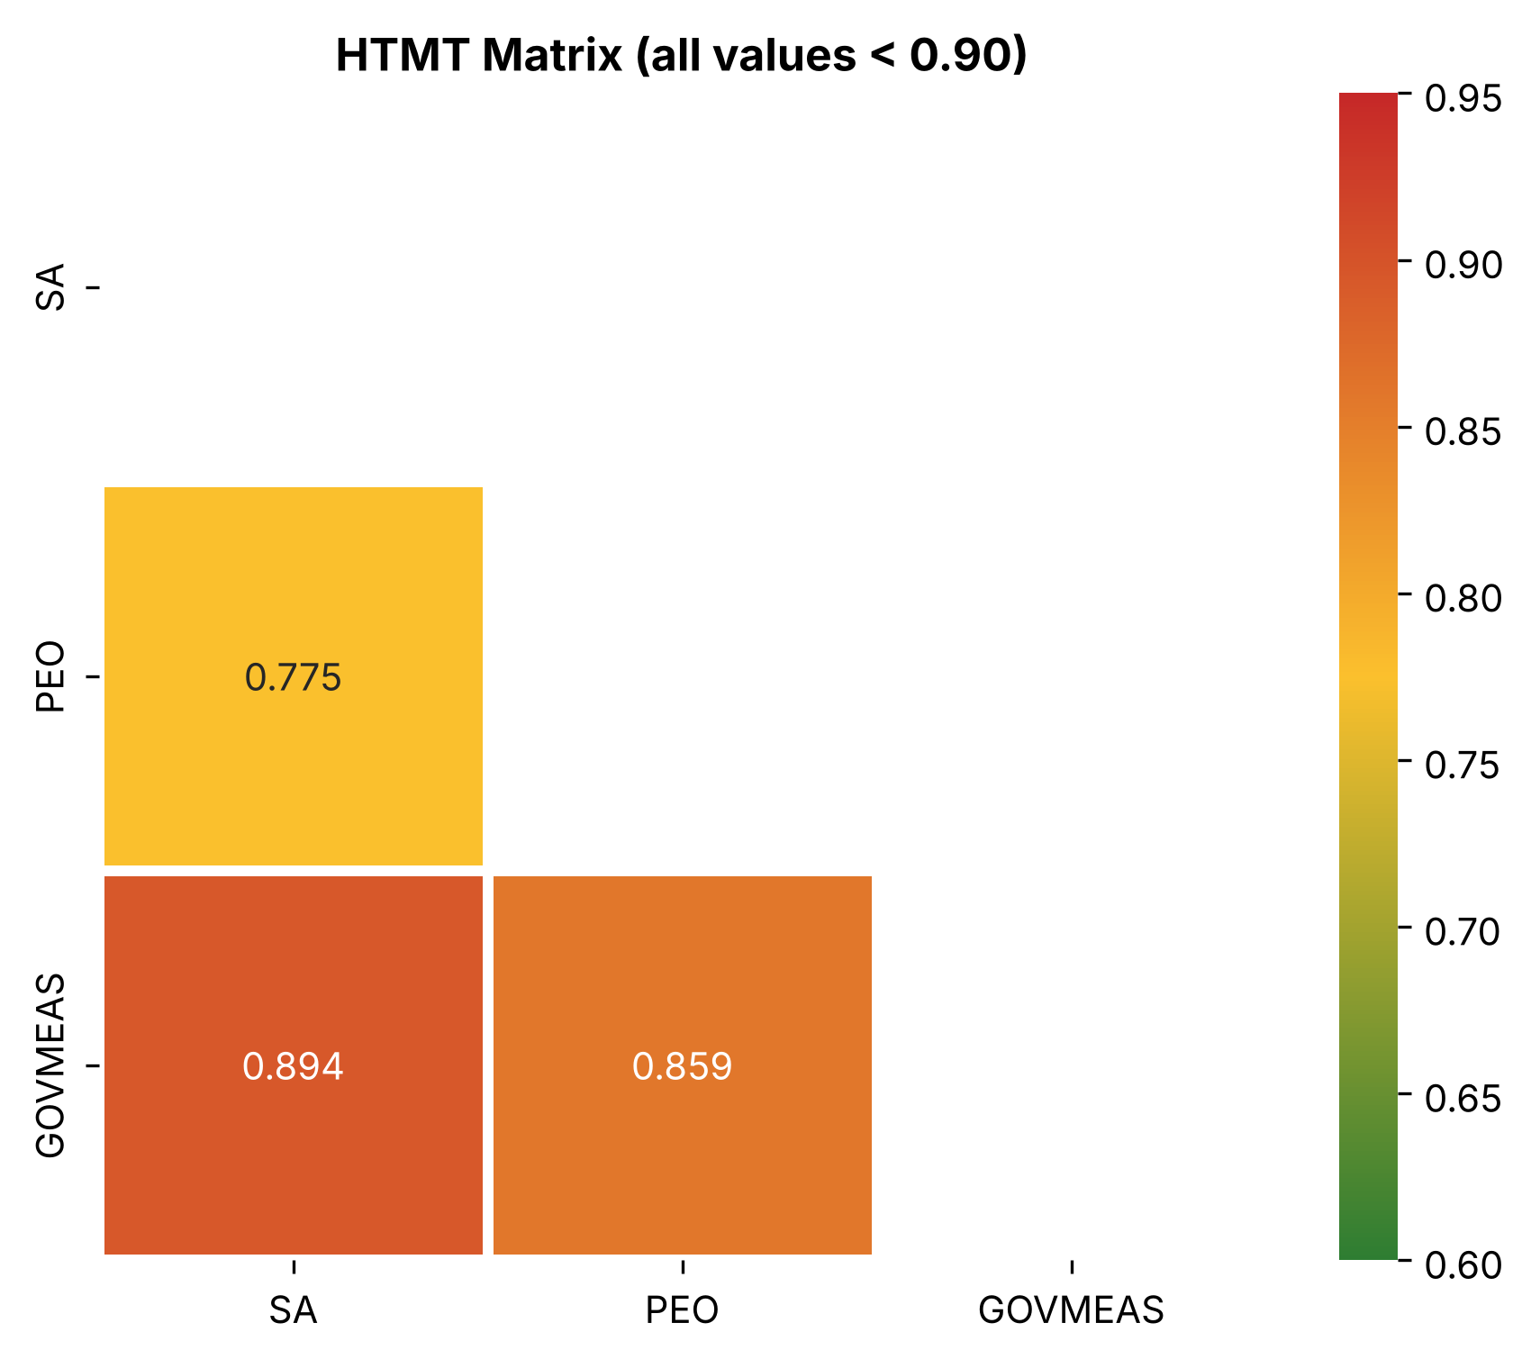
Figure 3. Heterotrait-monotrait (HTMT) matrix of the respecified model. All values fall below the 0.90 threshold, confirming discriminant validity.
As regards the second-stage formative measurement model (Table 2), the governance and measurement dimension exhibited the weight of greatest magnitude and statistical significance (w = 0.871; t = 5.65; p < 0.001), followed by human capabilities (w = 0.420; t = 2.37; p < 0.05), while strategic alignment presented a non-significant weight (w = 0.254; t = 1.14; p = 0.261). It should be noted that, in accordance with the guidelines of Hair et al. (2017), a formative indicator with a non-significant weight but a high outer loading —as is the case of strategic alignment, with a loading of 0.890— should be retained in the model for reasons of content validity. The same criterion supports the retention of indicators Ae10 and Md7 in the endogenous construct: although their weights do not reach statistical significance (0.063 and 0.163, respectively), their outer loadings (0.771 and 0.757) comfortably exceed the 0.50 criterion, so that their exclusion would undermine the content validity of the construct; it should be acknowledged, in any case, that the measurement of process outcomes empirically gravitates around indicator Co7 (w = 0.835; p < 0.001). With respect to collinearity, variance inflation factors fall mostly below the conservative threshold of 5, with the sole exception of indicator BPC3 (VIF = 5.312), which exceeds it marginally and remains comfortably below the liberal threshold of 10 (Hair et al., 2011); this slight excess is to be expected —and is theoretically interpretable— in a formative construct whose constituent dimensions are, by design, interdependent: precisely the interdependence that motivated the consolidation of the hierarchical model.
Table 2. Formative weights, loadings, and variance inflation factors of the second-order construct. Estimation by bootstrap with 3,000 subsamples.
Indicator → Construct | Weight | Loading | t | p | VIF | Decision
SA → BPM Cap. | 0.254 | 0.890 | 1.14 | 0.261 | 3.618 | Retain
PEO → BPM Cap. | 0.420 | 0.908 | 2.37 | 0.021 | 3.210 | Retain
GOVMEAS → BPM Cap. | 0.871 | 0.981 | 5.65 | < 0.001 | 5.312 | Retain

Common method bias. The cross-sectional, single-informant design of the study is structurally susceptible to common method bias, for which reason it was assessed through the two conventional diagnostics and is reported transparently. Harman's single-factor test (Harman, 1976) indicates that the first component explains 72.3% of the total variance, above the indicative 50% threshold, and the full collinearity variance inflation factors (Kock, 2015) range between 3.45 and 6.67, exceeding the 3.3 criterion. Both indicators must nevertheless be interpreted in the light of two considerations. The first is arithmetic-theoretical: the high values are, in part, a consequence of the high inter-construct correlation that the theoretical framework itself anticipates —the interdependence of organisational capabilities is, precisely, the foundation of the hierarchical consolidation of the model— and therefore cannot be attributed exclusively to method variance. The second is methodological: two of the three techniques in the tri-methodological design are structurally less vulnerable to common method inflation than linear correlations, since the asymmetric subset relations of fsQCA and the nonlinear importance measures of the neural network are not derived from the bivariate correlation matrix that this bias inflates (Podsakoff et al., 2003). Procedurally, the instrument was administered with a guarantee of anonymity and drew on previously validated scales. Nonetheless, the residual susceptibility to common method bias is explicitly acknowledged among the limitations of the study.

4.2 Structural model
Estimation of the structural model evidenced a positive, statistically significant, and substantial effect of BPM capability on process outcomes. The standardised path coefficient reached 0.934 (t = 54.2; p < 0.001), with a 95% confidence interval between 0.901 and 0.968, confirming the robustness of the effect and the corroboration of the hypothesis. The coefficient of determination reached 0.873 (adjusted R² = 0.871), a magnitude corresponding to substantial explanatory power according to the criteria of Hair et al. (2017). The associated effect size, f² = 6.87, amply exceeds the large-effect threshold (0.35), and a post hoc power analysis indicates that, for this effect with α = 0.05, the sample of fifty-six observations achieves a power above 0.99. Predictive relevance was examined through the PLSpredict procedure (Shmueli et al., 2019), contrasting the prediction error of the model against that of a linear model benchmark (LM) under ten-fold cross-validation with ten repetitions (Table 3). The Q²predict statistic was clearly positive for the three endogenous indicators (0.845, 0.491, and 0.482), confirming the out-of-sample predictive relevance of the model; the comparison with the linear benchmark revealed, however, a nuanced pattern: the model outperformed the LM on the indicator with the greatest weight (Co7), whereas on the remaining two the benchmark obtained marginally lower errors —differences of 0.014 and 0.002 standard deviations— a pattern which, under a strict reading of the criteria of Shmueli et al. (2019), corresponds to low predictive power and which must be weighed in the light of the negligible magnitude of such differences and the primarily explanatory purpose of the model.
Table 3. Predictive assessment through the PLSpredict procedure: comparison of the PLS model against the linear model benchmark (LM) under ten-fold cross-validation with ten repetitions. Errors are expressed on standardised indicators; Q²predict is computed relative to the training-set mean.
Indicator | RMSE PLS | RMSE LM | MAE PLS | MAE LM | Q²predict
Co7 | 0.401 | 0.401 | 0.291 | 0.292 | 0.845
Ae10 | 0.730 | 0.716 | 0.528 | 0.527 | 0.491
Md7 | 0.735 | 0.733 | 0.589 | 0.584 | 0.482

Reproducibility verification. Independent implementation of the PLS-SEM model in the R and Python environments produced numerically equivalent results (β = 0.934 and R² = 0.873 in both cases, with formative weights identical to the third decimal), a circumstance that constitutes evidence of the computational robustness of the analysis —in a context where the literature documents that apparently minor methodological choices can substantively alter results (Sarstedt et al., 2024)— and of the fidelity of the open-source implementations. After additionally aligning the optimiser and activation function of the Python implementation with those of nnet in R (L-BFGS and logistic activation), the neural network module also achieved cross-platform numerical equivalence, with differences below half a percentage point in the averaged importances.

4.3 Artificial neural network analysis
The instability of importance in single-run implementations. The artificial neural network analysis revealed a methodological finding of considerable relevance that merits detailed exposition. Conventional practice in the literature combining PLS-SEM with neural networks consists of training a single network and deriving from it the relative importance measures of the predictors (Le et al., 2023; Leong et al., 2020; Sharma et al., 2021). However, applying this procedure to the present dataset showed that the conclusions thus obtained are highly dependent on the random initialisation seed of the synaptic weights. As illustrated in Figure 4, when varying this seed across thirty runs, the identity of the dominant predictor oscillates among the three dimensions —human capabilities emerge as dominant in twelve runs, governance and measurement in nine, and strategic alignment in the remaining nine— with variation ranges reaching twenty-five percentage points. This circumstance reveals that any conclusion about the primacy of a predictor derived from a single run constitutes an artefact of initialisation, devoid of substantive validity. The overfitting of these unregularised networks is further manifested in the gap between the training mean squared error (0.014) and the test error (0.700), a contrast that quantitatively motivates the regularisation adopted in the robust protocol.
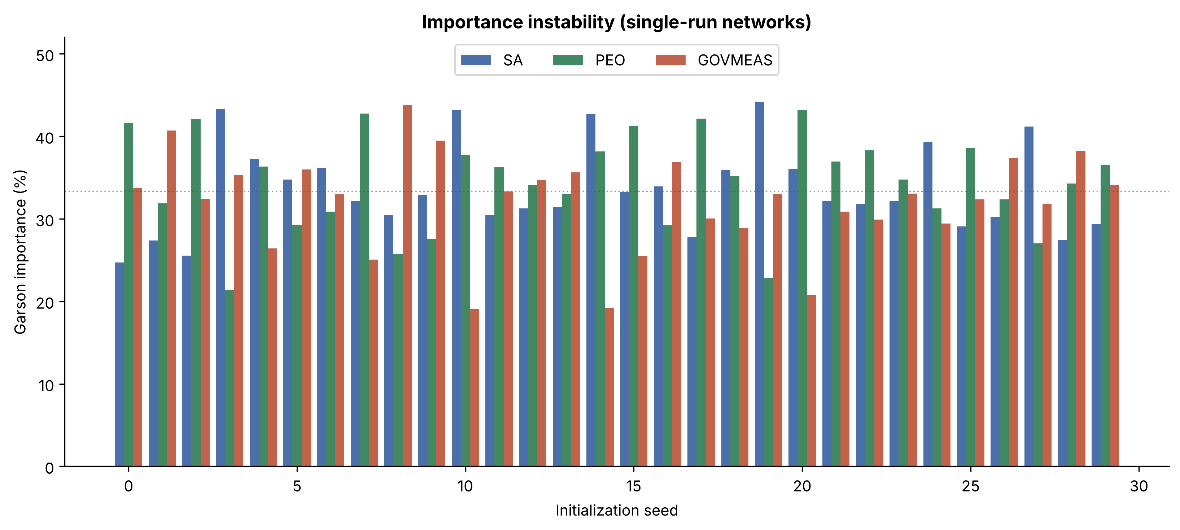
Figure 4. Instability of Garson's relative importance as a function of the random initialisation seed, across thirty single-run networks. The identity of the dominant predictor varies with the seed, evidencing the artefactual character of conclusions derived from a single run. These thirty networks deliberately correspond to the unregularised configuration (ten hidden neurons and zero decay), whose contrast with the regularised protocol of Figure 5 illustrates the effect of regularisation.
The robust averaging protocol. In order to obtain stable estimates of relative importance, a robust protocol was implemented consisting of training ten independent neural networks, each subjected to ten-fold cross-validation, with subsequent averaging of the importance measures. Under this procedure —and after regularising the network through a decay term and a more parsimonious architecture (three hidden neurons) that eliminates overfitting— relative importance stabilised markedly across networks (standard deviation below 0.3 percentage points) and revealed a definite hierarchy: governance and measurement emerges as the dominant predictor with 41.4 percent, followed by strategic alignment with 29.7 percent and human capabilities with 28.8 percent, as represented in Figure 5. This result embodies a twofold contribution: on the one hand, it demonstrates that the apparent equivalence among dimensions observed under unregularised networks was an artefact of overfitting, whose noise, averaged across networks, flattened the importance measures; on the other, once that overfitting is controlled, the nonlinear analysis converges with PLS-SEM and fsQCA in pointing to governance and measurement as the pre-eminent dimension. The evaluation of predictive fit confirmed the absence of overfitting, since the training mean squared error (0.106) was practically identical to the test error (0.107). It should be noted that the stability thus reported refers to variability across networks trained on the same sample; the sampling variability of nonlinear importance, of a different nature, is quantified in Section 4.6.
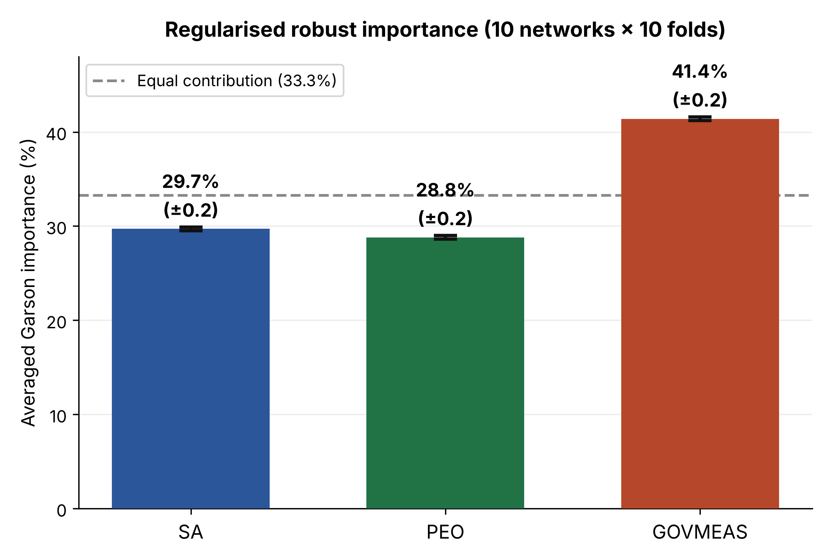
Figure 5. Robust relative importance obtained by averaging ten regularised neural networks, each subjected to ten-fold cross-validation (canonical R implementation; the Python implementation replicates the figures with differences below half a percentage point). Error bars represent the standard deviation across networks; the dashed line marks the theoretical equal contribution (33.3%), above which governance and measurement lies.
The convergence between the importance hierarchy derived from PLS-SEM —in which governance and measurement dominates with a formative weight of 0.871— and the pre-eminence of that same dimension under robust, regularised nonlinear modelling (41.4%) reinforces the solidity of the finding. Both the linear and the nonlinear analysis agree that governance and measurement constitutes the dimension with the greatest predictive weight; human capabilities and strategic alignment, with contributions close to one another (28.8% and 29.7%, respectively), operate as complementary factors. This agreement between techniques of different nature strengthens the interpretation of governance and measurement as the articulating axis of BPM capability.

4.4 Fuzzy-set qualitative comparative analysis
The analysis of necessary conditions, whose figures correspond to the canonical implementation of the QCA package in R, revealed that, for achieving high process outcomes, no individual dimension reaches the 0.90 consistency threshold (Schneider & Wagemann, 2012): governance and measurement records the highest consistency (0.883; RoN = 0.945; coverage = 0.943), followed by human capabilities (0.865; RoN = 0.913) and strategic alignment (0.863; RoN = 0.855), so that no condition can be claimed, on its own, to be necessary for success; the high RoN values indicate, in any event, that the observed consistencies are not artefacts of the ubiquity of the conditions. The analysis of the negated outcome provides the asymmetric reading (Pappas & Woodside, 2021): the absence of governance and measurement does constitute a necessary condition for poor outcomes (consistency = 0.938; RoN = 0.889), while the absence of human capabilities approaches the threshold without reaching it (0.899; RoN = 0.876). The practical implication is direct: neglecting governance and measurement determines, almost inexorably, unsatisfactory process outcomes, and neglecting human capabilities operates in the same direction with a consistency just below the criterion.
The sufficiency analysis was articulated in two stages: construction of the truth table and its Boolean minimisation through the conservative solution, without incorporating logical remainders. With the raw consistency (≥ 0.80) and PRI consistency (≥ 0.70) thresholds, three observed configurations pass the filter: the simultaneous presence of the three dimensions (twenty cases; consistency = 0.972; PRI = 0.947), the conjunction of human capabilities and governance in the absence of strategic alignment (one case; 0.982; 0.882), and the presence of governance and measurement in the absence of the other two dimensions (three cases; 0.986; 0.850). A fourth combination —strategic alignment and governance in the absence of human capabilities— exhibits high indicators (0.986; 0.886) but lacks empirical cases (n = 0), so it constitutes a logical remainder that is not incorporated into the solution. The pertinence of the PRI statistic is eloquently manifested in the contrast: the configuration combining strategic alignment and human capabilities in the absence of governance presents an apparently acceptable raw consistency (0.920) but a PRI of only 0.626, which disqualifies it as genuinely sufficient. Boolean minimisation of the three observed configurations yields the conservative solution M1 = ~SA·GOVMEAS + PEO·GOVMEAS (Table 4 and Figure 6): two alternative routes to superior outcomes, one in which governance and measurement compensates for the absence of strategic alignment (consistency = 0.977; PRI = 0.850; raw coverage = 0.453; unique coverage = 0.047) and another, of substantially greater coverage, in which it is conjoined with human capabilities (0.971; 0.943; 0.815; 0.409). The overall solution exhibits a consistency of 0.968, a PRI of 0.936, and a coverage of 0.862. The invariant presence of governance and measurement in both terms establishes it as the core condition of the configurational model.
Table 4. Conservative sufficiency solution for high process outcomes. The symbol ● denotes presence of the condition, ⊗ absence, and – a don't-care condition; raw coverage is reported with unique coverage in parentheses. The configuration SA·~PEO·GOVMEAS (n = 0) constitutes a logical remainder and is not incorporated into the solution.
Term | SA | PEO | GOVMEAS | Consist. | PRI | Raw cov. (unique)
T1 | ⊗ | – | ● | 0.977 | 0.850 | 0.453 (0.047)
T2 | – | ● | ● | 0.971 | 0.943 | 0.815 (0.409)
Conservative solution M1: consistency = 0.968; PRI = 0.936; coverage = 0.862

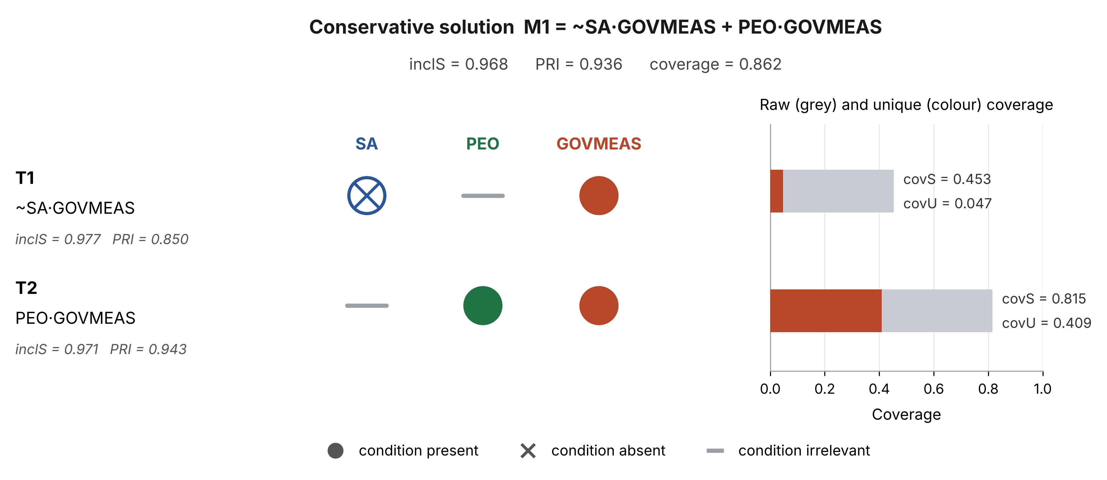
Figure 6. Graphical representation of the conservative solution M1 = ~SA·GOVMEAS + PEO·GOVMEAS. The left panel encodes the conditions of each term; the right panel contrasts the raw and unique coverage of each route. Governance and measurement is present in both terms, which establishes it as the core condition.
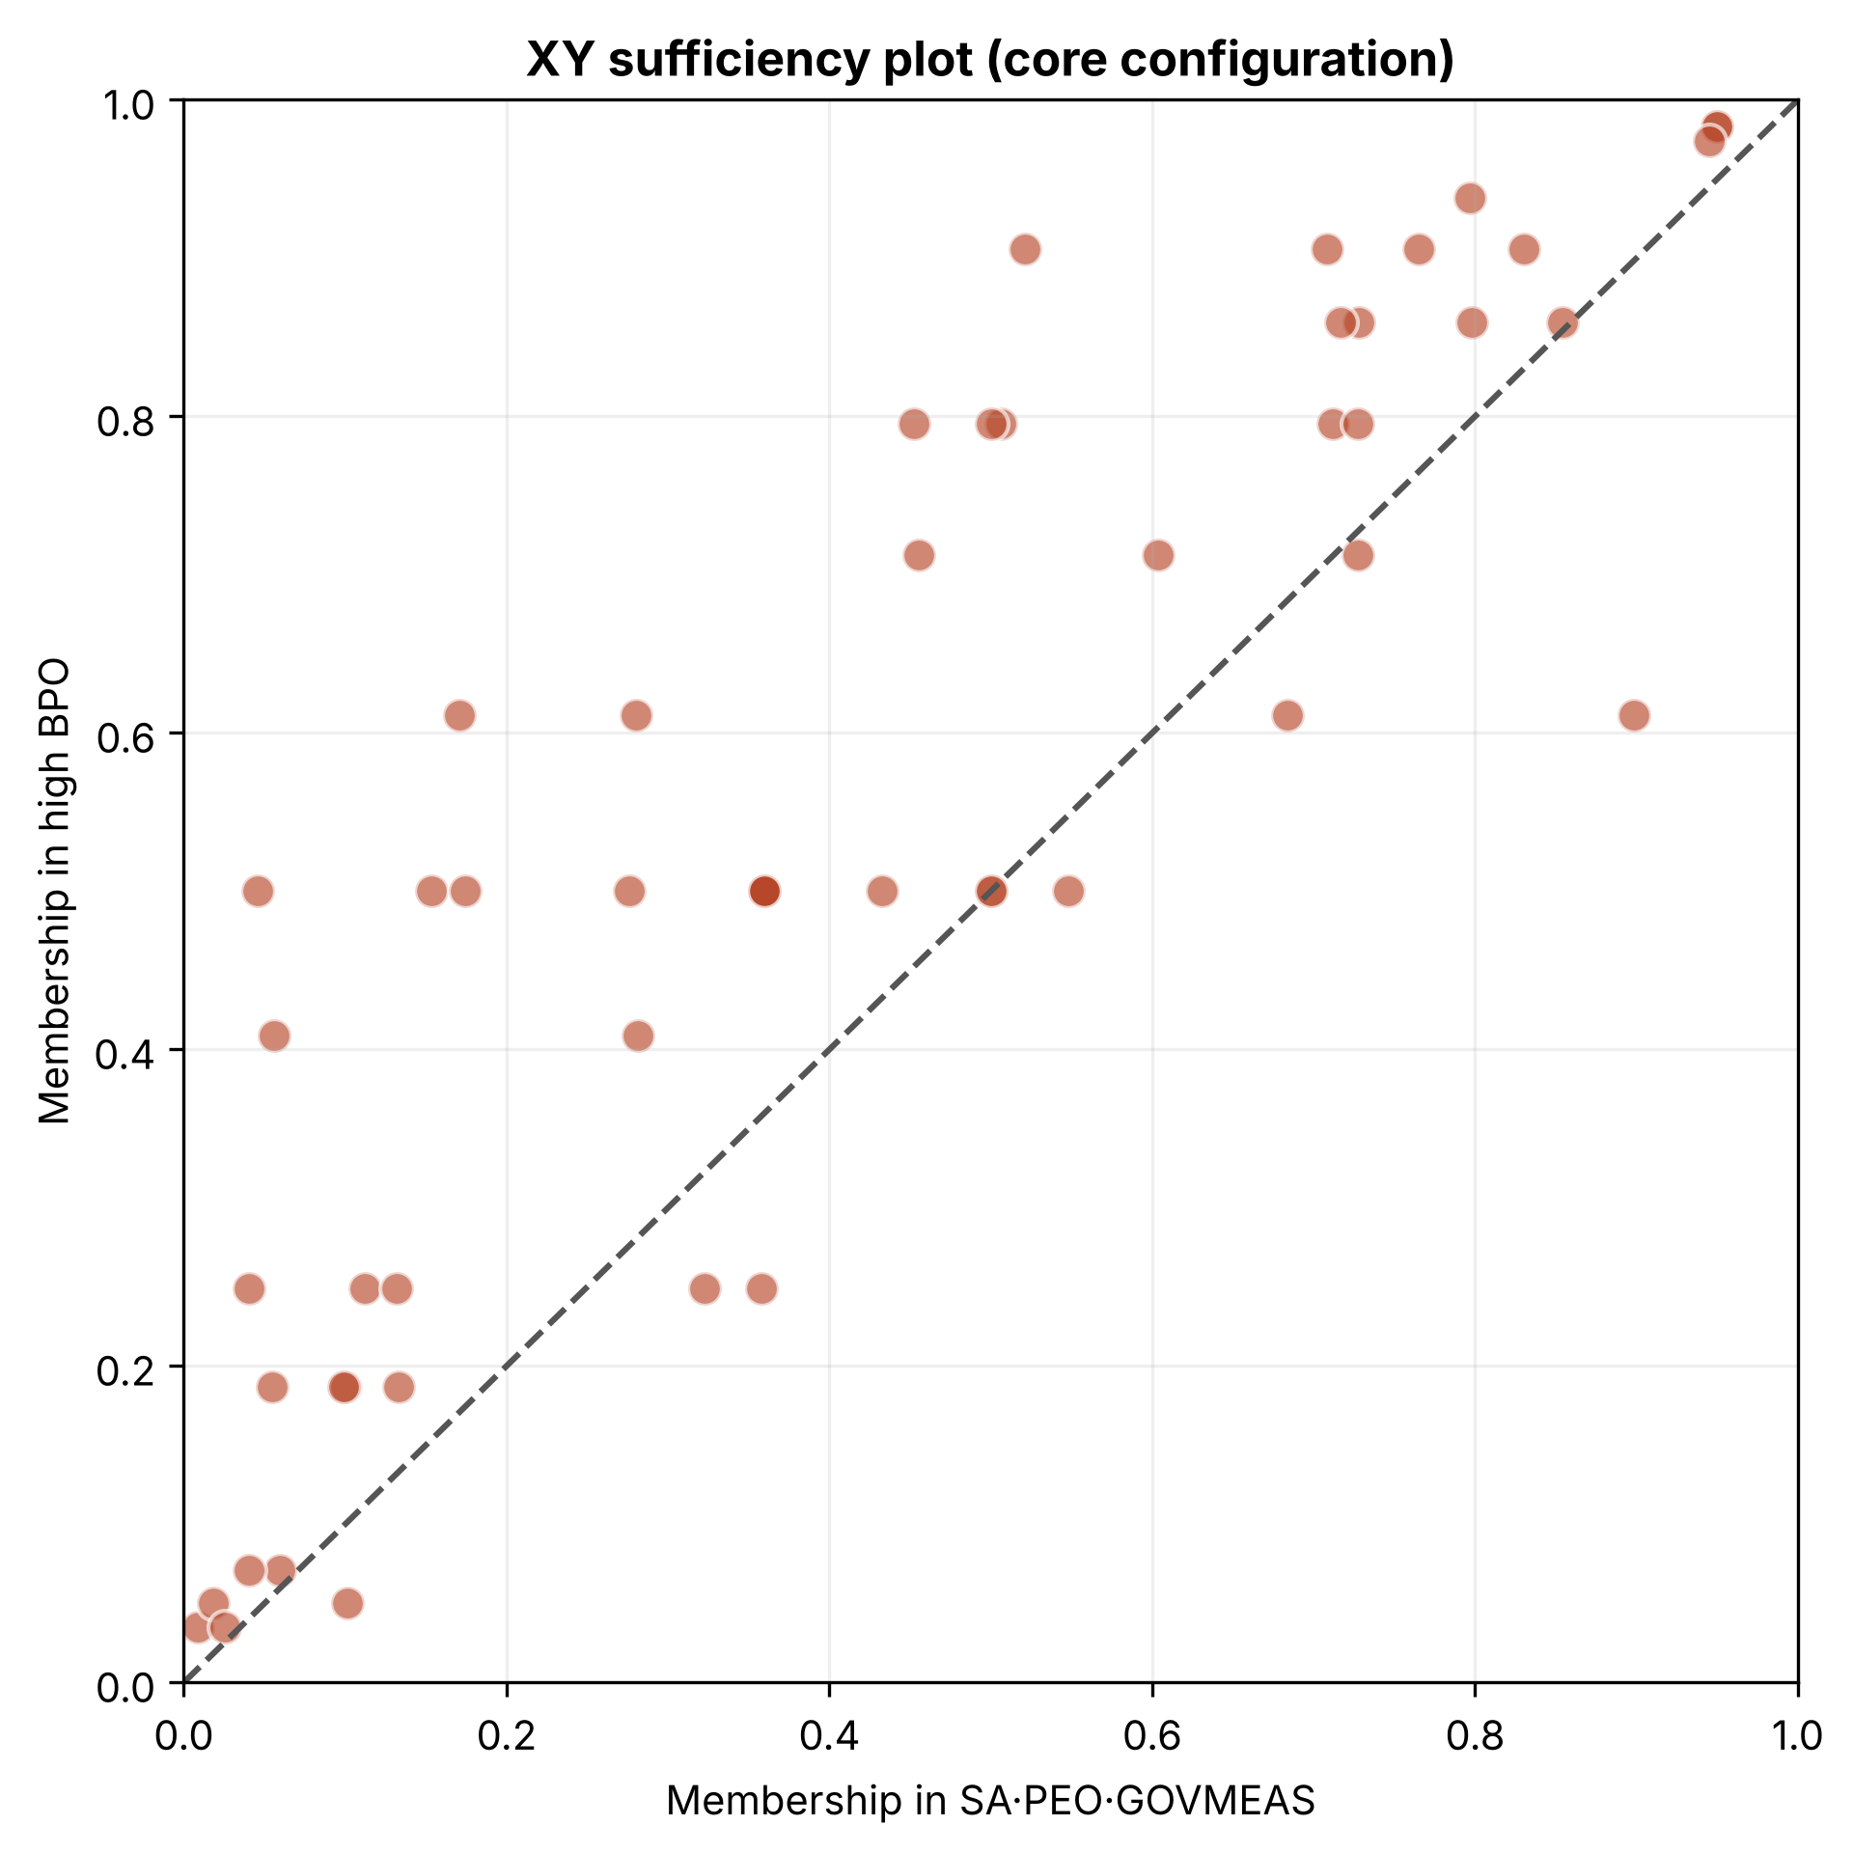
Figure 7. XY sufficiency plot for the central configuration, in which the three dimensions concur (twenty observed cases). The distribution of cases above the diagonal confirms the sufficiency relation.
Calibration sensitivity analysis. The robustness of the configurational inferences to the specification of the anchors was examined, in the first instance, by recalibrating the fuzzy sets with the 90th, 50th, and 10th percentiles. Under this alternative scheme, the structure of the solution remains unchanged —M1 = ~SA·GOVMEAS + PEO·GOVMEAS, with consistency of 0.956, PRI of 0.923, and coverage of 0.862— the combination of alignment and governance without human capabilities continues to constitute a logical remainder, and governance and measurement retains both the highest necessity consistency (0.885) and its presence in all sufficient terms. The formal robustness protocol, which generalises this check to 1,152 alternative specifications, is reported in Section 4.6.

4.5 Tri-methodological synthesis
The integration of the three analytical techniques provides a multidimensional understanding of the phenomenon that transcends the limitations inherent in each approach considered in isolation. Table 5 summarises the convergent and divergent findings, while Figure 8 represents them graphically. The most robust pattern emerging from the triangulation is the centrality of the governance and measurement dimension, which manifests as the predictor of greatest weight in the linear analysis and as the core condition in the configurational analysis. The robust nonlinear analysis, once regularised to avoid overfitting, corroborates this conclusion by likewise placing governance and measurement as the predictor of greatest nonlinear importance (41.4%), so that the three techniques converge in signalling its centrality.
Table 5. Synthesis of the relative importance of the dimensions according to the three analytical techniques. Notation: * p < 0.05; *** p < 0.001; n.s. = not significant.
Dimension | PLS-SEM (weight) | Robust ANN | fsQCA necessity | fsQCA config.
SA | 0.254 (n.s.) | 29.7% | 0.863 | Complementary
PEO | 0.420* | 28.8% | 0.865 | Complementary
GOVMEAS | 0.871*** | 41.4% | 0.883 | Core (2/2)

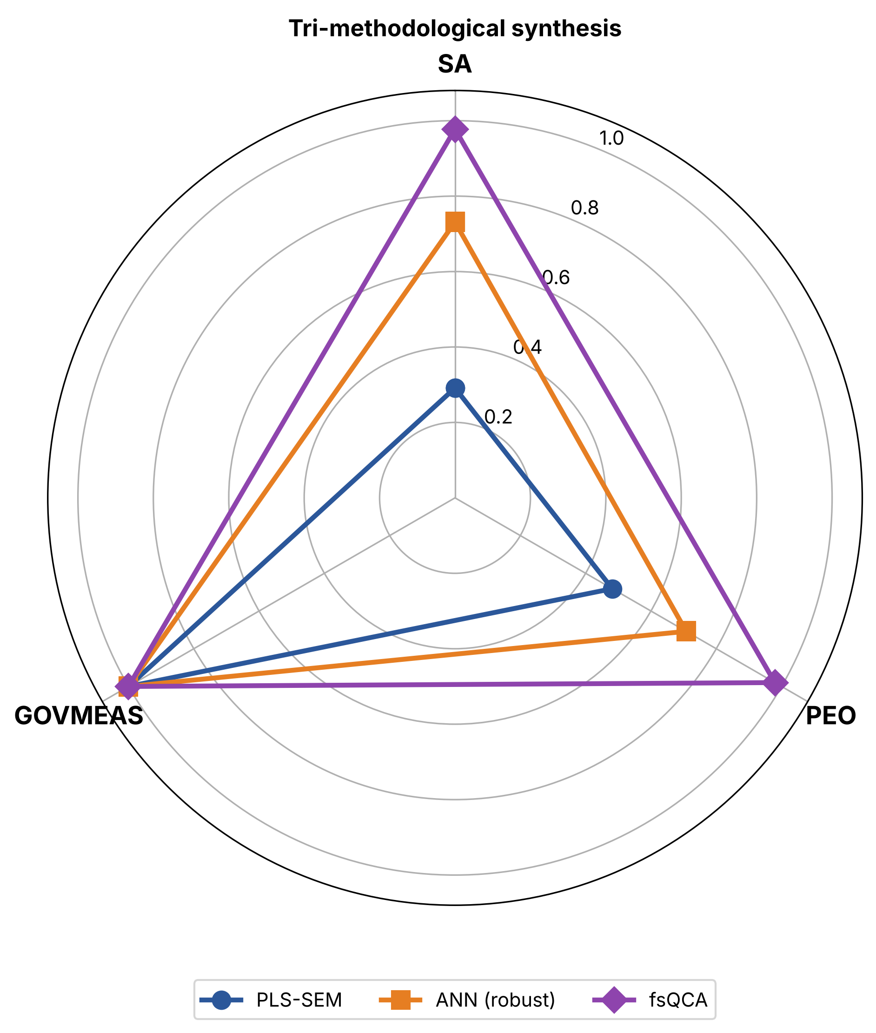
Figure 8. Radar chart of the tri-methodological synthesis. Each axis represents a dimension; the overlaid series encode the normalised relative importance according to PLS-SEM (linear), the robust ANN (nonlinear), and fsQCA (configurational).

4.6 Robustness analysis
Table 6 and Figure 9 summarise the results of the robustness analysis described in Section 3.2; the complete detail is reported in Appendix C.
PLS-SEM parameter recovery. The Monte Carlo study confirms that the structural effect is insensitive to sample size: with n = 56, the mean bias of β is 0.004, its root mean squared error 0.017, and the power to detect it as greater than 0.35 reaches 100% at all sizes examined, including n = 30. Under adverse scenarios in which the population effect is reduced to 0.70, 0.50, or 0.35, the sample detects it in all replications, albeit with the positive bias characteristic of PLS for weak effects (up to +0.11), which is absent in the observed case. The hierarchy of formative weights is more sensitive: the dominance of GOVMEAS is recovered in 92.1% of the n = 56 replications —versus 78.4% with n = 30 and 94.9% with n = 80— and the significance of the PEO weight, the most fragile inference of the structural model, in only 82.0% (94.0% with n = 80). The empirical coverage of the bootstrap intervals of the weights (0.907–0.947) approaches the nominal level, whereas that of the structural coefficient (0.847) indicates that the interval reported for β is slightly optimistic; since it lies far from zero, this undercoverage does not affect the substantive conclusion.
Specificity of the robust neural network protocol. Under the null hypothesis of equal contribution —identical conditional coefficients and preserved explained variance— the robust protocol returns a mean importance of 32.8 / 33.5 / 33.7 percent, with a standard deviation across replications of 4.4 percentage points, half that exhibited by the single-run network (8.9–10.5), and reduces the frequency of spurious gaps above ten points from 82% to 43%. Under the real data-generating process, it recovers the dominance of GOVMEAS in 81.7% of the replications, with a mean importance of 40.0% and a mean lead of 6.3 points over the second dimension. This result qualifies the reading of Section 4.3: the sampling variability of Garson importance with n = 56 is about five percentage points, so that the nonlinear primacy of governance constitutes a probable finding, whose solidity derives from its convergence with PLS-SEM and fsQCA rather than from the network considered in isolation. A complementary diagnostic with equalised bivariate correlations further shows that the protocol systematically penalises GOVMEAS (28.2%), the most collinear dimension, so that its dominance in the observed sample is not attributable to a bias of the method.
fsQCA robustness protocol. The Oana and Schneider (2024) protocol shows that the conservative solution is insensitive to the inclusion anchor (p80–p99) and to the raw consistency cut-off (0.70–0.97), and moderately sensitive to the crossover point (p45.5–p56), the exclusion anchor (p0.5–p10), and the PRI cut-off (0.63–0.845). The only parameter without margin is the frequency cut-off: with n ≥ 2 the single-case configuration that enables minimisation disappears and the solution takes its non-minimised form, SA·PEO·GOVMEAS + ~SA·~PEO·GOVMEAS, which is substantively equivalent. Over a test set of 1,152 specifications, 92% of the solutions are the initial solution or forms logically nested within it; the consistency of the intersection of all solutions (TS_min = 0.972) exceeds that of the initial solution, the set coincidence with TS_min and TS_max is 0.872 and 0.930, and the only appreciable loss occurs in coverage (RF_cov = 0.108). Of the twenty-one typical cases, nineteen are robust (RCR_typ = 0.905), and the membership of fifty of the fifty-six cases is stable in at least 95% of the specifications. The robust core of the solution is governance and measurement, present in at least one term in 100% of the specifications and in all terms in 93%; the remaining 7% corresponds entirely to a PRI cut-off of 0.65, under which the configuration SA·PEO·~GOVMEAS (PRI between 0.651 and 0.694) enters the solution, which illustrates the function of the 0.70 PRI threshold adopted.
Table 6. Summary of the robustness analysis. Monte Carlo: 1,000 replications per sample size (coverage and power over 150 replications with 250 bootstrap resamples each); ANN specificity: 120 replications per scenario; fsQCA: test set of 1,152 specifications.
Component | Criterion | Result (n = 56) | Reading
PLS-SEM · β | Bias / RMSE / power (β ≥ 0.35) | +0.004 / 0.017 / 1.000 | Insensitive to sample size
PLS-SEM · β | Bootstrap 95% CI coverage | 0.847 | Slightly optimistic interval
PLS-SEM · weights | P(GOVMEAS dominant) | 0.921 (0.949 with n = 80) | Robust
PLS-SEM · weights | P(PEO weight significant) | 0.820 (0.940 with n = 80) | Most fragile inference
ANN · H0 | Importance under equal contribution | 32.8 / 33.5 / 33.7 (σ = 4.4) | Protocol is specific
ANN · H1 | P(GOVMEAS dominant) | 0.817 (mean lead 6.3 pp) | Probable; rests on convergence
fsQCA · fit | Set coincidence IS–TS_min / IS–TS_max | 0.872 / 0.930 | Robust
fsQCA · cases | RCR_typ (robust typical cases) | 0.905 (19/21) | Robust
fsQCA · core | GOVMEAS in all terms | 93% of 1,152 (100% with PRI ≥ 0.70) | Robust core

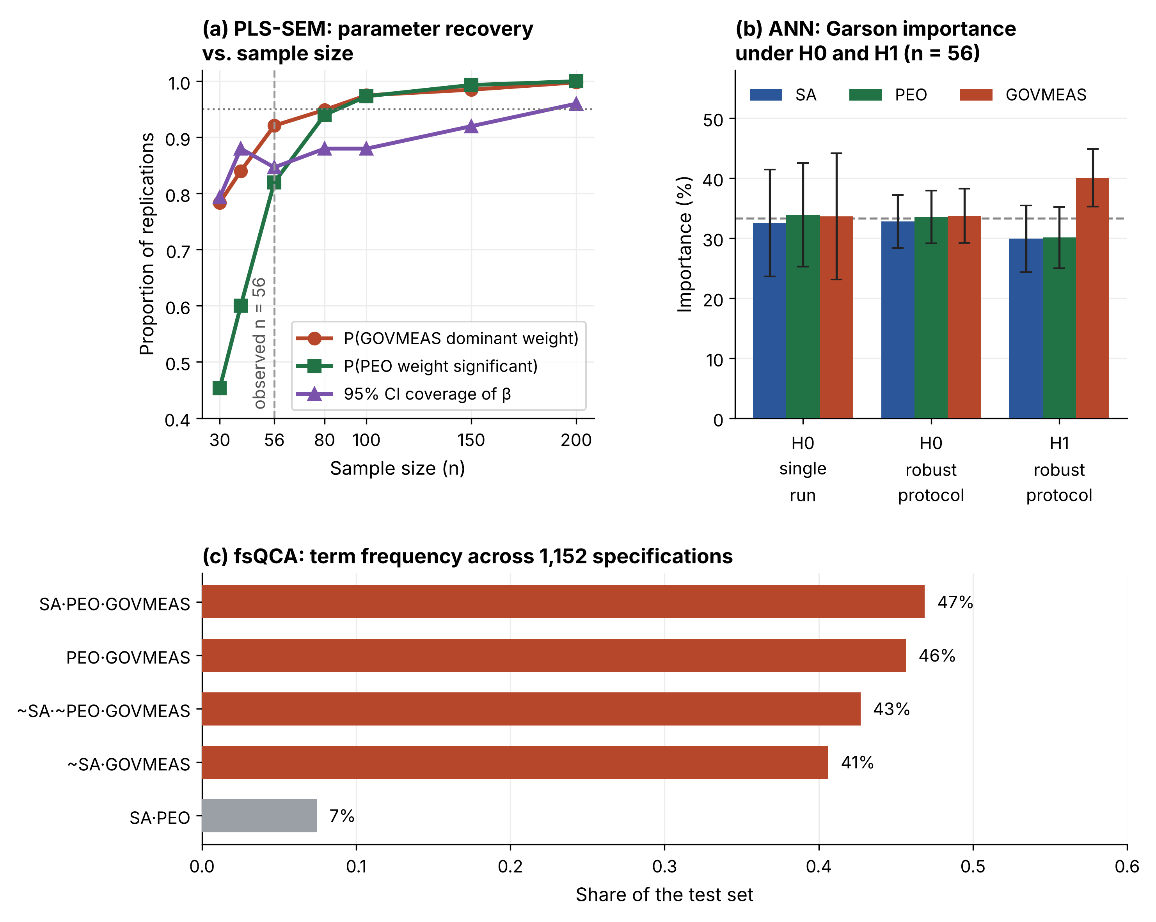
Figure 9. Graphical summary of the robustness analysis. (a) PLS-SEM parameter recovery as a function of sample size: proportion of replications in which GOVMEAS emerges as the dominant weight, in which the PEO weight is significant, and in which the bootstrap interval of β covers the population value. (b) Mean Garson importance (± standard deviation across replications) of the single-run network and the robust protocol under the null hypothesis of equal contribution, and of the robust protocol under the real data-generating process. (c) Frequency of each term across the 1,152 specifications of the fsQCA test set; terms including GOVMEAS are highlighted in colour.

5. Discussion

5.1 Governance as the articulating axis of the capability system
The most robust finding emerging from the tri-methodological triangulation is the central position occupied by the governance and measurement dimension in determining process outcomes. This centrality manifests convergently across the three techniques: governance exhibits the formative weight of greatest magnitude in the linear analysis, constitutes the condition of highest consistency in the necessity analysis, and is invariantly present in the two terms of the sufficient solution identified by the configurational analysis, a pattern consistent with the evidence that not all BPM capabilities contribute equally to the benefits of digitalisation (Antonucci et al., 2021). The robustness analysis adds a relevant qualification: the centrality of governance is not an artefact of specification, since it survives 93% of the alternative fsQCA specifications and is recovered in 92% of the simulated PLS-SEM replications. This pattern converges with the findings of Ongena and Ravesteyn (2019), who documented that technological support, resources and knowledge, and process measurement constituted the only statistically significant dimensions in their model —precisely the three facets that the present study integrates into the governance and measurement construct. The empirically validated merger of governance, measurement, and technological support as a unitary capability thus extends the principle of holism posited by vom Brocke et al. (2014), suggesting that these facets operate so interdependently that informants do not perceive them as conceptually separable dimensions.

5.2 The critical reconsideration of nonlinear importance
One of the most significant contributions of the present study, eminently methodological in nature, concerns the critical reconsideration of conclusions about nonlinear importance derived from single-run neural network implementations. The literature combining structural equation modelling with neural networks has proliferated in recent years (Le et al., 2023; Leong et al., 2020; Luyao et al., 2022; Sharma et al., 2021); however, a considerable proportion of these works derive their conclusions about the relative importance of predictors from a single run of the network. The present study empirically demonstrates that such practice is methodologically problematic: in the dataset analysed, the identity of the dominant predictor varies substantially with the random initialisation seed, so that a single-run implementation could have concluded, with identical apparent plausibility, that any of the three dimensions constitutes the pre-eminent nonlinear predictor. The robust averaging protocol across multiple initialisations, complemented by regularisation of the network to control overfitting, reveals that, in nonlinear terms, governance and measurement constitutes the dominant predictor stably across networks. The simulation-based specificity test adds two qualifications that delimit the scope of this recommendation: the protocol does not fabricate non-existent hierarchies —under equal contribution it returns equidistributed importances— and the sampling variability of nonlinear importance, of about five percentage points with fifty-six observations, requires Garson importance to be interpreted as complementary evidence rather than as a self-sufficient criterion. Both qualifications constitute a relevant corrective for research practice in the field and a methodological recommendation with implications that transcend the specific domain of BPM.
This pre-eminence of governance in nonlinear importance converges with the centrality evidenced by the remaining techniques and admits a theoretically grounded interpretation. The linear, nonlinear, and configurational analyses coincide in highlighting the articulating role of governance and measurement, while human capabilities and strategic alignment operate as complementary factors whose combination, once interaction effects are incorporated, determines the outcome. BPM capability thus emerges as a systemic property articulated around governance, consistent with the conception of dynamic capabilities as configurations of interdependent resources and routines (Teece, 2007).

5.3 Equifinality and causal asymmetry
The configurational analysis contributes a perspective that substantively complements the findings of the correlational techniques. The identification of two alternative sufficient routes to high process outcomes —one in which governance and measurement compensates for the absence of strategic alignment and another in which it is conjoined with human capabilities— evidences the principle of equifinality, according to which multiple causal trajectories lead to the same outcome (Fiss, 2011; Ragin, 2008). This plurality of paths carries relevant managerial implications: organisations enjoy strategic flexibility in configuring their BPM capabilities, without simultaneous excellence in all three dimensions being required, provided the presence of governance as the core condition is preserved. Causal asymmetry is likewise confirmed in the analysis of poor outcomes, in which the absence of governance and measurement emerges as a necessary condition (consistency = 0.938) and the absence of human capabilities approaches the threshold without reaching it (0.899), indicating that the paths to failure are not the mere mirror image of the paths to success. The incorporation of the PRI statistic, which made it possible to discard spuriously consistent configurations, reinforces the validity of these configurational inferences; the robustness protocol shows, in fact, that the only route without governance capable of entering the solution under alternative specifications does so exclusively when the PRI threshold is relaxed below 0.70. These implications acquire particular currency in the context of digitalisation, where process management operates as a vehicle for intellectual capital and continuous improvement (Broccardo et al., 2024; Scavarda et al., 2025) and where employee engagement conditions the success of transformation (Hernik et al., 2025).

5.4 Methodological contribution of the tri-methodological design
The sequential integration of structural equation modelling, artificial neural networks, and fuzzy-set qualitative comparative analysis constitutes, to the authors' knowledge, the first application of a tri-methodological design of this nature to the field of BPM. Each technique answers an epistemologically distinctive analytical question: PLS-SEM establishes the magnitude and significance of linear effects, answering the question of which dimensions matter; neural networks determine nonlinear importance and diagnose the presence of interactions, answering the question of how much they matter once such interactions are considered; and fsQCA reveals the sufficient and necessary combinations, answering the question of how the conditions combine to produce the outcome. The substantive value of triangulation resides precisely in the divergences between techniques, which, far from constituting inconsistencies, reveal complementary facets of the phenomenon that no single technique could capture. The robustness analysis fulfils, in this design, a closing function: by quantifying which inferences are stable with respect to sample size and analytical decisions and which depend on them, it makes it possible to grade the confidence placed in each finding rather than presenting triangulation as an undifferentiated guarantee.

5.5 Managerial implications
The findings carry direct implications for information technology management and for those responsible for BPM programmes. First, the convergent evidence from the three techniques and from the robustness analysis indicates that governance and measurement —understood as the integrated system of governance structures, performance metrics, and technological support— constitutes the investment with the highest marginal return: its presence is a core condition of all routes to high outcomes and its absence is a necessary condition of poor outcomes. Second, the principle of equifinality offers resource-constrained organisations a sequencing guide: once governance is consolidated, investment in human capabilities opens the route of greatest empirical coverage to success, whereas strategic alignment, whose formative weight does not reach statistical significance, may be developed progressively without compromising initial outcomes. Third, the empirical prevalence of governance over strategic alignment suggests that BPM programmes which prioritise strategy formulation without simultaneously institutionalising process measurement and governance mechanisms incur the failure pattern that the literature persistently documents. Finally, the availability of the entire analytical toolkit in open source allows organisations to replicate the diagnosis on their own data without incurring licensing costs, which extends the practical applicability of the model beyond the academic sphere.

6. Conclusions
The present study formulates six principal conclusions derived from the empirical analysis. First, BPM capability, operationalised as a second-order hierarchical construct, exerts a positive, statistically significant, and substantial effect on process outcomes, explaining eighty-seven percent of their variance and thereby corroborating the hypothesis; the Monte Carlo study confirms that this inference is insensitive to sample size. Second, the respecification of the model through the consolidation of five constructs into three dimensions comprehensively resolves the discriminant validity problem that affected the original specification, without detriment to content validity. Third, the governance and measurement dimension constitutes the articulating axis of the capability system, converging as the most critical dimension in the linear analysis, as the dominant nonlinear predictor, and as the core condition in the configurational analysis, a centrality that survives 93% of the alternative specifications of the robustness protocol.
Fourth, and in a methodologically relevant manner, the study demonstrates that conclusions about nonlinear importance derived from single-run neural network implementations constitute artefacts of random initialisation and overfitting; the robust averaging protocol, once the network is regularised, reveals that governance and measurement constitutes the dominant nonlinear predictor, in convergence with PLS-SEM and fsQCA, and the simulation-based specificity test attests that the protocol does not generate spurious hierarchies. Fifth, the principle of equifinality, evidenced by the identification of two sufficient routes —refined through the PRI consistency statistic and excluding logical remainders— confirms the existence of strategic flexibility in configuring BPM capabilities. Sixth, the implementation of the entire analysis with open-source tools, accompanied by equivalent scripts in R and Python and by a reproducible robustness analysis, constitutes a contribution to the democratisation and reproducibility of quantitative research in the discipline.

6.1 Limitations and future research directions
The findings of the present study must be interpreted in the light of certain limitations which, in turn, outline future research directions. First, the sample size, while adequate for PLS-SEM, is limiting for fully exploiting the potential of neural networks, whose capacity to detect complex nonlinear relationships would benefit from larger samples; the robustness analysis in Section 4.6 specifies the scope of this limitation by showing that the significance of the formative weight of human capabilities is recovered in only 82% of the simulated replications of size fifty-six, versus 94% with eighty observations, so that this inference should be regarded as provisional pending replication with larger samples; replication of the study with samples above two hundred observations therefore constitutes a priority. Second, the geographical concentration of the sample severely restricts the generalisation of the findings: among the observations that reported their origin, 95.1% correspond to a single country, while the absence of this datum in slightly more than a quarter of the sample precludes an exact characterisation of its composition. The inferences formulated here must therefore be confined to the Costa Rican context, and replication through multinational comparative studies with complete sociodemographic records constitutes a priority of the future agenda. Third, the retention of undifferentiated response cases, while methodologically justified, introduces a potential source of variability that future studies could examine through more exhaustive sensitivity analyses. Fourth, the cross-sectional design of the study precludes causal inferences of a temporal nature, a limitation that longitudinal designs could overcome. Fifth, the single-informant character of the design exposes the estimates to common method bias; the corresponding diagnostics were reported and argued transparently in Section 4.1, but definitive mitigation of this threat will require designs with multiple informants per organisation or the incorporation of objective outcome indicators. Sixth, the Monte Carlo study assumes multivariate normality in the data-generating process and fixes the population at the sample itself, so that it characterises the properties of the estimators under the conditions of the study and not the external validity of the findings. Finally, the incorporation of organisational performance as a third level in the causal chain, as well as the application of multigroup analysis by economic sector, represent promising extensions of the proposed model. Likewise, the future methodological agenda contemplates the application of necessary condition analysis (Dul, 2016) as a formal complement to the necessity analysis performed here, and of importance-performance map analysis (Ringle & Sarstedt, 2016) for the managerial translation of the findings; on the substantive plane, the emergence of generative artificial intelligence in the discipline delineates fertile ground for examining how the capabilities validated here condition its adoption (Rosemann et al., 2024; Vidgof et al., 2023).

Data availability statement
The anonymised dataset supporting the results (fifty-six observations and twenty indicators), the complete reproduction scripts in R and Python —included as Appendices A and B— and the robustness analysis scripts —Appendix C— are distributed under the MIT licence in the public repository https://github.com/henrylizano/bpm-plssem-ann-fsqca (Lizano-Mora, 2026). At the time of publication, the repository will be deposited with a persistent identifier (DOI), in keeping with the commitment to open science and computational reproducibility that the study subscribes to.

References
Ahmad, T., & Van Looy, A. (2025). Process-technology fit decisions: Evidence from an expert panel and case studies. Journal of Software: Evolution and Process, 37(1), e70000. https://doi.org/10.1002/smr.70000
Antonucci, Y. L., Fortune, A., & Kirchmer, M. (2021). An examination of associations between business process management capabilities and the benefits of digitalization: All capabilities are not equal. Business Process Management Journal, 27(1), 124–144. https://doi.org/10.1108/BPMJ-02-2020-0079
Baier, M.-S., Lockl, J., Röglinger, M., & Weidlich, R. (2022). Success factors of process digitalization projects: Insights from an exploratory study. Business Process Management Journal, 28(2), 325–347. https://doi.org/10.1108/BPMJ-07-2021-0484
Barclay, D., Higgins, C., & Thompson, R. (1995). The partial least squares (PLS) approach to causal modeling: Personal computer adoption and use as an illustration. Technology Studies, 2(2), 285–309.
Becker, J.-M., Klein, K., & Wetzels, M. (2012). Hierarchical latent variable models in PLS-SEM: Guidelines for using reflective-formative type models. Long Range Planning, 45(5–6), 359–394. https://doi.org/10.1016/j.lrp.2012.10.001
Beerepoot, I., Di Ciccio, C., Reijers, H. A., Rinderle-Ma, S., Bandara, W., Burattin, A., Calvanese, D., Chen, T., Cohen, I., Depaire, B., Di Federico, G., Dumas, M., Van Dun, C., Fehrer, T., Fischer, D. A., Gal, A., Indulska, M., Isahagian, V., Klinkmüller, C., … Zerbato, F. (2023). The biggest business process management problems to solve before we die. Computers in Industry, 146, 103837. https://doi.org/10.1016/j.compind.2022.103837
Bhaskar, H. L. (2025). Analysis and evaluation of business process management tools and techniques in Industry 4.0. International Journal of Data Mining, Modelling and Management, 17(2), 165–199. https://doi.org/10.1504/IJDMMM.2025.146584
Biernikowicz, A., Gabryelczyk, R., & Ashraf, R. U. (2025). Investigating the nexus between business process management maturity and digital maturity: An empirical study of organizations in Poland. Business Process Management Journal, 31(5), 1663–1683. https://doi.org/10.1108/BPMJ-07-2024-0666
Broccardo, L., Vola, P., Alshibani, S. M., & Tiscini, R. (2024). Business processes management as a tool to enhance intellectual capital in the digitalization era: The new challenges to face. Journal of Intellectual Capital, 25(1), 60–91. https://doi.org/10.1108/JIC-04-2023-0070
Decruyenaere, A., Dehaene, H., Rabaey, P., Polet, C., Decruyenaere, J., Vansteelandt, S., & Demeester, T. (2024). The real deal behind the artificial appeal: Inferential utility of tabular synthetic data. In N. Kiyavash & J. M. Mooij (Eds.), Proceedings of the Fortieth Conference on Uncertainty in Artificial Intelligence (Proceedings of Machine Learning Research, Vol. 244, pp. 966–996). PMLR. https://proceedings.mlr.press/v244/decruyenaere24a.html
Dul, J. (2016). Necessary condition analysis (NCA): Logic and methodology of “necessary but not sufficient” causality. Organizational Research Methods, 19(1), 10–52. https://doi.org/10.1177/1094428115584005
Dumas, M., La Rosa, M., Mendling, J., & Reijers, H. A. (2018). Fundamentals of Business Process Management (2nd ed.). Springer. https://doi.org/10.1007/978-3-662-56509-4
Fiedler, F. E. (1964). A contingency model of leadership effectiveness. In Advances in Experimental Social Psychology (Vol. 1, pp. 149–190). Academic Press. https://doi.org/10.1016/S0065-2601(08)60051-9
Fiss, P. C. (2011). Building better causal theories: A fuzzy set approach to typologies in organization research. Academy of Management Journal, 54(2), 393–420. https://doi.org/10.5465/amj.2011.60263120
Fornell, C., & Larcker, D. F. (1981). Evaluating structural equation models with unobservable variables and measurement error. Journal of Marketing Research, 18(1), 39–50. https://doi.org/10.2307/3151312
García-Río, E., Palos-Sánchez, P. R., Baena-Luna, P., & Aguayo-Camacho, M. (2023). Different approaches to analyzing e-government adoption during the Covid-19 pandemic. Government Information Quarterly, 40(4), 101866. https://doi.org/10.1016/j.giq.2023.101866
Garson, G. D. (1991). Interpreting neural-network connection weights. AI Expert, 6(4), 46–51.
Goodhue, D. L., & Thompson, R. L. (1995). Task-technology fit and individual performance. MIS Quarterly, 19(2), 213–236. https://doi.org/10.2307/249689
Hair, J. F., Hult, G. T. M., Ringle, C. M., & Sarstedt, M. (2017). A Primer on Partial Least Squares Structural Equation Modeling (PLS-SEM) (2nd ed.). Sage.
Hair, J. F., Ringle, C. M., & Sarstedt, M. (2011). PLS-SEM: Indeed a silver bullet. Journal of Marketing Theory and Practice, 19(2), 139–152. https://doi.org/10.2753/MTP1069-6679190202
Hair, J. F., Risher, J. J., Sarstedt, M., & Ringle, C. M. (2019). When to use and how to report the results of PLS-SEM. European Business Review, 31(1), 2–24. https://doi.org/10.1108/EBR-11-2018-0203
Hammer, M. (1990). Reengineering work: Don’t automate, obliterate. Harvard Business Review, 68(4), 104–112.
Hammer, M., & Champy, J. (1993). Reengineering the Corporation: A Manifesto for Business Revolution. HarperBusiness.
Harman, H. H. (1976). Modern Factor Analysis (3rd ed.). University of Chicago Press.
Henseler, J., Ringle, C. M., & Sarstedt, M. (2015). A new criterion for assessing discriminant validity in variance-based structural equation modeling. Journal of the Academy of Marketing Science, 43(1), 115–135. https://doi.org/10.1007/s11747-014-0403-8
Hernik, J., Sagan, A., Jarecki, W., & Grinberga-Zalite, G. (2025). Digital transformation in business process management: The role of employee engagement. Human Technology, 21(1), 203–221. https://doi.org/10.14254/1795-6889.2025.21-1.10
Huy, P. Q., & Phuc, V. K. (2025). Unveiling how business process management capabilities foster dynamic decision-making for effectiveness of sustainable digital transformation. Business Process Management Journal, 31(8), 67–103. https://doi.org/10.1108/BPMJ-06-2024-0467
Iden, J., Danilova, K. B., & Eikebrokk, T. R. (2025). Business process management and digitalization: A reciprocal relationship. Business Process Management Journal, 31(2), 393–415. https://doi.org/10.1108/BPMJ-02-2024-0083
Joshi, A., Kale, S., Chandel, S., & Pal, D. K. (2015). Likert scale: Explored and explained. British Journal of Applied Science & Technology, 7(4), 396–403. https://doi.org/10.9734/BJAST/2015/14975
Kock, N. (2015). Common method bias in PLS-SEM: A full collinearity assessment approach. International Journal of e-Collaboration, 11(4), 1–10. https://doi.org/10.4018/ijec.2015100101
Kock, N., & Hadaya, P. (2018). Minimum sample size estimation in PLS-SEM: The inverse square root and gamma-exponential methods. Information Systems Journal, 28(1), 227–261. https://doi.org/10.1111/isj.12131
Le, V. L. T., Nguyen, T. H., & Pham, K. D. (2023). What drives Industry 4.0 technologies adoption? Evidence from a SEM-neural network approach. Sustainability, 15(7), 5969. https://doi.org/10.3390/su15075969
Leong, L.-Y., Hew, T.-S., Ooi, K.-B., & Wei, J. (2020). Predicting mobile wallet resistance: A two-staged structural equation modeling-artificial neural network approach. International Journal of Information Management, 51, 102047. https://doi.org/10.1016/j.ijinfomgt.2019.102047
Little, R. J. A., & Rubin, D. B. (2019). Statistical Analysis with Missing Data (3rd ed.). John Wiley & Sons.
Lizano-Mora, H. (2026). BPM Tri-metodológico: PLS-SEM + ANN + fsQCA [Tri-methodological BPM: PLS-SEM + ANN + fsQCA] (Version 1.1.0) [Computer software]. https://github.com/henrylizano/bpm-plssem-ann-fsqca
Lizano-Mora, H., Palos-Sanchez, P. R., & Aguayo-Camacho, M. (2021). The evolution of business process management: A bibliometric analysis. IEEE Access, 9, 51088–51105. https://doi.org/10.1109/ACCESS.2021.3066340
Luyao, L., Al Mamun, A., Hayat, N., Yang, Q., Hoque, M. E., & Zainol, N. R. (2022). Wearable payment device adoption: A SEM-neural network approach. PLoS ONE, 17(8), e0273849. https://doi.org/10.1371/journal.pone.0273849
Martín Navarro, A. M., Lechuga Sancho, M. P., Szelągowski, M., & Medina-Garrido, J. A. (2025). Is user perception the key to unlocking the full potential of business process management systems (BPMS)? Enhancing BPMS efficacy through user perception. Journal of Organizational and End User Computing, 37(1), 1–27. https://doi.org/10.4018/JOEUC.364099
McCormack, K., & Johnson, W. (2001). Business Process Orientation: Gaining the E-Business Competitive Advantage. St. Lucie Press.
Oana, I.-E., & Schneider, C. Q. (2024). A robustness test protocol for applied QCA: Theory and R software application. Sociological Methods & Research, 53(1), 57–88. https://doi.org/10.1177/00491241211036158
Ongena, G., & Ravesteyn, P. (2019). Business process management maturity and performance: A multi group analysis of sectors and organization sizes. Business Process Management Journal, 26(1), 132–149. https://doi.org/10.1108/BPMJ-08-2018-0224
Pappas, I. O., & Woodside, A. G. (2021). Fuzzy-set qualitative comparative analysis (fsQCA): Guidelines for research practice in information systems and marketing. International Journal of Information Management, 58, 102310. https://doi.org/10.1016/j.ijinfomgt.2021.102310
Paxton, P., Curran, P. J., Bollen, K. A., Kirby, J., & Chen, F. (2001). Monte Carlo experiments: Design and implementation. Structural Equation Modeling: A Multidisciplinary Journal, 8(2), 287–312. https://doi.org/10.1207/S15328007SEM0802_7
Peng, R. D. (2011). Reproducible research in computational science. Science, 334(6060), 1226–1227. https://doi.org/10.1126/science.1213847
Podsakoff, P. M., MacKenzie, S. B., Lee, J.-Y., & Podsakoff, N. P. (2003). Common method biases in behavioral research: A critical review of the literature and recommended remedies. Journal of Applied Psychology, 88(5), 879–903. https://doi.org/10.1037/0021-9010.88.5.879
Ragin, C. C. (2008). Redesigning Social Inquiry: Fuzzy Sets and Beyond. University of Chicago Press.
Rasoolimanesh, S. M., Ringle, C. M., Sarstedt, M., & Olya, H. (2021). The combined use of symmetric and asymmetric approaches: Partial least squares-structural equation modeling and fuzzy-set qualitative comparative analysis. International Journal of Contemporary Hospitality Management, 33(5), 1571–1592. https://doi.org/10.1108/IJCHM-10-2020-1164
Ringle, C. M., & Sarstedt, M. (2016). Gain more insight from your PLS-SEM results: The importance-performance map analysis. Industrial Management & Data Systems, 116(9), 1865–1886. https://doi.org/10.1108/IMDS-10-2015-0449
Rosemann, M., vom Brocke, J., Van Looy, A., & Santoro, F. (2024). Business process management in the age of AI: Three essential drifts. Information Systems and e-Business Management, 22, 415–429. https://doi.org/10.1007/s10257-024-00689-9
Sarstedt, M., Adler, S. J., Ringle, C. M., Cho, G., Diamantopoulos, A., Hwang, H., & Liengaard, B. D. (2024). Same model, same data, but different outcomes: Evaluating the impact of method choices in structural equation modeling. Journal of Product Innovation Management, 41(6), 1100–1117. https://doi.org/10.1111/jpim.12738
Sarstedt, M., Hair, J. F., Cheah, J.-H., Becker, J.-M., & Ringle, C. M. (2019). How to specify, estimate, and validate higher-order constructs in PLS-SEM. Australasian Marketing Journal, 27(3), 197–211. https://doi.org/10.1016/j.ausmj.2019.05.003
Scavarda, L. F., Ceryno, P., Azevedo, T., & Goyannes Gusmão Caiado, R. (2025). A business process management lifecycle framework for continuous improvement towards operational excellence: Lessons learned from a longitudinal study in a Brazilian organisation. International Journal of Lean Six Sigma, 16(2), 296–327. https://doi.org/10.1108/IJLSS-12-2023-0218
Schneider, C. Q., & Wagemann, C. (2012). Set-Theoretic Methods for the Social Sciences: A Guide to Qualitative Comparative Analysis. Cambridge University Press. https://doi.org/10.1017/CBO9781139004244
Sharma, A., Dwivedi, Y. K., Arya, V., & Siddiqui, M. Q. (2021). Does SMS advertising still have relevance to increase consumer purchase intention? A hybrid PLS-SEM-neural network modelling approach. Computers in Human Behavior, 124, 106919. https://doi.org/10.1016/j.chb.2021.106919
Shmueli, G., Ray, S., Velasquez Estrada, J. M., & Chatla, S. B. (2016). The elephant in the room: Predictive performance of PLS models. Journal of Business Research, 69(10), 4552–4564. https://doi.org/10.1016/j.jbusres.2016.03.049
Shmueli, G., Sarstedt, M., Hair, J. F., Cheah, J.-H., Ting, H., Vaithilingam, S., & Ringle, C. M. (2019). Predictive model assessment in PLS-SEM: Guidelines for using PLSpredict. European Journal of Marketing, 53(11), 2322–2347. https://doi.org/10.1108/EJM-02-2019-0189
Škrinjar, R., & Trkman, P. (2013). Increasing process orientation with business process management: Critical practices. International Journal of Information Management, 33(1), 48–60. https://doi.org/10.1016/j.ijinfomgt.2012.05.011
Teece, D. J. (2007). Explicating dynamic capabilities: The nature and microfoundations of (sustainable) enterprise performance. Strategic Management Journal, 28(13), 1319–1350. https://doi.org/10.1002/smj.640
Trkman, P. (2010). The critical success factors of business process management. International Journal of Information Management, 30(2), 125–134. https://doi.org/10.1016/j.ijinfomgt.2009.07.003
van der Aalst, W. M. P. (2013). Business process management: A comprehensive survey. ISRN Software Engineering, 2013, 507984. https://doi.org/10.1155/2013/507984
Vidgof, M., Bachhofner, S., & Mendling, J. (2023). Large language models for business process management: Opportunities and challenges. In Business Process Management Forum (Lecture Notes in Business Information Processing, Vol. 490, pp. 107–123). Springer. https://doi.org/10.1007/978-3-031-41623-1_7
vom Brocke, J., & Rosemann, M. (Eds.). (2015). Handbook on Business Process Management 1: Introduction, Methods, and Information Systems (2nd ed.). Springer. https://doi.org/10.1007/978-3-642-45100-3
vom Brocke, J., Schmiedel, T., Recker, J., Trkman, P., Mertens, W., & Viaene, S. (2014). Ten principles of good business process management. Business Process Management Journal, 20(4), 530–548. https://doi.org/10.1108/BPMJ-06-2013-0074
Zuhaira, B., & Ahmad, N. (2021). Business process modeling, implementation, analysis, and management: The case of business process management tools. Business Process Management Journal, 27(1), 145–183. https://doi.org/10.1108/BPMJ-06-2018-0168

Appendix A. Reproducible source code in Python
The script fully reproduces the results of Sections 4.1 to 4.5 (two-stage PLS-SEM with bootstrap and PLSpredict, robust neural network protocol with L-BFGS optimiser and logistic activation, and fsQCA with direct logistic calibration, necessity analysis with RoN, conservative solution, and calibration sensitivity analysis). It requires Python ≥ 3.9 with NumPy, Pandas, SciPy, and Scikit-learn, and the file final_dataset_plssem.csv in the working directory. The current version is available in the repository (Lizano-Mora, 2026).
reproduce_article.py
# -*- coding: utf-8 -*-
"""
================================================================================
FULL REPRODUCTION SCRIPT — TRI-METHODOLOGICAL BPM ARTICLE
PLS-SEM + ANN + fsQCA Integration for a Hierarchical Business Process
Management Model.

Author: Henry Lizano-Mora
Institutions: Instituto Tecnológico de Costa Rica / Universidad de Sevilla

This script reproduces ALL numerical results and figures from the article.
Full open-source implementation (license cost: $0).

Requirements:
pip install numpy pandas scipy scikit-learn matplotlib seaborn

Usage:
python reproduce_article.py
(requires the file 'final_dataset_plssem.csv' in the same directory)

Structure:
MODULE 0 Data loading and score construction (Stage 1)
MODULE 1 Measurement model (reliability, AVE, HTMT)
MODULE 2 PLS-SEM Stage 2 (formative + structural + bootstrap)
MODULE 3 Predictive evaluation (simplified PLSpredict)
MODULE 4 Artificial Neural Networks (diagnostic + robust)
MODULE 5 fsQCA (calibration + necessity + sufficiency with PRI)
MODULE 6 Figure generation
================================================================================
"""
import numpy as np
import pandas as pd
from scipy import stats
from itertools import combinations, product
from sklearn.neural_network import MLPRegressor
from sklearn.preprocessing import MinMaxScaler
from sklearn.model_selection import KFold
from sklearn.metrics import mean_squared_error
import matplotlib
matplotlib.use("Agg")
import matplotlib.pyplot as plt
import matplotlib.patches as mpatches
from matplotlib.colors import LinearSegmentedColormap
import seaborn as sns
import warnings
warnings.filterwarnings("ignore")

np.random.seed(42)
SEED = 42

# Institutional color palette
C_SA, C_PEO, C_GOV = "#2B579A", "#217346", "#B7472A"

# ==============================================================================
# MODULE 0 — DATA LOADING AND SCORES (STAGE 1)
# ==============================================================================
print("="*70)
print("MODULE 0 — DATA LOADING AND SCORE CONSTRUCTION")
print("="*70)

data = pd.read_csv("final_dataset_plssem.csv").dropna().reset_index(drop=True)
N = len(data)
print(f"Valid observations: n = {N}")

# Construct definitions (re-specified HCM model)
SA_ITEMS = ["Ae1", "Ae2", "Ae3"]
PEO_ITEMS = ["Ep1", "Ep2", "Ep3", "Ep4", "Ep5"]
GOV_ITEMS = ["Co1", "Co2", "Co3", "Co4", "Co5", "Co8", "Md1", "Md3", "Md4"]
BPO_ITEMS = ["Co7", "Ae10", "Md7"]

def zscore(s):
"""Standardization (mean 0, standard deviation 1)."""
return (s - s.mean()) / s.std(ddof=1)

def construct_score(df, items):
"""Reflective construct score: mean of standardized indicators."""
return df[items].apply(zscore).mean(axis=1).values

SA = construct_score(data, SA_ITEMS)
PEO = construct_score(data, PEO_ITEMS)
GOV = construct_score(data, GOV_ITEMS)
BPO = data[BPO_ITEMS].mean(axis=1).values

print(f"Constructs built: SA ({len(SA_ITEMS)} items), "
f"PEO ({len(PEO_ITEMS)} items), GOVMEAS ({len(GOV_ITEMS)} items), "
f"BPO ({len(BPO_ITEMS)} items)")

# ==============================================================================
# MODULE 1 — MEASUREMENT MODEL
# ==============================================================================
print("\n" + "="*70)
print("MODULE 1 — MEASUREMENT MODEL (Reliability, AVE, HTMT)")
print("="*70)

def reliability(df, items, name):
"""Computes Cronbach's alpha, CR, AVE, and outer loadings."""
X = df[items].values
k = len(items)
item_var = X.var(axis=0, ddof=1)
total_var = X.sum(axis=1).var(ddof=1)
alpha = (k / (k - 1)) * (1 - item_var.sum() / total_var)
sc = df[items].apply(zscore).mean(axis=1).values
loadings = np.array([np.corrcoef(df[it].values, sc)[0, 1] for it in items])
sum_l = loadings.sum()
CR = sum_l**2 / (sum_l**2 + (1 - loadings**2).sum())
AVE = (loadings**2).mean()
return {"name": name, "alpha": alpha, "CR": CR, "AVE": AVE,
"sqrtAVE": np.sqrt(AVE), "loadings": loadings}

constructs = {"SA": SA_ITEMS, "PEO": PEO_ITEMS, "GOVMEAS": GOV_ITEMS}
rel_results = {n: reliability(data, it, n) for n, it in constructs.items()}

print(f"\n{'Construct':<10}{'α':>8}{'CR':>8}{'AVE':>8}{'√AVE':>8}")
for n, r in rel_results.items():
print(f"{n:<10}{r['alpha']:>8.3f}{r['CR']:>8.3f}{r['AVE']:>8.3f}{r['sqrtAVE']:>8.3f}")

def htmt_matrix(df, blocks):
"""Computes the HTMT matrix (Henseler et al., 2015)."""
zd = df.copy()
for c in zd.columns:
zd[c] = zscore(zd[c])
names = list(blocks.keys())
nc = len(names)
M = np.ones((nc, nc))
for i, j in combinations(range(nc), 2):
ii, jj = blocks[names[i]], blocks[names[j]]
Xi, Xj = zd[ii].values, zd[jj].values
hetero = np.abs(np.corrcoef(Xi.T, Xj.T)[:len(ii), len(ii):]).mean()
Ci = np.abs(np.corrcoef(Xi.T))
Cj = np.abs(np.corrcoef(Xj.T))
mi = np.tril(np.ones_like(Ci, dtype=bool), -1)
mj = np.tril(np.ones_like(Cj, dtype=bool), -1)
mono = np.sqrt(Ci[mi].mean() * Cj[mj].mean())
M[i, j] = M[j, i] = hetero / mono
return pd.DataFrame(M, index=names, columns=names)

HTMT = htmt_matrix(data, constructs)
print(f"\nHTMT Matrix (threshold < 0.90):")
print(f" SA–PEO = {HTMT.iloc[0,1]:.3f}")
print(f" SA–GOVMEAS = {HTMT.iloc[0,2]:.3f}")
print(f" PEO–GOVMEAS = {HTMT.iloc[1,2]:.3f}")
print(f" >>> {'ALL < 0.90: discriminant validity CONFIRMED' if (HTMT.values[np.triu_indices(3,1)]<0.90).all() else 'VIOLATION DETECTED'}")

# ==============================================================================
# MODULE 2 — PLS-SEM STAGE 2 (FORMATIVE + STRUCTURAL + BOOTSTRAP)
# ==============================================================================
print("\n" + "="*70)
print("MODULE 2 — PLS-SEM (Formative model, structural model and bootstrap)")
print("="*70)

# Standardized formative indicators
BPC = np.column_stack([SA, PEO, GOV])
BPO_ind = data[BPO_ITEMS].values.astype(float)
BPCz = (BPC - BPC.mean(0)) / BPC.std(0, ddof=1)
BPOz = (BPO_ind - BPO_ind.mean(0)) / BPO_ind.std(0, ddof=1)

def pls_formative(X_ind, Y_ind, max_iter=300, tol=1e-7):
"""PLS Mode B (formative) estimation using path weighting scheme."""
wx = np.ones(X_ind.shape[1]) / np.sqrt(X_ind.shape[1])
wy = np.ones(Y_ind.shape[1]) / np.sqrt(Y_ind.shape[1])
for _ in range(max_iter):
X = X_ind @ wx; Y = Y_ind @ wy
X = (X - X.mean()) / X.std(ddof=1)
Y = (Y - Y.mean()) / Y.std(ddof=1)
b = np.corrcoef(X, Y)[0, 1]
X_inner, Y_inner = b * Y, b * X
wx_new = np.linalg.lstsq(X_ind, X_inner, rcond=None)[0]
wy_new = np.linalg.lstsq(Y_ind, Y_inner, rcond=None)[0]
wx_new /= np.linalg.norm(X_ind @ wx_new) / np.sqrt(len(X))
wy_new /= np.linalg.norm(Y_ind @ wy_new) / np.sqrt(len(Y))
if np.abs(wx_new - wx).sum() + np.abs(wy_new - wy).sum() < tol:
wx, wy = wx_new, wy_new
break
wx, wy = wx_new, wy_new
X = X_ind @ wx; Y = Y_ind @ wy
X = (X - X.mean()) / X.std(ddof=1)
Y = (Y - Y.mean()) / Y.std(ddof=1)
return wx, wy, np.corrcoef(X, Y)[0, 1], X, Y

wx, wy, beta, Xsc, Ysc = pls_formative(BPCz, BPOz)
R2 = beta**2
R2_adj = 1 - (1 - R2) * (N - 1) / (N - 2)
print(f"\nStructural model: BPM_Capability → BPO")
print(f" β = {beta:.4f} R² = {R2:.4f} R²_adj = {R2_adj:.4f}")

# Formative loadings
load_bpc = np.array([np.corrcoef(BPCz[:, i], Xsc)[0, 1] for i in range(3)])
load_bpo = np.array([np.corrcoef(BPOz[:, i], Ysc)[0, 1] for i in range(3)])
wx_n = wx / np.linalg.norm(wx)
wy_n = wy / np.linalg.norm(wy)

def vif_scores(X):
"""Variance Inflation Factor for formative indicators."""
out = []
for i in range(X.shape[1]):
others = np.delete(X, i, axis=1)
design = np.column_stack([np.ones(len(X)), others])
b = np.linalg.lstsq(design, X[:, i], rcond=None)[0]
pred = design @ b
ss_res = np.sum((X[:, i] - pred)**2)
ss_tot = np.sum((X[:, i] - X[:, i].mean())**2)
r2 = 1 - ss_res / ss_tot
out.append(1 / (1 - r2) if r2 < 1 else np.inf)
return out

vif_bpc = vif_scores(BPCz)
vif_bpo = vif_scores(BPOz)

# Bootstrap
print(f"\nBootstrap ({3000} resamples)...")
B = 3000
betas, wx_bs, wy_bs = [], [], []
idx = np.arange(N)
for _ in range(B):
s = np.random.choice(idx, N, replace=True)
try:
wxb, wyb, bb, _, _ = pls_formative(BPCz[s], BPOz[s], max_iter=100)
if bb < 0:
bb, wxb, wyb = -bb, -wxb, -wyb
betas.append(bb)
wx_bs.append(wxb / np.linalg.norm(wxb))
wy_bs.append(wyb / np.linalg.norm(wyb))
except np.linalg.LinAlgError:
continue
betas = np.array(betas)
wx_bs = np.array(wx_bs)
se_beta = betas.std(ddof=1)
t_beta = beta / se_beta
ci_beta = np.percentile(betas, [2.5, 97.5])

print(f" β = {beta:.4f} SE = {se_beta:.4f} t = {t_beta:.2f} "
f"CI95% = [{ci_beta[0]:.3f}, {ci_beta[1]:.3f}]")
print(f"\n Formative weights for BPM_Capability construct:")
print(f" {'Indicator':<14}{'Weight':>8}{'Loading':>9}{'t':>7}{'p':>8}{'VIF':>8}")
for i, nm in enumerate(["BPC1(SA)", "BPC2(PEO)", "BPC3(GOV)"]):
col = wx_bs[:, i] * np.sign(wx_n[i])
se = col.std(ddof=1)
t = abs(wx_n[i]) / se
p = 2 * (1 - stats.t.cdf(t, N - 1))
print(f" {nm:<14}{wx_n[i]:>8.3f}{load_bpc[i]:>9.3f}{t:>7.2f}{p:>8.3f}{vif_bpc[i]:>8.3f}")

# ==============================================================================
# MODULE 3 — PREDICTIVE ASSESSMENT (PLSpredict: PLS vs. LM)
# ==============================================================================
print("\n" + "="*70)
print("MODULE 3 — PREDICTIVE ASSESSMENT (PLSpredict: PLS vs. LM)")
print("="*70)

# PLSpredict procedure (Shmueli et al., 2016, 2019): 10-fold cross-validation
# with 10 repetitions. Within each fold, data are standardized with TRAINING
# statistics, the PLS model is estimated, and the endogenous indicators of the
# holdout are predicted. The linear-model benchmark (LM) regresses each
# endogenous indicator on the three exogenous indicators. Q²predict uses the
# training mean as the naive benchmark.
Braw = np.column_stack([SA, PEO, GOV])
Yraw = BPO_ind.copy()

def plspredict(Braw, Yraw, n_folds=10, n_reps=10, seed0=200):
nobs = len(Braw)
r_pls = np.zeros((n_reps, 3)); r_lm = np.zeros((n_reps, 3))
m_pls = np.zeros((n_reps, 3)); m_lm = np.zeros((n_reps, 3))
q2p = np.zeros((n_reps, 3))
for rep in range(n_reps):
kf = KFold(n_splits=n_folds, shuffle=True, random_state=seed0 + rep)
e_pls = np.zeros((nobs, 3)); e_lm = np.zeros((nobs, 3))
yz = np.zeros((nobs, 3))
for tr, te in kf.split(Braw):
mB, sB = Braw[tr].mean(0), Braw[tr].std(0, ddof=1)
mY, sY = Yraw[tr].mean(0), Yraw[tr].std(0, ddof=1)
Xtr = (Braw[tr] - mB) / sB; Xte = (Braw[te] - mB) / sB
Ytr = (Yraw[tr] - mY) / sY; Yte = (Yraw[te] - mY) / sY
wx_t, wy_t, b_t, Xsc_t, Ysc_t = pls_formative(Xtr, Ytr)
if b_t < 0:
b_t, wx_t, Xsc_t = -b_t, -wx_t, -Xsc_t
sc_tr = Xtr @ wx_t
mu, esc = sc_tr.mean(), sc_tr.std(ddof=1)
lv_te = b_t * ((Xte @ wx_t) - mu) / esc
loadY = np.array([np.corrcoef(Ytr[:, i], Ysc_t)[0, 1]
for i in range(3)])
e_pls[te] = Yte - np.outer(lv_te, loadY)
D_tr = np.column_stack([np.ones(len(tr)), Xtr])
D_te = np.column_stack([np.ones(len(te)), Xte])
for i in range(3):
bc = np.linalg.lstsq(D_tr, Ytr[:, i], rcond=None)[0]
e_lm[te, i] = Yte[:, i] - D_te @ bc
yz[te] = Yte
r_pls[rep] = np.sqrt((e_pls**2).mean(0))
r_lm[rep] = np.sqrt((e_lm**2).mean(0))
m_pls[rep] = np.abs(e_pls).mean(0)
m_lm[rep] = np.abs(e_lm).mean(0)
q2p[rep] = 1 - (e_pls**2).sum(0) / (yz**2).sum(0)
return (r_pls.mean(0), r_lm.mean(0), m_pls.mean(0), m_lm.mean(0),
q2p.mean(0))

rmse_pls, rmse_lm, mae_pls, mae_lm, q2pred = plspredict(Braw, Yraw)
print(f"\n {'Indicator':<10}{'RMSE_PLS':>10}{'RMSE_LM':>9}"
f"{'MAE_PLS':>9}{'MAE_LM':>8}{'Q²pred':>8}")
wins = 0
for i, nm in enumerate(BPO_ITEMS):
wins_i = rmse_pls[i] < rmse_lm[i]; wins += int(wins_i)
print(f" {nm:<10}{rmse_pls[i]:>10.3f}{rmse_lm[i]:>9.3f}"
f"{mae_pls[i]:>9.3f}{mae_lm[i]:>8.3f}{q2pred[i]:>8.3f}"
f"{' PLS<LM' if wins_i else ' PLS>=LM'}")
power = "high" if wins == 3 else ("medium" if wins == 2 else "low")
print(f"\n >>> The PLS model outperforms the LM benchmark on {wins}/3 indicators")
print(f" >>> {power.capitalize()} predictive power per "
f"Shmueli et al. (2019)")

# ==============================================================================
# MODULE 4 — ARTIFICIAL NEURAL NETWORKS
# ==============================================================================
print("\n" + "="*70)
print("MODULE 4 — ARTIFICIAL NEURAL NETWORK (Diagnostic + Robust)")
print("="*70)

X = np.column_stack([SA, PEO, GOV])
y = BPO
sX = MinMaxScaler()
sy = MinMaxScaler()
Xs = sX.fit_transform(X)
ys = sy.fit_transform(y.reshape(-1, 1)).ravel()

def garson_importance(mlp):
"""Relative predictor importance (Garson algorithm, 1991)."""
w_ih = np.abs(mlp.coefs_[0])
w_ho = np.abs(mlp.coefs_[1]).ravel()
contrib = w_ih * w_ho[np.newaxis, :]
imp = contrib.sum(axis=1)
return imp / imp.sum() * 100

# --- DIAGNOSTIC: instability of single-run networks ---
print("\n [DIAGNOSTIC] Sensitivity to seed (30 single-run networks):")
single_runs = []
for seed in range(30):
mlp = MLPRegressor(hidden_layer_sizes=(10,), activation="tanh",
solver="adam", max_iter=2000, random_state=seed,
learning_rate_init=0.001)
mlp.fit(Xs, ys)
single_runs.append(garson_importance(mlp))
single_runs = np.array(single_runs)
dom = [["SA", "PEO", "GOVMEAS"][np.argmax(single_runs[i])] for i in range(30)]
from collections import Counter
print(f" 'Dominant' predictor by seed: {dict(Counter(dom))}")
print(f" Range (max-min): SA={np.ptp(single_runs[:,0]):.1f}pp "
f"PEO={np.ptp(single_runs[:,1]):.1f}pp GOV={np.ptp(single_runs[:,2]):.1f}pp")
print(f" >>> Single-run execution is NOT reliable (initialization artifact)")

# --- ROBUST: 10 networks × 10-fold cross-validation ---
print("\n [ROBUST] 10 networks × 10-fold cross-validation (averaged):")
n_networks = 10
net_imps, train_rmse, test_rmse = [], [], []
for net in range(n_networks):
kf = KFold(n_splits=10, shuffle=True, random_state=100 + net)
fold_imps = []
for tr, te in kf.split(Xs):
# Parsimonious architecture (3 neurons) + L2 regularization (alpha),
# with the L-BFGS optimizer and logistic activation: a replica of the
# nnet configuration in R (BFGS + sigmoid + decay = 0.1), ensuring
# cross-platform numerical equivalence of the finding.
mlp = MLPRegressor(hidden_layer_sizes=(3,), activation="logistic",
solver="lbfgs", alpha=0.1, max_iter=2000,
random_state=100 + net)
mlp.fit(Xs[tr], ys[tr])
fold_imps.append(garson_importance(mlp))
train_rmse.append(np.sqrt(mean_squared_error(ys[tr], mlp.predict(Xs[tr]))))
test_rmse.append(np.sqrt(mean_squared_error(ys[te], mlp.predict(Xs[te]))))
net_imps.append(np.mean(fold_imps, axis=0))
net_imps = np.array(net_imps)
imp_mean = net_imps.mean(0)
imp_std = net_imps.std(0)
print(f" {'Construct':<12}{'Importance':>14}{'SD':>8}")
for i, nm in enumerate(["SA", "PEO", "GOVMEAS"]):
print(f" {nm:<12}{imp_mean[i]:>13.1f}%{imp_std[i]:>8.1f}")
print(f" Training RMSE = {np.mean(train_rmse):.4f} "
f"Test RMSE = {np.mean(test_rmse):.4f} "
f"(diff = {np.mean(test_rmse)-np.mean(train_rmse):+.4f}, no overfitting)")
print(f" >>> With regularization (alpha) the networks are stable (SD < 0.3pp)")
print(f" >>> GOVMEAS emerges as the dominant predictor, consistent with PLS-SEM and fsQCA")

# ==============================================================================
# MODULE 5 — fsQCA (LOGISTIC CALIBRATION + NECESSITY/RoN + CONSERVATIVE SOLUTION)
# ==============================================================================
print("\n" + "="*70)
print("MODULE 5 — fsQCA (Calibration, Necessity+RoN, Sufficiency with PRI)")
print("="*70)

def calibrate(x, p_full=95, p_cross=50, p_out=5, idm=0.95):
"""Direct fuzzy calibration via Ragin's logistic method, numerically
equivalent to QCA::calibrate(type='fuzzy', logistic=TRUE) in R:
percentile anchors and log-odds = ±log(idm/(1-idm)) at the full-
membership and non-membership thresholds."""
e = np.percentile(x, p_full)
c = np.percentile(x, p_cross)
i = np.percentile(x, p_out)
L = np.log(idm / (1 - idm))
lo = np.where(x >= c, (x - c) * L / (e - c), (x - c) * L / (c - i))
return 1.0 / (1.0 + np.exp(-lo))

fSA = calibrate(SA); fPEO = calibrate(PEO)
fGOV = calibrate(GOV); fBPO = calibrate(BPO)

def necessity(cond, outcome):
"""Necessity consistency and coverage."""
inc = np.sum(np.minimum(cond, outcome)) / np.sum(outcome)
cov = np.sum(np.minimum(cond, outcome)) / np.sum(cond)
return inc, cov

def ron(cond, outcome):
"""Relevance of Necessity (Schneider & Wagemann, 2012)."""
return np.sum(1 - cond) / np.sum(1 - np.minimum(cond, outcome))

def necessity_table(pairs, outcome, title):
print(f" --- {title} ---")
print(f" {'Condition':<11}{'inclN':>8}{'RoN':>8}{'covN':>8}")
for nm, cnd in pairs:
inc, cov = necessity(cnd, outcome)
flag = " <- above 0.90" if inc >= 0.90 else ""
print(f" {nm:<11}{inc:>8.3f}{ron(cnd, outcome):>8.3f}"
f"{cov:>8.3f}{flag}")

print("\n NECESSITY analysis (consistency threshold >= 0.90):")
necessity_table([("SA", fSA), ("PEO", fPEO), ("GOVMEAS", fGOV)],
fBPO, "high BPO")
necessity_table([("~SA", 1 - fSA), ("~PEO", 1 - fPEO),
("~GOVMEAS", 1 - fGOV)], 1 - fBPO, "low BPO (~BPO)")

# ---- Sufficiency: truth table, remainders and conservative minimization ----
NAMES = ["SA", "PEO", "GOVMEAS"]

def memb(spec, conds):
"""Membership in a term; spec = tuple of 0/1/None per condition."""
m = np.ones(len(conds[0]))
for k, bit in enumerate(spec):
if bit is None:
continue
m = np.minimum(m, conds[k] if bit else 1 - conds[k])
return m

def incl_pri(m, out):
smy = np.sum(np.minimum(m, out)); sm = np.sum(m)
s3 = np.sum(np.minimum(np.minimum(m, out), 1 - out))
incl = smy / sm
pri = (smy - s3) / (sm - s3) if sm - s3 > 1e-12 else 0.0
return incl, pri

def truth_table(conds, out, inc_cut=0.80, pri_cut=0.70):
filas = []
for corner in product([0, 1], repeat=3):
m = memb(corner, conds)
n = int(np.sum(m > 0.5))
incl, pri = incl_pri(m, out)
o = "?" if n == 0 else ("1" if (incl >= inc_cut and pri >= pri_cut)
else "0")
filas.append((corner, n, incl, pri, o))
return filas

def minimize_conservative(tt):
"""Quine-McCluskey over the OBSERVED rows with OUT = 1; logical
remainders (n = 0) are NOT incorporated: conservative (complex) solution."""
pos = [tuple(c) for c, n, i, p, o in tt if o == "1"]
actual = {tuple(c): frozenset([tuple(c)]) for c in pos}
cambio = True
while cambio:
cambio = False
items = list(actual.items()); nuevo = {}; usados = set()
for a in range(len(items)):
for b in range(a + 1, len(items)):
t1, c1 = items[a]; t2, c2 = items[b]
dif = [k for k in range(3)
if t1[k] != t2[k] and t1[k] is not None
and t2[k] is not None]
same_dc = all((t1[k] is None) == (t2[k] is None)
for k in range(3))
if len(dif) == 1 and same_dc:
k = dif[0]
merged = tuple(None if j == k else t1[j] for j in range(3))
nuevo[merged] = nuevo.get(merged, frozenset()) | c1 | c2
usados.add(t1); usados.add(t2); cambio = True
for t, c in items:
if t not in usados:
nuevo[t] = nuevo.get(t, frozenset()) | c
actual = nuevo
primos = list(actual.items())
minterms = set().union(*[c for _, c in primos]) if primos else set()
sel, cubierto = [], set()
for mt in sorted(minterms):
cubren = [t for t, c in primos if mt in c]
if len(cubren) == 1 and cubren[0] not in sel:
sel.append(cubren[0]); cubierto |= dict(primos)[cubren[0]]
for t, c in sorted(primos, key=lambda x: -len(x[1])):
if minterms <= cubierto:
break
if t not in sel and c - cubierto:
sel.append(t); cubierto |= c
return sel

def expr(term):
parts = [("" if v else "~") + NAMES[k]
for k, v in enumerate(term) if v is not None]
return "*".join(parts) if parts else "1"

def solve(conds, out, label):
tt = truth_table(conds, out)
print(f"\n Truth table ({label}; incl.cut = 0.80, PRI.cut = 0.70):")
print(f" {'SA':>3}{'PEO':>5}{'GOV':>5}{'OUT':>5}{'n':>4}"
f"{'incl':>8}{'PRI':>7}")
for corner, n, incl, pri, o in sorted(
tt, key=lambda r: (-(r[4] == "1"), -r[2])):
note = " <- logical remainder" if o == "?" else ""
print(f" {corner[0]:>3}{corner[1]:>5}{corner[2]:>5}{o:>5}{n:>4}"
f"{incl:>8.3f}{pri:>7.3f}{note}")
sol = minimize_conservative(tt)
m_terms = [memb(t, conds) for t in sol]
m_union = np.zeros(len(out))
for m in m_terms:
m_union = np.maximum(m_union, m)
inclS, priS = incl_pri(m_union, out)
covS = np.sum(np.minimum(m_union, out)) / np.sum(out)
print("\n CONSERVATIVE solution (logical remainders are not used):")
print(f" {'Term':<16}{'inclS':>8}{'PRI':>8}{'covS':>8}{'covU':>8}")
for j, (t, m) in enumerate(zip(sol, m_terms)):
iT, pT = incl_pri(m, out)
cT = np.sum(np.minimum(m, out)) / np.sum(out)
resto = np.zeros(len(out))
for j2, m2 in enumerate(m_terms):
if j2 != j:
resto = np.maximum(resto, m2)
cU = covS - np.sum(np.minimum(resto, out)) / np.sum(out)
print(f" {expr(t):<16}{iT:>8.3f}{pT:>8.3f}{cT:>8.3f}{cU:>8.3f}")
print(f" {'M1 (solution)':<16}{inclS:>8.3f}{priS:>8.3f}"
f"{covS:>8.3f}{'--':>8}")
return sol, inclS, priS, covS

sol, sol_cons, sol_pri, sol_cov = solve([fSA, fPEO, fGOV], fBPO,
"anchors 95/50/5")
sol_expr = " + ".join(expr(t) for t in sol)
n_gov = sum(1 for t in sol if t[2] == 1)
print(f" >>> GOVMEAS present in {n_gov}/{len(sol)} solution terms "
f"= CORE CONDITION")

# ---- A10: calibration sensitivity (90/50/10 anchors) ------------------------
print("\n CALIBRATION SENSITIVITY — alternative anchors 90/50/10:")
fSA2 = calibrate(SA, 90, 50, 10); fPEO2 = calibrate(PEO, 90, 50, 10)
fGOV2 = calibrate(GOV, 90, 50, 10); fBPO2 = calibrate(BPO, 90, 50, 10)
inc2 = [necessity(c, fBPO2)[0] for c in (fSA2, fPEO2, fGOV2)]
print(f" Necessity (high BPO): SA={inc2[0]:.3f} PEO={inc2[1]:.3f} "
f"GOVMEAS={inc2[2]:.3f}")
sol2, c2, p2, v2 = solve([fSA2, fPEO2, fGOV2], fBPO2,
"anchors 90/50/10")
print(f" Solution 90/50/10: {' + '.join(expr(t) for t in sol2)}"
f" (inclS={c2:.3f}, PRI={p2:.3f}, covS={v2:.3f})")
print(" >>> The solution structure and the centrality of GOVMEAS hold "
"under both anchoring schemes")

# ==============================================================================
# MODULE 6 — FIGURE GENERATION
# ==============================================================================
print("\n" + "="*70)
print("MODULE 6 — FIGURE GENERATION")
print("="*70)
import os
os.makedirs("figs_en", exist_ok=True)

# FIG 2 — Outer loadings
fig, ax = plt.subplots(figsize=(12, 4.8))
items, lds, cols = [], [], []
for nm, it in constructs.items():
for item, l in zip(it, rel_results[nm]["loadings"]):
items.append(item); lds.append(l)
cols.append({"SA": C_SA, "PEO": C_PEO, "GOVMEAS": C_GOV}[nm])
xp = np.arange(len(items))
ax.bar(xp, lds, color=cols, alpha=0.88, edgecolor="white", width=0.72)
ax.axhline(0.708, color="#C00", ls="--", lw=1.3, alpha=0.75)
ax.set_xticks(xp); ax.set_xticklabels(items, rotation=45, ha="right", fontsize=9)
ax.set_ylabel("Outer loading (λ)"); ax.set_ylim(0, 1.05)
ax.set_title("Outer loadings by construct", fontweight="bold")
patches = [mpatches.Patch(color=C_SA, label="SA"),
mpatches.Patch(color=C_PEO, label="PEO"),
mpatches.Patch(color=C_GOV, label="GOVMEAS")]
ax.legend(handles=patches, loc="lower right")
sns.despine(); plt.tight_layout()
plt.savefig("figs_en/fig2_loadings.png", dpi=300, bbox_inches="tight"); plt.close()

# FIG 3 — HTMT
fig, ax = plt.subplots(figsize=(6, 5))
mask = np.triu(np.ones_like(HTMT, dtype=bool), 0)
cmap = LinearSegmentedColormap.from_list("h", ["#2E7D32", "#FBC02D", "#C62828"])
sns.heatmap(HTMT, annot=True, fmt=".3f", cmap=cmap, vmin=0.6, vmax=0.95,
mask=mask, square=True, linewidths=2.5, linecolor="white", ax=ax)
ax.set_title("HTMT Matrix (all values < 0.90)", fontweight="bold")
plt.tight_layout()
plt.savefig("figs_en/fig3_htmt.png", dpi=300, bbox_inches="tight"); plt.close()

# FIG 4 — ANN instability
fig, ax = plt.subplots(figsize=(11, 5))
xp = np.arange(len(single_runs)); w = 0.27
ax.bar(xp - w, single_runs[:, 0], w, label="SA", color=C_SA, alpha=0.85)
ax.bar(xp, single_runs[:, 1], w, label="PEO", color=C_PEO, alpha=0.85)
ax.bar(xp + w, single_runs[:, 2], w, label="GOVMEAS", color=C_GOV, alpha=0.85)
ax.axhline(33.3, color="#555", ls=":", lw=1, alpha=0.6)
ax.set_xlabel("Initialization seed"); ax.set_ylabel("Garson importance (%)")
ax.set_title("Importance instability (single-run networks)", fontweight="bold")
ax.legend(ncol=3, loc="upper center"); ax.set_ylim(0, 52)
sns.despine(); plt.tight_layout()
plt.savefig("figs_en/fig4_ann_unstable.png", dpi=300, bbox_inches="tight"); plt.close()

# FIG 5 — Robust ANN
fig, ax = plt.subplots(figsize=(8, 5))
nm3 = ["SA", "PEO", "GOVMEAS"]; cs3 = [C_SA, C_PEO, C_GOV]
ax.bar(nm3, imp_mean, yerr=imp_std, capsize=8, color=cs3, alpha=0.88,
edgecolor="white", linewidth=1.5, error_kw={"elinewidth": 2})
ax.axhline(33.33, color="#555", ls="--", lw=1.3, alpha=0.7,
label="Equal contribution (33.3%)")
for i, (m, s) in enumerate(zip(imp_mean, imp_std)):
ax.text(i, m + s + 1, f"{m:.1f}%\n(±{s:.1f})", ha="center", fontweight="bold")
ax.set_ylabel("Averaged Garson importance (%)"); ax.set_ylim(0, 48)
ax.set_title("Regularized robust importance (10 networks × 10 folds)", fontweight="bold")
ax.legend(); sns.despine(); plt.tight_layout()
plt.savefig("figs_en/fig5_ann_robust.png", dpi=300, bbox_inches="tight"); plt.close()

# FIG 7 — fsQCA XY plot
config = np.minimum(np.minimum(fSA, fPEO), fGOV)
fig, ax = plt.subplots(figsize=(6.5, 6.5))
ax.scatter(config, fBPO, s=70, c=C_GOV, alpha=0.65, edgecolor="white")
ax.plot([0, 1], [0, 1], "--", color="#555", lw=1.5)
ax.set_xlabel("Membership in SA·PEO·GOVMEAS")
ax.set_ylabel("Membership in high BPO")
ax.set_title("XY sufficiency plot (core configuration)", fontweight="bold")
ax.set_xlim(0, 1); ax.set_ylim(0, 1); ax.grid(alpha=0.2)
plt.tight_layout()
plt.savefig("figs_en/fig7_fsqca_xy.png", dpi=300, bbox_inches="tight"); plt.close()

# FIG 9 — Radar chart
cats = ["SA", "PEO", "GOVMEAS"]
ang = np.linspace(0, 2*np.pi, 3, endpoint=False).tolist() + [0]
pls_w = [wx_n[0], wx_n[1], wx_n[2]]; pls = [v/max(pls_w) for v in pls_w]
ann = [v/max(imp_mean) for v in imp_mean]
fsq_w = [necessity(fSA, fBPO)[0], necessity(fPEO, fBPO)[0],
necessity(fGOV, fBPO)[0]]
fsq = [v/max(fsq_w) for v in fsq_w]
for v in [pls, ann, fsq]:
v.append(v[0])
fig, ax = plt.subplots(figsize=(7.5, 7.5), subplot_kw=dict(polar=True))
ax.set_theta_offset(np.pi/2); ax.set_theta_direction(-1)
ax.set_xticks(ang[:-1]); ax.set_xticklabels(cats, fontsize=13, fontweight="bold")
ax.plot(ang, pls, 'o-', color=C_SA, lw=2.5, ms=9, label="PLS-SEM")
ax.plot(ang, ann, 's-', color="#E67E22", lw=2.5, ms=9, label="ANN (robust)")
ax.plot(ang, fsq, 'D-', color="#8E44AD", lw=2.5, ms=9, label="fsQCA")
ax.set_ylim(0, 1.08)
ax.legend(loc="upper center", bbox_to_anchor=(0.5, -0.08), ncol=3)
ax.set_title("Tri-methodological synthesis", fontweight="bold", pad=28)
plt.tight_layout()
plt.savefig("figs_en/fig9_radar.png", dpi=300, bbox_inches="tight"); plt.close()

print(" Figures saved to figs_en/")
print("\n" + "="*70)
print("FULL REPRODUCTION COMPLETE")
print("="*70)
print(f"""
KEY RESULTS SUMMARY:
PLS-SEM : β = {beta:.3f}, R² = {R2:.3f}, t = {t_beta:.1f}
GOVMEAS dominant formative weight = {wx_n[2]:.3f}
PLSpredict: PLS outperforms the LM benchmark on {wins}/3 indicators (RMSE)
ANN (L-BFGS + logistic, regularized):
GOVMEAS dominant = {imp_mean[2]:.1f}% (SA = {imp_mean[0]:.1f}%, PEO = {imp_mean[1]:.1f}%)
cross-network stability: max SD = {imp_std.max():.1f} pp
fsQCA : conservative solution M1 = {sol_expr}
inclS = {sol_cons:.3f}, PRI = {sol_pri:.3f}, covS = {sol_cov:.3f}
GOVMEAS present in all terms = core condition
""")

Appendix B. Reproducible source code in R
Canonical R implementation of the same stages, with the packages SEMinR (PLS-SEM), nnet and NeuralNetTools (neural networks and Garson's algorithm), caret (cross-validation), and QCA (calibration, truth table, and minimisation). The figures in the main text for the neural network and the fsQCA correspond to this implementation.
reproduce_article_en.R
# =============================================================================
# FULL REPRODUCTION SCRIPT — TRI-METHODOLOGICAL BPM ARTICLE
# Integration of PLS-SEM + ANN + fsQCA for a hierarchical Business Process
# Management model.
#
# Author: Henry Lizano-Mora
# Institutions: Costa Rica Institute of Technology / University of Seville
#
# Reproduces ALL numerical results and figures of the article. Fully
# open-source implementation (license cost: $0).
#
# Requirements (install once):
# install.packages(c("seminr", "QCA", "nnet", "NeuralNetTools",
# "caret", "ggplot2", "reshape2"))
#
# Usage: source("reproduce_article_en.R") in RStudio
# (renders plots in the Plots pane and writes PNGs to figs_en/;
# requires 'final_dataset_plssem.csv' in the same directory)
# =============================================================================

suppressPackageStartupMessages({
library(seminr); library(QCA); library(nnet)
library(NeuralNetTools); library(caret)
library(ggplot2); library(reshape2)
})
set.seed(42)
C_SA <- "#2B579A"; C_PEO <- "#217346"; C_GOV <- "#B7472A"

# =============================================================================
# MODULE 0 — DATA LOADING AND SCORES (STAGE 1)
# =============================================================================
cat(strrep("=", 70), "\nMODULE 0 — DATA LOADING AND SCORES\n", strrep("=", 70), "\n")
data <- read.csv("final_dataset_plssem.csv")
data <- data[complete.cases(data), ]
N <- nrow(data)
cat(sprintf("Valid observations: n = %d\n", N))

SA_ITEMS <- c("Ae1", "Ae2", "Ae3")
PEO_ITEMS <- c("Ep1", "Ep2", "Ep3", "Ep4", "Ep5")
GOV_ITEMS <- c("Co1", "Co2", "Co3", "Co4", "Co5", "Co8", "Md1", "Md3", "Md4")
BPO_ITEMS <- c("Co7", "Ae10", "Md7")

construct_score <- function(df, items) rowMeans(scale(df[, items]))
SA <- construct_score(data, SA_ITEMS)
PEO <- construct_score(data, PEO_ITEMS)
GOV <- construct_score(data, GOV_ITEMS)
BPO <- rowMeans(data[, BPO_ITEMS])

# =============================================================================
# MODULE 1 — MEASUREMENT MODEL (Reliability, AVE, HTMT)
# =============================================================================
cat("\n", strrep("=", 70), "\nMODULE 1 — MEASUREMENT MODEL\n", strrep("=", 70), "\n", sep = "")
reliability <- function(df, items) {
X <- as.matrix(df[, items]); k <- ncol(X)
alpha <- (k / (k - 1)) * (1 - sum(apply(X, 2, var)) / var(rowSums(X)))
sc <- rowMeans(scale(X))
loadings <- sapply(seq_len(k), function(i) cor(X[, i], sc))
CR <- sum(loadings)^2 / (sum(loadings)^2 + sum(1 - loadings^2))
AVE <- mean(loadings^2)
list(alpha = alpha, CR = CR, AVE = AVE, sqrtAVE = sqrt(AVE), loadings = loadings)
}
constructs <- list(SA = SA_ITEMS, PEO = PEO_ITEMS, GOVMEAS = GOV_ITEMS)
rel_results <- lapply(constructs, function(it) reliability(data, it))
cat(sprintf("\n%-10s%8s%8s%8s%8s\n", "Construct", "alpha", "CR", "AVE", "sqrtAVE"))
for (nm in names(rel_results)) {
r <- rel_results[[nm]]
cat(sprintf("%-10s%8.3f%8.3f%8.3f%8.3f\n", nm, r$alpha, r$CR, r$AVE, r$sqrtAVE))
}

mm_reflective <- constructs(
reflective("SA", SA_ITEMS),
reflective("PEO", PEO_ITEMS),
reflective("GOVMEAS", GOV_ITEMS))
sm_dummy <- relationships(
paths(from = "SA", to = "GOVMEAS"),
paths(from = "PEO", to = "GOVMEAS"))
model_htmt <- estimate_pls(data = data, measurement_model = mm_reflective,
structural_model = sm_dummy, inner_weights = path_weighting)
htmt_mat <- summary(model_htmt)$validity$htmt
cat("\nHTMT matrix (threshold < 0.90):\n"); print(round(htmt_mat, 3))

# =============================================================================
# MODULE 2 — PLS-SEM STAGE 2 (HCM, two-stage)
# =============================================================================
cat("\n", strrep("=", 70), "\nMODULE 2 — PLS-SEM\n", strrep("=", 70), "\n", sep = "")
data$BPC1 <- as.numeric(scale(SA)); data$BPC2 <- as.numeric(scale(PEO))
data$BPC3 <- as.numeric(scale(GOV))
data$BPO1 <- as.numeric(scale(data$Co7)); data$BPO2 <- as.numeric(scale(data$Ae10))
data$BPO3 <- as.numeric(scale(data$Md7))

mm_formative <- constructs(
composite("BPM_Capability", c("BPC1", "BPC2", "BPC3"), weights = mode_B),
composite("BPO", c("BPO1", "BPO2", "BPO3"), weights = mode_B))
sm <- relationships(paths(from = "BPM_Capability", to = "BPO"))
pls_model <- estimate_pls(data = data, measurement_model = mm_formative,
structural_model = sm, inner_weights = path_weighting)
boot_model <- bootstrap_model(seminr_model = pls_model, nboot = 3000, seed = 42)
s <- summary(pls_model); sb <- summary(boot_model)
cat(sprintf("\nbeta = %.4f R2 = %.4f R2_adj = %.4f\n",
s$paths["BPM_Capability", "BPO"], s$paths["R^2", "BPO"],
s$paths["AdjR^2", "BPO"]))
cat("\nStructural path (bootstrap):\n"); print(round(sb$bootstrapped_paths, 3))
cat("\nFormative weights (bootstrap):\n"); print(round(sb$bootstrapped_weights, 3))
cat("\nVIF:\n"); print(lapply(s$validity$vif_items, round, 3))

# =============================================================================
# MODULE 3 — PREDICTIVE ASSESSMENT (PLSpredict)
# =============================================================================
cat("\n", strrep("=", 70), "\nMODULE 3 — PLSpredict\n", strrep("=", 70), "\n", sep = "")
pred <- predict_pls(model = pls_model, technique = predict_DA, noFolds = 10, reps = 10)
cat("\nPLS model predictive metrics:\n"); print(round(summary(pred)$PLS_out_of_sample, 3))
cat("\nLinear-model benchmark (LM), same folds:\n"); print(round(summary(pred)$LM_out_of_sample, 3))

# =============================================================================
# MODULE 4 — ARTIFICIAL NEURAL NETWORKS
# =============================================================================
cat("\n", strrep("=", 70), "\nMODULE 4 — ANN (Diagnostic + Robust)\n", strrep("=", 70), "\n", sep = "")
mm_norm <- function(x) (x - min(x)) / (max(x) - min(x))
ann_data <- data.frame(SA = mm_norm(SA), PEO = mm_norm(PEO),
GOVMEAS = mm_norm(GOV), BPO = mm_norm(BPO))

cat("\n[DIAGNOSTIC] 30 single-run networks:\n")
single_runs <- matrix(NA, 30, 3); colnames(single_runs) <- c("SA", "PEO", "GOVMEAS")
for (seed in 0:29) {
set.seed(seed)
nn <- nnet(BPO ~ SA + PEO + GOVMEAS, data = ann_data, size = 10,
linout = TRUE, maxit = 2000, trace = FALSE)
gi <- garson(nn, bar_plot = FALSE)
imp <- gi$rel_imp[match(c("SA", "PEO", "GOVMEAS"), rownames(gi))]
single_runs[seed + 1, ] <- imp * 100 / sum(imp)
}
dom <- apply(single_runs, 1, function(r) c("SA", "PEO", "GOVMEAS")[which.max(r)])
cat(" 'Dominant' predictor by seed:\n"); print(table(dom))
cat(sprintf(" Range: SA=%.1fpp PEO=%.1fpp GOV=%.1fpp\n",
diff(range(single_runs[, 1])), diff(range(single_runs[, 2])),
diff(range(single_runs[, 3]))))
cat(" >>> Single run NOT reliable (initialization artifact)\n")

cat("\n[ROBUST] 10 networks x 10-fold cross-validation:\n")
n_networks <- 10
net_imps <- matrix(NA, n_networks, 3); colnames(net_imps) <- c("SA", "PEO", "GOVMEAS")
train_rmse <- c(); test_rmse <- c()
for (net in seq_len(n_networks)) {
set.seed(100 + net)
folds <- createFolds(ann_data$BPO, k = 10)
fold_imps <- matrix(NA, 10, 3)
for (f in seq_along(folds)) {
te <- folds[[f]]; tr_data <- ann_data[-te, ]; te_data <- ann_data[te, ]
set.seed(100 + net)
# reduced size + decay (L2 regularization) to prevent overfitting:
# closes the train/test gap and stabilizes importance across networks.
nn <- nnet(BPO ~ SA + PEO + GOVMEAS, data = tr_data, size = 3,
decay = 0.1, linout = TRUE, maxit = 2000, trace = FALSE)
gi <- garson(nn, bar_plot = FALSE)
imp <- gi$rel_imp[match(c("SA", "PEO", "GOVMEAS"), rownames(gi))]
fold_imps[f, ] <- imp * 100 / sum(imp)
train_rmse <- c(train_rmse, sqrt(mean((tr_data$BPO - predict(nn, tr_data))^2)))
test_rmse <- c(test_rmse, sqrt(mean((te_data$BPO - predict(nn, te_data))^2)))
}
net_imps[net, ] <- colMeans(fold_imps)
}
imp_mean <- colMeans(net_imps); imp_std <- apply(net_imps, 2, sd)
cat(sprintf(" %-12s%14s%8s\n", "Construct", "Importance", "SD"))
for (i in 1:3) cat(sprintf(" %-12s%13.1f%%%8.1f\n", colnames(net_imps)[i], imp_mean[i], imp_std[i]))
cat(sprintf(" RMSE train=%.4f test=%.4f (diff=%+.4f)\n",
mean(train_rmse), mean(test_rmse), mean(test_rmse) - mean(train_rmse)))
cat(" >>> With regularization (decay) the networks are stable (SD < 0.3pp);\n")
cat(" >>> GOVMEAS emerges as the dominant predictor, consistent with fsQCA\n")

# =============================================================================
# MODULE 5 — fsQCA (Calibration, Necessity, Sufficiency with PRI)
# =============================================================================
cat("\n", strrep("=", 70), "\nMODULE 5 — fsQCA\n", strrep("=", 70), "\n", sep = "")
calibrate_fuzzy <- function(x) {
q <- quantile(x, probs = c(0.95, 0.50, 0.05))
calibrate(x, type = "fuzzy", thresholds = c(q[3], q[2], q[1]))
}
fsqca_data <- data.frame(
SA = calibrate_fuzzy(SA), PEO = calibrate_fuzzy(PEO),
GOVMEAS = calibrate_fuzzy(GOV), BPO = calibrate_fuzzy(BPO))

cat("\nNECESSITY — high BPO:\n")
print(pof(fsqca_data[, c("SA", "PEO", "GOVMEAS")], fsqca_data$BPO,
relation = "necessity")$incl.cov)
cat("\nNECESSITY — low BPO (~BPO):\n")
neg_data <- 1 - fsqca_data[, c("SA", "PEO", "GOVMEAS")]
print(pof(neg_data, 1 - fsqca_data$BPO, relation = "necessity")$incl.cov)

cat("\nTruth table (sufficiency with PRI):\n")
tt <- truthTable(fsqca_data, outcome = "BPO", conditions = c("SA", "PEO", "GOVMEAS"),
incl.cut = 0.80, pri.cut = 0.70, complete = TRUE, show.cases = TRUE)
print(tt)
cat("\nSufficiency solution:\n")
sol <- minimize(tt, details = TRUE, show.cases = TRUE)
print(sol)
cat(" >>> GOVMEAS present in all configurations = CORE CONDITION\n")

# ---- Calibration sensitivity: alternative 90/50/10 anchors ------------------
cat("\nCalibration SENSITIVITY (90/50/10 anchors):\n")
calibrate_fuzzy2 <- function(x) {
q <- quantile(x, probs = c(0.90, 0.50, 0.10))
calibrate(x, type = "fuzzy", thresholds = c(q[3], q[2], q[1]))
}
fs2 <- data.frame(SA = calibrate_fuzzy2(SA), PEO = calibrate_fuzzy2(PEO),
GOVMEAS = calibrate_fuzzy2(GOV), BPO = calibrate_fuzzy2(BPO))
cat(" Necessity (high BPO):\n")
print(pof(fs2[, c("SA", "PEO", "GOVMEAS")], fs2$BPO,
relation = "necessity")$incl.cov)
tt2 <- truthTable(fs2, outcome = "BPO", conditions = c("SA", "PEO", "GOVMEAS"),
incl.cut = 0.80, pri.cut = 0.70, complete = TRUE)
sol2 <- minimize(tt2, details = TRUE)
print(sol2)
cat(" >>> Solution structure and GOVMEAS centrality remain stable\n")
cat(" >>> under both anchoring schemes (95/50/5 and 90/50/10)\n")

# =============================================================================
# MODULE 6 — FIGURE GENERATION (ggplot2)
# =============================================================================
cat("\n", strrep("=", 70), "\nMODULE 6 — FIGURES\n", strrep("=", 70), "\n", sep = "")
out_dir <- "figs_en"
dir.create(out_dir, showWarnings = FALSE)

ld_df <- do.call(rbind, lapply(names(constructs), function(nm)
data.frame(item = constructs[[nm]], loading = rel_results[[nm]]$loadings, construct = nm)))
ld_df$item <- factor(ld_df$item, levels = ld_df$item)
p_fig2 <- ggplot(ld_df, aes(item, loading, fill = construct)) +
geom_col(alpha = 0.88, width = 0.72) +
geom_hline(yintercept = 0.708, linetype = "dashed", color = "#C00") +
scale_fill_manual(values = c(SA = C_SA, PEO = C_PEO, GOVMEAS = C_GOV)) +
labs(title = "Outer loadings by construct", x = NULL,
y = expression(paste("Loading (", lambda, ")"))) +
theme_minimal(base_size = 11) +
theme(axis.text.x = element_text(angle = 45, hjust = 1),
plot.title = element_text(face = "bold"))
print(p_fig2)
ggsave(file.path(out_dir, "fig2_loadings.png"), p_fig2, width = 12, height = 4.8, dpi = 300)

rob_df <- data.frame(construct = factor(c("SA", "PEO", "GOVMEAS"),
levels = c("SA", "PEO", "GOVMEAS")), mean = imp_mean, sd = imp_std)
p_fig5 <- ggplot(rob_df, aes(construct, mean, fill = construct)) +
geom_col(alpha = 0.88, width = 0.6) +
geom_errorbar(aes(ymin = mean - sd, ymax = mean + sd), width = 0.2) +
geom_hline(yintercept = 33.33, linetype = "dashed", color = "#555") +
scale_fill_manual(values = c(SA = C_SA, PEO = C_PEO, GOVMEAS = C_GOV)) +
labs(title = "Regularized robust importance (10 networks x 10 folds)", x = NULL,
y = "Garson importance (%)") +
theme_minimal(base_size = 11) +
theme(plot.title = element_text(face = "bold"), legend.position = "none")
print(p_fig5)
ggsave(file.path(out_dir, "fig5_ann_robust.png"), p_fig5, width = 8, height = 5, dpi = 300)

config_central <- pmin(fsqca_data$SA, fsqca_data$PEO, fsqca_data$GOVMEAS)
p_fig7 <- ggplot(data.frame(config = config_central, bpo = fsqca_data$BPO),
aes(config, bpo)) +
geom_point(size = 3, alpha = 0.65, color = C_GOV) +
geom_abline(slope = 1, intercept = 0, linetype = "dashed", color = "#555") +
labs(title = "Sufficiency XY plot (core configuration)",
x = "Membership in SA\u00b7PEO\u00b7GOVMEAS", y = "Membership in high BPO") +
xlim(0, 1) + ylim(0, 1) + theme_minimal(base_size = 11) +
theme(plot.title = element_text(face = "bold"))
print(p_fig7)
ggsave(file.path(out_dir, "fig7_fsqca_xy.png"), p_fig7, width = 6.5, height = 6.5, dpi = 300)

# Figure 8 — Tri-methodological synthesis radar (PLS-SEM, ANN, fsQCA).
# Each series is normalized to its own maximum to compare importance profiles.
pls_w <- as.numeric(pls_model$outer_weights[c("BPC1", "BPC2", "BPC3"), "BPM_Capability"])
ann_w <- as.numeric(imp_mean[c("SA", "PEO", "GOVMEAS")])
nec_w <- c(
QCA::pof(fsqca_data$SA, fsqca_data$BPO, relation = "necessity")$incl.cov$inclN,
QCA::pof(fsqca_data$PEO, fsqca_data$BPO, relation = "necessity")$incl.cov$inclN,
QCA::pof(fsqca_data$GOVMEAS, fsqca_data$BPO, relation = "necessity")$incl.cov$inclN
)
v_pls <- pls_w / max(pls_w)
v_ann <- ann_w / max(ann_w)
v_fsq <- nec_w / max(nec_w)

# SA top, PEO bottom-right, GOVMEAS bottom-left
ang_radar <- c(SA = 90, PEO = -30, GOVMEAS = 210) * pi / 180
rmax_radar <- 1.08
C_PLS <- C_SA; C_ANN <- "#E67E22"; C_FSQ <- "#8E44AD"

draw_radar <- function() {
op <- par(mar = c(4, 2, 4, 2), xpd = NA); on.exit(par(op))
plot(NA, xlim = c(-1.35, 1.35), ylim = c(-1.5, 1.35), asp = 1,
axes = FALSE, xlab = "", ylab = "")
for (r in c(0.2, 0.4, 0.6, 0.8, 1.0)) {
th <- seq(0, 2 * pi, length.out = 200)
lines(r * cos(th), r * sin(th), col = "grey75", lwd = 1)
}
th <- seq(0, 2 * pi, length.out = 300)
lines(rmax_radar * cos(th), rmax_radar * sin(th), col = "black", lwd = 1.5)
for (a in ang_radar) lines(c(0, rmax_radar * cos(a)), c(0, rmax_radar * sin(a)), col = "grey75")
la <- 68 * pi / 180
for (r in c(0.2, 0.4, 0.6, 0.8, 1.0))
text(r * cos(la), r * sin(la), sprintf("%.1f", r), col = "grey35", cex = 0.8)
serie <- function(v, col, pch) {
x <- v * cos(ang_radar); y <- v * sin(ang_radar)
lines(c(x, x[1]), c(y, y[1]), col = col, lwd = 4)
points(x, y, col = col, pch = pch, cex = 1.8)
}
serie(v_pls, C_PLS, 19); serie(v_ann, C_ANN, 15); serie(v_fsq, C_FSQ, 18)
text(0, rmax_radar + 0.12, "SA", font = 2, cex = 1.3)
text((rmax_radar + 0.14) * cos(ang_radar["PEO"]), (rmax_radar + 0.14) * sin(ang_radar["PEO"]),
"PEO", font = 2, cex = 1.3, adj = c(0, 1))
text((rmax_radar + 0.14) * cos(ang_radar["GOVMEAS"]), (rmax_radar + 0.14) * sin(ang_radar["GOVMEAS"]),
"GOVMEAS", font = 2, cex = 1.3, adj = c(1, 1))
text(0, 1.5, "Tri-methodological synthesis", font = 2, cex = 1.4)
legend(0, -1.42, legend = c("PLS-SEM", "ANN (robust)", "fsQCA"),
col = c(C_PLS, C_ANN, C_FSQ), pch = c(19, 15, 18), lwd = 4, pt.cex = 1.8,
horiz = TRUE, bty = "n", xjust = 0.5, cex = 1.0)
}

draw_radar() # Plots pane
png(file.path(out_dir, "fig8_radar.png"), width = 1908, height = 2219, res = 300)
draw_radar() # to disk
dev.off()

cat(" Figures saved to figs_en/\n")
cat("\n", strrep("=", 70), "\nFULL REPRODUCTION COMPLETE\n", strrep("=", 70), "\n", sep = "")

# =============================================================================
# NOTE ON EQUIVALENCE WITH THE PYTHON IMPLEMENTATION
# This script reproduces the same results as 'reproduce_article.py'.
# Marginal differences (3rd decimal) may arise from different optimization
# seeds and pseudo-random number generators. The substantive convergence of
# both implementations constitutes evidence of the robustness of the findings.
# =============================================================================

Appendix C. Robustness analysis: scripts and complete tables
This appendix documents the three components of the robustness analysis in Section 4.6. Tables C1 to C9 report the complete results; scripts C.1 to C.3 (Python) reproduce them from the file final_dataset_plssem.csv. The equivalent R replicas (robustness_montecarlo_pls.R, robustness_montecarlo_ann.R, and fsqca_robustness.R), which use the canonical packages MASS, nnet, NeuralNetTools, caret, and QCA, are distributed in the project repository. The simulated data are generated by the script itself in each run and are not part of the study dataset.

C.1 PLS-SEM parameter recovery (Monte Carlo)
Data-generating process: multivariate normal distribution with the observed mean vector and covariance matrix of the six second-stage indicators (SA, PEO, GOVMEAS, Co7, Ae10, Md7); population values: β = 0.934, formative weights (0.254, 0.420, 0.871). In each replication the Mode B PLS-SEM model is re-estimated with the same algorithm as in Appendix A. Coverage and power are computed over 150 replications per size with 250 bootstrap resamples each.
Table C1. Recovery of the structural coefficient and of the weight hierarchy by sample size (1,000 replications per n).
n | β̄ | Bias | RMSE | 95% CI width | P(GOV dominant) | Power (β ≥ 0.35) | P(w_PEO sig.)
30 | 0.943 | +0.009 | 0.024 | 0.073 | 0.784 | 1.000 | 0.453
40 | 0.941 | +0.006 | 0.021 | 0.070 | 0.840 | 1.000 | 0.600
56 | 0.939 | +0.004 | 0.017 | 0.058 | 0.921 | 1.000 | 0.820
80 | 0.938 | +0.004 | 0.014 | 0.050 | 0.949 | 1.000 | 0.940
100 | 0.936 | +0.002 | 0.013 | 0.045 | 0.975 | 1.000 | 0.973
150 | 0.936 | +0.001 | 0.010 | 0.038 | 0.985 | 1.000 | 0.993
200 | 0.935 | +0.001 | 0.009 | 0.034 | 0.998 | 1.000 | 1.000

Table C2. Mean bias (standard deviation across replications) of the formative weights and mean loadings by sample size. Population values of the weights: 0.254 / 0.420 / 0.871.
n | Bias w_SA (σ) | Bias w_PEO (σ) | Bias w_GOV (σ) | Mean loadings SA / PEO / GOV
30 | +0.005 (0.260) | −0.012 (0.215) | −0.090 (0.204) | 0.879 / 0.898 / 0.972
40 | +0.015 (0.226) | −0.010 (0.179) | −0.065 (0.163) | 0.882 / 0.900 / 0.975
56 | +0.004 (0.188) | −0.010 (0.159) | −0.040 (0.122) | 0.885 / 0.904 / 0.977
80 | +0.006 (0.158) | +0.000 (0.134) | −0.033 (0.104) | 0.886 / 0.906 / 0.978
100 | +0.011 (0.142) | +0.000 (0.119) | −0.028 (0.089) | 0.888 / 0.906 / 0.979
150 | +0.005 (0.121) | −0.003 (0.098) | −0.017 (0.074) | 0.889 / 0.906 / 0.980
200 | +0.004 (0.107) | +0.004 (0.083) | −0.016 (0.063) | 0.889 / 0.907 / 0.980

Table C3. Empirical coverage of the 95% bootstrap confidence intervals (percentile; 150 replications × 250 resamples per sample size).
n | β | w_SA | w_PEO | w_GOV
30 | 0.793 | 0.980 | 0.947 | 0.980
40 | 0.880 | 0.940 | 0.927 | 0.940
56 | 0.847 | 0.947 | 0.907 | 0.927
80 | 0.880 | 0.927 | 0.920 | 0.933
100 | 0.880 | 0.940 | 0.940 | 0.960
150 | 0.920 | 0.933 | 0.940 | 0.947
200 | 0.960 | 0.913 | 0.940 | 0.900

Table C4. Adverse scenarios with n = 56 (150 replications): the population effect is reduced by rescaling the covariance between the exogenous and endogenous blocks, preserving the internal structure of each block.
Population β | Recovered β̄ | Bias | P(95% CI excludes 0) | P(GOV dominant)
0.934 | 0.938 | +0.004 | 1.000 | 0.880
0.700 | 0.731 | +0.031 | 1.000 | 0.603
0.498 | 0.566 | +0.068 | 1.000 | 0.497
0.350 | 0.460 | +0.111 | 1.000 | 0.463

C.1 — robustness_montecarlo_pls.py
#!/usr/bin/env python3
# -*- coding: utf-8 -*-
"""
==============================================================================
ROBUSTNESS ANALYSIS (1/3) — MONTE CARLO PARAMETER-RECOVERY STUDY
Tri-methodological BPM article (PLS-SEM + ANN + fsQCA) — Appendix C
Author: Henry Lizano-Mora · MIT License
==============================================================================
Logic:
• The data-generating process (DGP) is not invented: the mean vector and
covariance matrix of the six stage-2 indicators (SA, PEO, GOVMEAS scores
and items Co7, Ae10, Md7) are taken exactly as observed in the real sample
(n = 56). Multivariate-normal replications of size n are drawn from that
population and the article's PLS Mode B estimator is re-fitted.
• For n ∈ {30, 40, 56, 80, 100, 150, 200} the script reports: bias, RMSE and
SD of β; bias of the formative weights; 95 % bootstrap CI coverage; power
to detect β ≥ 0.35; probability that GOVMEAS emerges as the dominant
weight; probability that the PEO weight is significant.
• Adverse scenario: the BPC↔BPO cross-covariance is rescaled to fix the
population β at 0.70, 0.50 and 0.35, and detection is assessed at n = 56.
Simulated data characterise the estimator; they never enter the substantive
inference (Decruyenaere et al., 2024).
Usage: python robustness_montecarlo_pls.py (requires final_dataset_plssem.csv)
Output: montecarlo_pls_results.json
==============================================================================
"""
import numpy as np, pandas as pd, json, time, warnings, functools
print = functools.partial(print, flush=True)
warnings.filterwarnings("ignore")

t0 = time.time()

# =============================================================================
# 0) Real sample → stage-1 scores → stage-2 matrix
# =============================================================================
data = pd.read_csv("final_dataset_plssem.csv")
SA_ITEMS = ["Ae1", "Ae2", "Ae3"]
PEO_ITEMS = ["Ep1", "Ep2", "Ep3", "Ep4", "Ep5"]
GOV_ITEMS = ["Co1", "Co2", "Co3", "Co4", "Co5", "Co8", "Md1", "Md3", "Md4"]
BPO_ITEMS = ["Co7", "Ae10", "Md7"]

def zscore(s): return (s - s.mean()) / s.std(ddof=1)
def cscore(df, items): return df[items].apply(zscore).mean(axis=1).values

N = len(data)
BPC = np.column_stack([cscore(data, SA_ITEMS), cscore(data, PEO_ITEMS),
cscore(data, GOV_ITEMS)])
BPO = data[BPO_ITEMS].values.astype(float)
Z6 = np.column_stack([BPC, BPO]) # 56 × 6
MU, SIGMA = Z6.mean(0), np.cov(Z6, rowvar=False, ddof=1)

# =============================================================================
# 1) PLS Mode B estimator (identical to the reproduction script)
# =============================================================================
def pls_formative(X_ind, Y_ind, max_iter=300, tol=1e-7):
wx = np.ones(X_ind.shape[1]) / np.sqrt(X_ind.shape[1])
wy = np.ones(Y_ind.shape[1]) / np.sqrt(Y_ind.shape[1])
for _ in range(max_iter):
X = X_ind @ wx; Y = Y_ind @ wy
X = (X - X.mean()) / X.std(ddof=1); Y = (Y - Y.mean()) / Y.std(ddof=1)
b = np.corrcoef(X, Y)[0, 1]
wx_new = np.linalg.lstsq(X_ind, b * Y, rcond=None)[0]
wy_new = np.linalg.lstsq(Y_ind, b * X, rcond=None)[0]
wx_new /= np.linalg.norm(X_ind @ wx_new) / np.sqrt(len(X))
wy_new /= np.linalg.norm(Y_ind @ wy_new) / np.sqrt(len(Y))
done = np.abs(wx_new - wx).sum() + np.abs(wy_new - wy).sum() < tol
wx, wy = wx_new, wy_new
if done: break
X = X_ind @ wx; Y = Y_ind @ wy
X = (X - X.mean()) / X.std(ddof=1); Y = (Y - Y.mean()) / Y.std(ddof=1)
return wx, wy, np.corrcoef(X, Y)[0, 1], X, Y

def zmat(M): return (M - M.mean(0)) / M.std(0, ddof=1)

def fit_pls(Z):
"""Returns β, normalised BPC weights, BPC loadings, BPO weights, scores."""
Xz, Yz = zmat(Z[:, :3]), zmat(Z[:, 3:])
wx, wy, beta, Xs, Ys = pls_formative(Xz, Yz)
sgn = np.sign(np.corrcoef(Xs, Z[:, :3].sum(1))[0, 1]) or 1.0
wx_n = wx / np.linalg.norm(wx) * sgn
wy_n = wy / np.linalg.norm(wy) * sgn
load = np.array([np.corrcoef(Xz[:, i], Xs * sgn)[0, 1] for i in range(3)])
return abs(beta), wx_n, load, wy_n, Xs * sgn, Ys * sgn

# --- "population" values = estimates on the real sample -----------------
beta_pop, w_pop, l_pop, wy_pop, Xs_real, Ys_real = fit_pls(Z6)
print("=" * 72)
print("DGP fixed at the real sample (n = 56)")
print("=" * 72)
print(f" β_pop = {beta_pop:.4f} | BPC weights = {np.round(w_pop,3)} | "
f"loadings = {np.round(l_pop,3)} | BPO weights = {np.round(wy_pop,3)}")

def boot_ci(Z, B=500, rng=None):
"""Percentile bootstrap CI for β and BPC weights."""
n = len(Z); bs_b, bs_w = [], []
for _ in range(B):
idx = rng.integers(0, n, n)
try:
b, w, *_ = fit_pls(Z[idx]); bs_b.append(b); bs_w.append(w)
except Exception:
continue
bs_b, bs_w = np.array(bs_b), np.array(bs_w)
return (np.percentile(bs_b, [2.5, 97.5]),
np.percentile(bs_w, [2.5, 97.5], axis=0))

# =============================================================================
# 2) Parameter recovery as a function of n
# =============================================================================
R_MAIN = 1000 # replications per size (no bootstrap)
R_COV = 150 # replications with bootstrap for coverage (costly)
B_BOOT = 250
SIZES = [30, 40, 56, 80, 100, 150, 200]

results = {}
print("\n" + "=" * 72)
print(f"MONTE CARLO PARAMETER RECOVERY ({R_MAIN} replications per n)")
print("=" * 72)
hdr = (f"{'n':>4} {'β̄':>7} {'bias':>7} {'RMSE':>7} {'CI95% width':>12} "
f"{'P(GOV dom.)':>12} {'P(β>0.35 sig)':>14} {'P(w_PEO sig)':>13}")
print(hdr)
for n in SIZES:
rng = np.random.default_rng(1000 + n)
betas, ws, ls = [], [], []
for r in range(R_MAIN):
Z = rng.multivariate_normal(MU, SIGMA, size=n)
try:
b, w, l, *_ = fit_pls(Z)
except Exception:
continue
betas.append(b); ws.append(w); ls.append(l)
betas, ws, ls = np.array(betas), np.array(ws), np.array(ls)
gov_dom = np.mean(np.argmax(ws, axis=1) == 2)
# coverage and power with bootstrap on a subset of replications
cov_b, cov_w, sig_b, sig_peo, widths = 0, np.zeros(3), 0, 0, []
rngc = np.random.default_rng(5000 + n)
for r in range(R_COV):
Z = rng.multivariate_normal(MU, SIGMA, size=n)
try:
b, w, *_ = fit_pls(Z)
cib, ciw = boot_ci(Z, B=B_BOOT, rng=rngc)
except Exception:
continue
cov_b += (cib[0] <= beta_pop <= cib[1])
cov_w += ((ciw[0] <= w_pop) & (w_pop <= ciw[1]))
sig_b += (cib[0] > 0.35) # β detectable as ≥ 0.35
sig_peo += (ciw[0, 1] > 0) # PEO weight significant
widths.append(cib[1] - cib[0])
results[n] = dict(
beta_mean=float(betas.mean()), beta_sd=float(betas.std(ddof=1)),
bias=float(betas.mean() - beta_pop),
rmse=float(np.sqrt(np.mean((betas - beta_pop) ** 2))),
w_mean=ws.mean(0).tolist(), w_sd=ws.std(0, ddof=1).tolist(),
w_bias=(ws.mean(0) - w_pop).tolist(),
load_mean=ls.mean(0).tolist(),
p_gov_dominant=float(gov_dom),
coverage_beta=cov_b / R_COV, coverage_w=(cov_w / R_COV).tolist(),
power_beta_035=sig_b / R_COV, power_w_peo=sig_peo / R_COV,
ci_width_mean=float(np.mean(widths)))
print(f"{n:>4} {betas.mean():>7.3f} {betas.mean()-beta_pop:>+7.3f} "
f"{results[n]['rmse']:>7.3f} {np.mean(widths):>12.3f} "
f"{gov_dom:>12.3f} {sig_b/R_COV:>14.3f} {sig_peo/R_COV:>13.3f}", flush=True)
json.dump(results, open('montecarlo_pls_results.json','w'), indent=2)

print("\n Bootstrap 95% CI coverage (nominal 0.95):")
print(f" {'n':>4} {'β':>7} {'w_SA':>7} {'w_PEO':>7} {'w_GOV':>7}")
for n in SIZES:
r = results[n]
print(f" {n:>4} {r['coverage_beta']:>7.3f} "
+ " ".join(f"{c:>7.3f}" for c in r['coverage_w']))

print("\n Bias of the formative weights (mean − population):")
print(f" {'n':>4} {'w_SA':>8} {'w_PEO':>8} {'w_GOV':>8} σ(w_SA) σ(w_PEO) σ(w_GOV)")
for n in SIZES:
r = results[n]
print(f" {n:>4} " + " ".join(f"{b:>+8.3f}" for b in r['w_bias'])
+ " " + " ".join(f"{s:>7.3f}" for s in r['w_sd']))

# --- Adverse scenario: weaker population effect ------------------------
print("\n Adverse scenario: artificially reduced β_pop (n = 56)")
print(f" {'β_pop':>6} {'β̄':>7} {'bias':>7} {'P(CI excl. 0)':>14} {'P(GOV dom.)':>12}")
for target in [0.934, 0.70, 0.50, 0.35]:
# alternative DGP: rescale the BPC↔BPO cross-covariance
scale = target / beta_pop
S = SIGMA.copy()
S[:3, 3:] *= scale; S[3:, :3] *= scale
# ensure positive definiteness
ev = np.linalg.eigvalsh(S)
if ev.min() <= 0: S += np.eye(6) * (abs(ev.min()) + 1e-3)
rng = np.random.default_rng(7000 + int(target * 100))
bs, gd, excl = [], [], 0
for r in range(300):
Z = rng.multivariate_normal(MU, S, size=56)
b, w, *_ = fit_pls(Z); bs.append(b); gd.append(np.argmax(w) == 2)
if r < 100:
cib, _ = boot_ci(Z, B=250, rng=rng); excl += cib[0] > 0
b_true, *_ = fit_pls(rng.multivariate_normal(MU, S, size=200000))
print(f" {b_true:>6.3f} {np.mean(bs):>7.3f} {np.mean(bs)-b_true:>+7.3f} "
f"{excl/100:>14.3f} {np.mean(gd):>12.3f}")
results[f"adverse_{target}"] = dict(beta_true=float(b_true),
beta_mean=float(np.mean(bs)), p_excl0=excl/100, p_gov=float(np.mean(gd)))

json.dump(results, open("montecarlo_pls_results.json", "w"), indent=2)
print(f"\nTotal time: {(time.time()-t0)/60:.1f} min → montecarlo_pls_results.json")

C.2 Specificity of the robust neural network protocol
Observed correlations with BPO: SA = 0.813, PEO = 0.801, GOVMEAS = 0.878; correlations among dimensions: SA–PEO = 0.733, SA–GOVMEAS = 0.849, PEO–GOVMEAS = 0.828. Control on the real sample (Python): 30.0 / 29.0 / 41.0 (standard deviation across networks 0.10 / 0.14 / 0.15). H0a equalises the bivariate correlations with BPO at their mean (diagnostic); H0b equalises the conditional regression coefficients while preserving R² (null hypothesis of equal contribution); H1 uses the real data-generating process. 120 replications of n = 56 per scenario.
Table C5. Mean Garson importance (standard deviation across replications), proportion of replications in which each dimension is dominant, and gap between the most and least important dimension, for the single-run network (10 neurons, no regularisation) and the robust protocol (10 networks × 10 folds, 3 neurons, decay 0.1).
Scenario | Network | SA | PEO | GOVMEAS | P(dom.) SA / PEO / GOV | Mean gap | P(gap > 10 pp)
H0a (bivariate) | Single | 37.9 (9.5) | 38.5 (9.9) | 23.6 (9.2) | 0.43 / 0.47 / 0.10 | 25.7 | 0.96
H0a (bivariate) | Robust | 35.4 (5.2) | 36.4 (5.2) | 28.2 (5.1) | 0.46 / 0.46 / 0.08 | 13.2 | 0.60
H0b (conditional) | Single | 32.5 (8.9) | 33.9 (8.6) | 33.6 (10.5) | 0.30 / 0.30 / 0.40 | 19.7 | 0.82
H0b (conditional) | Robust | 32.8 (4.4) | 33.5 (4.4) | 33.7 (4.5) | 0.29 / 0.33 / 0.38 | 9.2 | 0.43
H1 (real DGP) | Robust | 29.9 (5.6) | 30.1 (5.1) | 40.0 (4.8) | — / — / 0.82 | 6.3* | —
* Mean lead of GOVMEAS over the second dimension; P(lead > 5 pp) = 0.56; percentile 95% CI [−8.0, 22.7].
C.2 — robustness_montecarlo_ann.py
#!/usr/bin/env python3
# -*- coding: utf-8 -*-
"""
==============================================================================
ROBUSTNESS ANALYSIS (2/3) — SPECIFICITY OF THE ROBUST ANN PROTOCOL
Tri-methodological BPM article (PLS-SEM + ANN + fsQCA) — Appendix C
Author: Henry Lizano-Mora · MIT License
==============================================================================
Question: does the robust protocol (10 networks × 10 folds, 3 hidden
neurons, L2 decay = 0.1, logistic activation, L-BFGS optimiser) return a
Garson importance of ~33/33/33 when the three dimensions contribute equally,
and does it recover the observed hierarchy when the DGP is the real one?

Design (n = 56 in every replication; preprocessing identical to the article:
stage-1 scores and the mean of the BPO items rescaled Min-Max):
• CONTROL: robust protocol on the real sample (must reproduce the Appendix A
figures: 30.0 / 29.0 / 41.0).
• H0a: bivariate correlations of SA, PEO and GOVMEAS with BPO equalised at
their mean. Reported as a diagnostic: owing to GOVMEAS's higher
collinearity, this hypothesis implies a LOWER conditional contribution
of GOVMEAS.
• H0b: equal conditional contribution (identical regression coefficients
β_j, R² preserved). This is the correct null hypothesis of equal
contribution.
• H1: real DGP (observed mean vector and covariance matrix).
In every replication the single-run network (10 neurons, no regularisation)
is compared with the robust protocol.
Usage: python robustness_montecarlo_ann.py (requires final_dataset_plssem.csv)
Output: montecarlo_ann_results.json
==============================================================================
"""
import numpy as np, pandas as pd, json, time, warnings, functools
from sklearn.neural_network import MLPRegressor
from sklearn.model_selection import KFold
from sklearn.preprocessing import MinMaxScaler
warnings.filterwarnings("ignore")
print = functools.partial(print, flush=True)
t0 = time.time()

# ------------------------------------------------------------------ data
data = pd.read_csv("final_dataset_plssem.csv")
SA_I = ["Ae1", "Ae2", "Ae3"]; PEO_I = ["Ep1", "Ep2", "Ep3", "Ep4", "Ep5"]
GOV_I = ["Co1", "Co2", "Co3", "Co4", "Co5", "Co8", "Md1", "Md3", "Md4"]
BPO_I = ["Co7", "Ae10", "Md7"]
def z(s): return (s - s.mean()) / s.std(ddof=1)
def cs(df, it): return df[it].apply(z).mean(axis=1).values
BPC = np.column_stack([cs(data, SA_I), cs(data, PEO_I), cs(data, GOV_I)])
BPOm = data[BPO_I].mean(axis=1).values
Z4 = np.column_stack([BPC, BPOm]) # 56 × 4 (SA, PEO, GOV, BPO)
MU, SIG = Z4.mean(0), np.cov(Z4, rowvar=False, ddof=1)
D = np.sqrt(np.diag(SIG)); R = SIG / np.outer(D, D)
print("Observed correlations with BPO:", np.round(R[:3, 3], 3))
print("Correlations among dimensions : SA-PEO %.3f SA-GOV %.3f PEO-GOV %.3f"
% (R[0, 1], R[0, 2], R[1, 2]))

# ------------------------------------------------------- networks and Garson
def garson(m):
"""Garson (1991) relative importance from the network weights."""
a = np.abs(m.coefs_[0]); b = np.abs(m.coefs_[1]).ravel()
imp = (a * b[None, :]).sum(1); return imp / imp.sum() * 100

def prep(Z):
"""Article preprocessing: Min-Max scaling of predictors and criterion."""
return (MinMaxScaler().fit_transform(Z[:, :3]),
MinMaxScaler().fit_transform(Z[:, 3:4]).ravel())

def single(Xs, ys, seed):
"""Single-run network (unregularised configuration)."""
m = MLPRegressor(hidden_layer_sizes=(10,), activation="logistic", solver="lbfgs",
max_iter=2000, random_state=seed)
m.fit(Xs, ys); return garson(m)

def robust(Xs, ys, base=100, n_nets=10):
"""Robust protocol: 10 regularised networks × 10-fold cross-validation."""
out = []
for k in range(n_nets):
kf = KFold(10, shuffle=True, random_state=base + k); fi = []
for tr, _ in kf.split(Xs):
m = MLPRegressor(hidden_layer_sizes=(3,), activation="logistic", solver="lbfgs",
alpha=0.1, max_iter=2000, random_state=base + k)
m.fit(Xs[tr], ys[tr]); fi.append(garson(m))
out.append(np.mean(fi, 0))
out = np.array(out); return out.mean(0), out.std(0)

# --- CONTROL on the real sample ----------------------------------------------
Xr, yr = prep(Z4); mr, sr = robust(Xr, yr)
print(f"\nCONTROL real sample: robust = {np.round(mr, 1)} (±{np.round(sr, 2)})")

# --- DGP H0a: equal bivariate correlations with BPO ------------------------
R0 = R.copy(); R0[:3, 3] = R0[3, :3] = R[:3, 3].mean()
S0a = R0 * np.outer(D, D)
# --- DGP H0b: equal CONDITIONAL contribution (identical β_j, R² preserved) ---
Rxx = R[:3, :3]; beta_eq = np.ones(3)
rho = Rxx @ beta_eq # standardised cov(X_j, Y)
c = (np.sqrt(R[:3, 3] @ np.linalg.solve(Rxx, R[:3, 3]))
/ np.sqrt(beta_eq @ Rxx @ beta_eq)) # match the observed R²
rho = rho * c
R0b = R.copy(); R0b[:3, 3] = R0b[3, :3] = rho
S0b = R0b * np.outer(D, D)
for S in (S0a, S0b): # ensure positive definiteness
ev = np.linalg.eigvalsh(S)
if ev.min() <= 0: S += np.eye(4) * (abs(ev.min()) + 1e-3)

def run(S, label, Rn=120, seed=0):
rng = np.random.default_rng(seed)
rob, sing, drob, dsing = [], [], [], []
for r in range(Rn):
Z = rng.multivariate_normal(MU, S, size=56); Xs, ys = prep(Z)
m, _ = robust(Xs, ys, base=100 + r); rob.append(m); drob.append(np.argmax(m))
s = single(Xs, ys, seed=r); sing.append(s); dsing.append(np.argmax(s))
rob, sing = np.array(rob), np.array(sing)
def summ(name, A, d):
cnt = np.bincount(d, minlength=3) / len(d); gap = A.max(1) - A.min(1)
print(f" {name:<18} mean={np.round(A.mean(0), 1)} σ={np.round(A.std(0), 1)} "
f"P(dom): SA={cnt[0]:.2f} PEO={cnt[1]:.2f} GOV={cnt[2]:.2f} "
f"mean gap={gap.mean():.1f}pp P(>10pp)={np.mean(gap > 10):.2f}")
return dict(mean=A.mean(0).tolist(), sd=A.std(0).tolist(), dom=cnt.tolist(),
gap_mean=float(gap.mean()), p_gap10=float(np.mean(gap > 10)))
print(f"\n{label} ({Rn} replications, n = 56)")
return dict(single=summ("Single run", sing, dsing),
robust=summ("Robust protocol", rob, drob))

res = dict(control=mr.tolist(), corr_bpo=R[:3, 3].tolist())
res["H0a_equal_bivariate"] = run(S0a, "H0a — equal bivariate correlations with BPO", seed=11)
res["H0b_equal_conditional"] = run(S0b, "H0b — equal conditional contribution (equal β_j)", seed=22)

# --- H1: real DGP ------------------------------------------------------------
rng = np.random.default_rng(33); rob = []; gaps = []
for r in range(120):
Z = rng.multivariate_normal(MU, SIG, size=56); Xs, ys = prep(Z)
m, _ = robust(Xs, ys, base=300 + r); rob.append(m); gaps.append(m[2] - max(m[0], m[1]))
rob = np.array(rob); gaps = np.array(gaps)
print(f"\nH1 — real DGP (120 replications, n = 56), robust protocol")
print(f" mean={np.round(rob.mean(0), 1)} σ={np.round(rob.std(0), 1)} "
f"P(GOV dominant)={np.mean(np.argmax(rob, 1) == 2):.3f} "
f"GOV lead: mean={gaps.mean():.1f}pp P(>5pp)={np.mean(gaps > 5):.2f} "
f"CI95%=[{np.percentile(gaps, 2.5):.1f}, {np.percentile(gaps, 97.5):.1f}]")
res["H1"] = dict(mean=rob.mean(0).tolist(), sd=rob.std(0).tolist(),
p_gov=float(np.mean(np.argmax(rob, 1) == 2)), gap_mean=float(gaps.mean()),
gap_ci=np.percentile(gaps, [2.5, 97.5]).tolist())
json.dump(res, open("montecarlo_ann_results.json", "w"), indent=2)
print(f"\nTime: {(time.time() - t0) / 60:.1f} min → montecarlo_ann_results.json")

C.3 fsQCA robustness protocol (Oana & Schneider, 2024)
Initial solution (IS): anchors p95/p50/p5, raw consistency ≥ 0.80, PRI ≥ 0.70, frequency ≥ 1; IS = PEO·GOVMEAS + ~SA·GOVMEAS (consistency 0.968; PRI 0.936; coverage 0.862), identical to that reported in Table 4. The Python implementation exactly reproduces the figures of the R QCA package for the initial solution.
Table C6. Test 1 — sensitivity ranges (one parameter at a time). The interval of the parameter over which the solution remains identical to IS, its share of the grid, and the alternative solutions appearing outside that interval are reported.
Parameter | Base | Grid | Range with IS | % of grid | Alternative solutions (no. of values)
Inclusion anchor (p_in) | 95 | 80–99 | 80–99 | 100% | None
Crossover point (p_cross) | 50 | 30–70 | 45.5–56 | 33% | SA·GOV + ~PEO·GOV (15); PEO·GOV + SA·GOV (12); GOV + SA·PEO (9); PEO·GOV + SA·GOV + SA·PEO (6); GOV (6); PEO·GOV (3); SA·PEO·GOV + ~SA·~PEO·GOV (3)
Exclusion anchor (p_ex) | 5 | 0.5–20 | 0.5–10 | 50% | PEO·GOV (20)
Raw consistency cut-off | 0.80 | 0.70–0.995 | 0.70–0.97 | 92% | ~SA·GOV (2); ∅ (2); ~SA·~PEO·GOV (1)
PRI cut-off | 0.70 | 0.50–0.945 | 0.63–0.845 | 49% | SA·PEO + ~SA·GOV (26); SA·PEO·GOV (13); PEO·GOV (7)
Frequency cut-off | 1 | 1–5 | 1 | 20% | SA·PEO·GOV + ~SA·~PEO·GOV (2); SA·PEO·GOV (2)

Table C7. Test 2 — distribution of solutions and term frequency across the test set (TS) of 1,152 plausible specifications (p_in ∈ {90, 92.5, 95, 97.5}; p_cross ∈ {45, 50, 55}; p_ex ∈ {2.5, 5, 7.5, 10}; consistency cut-off ∈ {0.75, 0.80, 0.85, 0.90}; PRI cut-off ∈ {0.65, 0.70, 0.75}; frequency ∈ {1, 2}).
Solution in TS | n | % | Term | Frequency in TS
SA·PEO·GOV + ~SA·~PEO·GOV | 456 | 40% | SA·PEO·GOVMEAS | 47%
PEO·GOV + ~SA·GOV (= IS) | 418 | 36% | PEO·GOVMEAS | 46%
PEO·GOV | 108 | 9% | ~SA·~PEO·GOVMEAS | 43%
SA·PEO·GOV | 84 | 7% | ~SA·GOVMEAS | 41%
SA·PEO + ~SA·GOV | 50 | 4% | SA·PEO | 7%
SA·PEO + ~SA·~PEO·GOV | 36 | 3% | GOVMEAS in all terms | 93%
Empty solutions | 0 | 0% | GOVMEAS in at least one term | 100%

Table C8. Test 2 — fit parameters of the initial solution (IS), of the intersection of all TS solutions (TS_min) and of their union (TS_max); set coincidence (SC) with IS and robustness fit ranges (RF).
Solution | Consistency | Coverage | SC(IS, ·)
IS | 0.968 | 0.862 | —
TS_min | 0.972 | 0.754 | 0.872
TS_max | 0.937 | 0.897 | 0.930
RF_cons = cons(IS) − cons(TS_min) | −0.004
RF_cov = cov(IS) − cov(TS_min) |  | +0.108

Table C9. Test 3 — case-oriented robustness.
Indicator | Value
Typical cases in IS | 21
robust (also typical in TS_min) | 19
shaky (typical only in IS and TS_max) | 2
possible (typical only in TS_max) | 0
Deviant cases in consistency in IS / robust | 3 / 1
RCR_typ / RCR_dev | 0.905 / 0.333
Mean standard deviation of solution membership across the TS | 0.031
Cases with membership > 0.5 in ≥ 95% of TS / ≤ 5% of TS / ambiguous | 20 / 30 / 6

C.3 — fsqca_robustness.py
#!/usr/bin/env python3
# -*- coding: utf-8 -*-
"""
==============================================================================
ROBUSTNESS ANALYSIS (3/3) — ROBUSTNESS TEST PROTOCOL FOR fsQCA
Tri-methodological BPM article (PLS-SEM + ANN + fsQCA) — Appendix C
Author: Henry Lizano-Mora · MIT License
==============================================================================
Robustness test protocol for fsQCA (Oana & Schneider, 2024; SetMethods package):
Test 1 — Sensitivity ranges (calibration anchors, raw-consistency, PRI and
frequency cut-offs), one parameter at a time.
Test 2 — Fit-oriented robustness: test set (TS) of plausible solutions;
RF_cons, RF_cov and set coincidence between the initial solution
(IS) and TS_min / TS_max.
Test 3 — Case-oriented robustness: robust typical-case ratio (RCR_typ) and
robust deviant-case ratio (RCR_dev); each case classified as
robust / shaky / possible.
Robust core — the part of the solution that survives every test.
Calibration: direct logistic method (Ragin, 2008) as in QCA::calibrate.
Necessity measures follow the standard convention: inclN = Σmin(X,Y)/ΣY,
covN = Σmin(X,Y)/ΣX, RoN = Σ(1−X)/Σ(1−min(X,Y)) (Schneider & Wagemann, 2012).
Usage: python fsqca_robustness.py (requires final_dataset_plssem.csv)
Output: fsqca_robustness_results.json
==============================================================================
"""
import numpy as np, pandas as pd, json, itertools, functools
from collections import Counter, defaultdict
print = functools.partial(print, flush=True)

# ----------------------------------------------------------------- data
data = pd.read_csv("final_dataset_plssem.csv")
SA_I = ["Ae1","Ae2","Ae3"]; PEO_I = ["Ep1","Ep2","Ep3","Ep4","Ep5"]
GOV_I = ["Co1","Co2","Co3","Co4","Co5","Co8","Md1","Md3","Md4"]; BPO_I = ["Co7","Ae10","Md7"]
def z(s): return (s - s.mean()) / s.std(ddof=1)
def cs(df, it): return df[it].apply(z).mean(axis=1).values
RAW = dict(SA=cs(data,SA_I), PEO=cs(data,PEO_I), GOVMEAS=cs(data,GOV_I),
BPO=data[BPO_I].mean(axis=1).values)
COND = ["SA","PEO","GOVMEAS"]; N = len(data)

# ------------------------------------------------------------ calibration
def calibrate(x, p_in=95, p_cross=50, p_ex=5):
i, c, e = np.percentile(x, [p_in, p_cross, p_ex]); L = np.log(0.95/0.05)
y = np.where(x >= c, (x - c)/(i - c)*L, (x - c)/(c - e)*L)
return 1/(1+np.exp(-y))

def calibrate_all(p_in=95, p_cross=50, p_ex=5):
return {k: calibrate(v, p_in, p_cross, p_ex) for k, v in RAW.items()}

# ----------------------------------------------------- set-theoretic measures
def incl(m, y): return np.minimum(m, y).sum()/m.sum()
def cov(m, y): return np.minimum(m, y).sum()/y.sum()
def pri(m, y):
a = np.minimum(m, y).sum(); b = np.minimum(np.minimum(m, y), 1-y).sum()
d = m.sum() - b; return (a - b)/d if d > 1e-9 else 0.0
def ron(m, y): return (1-m).sum()/(1-np.minimum(m, y)).sum()

def corner_m(F, corner):
m = np.ones(N)
for k, b in enumerate(corner):
m = np.minimum(m, F[COND[k]] if b else 1-F[COND[k]])
return m

def term_m(F, term): # term: tuple of (None|0|1) per condition
m = np.ones(N)
for k, b in enumerate(term):
if b is None: continue
m = np.minimum(m, F[COND[k]] if b else 1-F[COND[k]])
return m

def term_str(term):
p = [("" if b else "~")+COND[k] for k, b in enumerate(term) if b is not None]
return "*".join(p) if p else "1"

# ---------------------------------------------------- truth table
def truth_table(F, y, incl_cut, pri_cut, n_cut):
rows = []
for corner in itertools.product([0,1], repeat=3):
m = corner_m(F, corner); n_cases = int((m > 0.5).sum())
if n_cases < n_cut or m.sum() < 1e-9:
rows.append((corner, n_cases, np.nan, np.nan, "?")); continue
ic, pr = incl(m, y), pri(m, y)
rows.append((corner, n_cases, ic, pr, "1" if (ic >= incl_cut and pr >= pri_cut) else "0"))
return rows

# --------------------------------------------- conservative minimisation
def minimize_conservative(rows):
ones = [r[0] for r in rows if r[4] == "1"]
if not ones: return []
ones_set = set(ones)
# implicants: every term (with None) covering only "1" rows
implicants = []
for term in itertools.product([None,0,1], repeat=3):
if all(b is None for b in term): continue
covered = [c for c in itertools.product([0,1], repeat=3)
if all(b is None or b == c[k] for k, b in enumerate(term))]
if all(c in ones_set for c in covered):
implicants.append((term, set(covered)))
# primes = not contained in a more general implicant
primes = [t for t in implicants
if not any(o != t and o[1] > t[1] for o in implicants)]
# minimum cover (exhaustive search, 3 conditions)
best = None
for r in range(1, len(primes)+1):
for combo in itertools.combinations(primes, r):
if set().union(*[c[1] for c in combo]) == ones_set:
best = [c[0] for c in combo]; break
if best: break
return sorted(best, key=term_str)

def solve(p_in=95, p_cross=50, p_ex=5, incl_cut=0.80, pri_cut=0.70, n_cut=1):
F = calibrate_all(p_in, p_cross, p_ex); y = F["BPO"]
rows = truth_table(F, y, incl_cut, pri_cut, n_cut)
terms = minimize_conservative(rows)
if not terms:
return dict(terms=[], expr="∅", m=np.zeros(N), cons=np.nan, pri=np.nan,
cov=np.nan, F=F, rows=rows, term_stats=[])
ms = [term_m(F, t) for t in terms]; m = np.max(ms, axis=0)
ts = []
for t, mt in zip(terms, ms):
others = [o for o in ms if o is not mt]
uniq = ((np.minimum(m, y).sum() - np.minimum(np.max(others, axis=0), y).sum())/y.sum()
if others else cov(mt, y))
ts.append(dict(term=term_str(t), inclS=incl(mt,y), PRI=pri(mt,y),
covS=cov(mt,y), covU=uniq))
return dict(terms=terms, expr=" + ".join(term_str(t) for t in terms), m=m,
cons=incl(m,y), pri=pri(m,y), cov=cov(m,y), F=F, rows=rows, term_stats=ts)

# ===================================================== SOLUCIÓN INICIAL (IS)
print("="*74); print("INITIAL SOLUTION (IS) — anchors 95/50/5, incl ≥ 0.80, PRI ≥ 0.70, n ≥ 1")
print("="*74)
IS = solve()
F0, y0 = IS["F"], IS["F"]["BPO"]
print(" Necessity (high BPO):")
for c in COND:
m = F0[c]; print(f" {c:<8} inclN={cov(m,y0):.3f} RoN={ron(m,y0):.3f} covN={incl(m,y0):.3f}")
print(" Necessity (~BPO):")
for c in COND:
m = 1-F0[c]; print(f" ~{c:<7} inclN={cov(m,1-y0):.3f} RoN={ron(m,1-y0):.3f}")
print("\n Truth table:")
for corner, n, ic, pr, out in sorted(IS["rows"], key=lambda r: (r[4]!="1", -(r[2] if r[2]==r[2] else 0))):
print(f" {corner} n={n:<3} incl={ic:.3f} PRI={pr:.3f} OUT={out}" if ic==ic
else f" {corner} n={n:<3} (remainder)")
print(f"\n IS = {IS['expr']}")
for t in IS["term_stats"]:
print(f" {t['term']:<16} inclS={t['inclS']:.3f} PRI={t['PRI']:.3f} covS={t['covS']:.3f} covU={t['covU']:.3f}")
print(f" inclS={IS['cons']:.3f} PRI={IS['pri']:.3f} covS={IS['cov']:.3f}")
IS_EXPR = IS["expr"]

# ================================================ TEST 1 — SENSITIVITY RANGES
print("\n" + "="*74); print("TEST 1 — SENSITIVITY RANGES (one parameter at a time)")
print("="*74)
BASE = dict(p_in=95, p_cross=50, p_ex=5, incl_cut=0.80, pri_cut=0.70, n_cut=1)
GRIDS = dict(
p_in=np.arange(80, 99.5, 0.5), p_cross=np.arange(30, 70.5, 0.5),
p_ex=np.arange(0.5, 20.5, 0.5), incl_cut=np.arange(0.70, 0.995, 0.005),
pri_cut=np.arange(0.50, 0.95, 0.005), n_cut=[1,2,3,4,5])
sens = {}
for par, grid in GRIDS.items():
same = []
for v in grid:
kw = dict(BASE); kw[par] = float(v) if par != "n_cut" else int(v)
try: s = solve(**kw)
except Exception: continue
same.append((v, s["expr"] == IS_EXPR, s["expr"]))
# contiguous range containing the base value that keeps IS
base_v = BASE[par]; vals = [v for v,_,_ in same]
idx = min(range(len(vals)), key=lambda i: abs(vals[i]-base_v))
lo = idx
while lo-1 >= 0 and same[lo-1][1]: lo -= 1
hi = idx
while hi+1 < len(same) and same[hi+1][1]: hi += 1
rng = (vals[lo], vals[hi]); frac = np.mean([k for _,k,_ in same])
alt = Counter(e for _,k,e in same if not k)
sens[par] = dict(range=[float(rng[0]), float(rng[1])], share_same=float(frac),
grid=[float(vals[0]), float(vals[-1])], alternatives=dict(alt))
print(f" {par:<9} base={base_v:<6} IS holds over [{rng[0]:g}, {rng[1]:g}] "
f"of the grid [{vals[0]:g}, {vals[-1]:g}] ({frac:.0%} of the grid)")
for e, k in alt.most_common(3): print(f" alternative: {e} ({k} values)")

# ===================================== TEST 2 — FIT-ORIENTED ROBUSTNESS
print("\n" + "="*74); print("TEST 2 — FIT-ORIENTED ROBUSTNESS (test set TS)")
print("="*74)
TS_GRID = dict(p_in=[90, 92.5, 95, 97.5], p_cross=[45, 50, 55],
p_ex=[2.5, 5, 7.5, 10], incl_cut=[0.75, 0.80, 0.85, 0.90],
pri_cut=[0.65, 0.70, 0.75], n_cut=[1, 2])
TS = []
for combo in itertools.product(*TS_GRID.values()):
kw = dict(zip(TS_GRID.keys(), combo))
s = solve(**kw); s["kw"] = kw; TS.append(s)
exprs = Counter(s["expr"] for s in TS)
print(f" Plausible solutions evaluated: {len(TS)}")
print(f" Distribution of solutions across TS:")
for e, k in exprs.most_common(8): print(f" {k:>4} ({k/len(TS):.0%}) {e}")
# frequency of each term and of GOVMEAS as a present condition
term_freq = Counter(); gov_present = 0
for s in TS:
for t in s["terms"]: term_freq[term_str(t)] += 1
if s["terms"] and all(t[2] == 1 for t in s["terms"]): gov_present += 1
print("\n Term frequency across TS:")
for t, k in term_freq.most_common(): print(f" {t:<22} {k/len(TS):.0%}")
print(f" GOVMEAS present in ALL terms: {gov_present/len(TS):.0%} of TS")

# TS_min / TS_max on the IS calibration (memberships of the alternative
# solutions are evaluated in the base calibration space so they are comparable)
nonempty = [s for s in TS if s["terms"]]
Ms = np.array([np.max([term_m(F0, t) for t in s["terms"]], axis=0) for s in nonempty])
TSmin, TSmax = Ms.min(0), Ms.max(0)
def sc(a, b): return np.minimum(a,b).sum()/np.maximum(a,b).sum()
fit = dict(IS=dict(cons=incl(IS["m"],y0), cov=cov(IS["m"],y0)),
TSmin=dict(cons=incl(TSmin,y0), cov=cov(TSmin,y0), SC=sc(IS["m"],TSmin)),
TSmax=dict(cons=incl(TSmax,y0), cov=cov(TSmax,y0), SC=sc(IS["m"],TSmax)))
print(f"\n {'':<8}{'inclS':>8}{'covS':>8}{'SC(IS,·)':>10}")
print(f" {'IS':<8}{fit['IS']['cons']:>8.3f}{fit['IS']['cov']:>8.3f}{'—':>10}")
print(f" {'TS_min':<8}{fit['TSmin']['cons']:>8.3f}{fit['TSmin']['cov']:>8.3f}{fit['TSmin']['SC']:>10.3f}")
print(f" {'TS_max':<8}{fit['TSmax']['cons']:>8.3f}{fit['TSmax']['cov']:>8.3f}{fit['TSmax']['SC']:>10.3f}")
print(f" RF_cons = inclS(IS) − inclS(TS_min) = {fit['IS']['cons']-fit['TSmin']['cons']:+.3f}")
print(f" RF_cov = covS(IS) − covS(TS_min) = {fit['IS']['cov']-fit['TSmin']['cov']:+.3f}")

# ===================================== TEST 3 — CASE-ORIENTED ROBUSTNESS
print("\n" + "="*74); print("TEST 3 — CASE-ORIENTED ROBUSTNESS")
print("="*74)
typ_IS = (IS["m"] > 0.5) & (y0 > 0.5)
dev_IS = (IS["m"] > 0.5) & (y0 <= 0.5)
typ_min = (TSmin > 0.5) & (y0 > 0.5); typ_max = (TSmax > 0.5) & (y0 > 0.5)
dev_min = (TSmin > 0.5) & (y0 <= 0.5); dev_max = (TSmax > 0.5) & (y0 <= 0.5)
RCR_typ = (typ_IS & typ_min).sum()/typ_IS.sum() if typ_IS.sum() else np.nan
RCR_dev = (dev_IS & dev_min).sum()/dev_IS.sum() if dev_IS.sum() else np.nan
robust_t = typ_IS & typ_min; shaky_t = typ_IS & ~typ_min; possible_t = ~typ_IS & typ_max
print(f" Typical cases in IS: {typ_IS.sum()} → robust {robust_t.sum()}, "
f"shaky {shaky_t.sum()}, possible (only in TS_max) {possible_t.sum()}")
print(f" Deviant cases (consistency) in IS: {dev_IS.sum()} → robust {(dev_IS&dev_min).sum()}")
print(f" RCR_typ = {RCR_typ:.3f} RCR_dev = {RCR_dev if RCR_dev==RCR_dev else float('nan'):.3f}")
# stability of each case's membership across the TS
memb_sd = Ms.std(0); above = (Ms > 0.5).mean(0)
print(f" Solution membership: mean σ across TS = {memb_sd.mean():.3f}; "
f"cases with membership >0.5 in ≥95% of TS: {(above>=0.95).sum()}; "
f"in ≤5%: {(above<=0.05).sum()}; ambiguous: {((above>0.05)&(above<0.95)).sum()}")

# ============================================================ ROBUST CORE
print("\n" + "="*74); print("ROBUST CORE")
print("="*74)
core_expr = Counter()
for s in nonempty:
for t in s["terms"]: core_expr[term_str(t)] += 1
always = [t for t,k in core_expr.items() if k == len(nonempty)]
gov_core = all(all(t[2]==1 for t in s["terms"]) for s in nonempty)
print(f" Terms present in 100 % of non-empty TS: {always if always else 'none literally'}")
print(f" GOVMEAS present in every term of every solution: {gov_core}")
print(f" Empty solutions in TS: {len(TS)-len(nonempty)} of {len(TS)}")

json.dump(dict(IS=dict(expr=IS_EXPR, cons=IS['cons'], pri=IS['pri'], cov=IS['cov'],
terms=IS['term_stats']),
sensitivity=sens, TS_n=len(TS),
TS_dist={e:k for e,k in exprs.most_common()},
term_freq={t:k/len(TS) for t,k in term_freq.items()},
gov_in_all_terms_share=gov_present/len(TS), fit=fit,
cases=dict(typ_IS=int(typ_IS.sum()), robust=int(robust_t.sum()),
shaky=int(shaky_t.sum()), possible=int(possible_t.sum()),
dev_IS=int(dev_IS.sum()), RCR_typ=float(RCR_typ),
RCR_dev=float(RCR_dev) if RCR_dev==RCR_dev else None,
stable_in=int((above>=0.95).sum()), stable_out=int((above<=0.05).sum()),
ambiguous=int(((above>0.05)&(above<0.95)).sum())),
robust_core=dict(always=always, gov_core=gov_core)),
open("fsqca_robustness_results.json","w"), indent=2, default=float)
print("\n→ fsqca_robustness_results.json")

