CS168 Project 5

1.

B.

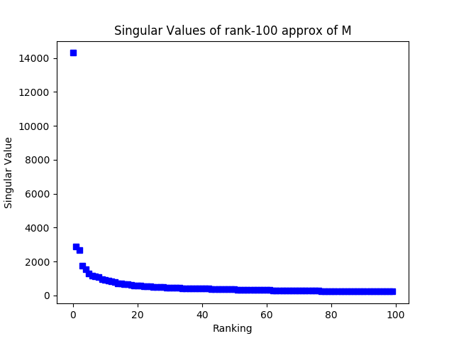

Yes, M seems to be close to a low rank matrix because only the first few singular values are notably higher than the rest.

C. :s UNFINISHED

D.

i. 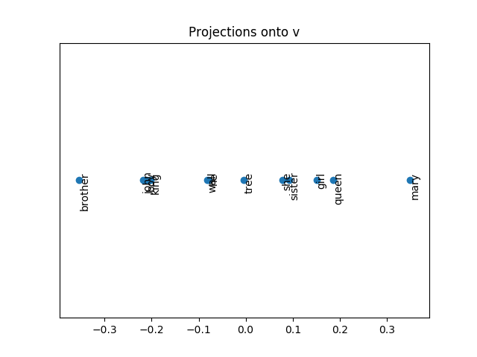

The highest values are female-associated words, such as “Mary” (a typical name for a woman, “queen”, “girl”, “sister”, and “she”. The lowest values are male-associated words, such as “brother”, “John”, “boy”, and “king”. “Tree”, being a gender-neutral word is near a value of 0, and “wall” and “he” are tied slightly closer to the male side.

ii.

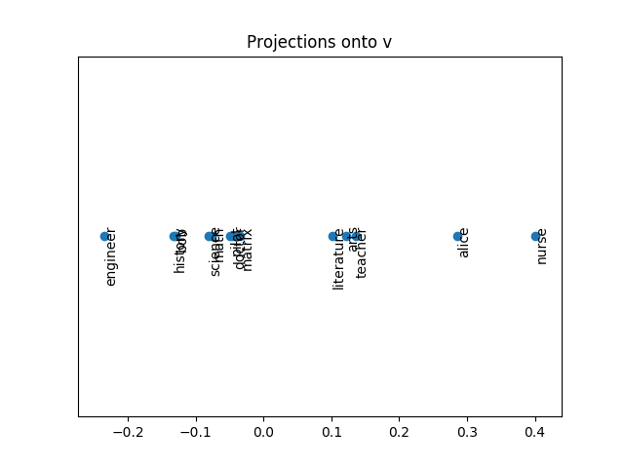

Professions typically associated with women, such as “nurse”, “teacher”, “arts”, and “literature”, have positive values while professions typically associated with men, such as “engineer”, “history”, “science”, “math”, and “doctor” have negative values; since these professions have historically been dominated by one gender or another, Wikipedia articles reflect this by containing more articles with men as doctors and women as nurses, for example. This could be harmful; for example, if LinkedIn used these embeddings to improve their “search for qualified job candidates” option, men would automatically be seen as more qualified for engineering and math positions while women would be seen as more qualified for nursing and teaching positions before any consideration for the rest of the parts of their resumes.

E.

i. The words most similar to “stanford” are other highly ranked schools; “harvard”, “cornell”, “ucla”, “yale”, “princeton”, “penn”, “auburn”, “mit”, and “berkeley”.

ii. The accuracy was 18.9%. UNFINISHED

2.

A. I expect that for any column or row that does not include the moon, there to be a completely black column. This is because there is no need to capture anything else besides the black pixels. For the rows and columns that do include the moon, I expect them to be varying shades of gray depending on how much of the moon they must include in the approximation (and the color of the moon itself). This is because since this is only the rank 1 approximation, the approximation is unable to capture much more than the distribution of white/black pixels in each row and column.

B.

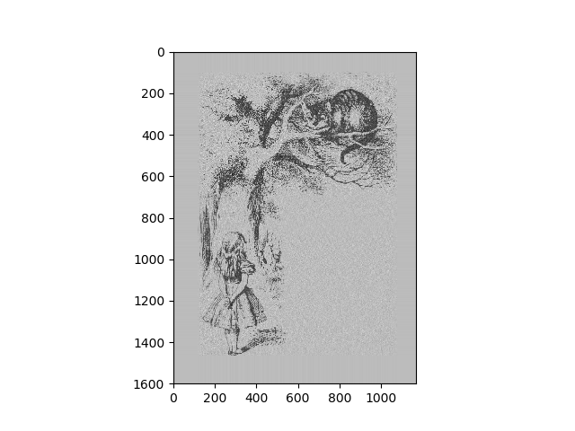

C. We stopped at 1170 because the dimensions of V are 1170 by 1170, meaning that there are only up to rank 1170 approximations.

D.

$$Rank 150 Approximation Space≈150*\left(1600+1170\right)=415,500 units of memory$$

$$Original Matrix Space≈1600*1170=1,872,000 units of memory$$

With the Rank 150 approximation, it is about 4.5 times more memory efficient.

E. ?