CS168 Project 6

Henry Lin, Kaylee Bement

1. A.

Line Graph:

Line Graph with Added Point:

Circle Graph:

Circle Graph with Added Point:

B.

In general, vtLv is the sum of squares of differences between values of neighboring nodes, and eigenvectors corresponding to the lowest eigenvalues minimize the squared distance between neighbors, while those with high eigenvalues maximize discrepancy between neighbor values.

Line Graph:

Laplacian

Smallest: 7.4397 \* 10-16

2nd Smallest: 0.000987

Largest: 3.999

2nd Largest: 3.996

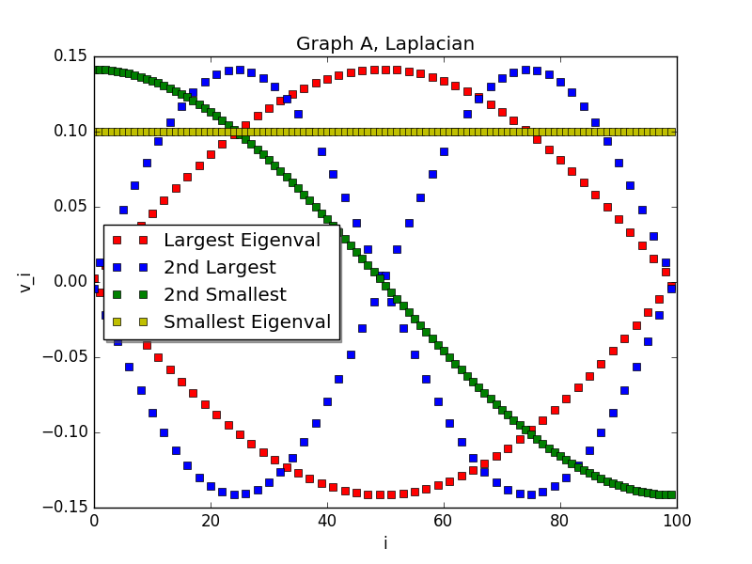

These eigenvectors make sense because the smallest eigenvalue vector has the same value since the graph has a single connected component, the second smallest eigenvalue vector has a very small distance between each of the points, which will make vtLv very small, and the two large eigenvalue vectors have very large distances between each of the points, which will make vtLv very large.

Adjacency

Smallest: -1.999

2nd Smallest: -1.996

Largest: 1.999

2nd Largest: 1.996

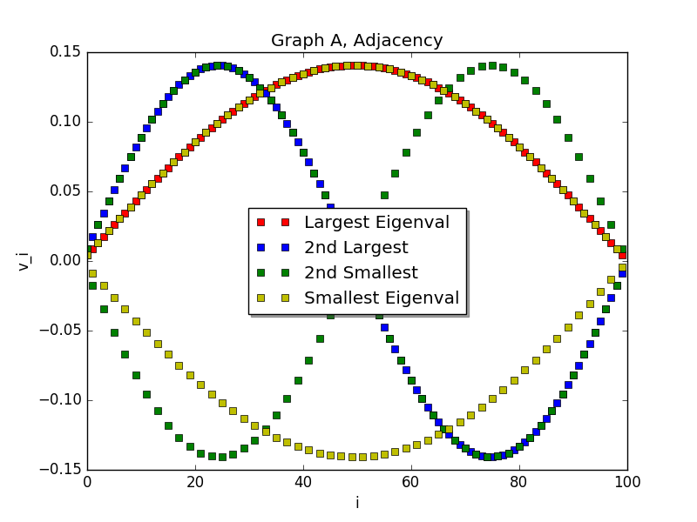

Line Graph with Added Point:

Laplacian

Smallest: -8.919 \* 10-16

2nd Smallest: 1.001

Largest: 99.999

2nd Largest: 4.999

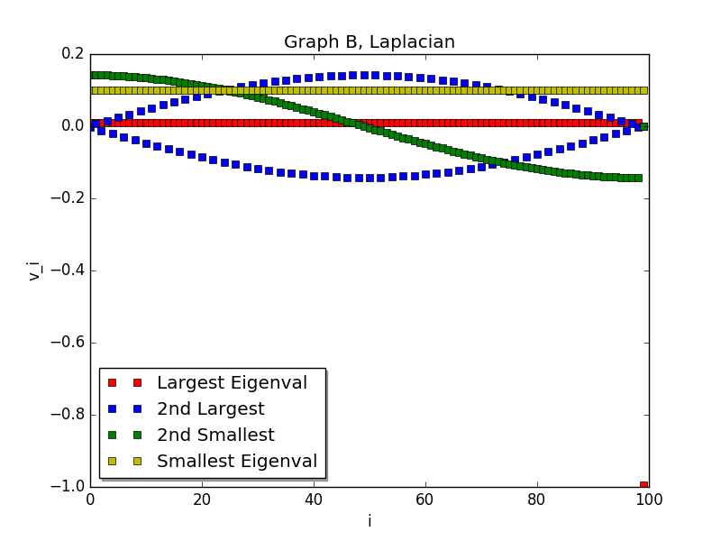

Adjacency

Smallest: -9.01

2nd Smallest: -1.999

Largest: 10.989

2nd Largest: 1.996

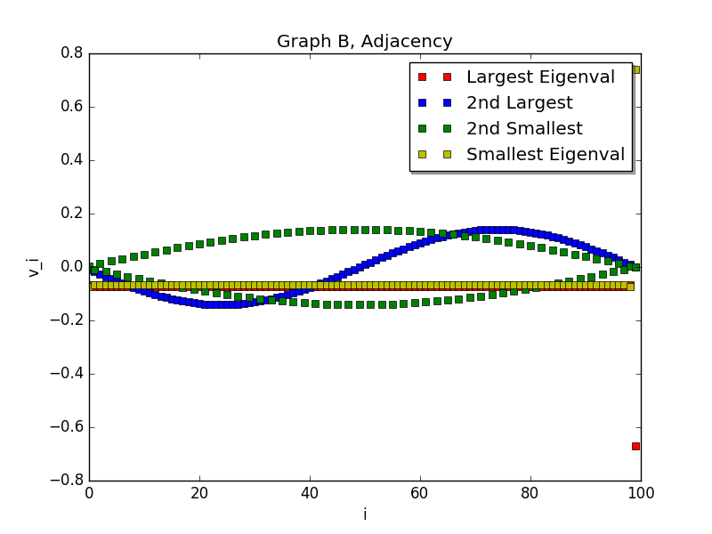

Circle:

Laplacian

Smallest: 1.332 \* 10-15

2nd Smallest: 0.0039

Largest: 3.9999

2nd Largest: 3.996

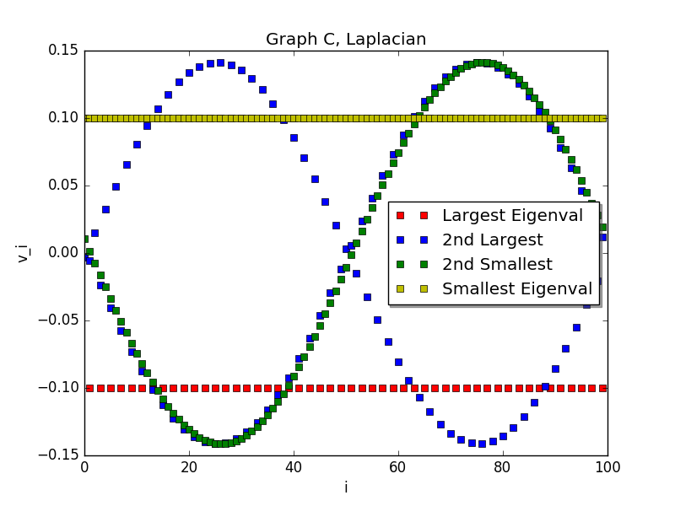

Adjacency

Smallest: -1.999

2nd Smallest: -1.996

Largest: 2.000

2nd Largest: 1.996

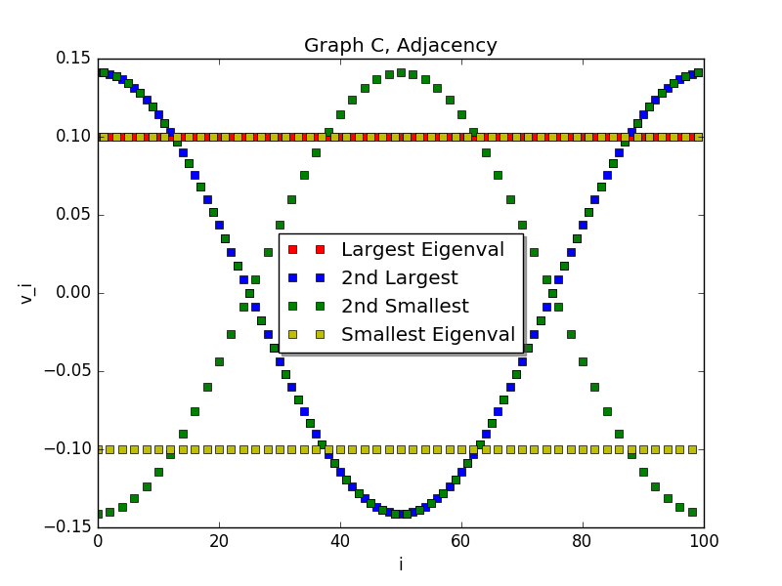

Circle with Added Point:

Laplacian

Smallest: -2.345 \* 10-15

2nd Smallest: 1.004

Largest: 99.999

2nd Largest: 4.999

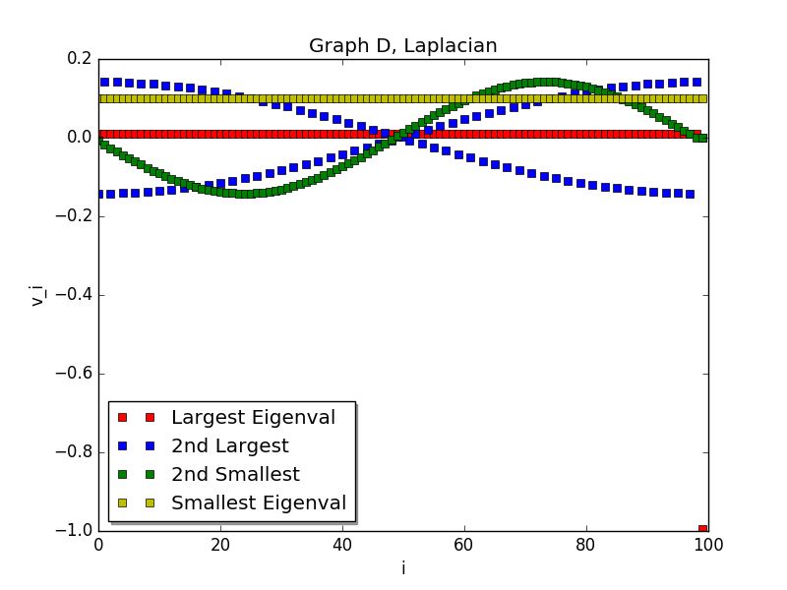

Adjacency

Smallest: -9.00

2nd Smallest: -1.999

Largest: 10.999

2nd Largest: 1.996

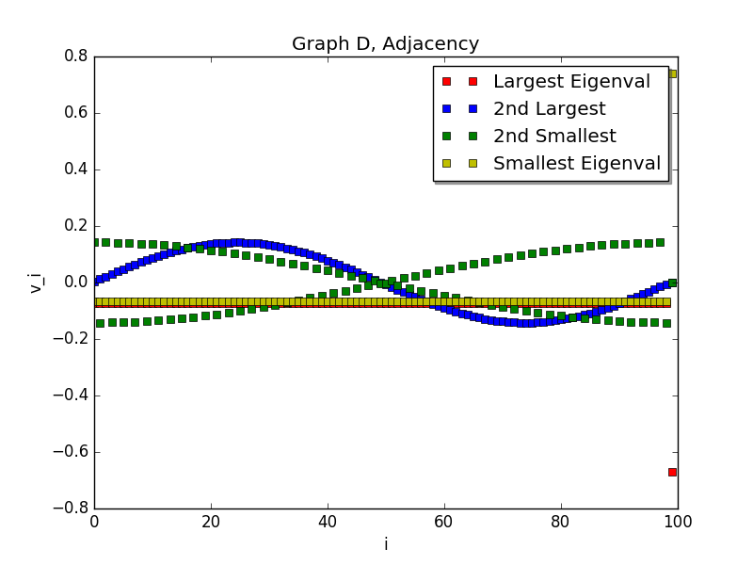

C.

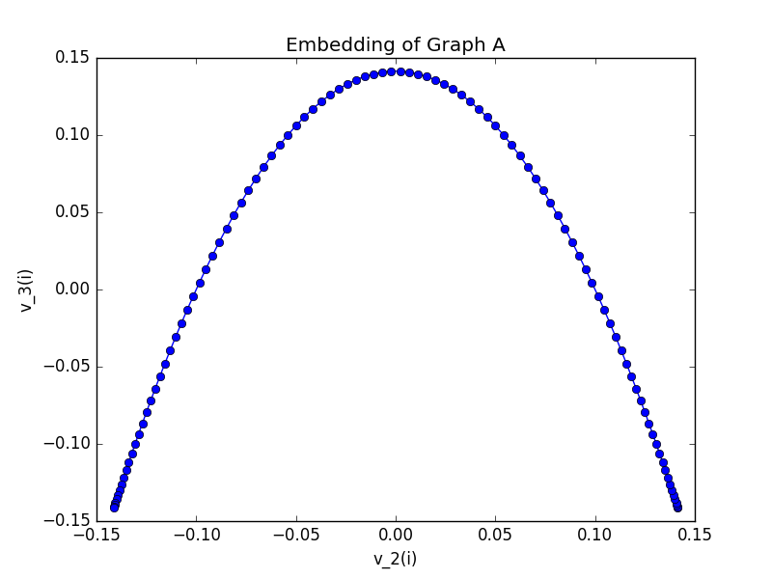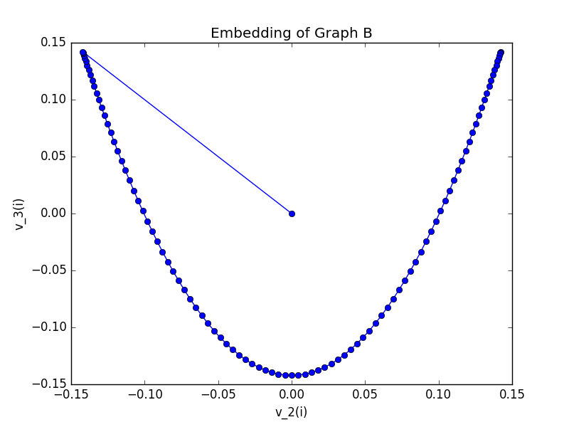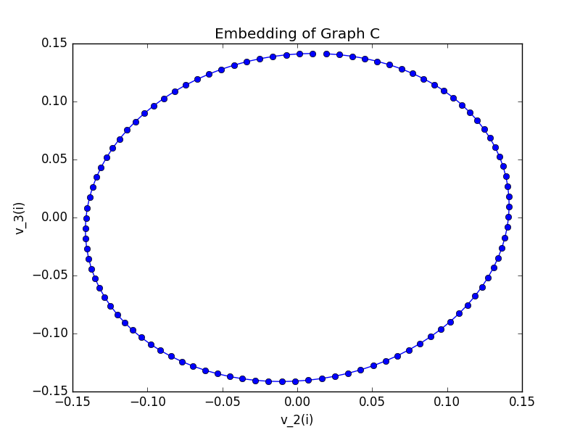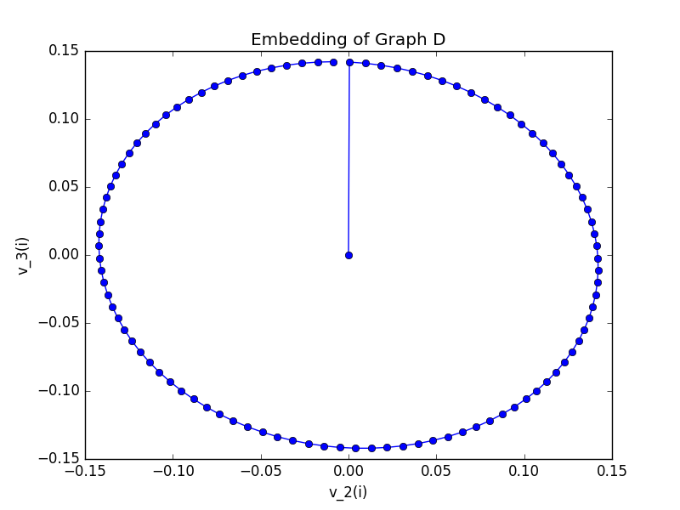

D.

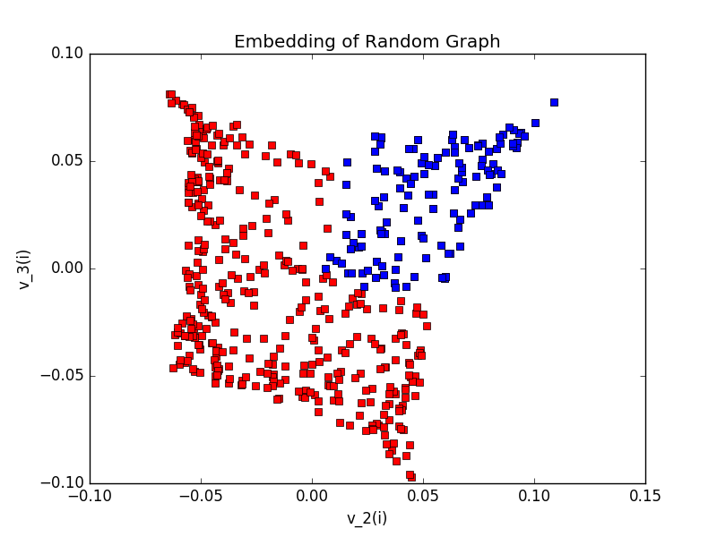

The blue squares represent the images of points where both coordinates are less than 1/2. These points are clustered together in the embedding. Since low eigenvectors are trying to find ways of assigning different values to vertices such that neighbors have similar values, looking at the embedding of low eigenvectors is a good way to find clusterings such as those where both coordinates of a point are less than ½ in this case since all such points will be neighbors (as they all have a distance of ¼ or less from each other).

1. A.

B.

C.

D.

E.