CS168 Miniproject 8

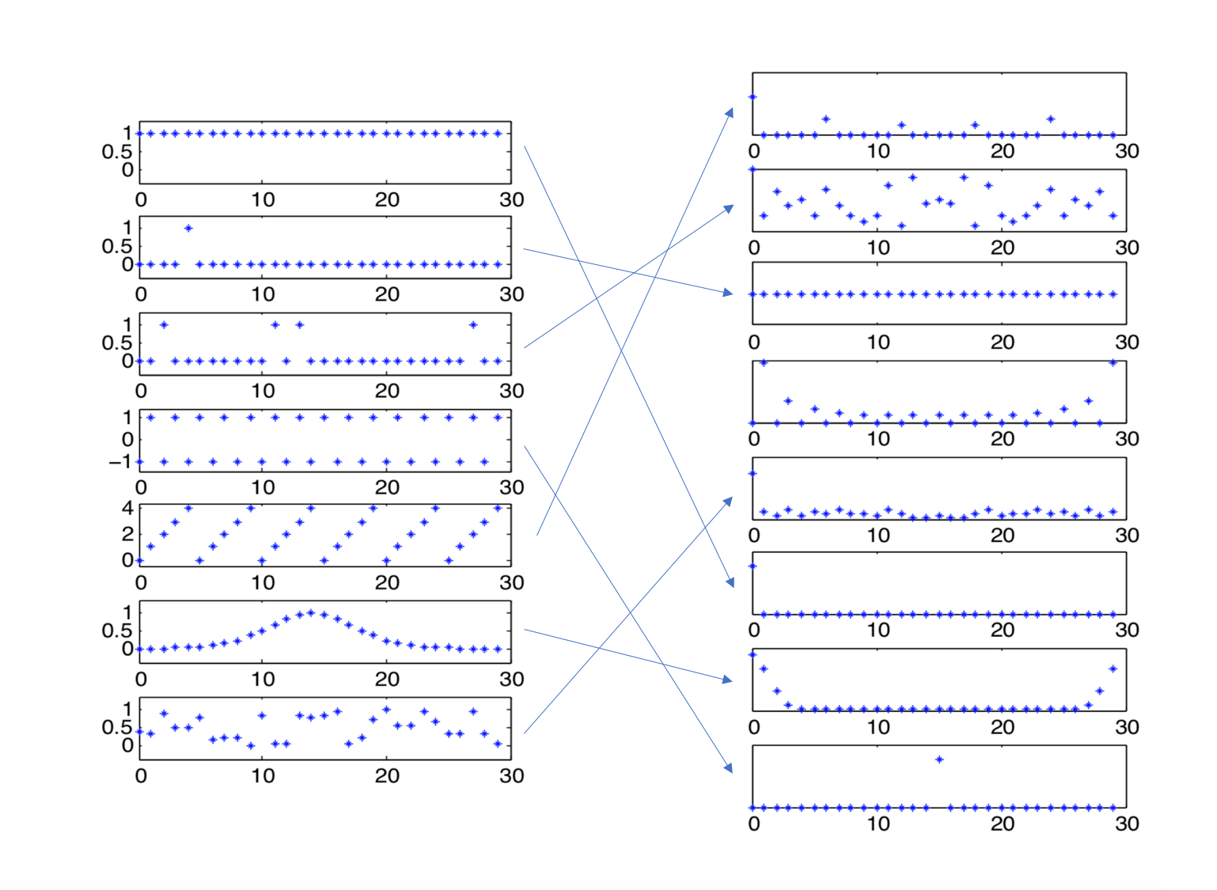Kaylee Bement, Henry Lin

Starting from the top left discrete vector and moving downward:

Vector 1:

Vector 2:

Vector 3:

Vector 4:

Vector 5:

Vector 6: The Fourier Transform of a Gaussian distribution is also a Gaussian distribution where you must put the sides together. This is shown as the left vector is a Gaussian and the right is also a Gaussian.

Vector 7:

1. A.

B.

C.

D.

E.

1. A.

B.

C.

D.

E.

F.