2020

Maptek Staff Management Utility

Setup Manual

SMU6

Table of Contents

1.Requirements: 3

2.Import files from Git repository to Google Apps Script 3

• Use your web browser, go to the main page of Google Apps Script 3

• Sign in with the Google company account of the administrative user 3

3.Deploy the project as a web app 5

4.Update configuration 7

5. Format of spreadsheet 11

# 1.Requirements:

1. Install Node.js (https://nodejs.org/en/)
2. Install clasp with Node.js:

On your command-line tool, run:

sudo npm install @google/clasp -g

(Alternatively, for mac-user: sudo npm i -g grpc @google/clasp –unsafe–perm)

# 2.Import files from Git repository to Google Apps Script

## Use your web browser, go to the main page of Google Apps Script

https://www.google.com/script/.

## Sign in with the Google company account of the administrative user

If your web browser does not recognize any Google user signed in before, click “Start Scripting” on the following page:

1. Enable App Script API at <https://script.google.com/u/1/home/usersettings>

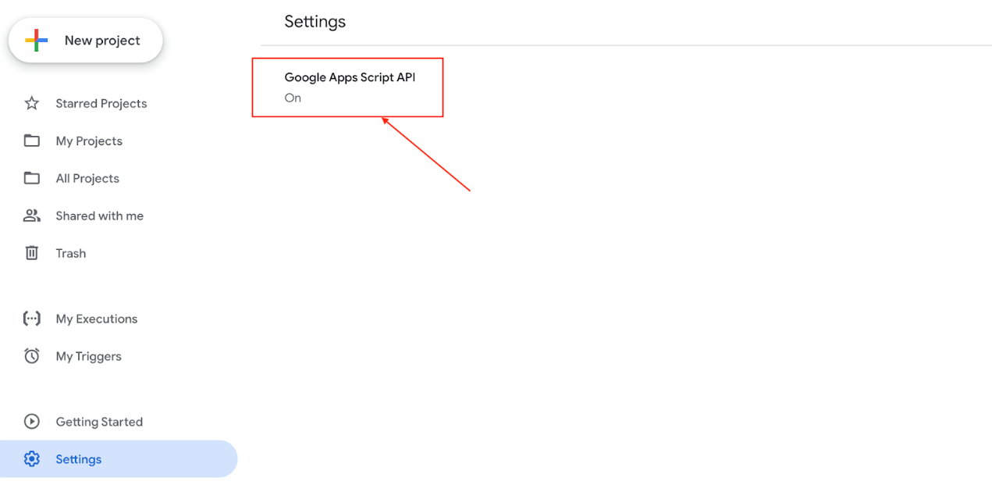

1. Create a new folder for the SMU on the local computer. Navigate to that folder with your command-line tool.

*Note: It should be different from the folder of the git repository

1. Login to your Google company account with a clasp with the following command:

*sudo clasp login*

1. Create a new Google Apps Script standalone project with the clasp on your command-line tool using the following command:

*sudo clasp create [project_name]*

Then select standalone and press enter.

1. Copy all the files except. Idea, clasp. Son and appsscript.json from /src in the git repository to the SMU folder created in step 4.
2. Push all the files to the Google Apps Script project created in step 6 using the following command:

*sudo clasp push*

1. Reload or go to the Google Apps Script main page; you should find the project created in step 6 with all the imported files.

# 3.Deploy the project as a web app

1.Open the project.

You can open your project via the Google Apps Script main page or use the command below in your project’s local path:

*sudo clasp open*

Click “Publish > Deploy as web app…”.

1. At "Execute the app as:," choose "User accessing the web app."

1. At "Who has access to the app:," choose "Anyone within *[company_name]*”

1. Click “Deploy” to deploy the project as a web app. You will then receive a web app URL for the SMU.
2. Copy and paste the web app URL on your web browser and visit the web app. Click “Review permissions”:

1. Choose the account of the administrative user. Click “Allow” to allow subsequent access to the web app:

# 4.Update configuration

1. At “Publish > Deploy as web app…” on the Google Apps Script project. Copy the “Current web app URL” and assign it to the “url_root” variable in Config.gs:

1. Import “demo_spreadsheet.xlsx” in the git repository to the google spreadsheet:

1. Retrieve the spreadsheet id of the imported Google spreadsheet. The spreadsheet id can be retrieved from the URL of the imported Google spreadsheet, where the URL would be in the form of [https://docs.google.com/spreadsheets/d/**[**](https://docs.google.com/spreadsheets/d/1UNHqQxipa0k-2y1XPk8X3qIJ7hnq7NSTeZ14unwHRow/edit#gid=0)**spreadsheetId**[**]**/edit#gid=0](https://docs.google.com/spreadsheets/d/1UNHqQxipa0k-2y1XPk8X3qIJ7hnq7NSTeZ14unwHRow/edit#gid=0).

For example, for the Google spreadsheet with URL:

<https://docs.google.com/spreadsheets/d/1UNHqQxipa0k-2y1XPk8X3qIJ7hnq7NSTeZ14unwHRow/edit#gid=0>

The spreadsheet id is **1UNHqQxipa0k-2y1XPk8X3qIJ7hnq7NSTeZ14unwHRow**, which is the part between “<https://docs.google.com/spreadsheets/d/>” and “/edit#gid=0."

1. Update the variable “spreadsheetId” in Config.gs to be the spreadsheet id retrieved in step 3:

1. Go to “Resources > Advanced Google services…”. Turn on Drive API.

1. Deploy as a web app again. Go to "Publish > Deploy as web app…". At "Project version," select "New." Then click "Update":

1. For now, you should be able to get the demo data displayed on the web app in your company environment. You can then replace the data on the uploaded spreadsheet with the real data and reload the web app's page for it to work. But note that the spreadsheet should be maintained in the required format.

# 5. Format of spreadsheet

The following instructions allow you to upload and maintain your spreadsheet; please follow the format introduced below.

**Use of each column:**

|  |  |  |
| --- | --- | --- |
| **Col index** | **Name of column** | **Meaning** |
| A | Department | The assigned department where the staff works. |
| B | Name | The full name of each staff (last name, first name, and middle name). |
| C | Job Title | The job title for each staff. (This job title can be detailed to the teams that subordinate to the department) |
| D | Supervisor | The immediate supervisor of each staff. |
| E | Office Location | The current office location of each staff. |
| F | Email | The email address of each staff. |
| G | Phone | The phone number for each staff. |
| H | Colour | Enter the hexadecimal colour code. This colour attribute is for displaying the different teams or departments with different colours. E.g., #ffffff, which is presented as white.  *Note that you can leave this column as blank, then the employee's node would be displayed as grey default colour |
| I | Staff ID | The unique ID of each employee.  *Note that a unique ID must be entered in this col |
| J | SPV ID | The ID of the staff’s supervisor.  *Note that you can leave this column as blank, which means this employee does not have any supervisor. |
| K | Image | The profile photo of each staff. The photograph shall be uploaded to the google drive and be shared with the public, and the image ID should be put in this column. The share link of the image in your drive should be like *https://drive.google.com/file/d/****[ImageID]****/view?usp=sharing*  e.g., the image ID of the following link is 1AjJrSNCMvJT3Po7Ja9OyIpq3BTKHC6ge  *https://drive.google.com/file/d/****1AjJrSNCMvJT3Po7Ja9OyIpq3BTKHC6ge****/view?usp=sharing*  *Note that this column can be left as blank, then there would be no profile photo shown in the employee’s profile |
| L | Birthday | The format of the birthday is *DD/MM/YYYY.* |
| M | Gender | Enter male or female. |
| N | Employed Time | The first day of each staff working in Maptek.  *Note that it must be in a format of *YYYY/MM/DD* |
| O | Current Time | The Current Time updates in real-time.  *Note that the value of this column should always be *=TODAY()* |
| P | Employed (Month) | The months in the company for all (or some) employees. Employed equals Current Time minus Employed Time.  *Note that the formula in this column must be *=DATEDIF (N*row number, O*row number,"M"). For example, in the second row, the formula is =DATEDIF (N2, O2, "M").* |
| Q | Optional Information | Starting from this column, you can customize additional information. All the employee's information shall be displayed after you click the '...' button in the organization chart. |

As displayed in the image, information from column A to P must be fixed in the spreadsheet. And you can add additional information in the columns after Employed (Month). All of the staff information will be displayed in each staff's popup window in the organization chart.



We have provided a sample spreadsheet for you, and you should modify that sheet to your version. Please only work on the first worksheet; the rest sheets are used for other purposes.

Add or delete staff information.

Add a new staff: Enter the staff information according to the table Use of each column.

Remove a staff: Delete the row of the corresponding staff.