LIMKOKWING UNIVERSITY OF CREATIVE TECHNOLOGY
SIERRA LEONE
Department of Information and Communication Technology
PROG101
PRINCIPLES OF PROGRAMMING LOGIC AND DESIGN
Individual Assignment 1
Designing Logical Solutions for Sierra Leone Community Challenges
Project: CleanFreetown – A Community Waste Reporting and Collection Scheduling System
Supported SDGs: SDG 11 (primary), SDG 3, SDG 6, SDG 13
Detail | Information
Student Name | HENRY MOPEHTHOMAS
Student ID | 905006240
Programme | BSc Software Engineering with Multimedia
Examiner | Elijah Fullah
Semester | Semester 01 (September 2026 – January 2027)
Submission Deadline | Week 4
TABLE OF CONTENTS
1. RATIONALE 3
1.1 Problem Description 3
1.2 Background 3
1.3 Community Impact 3
1.4 Proposed Solution 3
1.5 Computational Thinking Process 3
1.6 Algorithm Design 4
1.7 SDG Alignment 4
1.8 Open Source Justification 4
1.9 Digital Public Goods Justification 4
2. ALGORITHM 6
2.1 Input, Processing and Output 6
2.2 Step-by-Step Algorithm 6
3. PSEUDOCODE 7
3.1 Constants and Variables 7
3.2 Functions and Procedure 8
3.3 Main Module 9
4. FLOWCHARTS 10
5. FUNCTIONAL MODULES 12
5.1 Programming Logic Coverage 12
6. EXPECTED OUTPUTS 13
6.1 Scenario A – Six Reports (including one invalid entry) 13
6.2 Scenario B – Boundary Tests for classifyPriority() 13
6.3 Scenario C – Invalid Number of Reports 14
7. GITHUB EVIDENCE 15
7.1 Suggested Commit Plan 15
8. REFERENCES 16

1. RATIONALE

1.1 Problem Description
Waste management is one of the most visible community problems in Sierra Leone, particularly in Freetown. Households, markets and informal settlements produce waste daily, but collection is irregular and there is no simple, reliable channel through which residents can tell the authorities that a bin or dumping point is full. As a result, waste piles up in streets, drains and open spaces.
Who is affected? Residents of densely populated and low-lying communities (for example Kroo Bay, Congo Town and Wellington), market traders, children, schools and clinics near dumping sites, and the city council and collection teams who must plan routes without reliable information.
Why does the problem exist? Collection trucks and workers are limited, routes are often planned without knowing which areas are most urgent, residents have no easy way to report overflowing waste, and there is no record of how often each area is serviced. Reporting is mostly verbal or by phone call, which is slow, easily forgotten and impossible to analyse.

1.2 Background
Freetown has a high population density, a rainy season that brings heavy rainfall, and many settlements built on low ground or steep hillsides. When waste blocks drains and waterways, flooding becomes more severe and standing dirty water increases the risk of waterborne diseases such as cholera and typhoid. Previous flooding and cholera events in the country have shown how closely sanitation, waste and public health are linked. Cleanliness efforts by the council and community groups are limited by resources and by a lack of data on where waste problems are worst.
Because many residents have access to a basic mobile phone, a simple report-and-prioritise system built around short inputs is realistic. This assignment does not build the program; it designs the complete logic so developers can later implement it in any language.

1.3 Community Impact
- Problem being solved: Delayed and poorly prioritised waste collection.
- Expected impact: Faster response to critical sites (full bins and hazardous waste), fewer blocked drains, cleaner streets and better planning of truck trips.
- Beneficiaries: Residents, traders, schools, health facilities, collection crews, and the Freetown City Council.
- Long-term sustainability: The system is low-cost, uses open tools, and can be maintained by local developers and students. Collected data helps the council plan budgets and truck routes over time.

1.4 Proposed Solution
CleanFreetown is a community waste reporting and collection scheduling system. A resident, community volunteer or ward officer submits a report containing the ward name, bin fill level (0–100%), waste type, whether the waste is hazardous, and the number of days since the last collection. The system validates the report, classifies it as CRITICAL, HIGH, MEDIUM or LOW priority, counts reports by priority, calculates how many truck trips are needed, and produces a summary for the collection team.

1.5 Computational Thinking Process
Concept | How it was applied to CleanFreetown
Decomposition | The large problem “improve waste collection” was broken into: collect report, validate report, classify priority, count reports, calculate trips, display summary.
Pattern recognition | Reports follow the same pattern (ward, fill level, type, hazard, days). Priority rules repeat for every report, so a loop and one reusable function can process them all.
Abstraction | Unnecessary details (truck brand, road layout, resident’s full address) are ignored. Only the data that affects priority is kept.
Algorithm design | A clear step-by-step sequence with decisions and a loop was written, then expressed as pseudocode and flowcharts (Sections 2 to 4).

1.6 Algorithm Design
The algorithm uses sequence, selection (IF / ELSE IF for validation and priority) and iteration (a FOR loop for reports and a REPEAT-UNTIL loop for invalid data). It is divided into three functions (validateReport, classifyPriority, calculateTrips) and one procedure (displaySummary) controlled by a main module. Boolean logic combines conditions, for example a bin is CRITICAL if it is 90% full OR the waste is hazardous.

1.7 SDG Alignment
SDG | Goal | Contribution of CleanFreetown
SDG 11 | Sustainable Cities and Communities (primary) | Supports better municipal waste management and cleaner, safer neighbourhoods (Target 11.6 – reduce the adverse environmental impact of cities, including waste management).
SDG 3 | Good Health and Well-being | Faster removal of hazardous and overflowing waste reduces disease risk.
SDG 6 | Clean Water and Sanitation | Less waste in drains and waterways helps protect water and sanitation.
SDG 13 | Climate Action | Fewer open dumps and better planned trips reduce pollution and help communities cope with flooding.

1.8 Open Source Justification
Why open source? The system is meant for public benefit, so its design and any future code should be free to inspect, use and adapt. Open source removes licence costs, avoids vendor dependence, and builds trust because anyone can see how reports are prioritised.
Benefits for Sierra Leone: Lower cost for government and councils, local skills development for students and developers, and the freedom to adapt the system to local languages (such as Krio), local wards and local rules.
Potential community contributions: Students can improve the logic and write the code, translators can add Krio, community health workers can suggest waste categories, and other councils can adapt it for their own towns and report bugs or improvements through GitHub issues and pull requests.

1.9 Digital Public Goods Justification
A Digital Public Good (DPG) is open-source software, open data or open content that is freely accessible, adaptable and designed to help reach the SDGs without causing harm. CleanFreetown could become a DPG by releasing its design, code and anonymised waste data under an open licence (for example MIT or Apache 2.0 for code, and a Creative Commons licence for documentation and data), with clear documentation in the README.md.
- Accessibility: Simple inputs that work on low-end phones and SMS-style forms, low data use, and a plain-language interface.
- Openness: Public repository, open licence, open documentation and open data standards so other communities and countries can reuse it.
- Public benefit: Free for councils, schools and community groups; no personal data beyond what is necessary; and it directly supports SDG 11.

2. ALGORITHM
The following step-by-step algorithm describes how CleanFreetown processes waste reports.

2.1 Input, Processing and Output
Stage | Description
Input | totalReports; and for each report: wardName, fillLevel (0–100), wasteType, isHazardous (TRUE/FALSE), daysSinceCollection.
Processing | Validate each report; classify its priority; count reports by priority; calculate the number of truck trips.
Output | Confirmation for each report (ward and priority) and a final summary: counts for CRITICAL, HIGH, MEDIUM, LOW, total valid reports and trips needed.

2.2 Step-by-Step Algorithm
Step 1: Start.
Step 2: Define constants: CRITICAL_LEVEL = 90, HIGH_LEVEL = 70, MEDIUM_LEVEL = 40, OVERDUE_DAYS = 3, TRUCK_CAPACITY = 5.
Step 3: Set criticalCount, highCount, mediumCount and lowCount to 0.
Step 4: Input totalReports.
Step 5: If totalReports is less than 1, display “invalid number of reports”. Otherwise(totalReports is 1 or more)
Step 6: Set i = 1.
Step 7: If i is greater than totalReports, go to Step 15.
Step 8: Input wardName, fillLevel, wasteType, isHazardous and daysSinceCollection.
Step 9: Call validateReport(). If it returns FALSE, display “Invalid data, re-enter report” and go back to Step 8.
Step 10: Call classifyPriority(fillLevel, isHazardous, daysSinceCollection) and store the result in priority.
Step 11: Increase the counter that matches priority (critical, high, medium or low) by 1.
Step 12: Display the confirmation: ward name and priority.
Step 13: Set i = i + 1.
Step 14: Go back to Step 7.
Step 15: Call calculateTrips(totalReports) and store the result in trips.
Step 16: Call displaySummary() to show the counts and the number of trips.
Step 17: Stop.

3. PSEUDOCODE
The pseudocode below is written in plain, language-independent form. Constants are written in capital letters, and each function has a single clear purpose.

3.1 Constants and Variables
Name | Data Type | Purpose
CRITICAL_LEVEL = 90 | Constant (Integer) | Fill level (%) at or above which a report is CRITICAL.
HIGH_LEVEL = 70 | Constant (Integer) | Fill level (%) for HIGH priority (with overdue collection).
MEDIUM_LEVEL = 40 | Constant (Integer) | Fill level (%) at or above which a report is MEDIUM.
OVERDUE_DAYS = 3 | Constant (Integer) | Days without collection after which a site is overdue.
TRUCK_CAPACITY = 5 | Constant (Integer) | Number of report sites one truck can serve in one trip.
totalReports | Integer | Number of reports to be processed.
wardName, wasteType | String | Community ward and type of waste (e.g. plastic, organic, medical).
fillLevel, daysSinceCollection | Integer | Bin fill percentage and days since last collection.
isHazardous, isValid | Boolean | TRUE or FALSE flags for hazardous waste and valid data.
priority | String | CRITICAL, HIGH, MEDIUM or LOW.
criticalCount, highCount, mediumCount, lowCount, trips, i | Integer | Counters, trip total and loop counter.

3.2 Functions and Procedure
FUNCTION validateReport(wardName, fillLevel, daysSince) RETURNS BOOLEAN
IF wardName = "" THEN
RETURN FALSE
END IF
IF fillLevel < 0 OR fillLevel > 100 THEN
RETURN FALSE
END IF
IF daysSince < 0 THEN
RETURN FALSE
END IF
RETURN TRUE
END FUNCTION

FUNCTION classifyPriority(fillLevel, isHazardous, daysSince) RETURNS STRING
IF fillLevel >= CRITICAL_LEVEL OR isHazardous = TRUE THEN
RETURN "CRITICAL"
ELSE IF fillLevel >= HIGH_LEVEL AND daysSince >= OVERDUE_DAYS THEN
RETURN "HIGH"
ELSE IF fillLevel >= MEDIUM_LEVEL THEN
RETURN "MEDIUM"
ELSE
RETURN "LOW"
END IF
END FUNCTION

FUNCTION calculateTrips(totalReports) RETURNS INTEGER
trips <- totalReports DIV TRUCK_CAPACITY
IF totalReports MOD TRUCK_CAPACITY > 0 THEN
trips <- trips + 1
END IF
RETURN trips
END FUNCTION

PROCEDURE displaySummary(critical, high, medium, low, trips)
OUTPUT "===== CLEANFREETOWN SUMMARY ====="
OUTPUT "CRITICAL: ", critical
OUTPUT "HIGH: ", high
OUTPUT "MEDIUM: ", medium
OUTPUT "LOW: ", low
OUTPUT "Total valid reports: ", critical + high + medium + low
OUTPUT "Truck trips needed: ", trips
END PROCEDURE

3.3 Main Module
MAIN
criticalCount <- 0 ; highCount <- 0 ; mediumCount <- 0 ; lowCount <- 0
OUTPUT "Enter number of reports:"
INPUT totalReports
IF totalReports < 1 THEN
OUTPUT "Invalid number of reports"
STOP
END IF

FOR i <- 1 TO totalReports
REPEAT
INPUT wardName, fillLevel, wasteType, isHazardous, daysSince
isValid <- validateReport(wardName, fillLevel, daysSince)
IF isValid = FALSE THEN
OUTPUT "Invalid data, re-enter report"
END IF
UNTIL isValid = TRUE

priority <- classifyPriority(fillLevel, isHazardous, daysSince)
CASE priority OF
"CRITICAL" : criticalCount <- criticalCount + 1
"HIGH" : highCount <- highCount + 1
"MEDIUM" : mediumCount <- mediumCount + 1
"LOW" : lowCount <- lowCount + 1
END CASE
OUTPUT wardName, " -> ", priority
END FOR

trips <- calculateTrips(totalReports)
displaySummary(criticalCount, highCount, mediumCount, lowCount, trips)
END MAIN

4. FLOWCHARTS
Flowcharts were drawn using standard symbols: rounded rectangles for START/END, parallelograms for input/output, rectangles for processes, and diamonds for decisions.
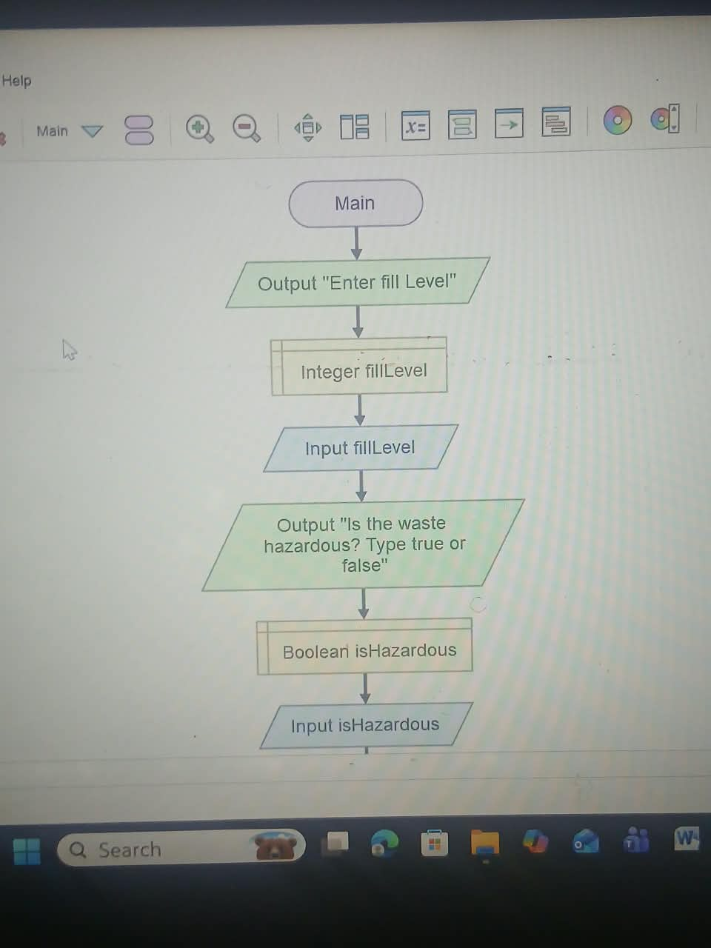
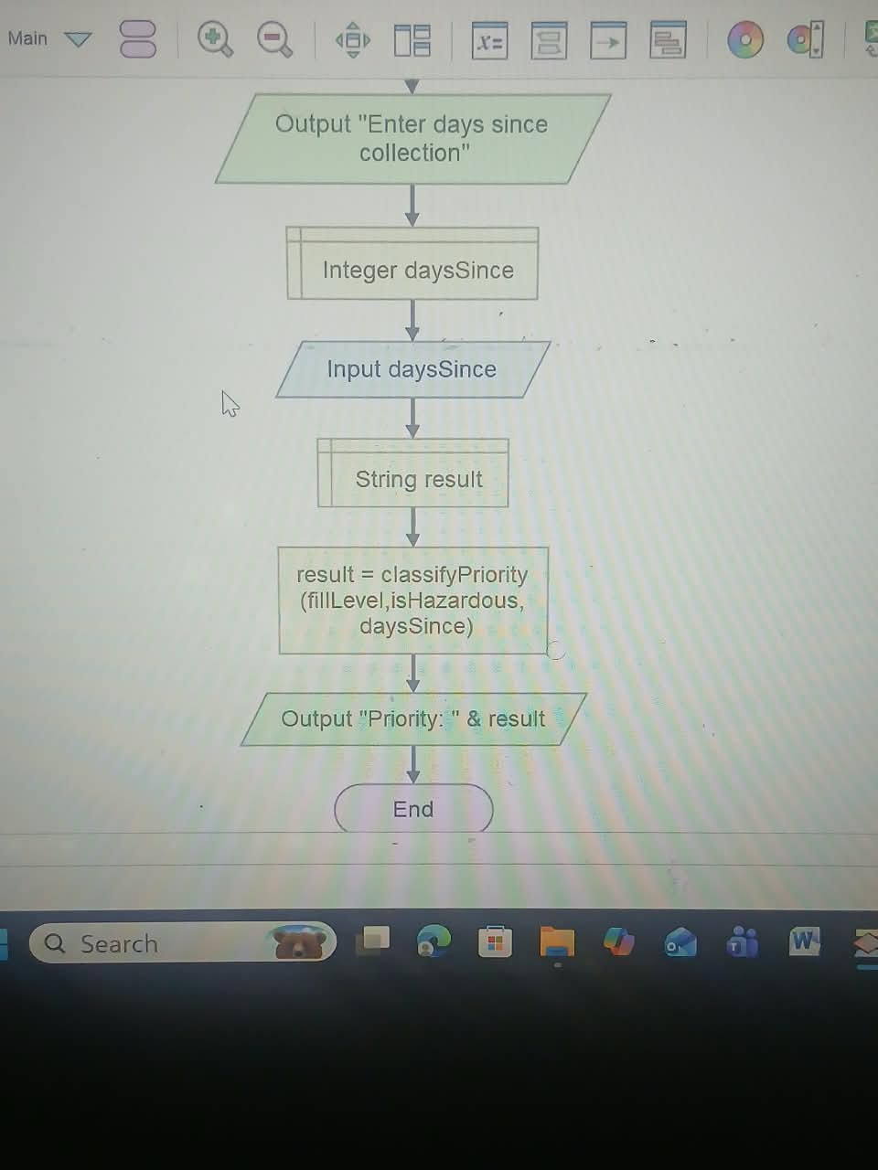
Fig1. Flowchart for classifypriority

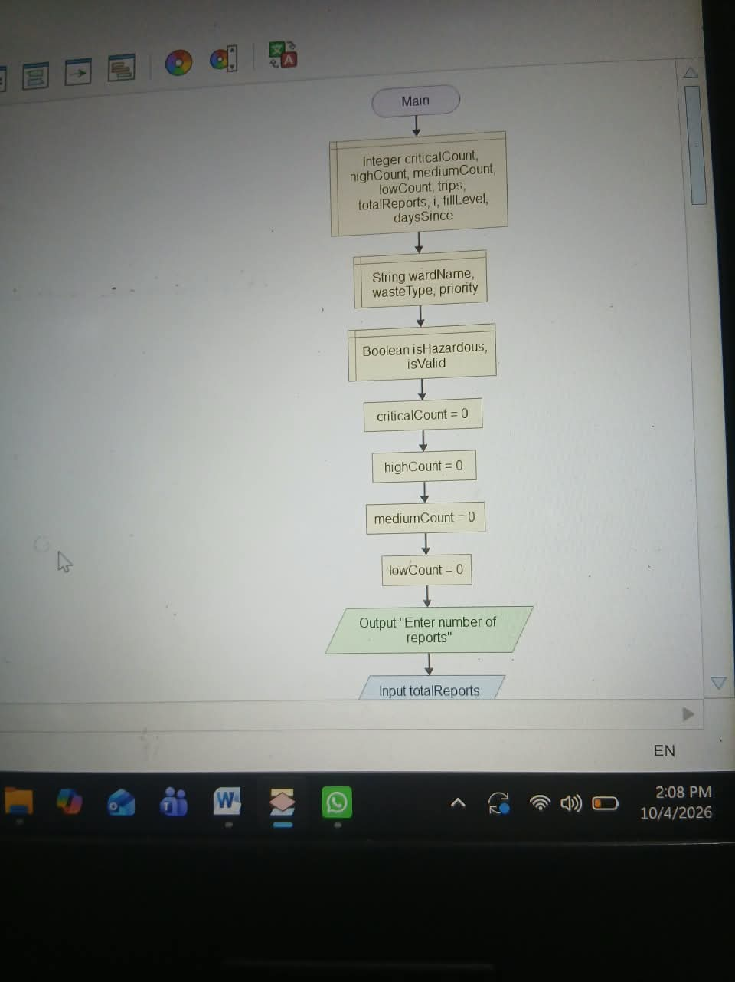
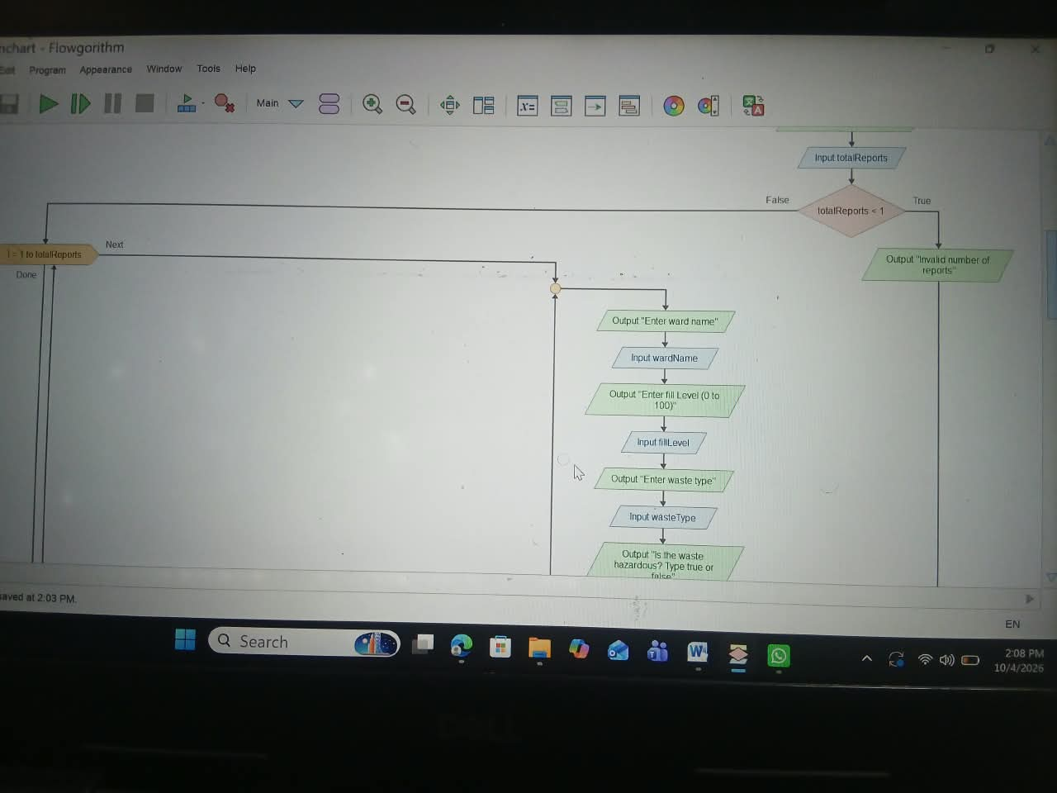
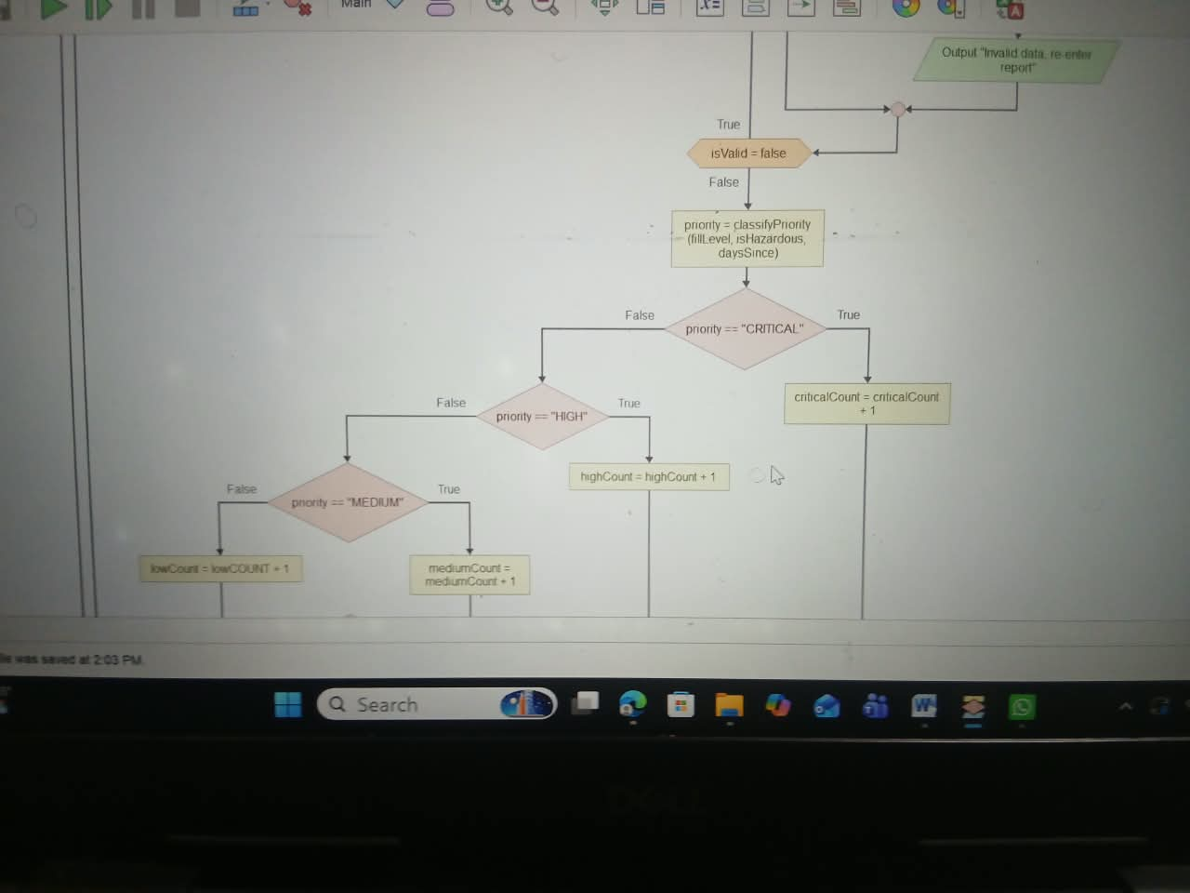
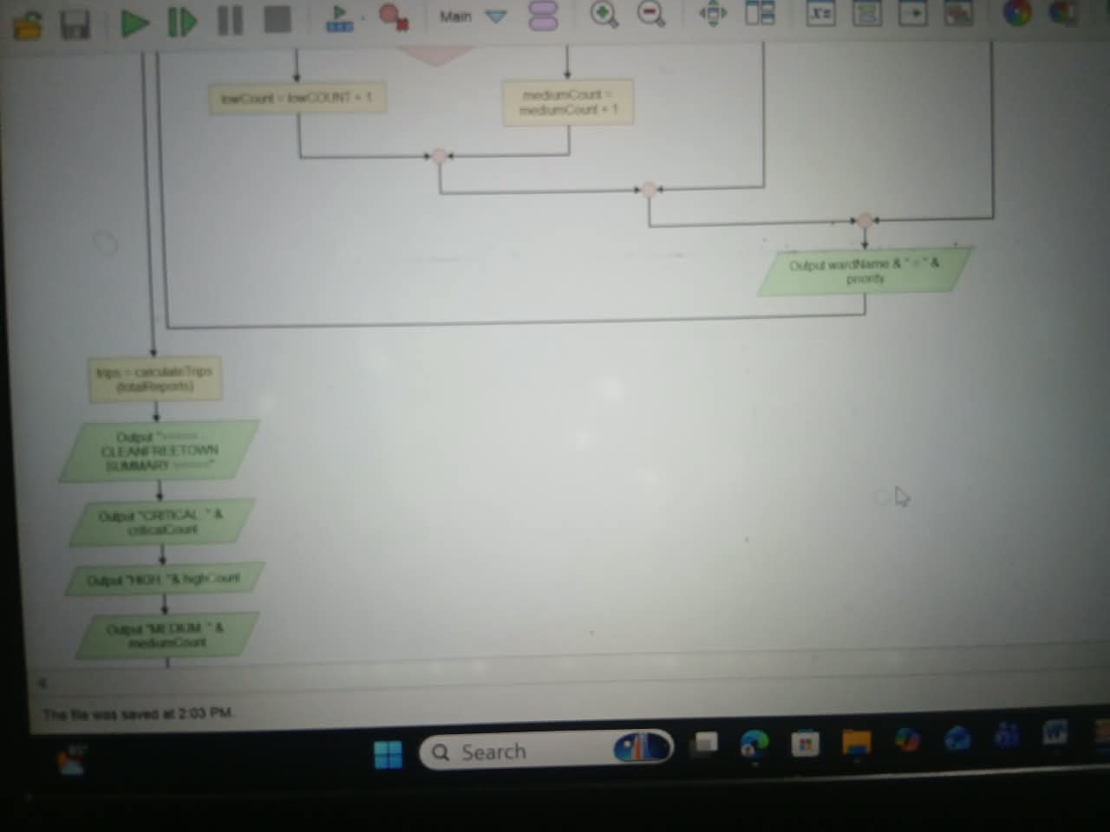
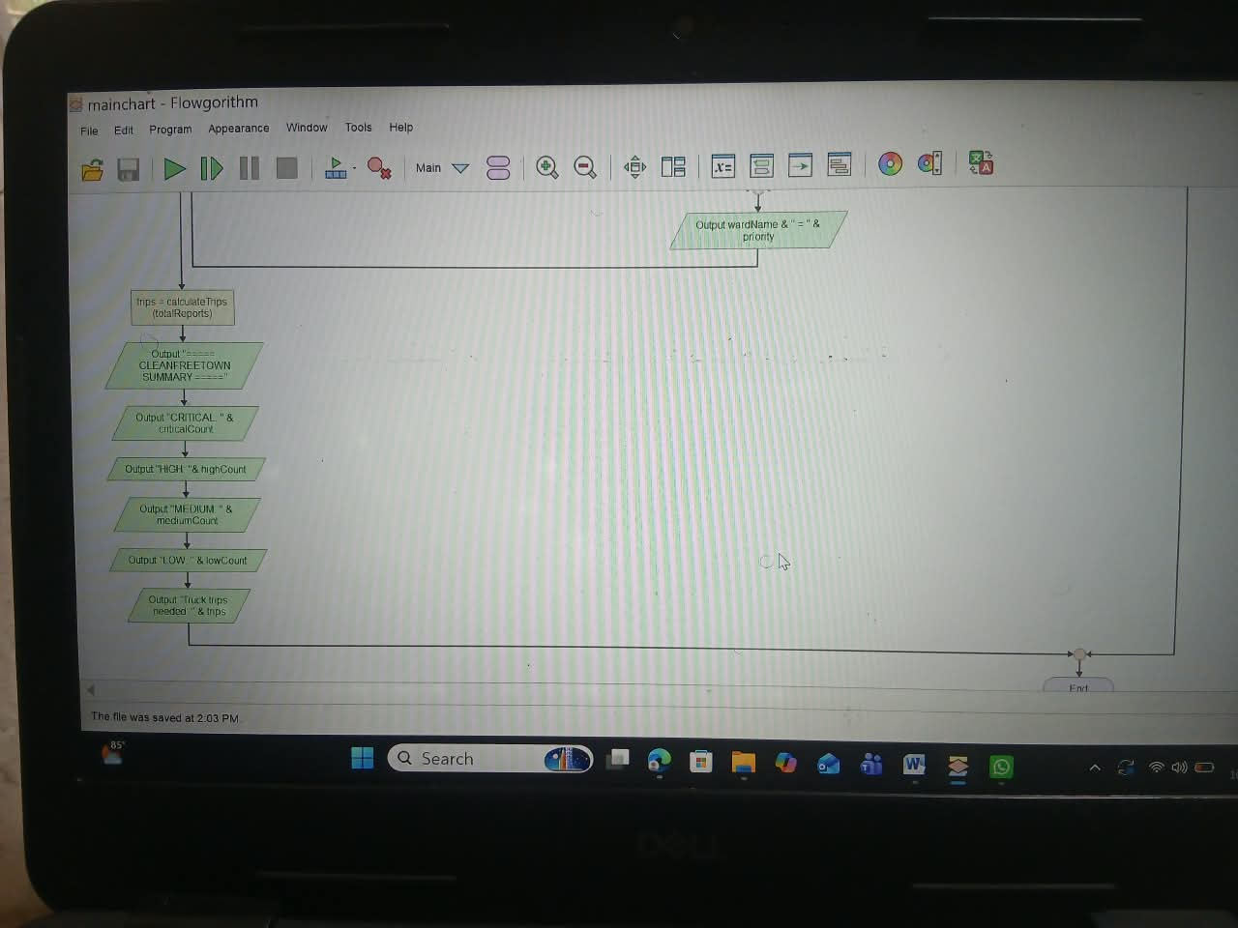Figure 2: Flowchart for mainchart

5. FUNCTIONAL MODULES
Modular design divides the system into independent parts so that each module can be designed, tested and improved separately. This is also an example of problem decomposition.
No. | Module | Type | Responsibility
M1 | Report Intake | Part of MAIN (input) | Reads totalReports and each report’s details and repeats input until data is valid.
M2 | validateReport() | Function → Boolean | Checks that the ward is not empty, fillLevel is 0–100 and days are not negative.
M3 | classifyPriority() | Function → String | Uses decision structures and Boolean logic to return CRITICAL, HIGH, MEDIUM or LOW.
M4 | Counting (CASE) | Part of MAIN (selection) | Updates the four priority counters.
M5 | calculateTrips() | Function → Integer | Calculates truck trips using DIV and MOD with TRUCK_CAPACITY.
M6 | displaySummary() | Procedure | Prints the final counts and the number of trips.

5.1 Programming Logic Coverage
Requirement | Where it appears in the design
Variables and data types | Section 3.1 – integers, strings and Booleans.
Constants | CRITICAL_LEVEL, HIGH_LEVEL, MEDIUM_LEVEL, OVERDUE_DAYS, TRUCK_CAPACITY.
Decision structures | IF / ELSE IF in validateReport() and classifyPriority(); CASE in MAIN.
Boolean logic | OR in the CRITICAL rule and range check; AND in the HIGH rule.
Repetition structures | FOR loop over reports; REPEAT-UNTIL loop for valid input.
Functions / modules | Three functions and one procedure called by MAIN.
Problem decomposition | Section 1.5 and the module table above.

6. EXPECTED OUTPUTS
The scenarios below use sample data to show what the system should output. Scenario A is entered with totalReports = 6.

6.1 Scenario A – Six Reports (including one invalid entry)
No. | Ward | Fill % | Hazardous | Days | Valid? | Priority | Reason
1 | Kroo Bay | 95 | No | 1 | Yes | CRITICAL | 95 >= 90
2 | Wellington | 75 | No | 4 | Yes | HIGH | 75 >= 70 AND 4 >= 3
3 | Lumley | 45 | No | 1 | Yes | MEDIUM | 45 >= 40
4 | Goderich | 20 | No | 0 | Yes | LOW | Below all limits
5a | Murray Town | 130 | No | 2 | No | Rejected | Fill level > 100; user must re-enter
5b | Congo Town | 30 | Yes | 2 | Yes | CRITICAL | Hazardous = TRUE
6 | Murray Town | 55 | No | 1 | Yes | MEDIUM | 55 >= 40

Expected screen output for Scenario A:
Kroo Bay -> CRITICAL
Wellington -> HIGH
Lumley -> MEDIUM
Goderich -> LOW
Invalid data, re-enter report
Congo Town -> CRITICAL
Murray Town -> MEDIUM

===== CLEANFREETOWN SUMMARY =====
CRITICAL: 2
HIGH: 1
MEDIUM: 2
LOW: 1
Total valid reports: 6
Truck trips needed: 2

Trip calculation check: 6 DIV 5 = 1 and 6 MOD 5 = 1, which is greater than 0, so trips = 1 + 1 = 2.

6.2 Scenario B – Boundary Tests for classifyPriority()
Fill % | Hazardous | Days | Expected Priority | Reason
90 | No | 0 | CRITICAL | Exactly on CRITICAL_LEVEL
89 | No | 5 | HIGH | Below 90; 89 >= 70 and 5 >= 3
70 | No | 2 | MEDIUM | 70 >= 70 but days < 3, so HIGH fails; 70 >= 40
70 | No | 3 | HIGH | Both HIGH conditions true
40 | No | 0 | MEDIUM | Exactly on MEDIUM_LEVEL
39 | No | 9 | LOW | Below 40
10 | Yes | 0 | CRITICAL | Hazardous overrides low fill level

6.3 Scenario C – Invalid Number of Reports
Input: totalReports = 0. Expected output: “Invalid number of reports”, and the program stops without processing any report.

7. GITHUB EVIDENCE
This section must be completed with real evidence from your own repository. Paste the items below into this page before printing.
Github repository | PROG101_Assignment_Henry-MopehthomAS_905006240
Repository URL | https://github.com/henrymopehthomas18-crypto/PROG101_Assignment1_Henry-Mopehthomas_905006240
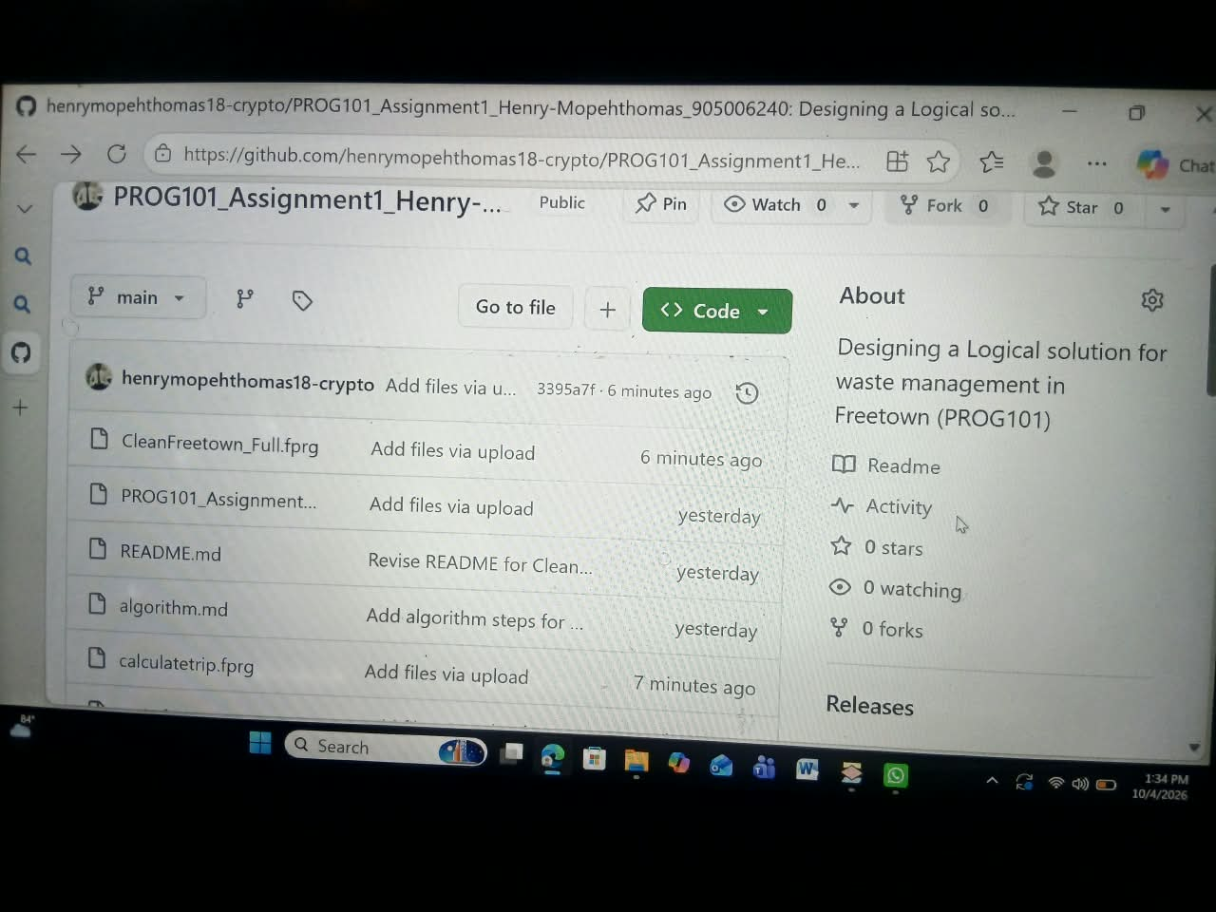

7.1 Suggested Commit Plan
No. | Commit message
1 | Initial commit: add README.md and project folder
2 | Add problem analysis and rationale draft
3 | Add step-by-step algorithm
4 | Add pseudocode for functions and main module
5 | Add main program flowchart
6 | Add classifyPriority flowchart
7 | Add expected outputs and test scenarios
8 | Add final report and update README

8. REFERENCES
Verify each link and access date before submitting, and add any other sources you actually used.
- United Nations (n.d.) Sustainable Development Goals. Available at: https://sdgs.un.org/goals (Accessed: [date]).
- United Nations (n.d.) Goal 11: Make cities inclusive, safe, resilient and sustainable. Available at: https://sdgs.un.org/goals/goal11 (Accessed: [date]).
- Digital Public Goods Alliance (n.d.) What is a digital public good? Available at: https://digitalpublicgoods.net (Accessed: [date]).
- Open Source Initiative (n.d.) The Open Source Definition. Available at: https://opensource.org/osd (Accessed: [date]).
- Git (n.d.) Git documentation. Available at: https://git-scm.com/doc (Accessed: [date]).
- GitHub (n.d.) GitHub Docs. Available at: https://docs.github.com (Accessed: [date]).
- Limkokwing University of Creative Technology, Sierra Leone (2026) PROG101 Assignment brief: Designing Logical Solutions for Sierra Leone Community Challenges.

