MBO-Weekly Report (Quản lý mục tiêu – Báo cáo hàng tuần)

From (Ngày): to (đến)
Prepared (Bộ phận): Henry_ Hardware & Technician support

Group Objectives
- Digitize and statistic the working item of each team
- Support customer handling issue ASAP
- Ensuring the quality of incoming and outgoing products, and post-return repairs.

Department Tasks
- Update and modify data of statistic working data of all team on internal website hardware.eup.net.vn
- Training new staff of technical support team and warehouse
- Analyze and provide feedback on the Police Department’s draft proposals regarding the new technical regulation QCVN 06.

Team Tasks
- Warehouse: Standardize workflows and update daily work data. Ensure sufficient inventory levels for sales.
- Repairing: Quickly repair devices to ensure KPI (devices need fixed in 5 days after return to warehouse) and statistic type error of devices
- Technical support:
  - Collect the fuel issue and sent to Taiwan R&D to fix and response to sales
  - Support customer through our hotline
- QA:
  - Analysis and statistic all new installation and maintenance dispatch of technician
  - Ask assistant to arrange the technician come to customer side to recheck all of dispatch order which have problems
  - Testing all the package devices which imported to warehouse as ISO 9001

Plan of next week
- Training new technical support team staff for installation device in customer side
- Create website hardware.eup.net.vn for internal management
Type of devices | Quantity
VN88-4G | 7621
VN88-4G (H) | 14866
VN88-2G | 113
S168-M3T | 59
S168-M3 | 1
S168-M | 10
S168 | 10
JAS121 | 4
BEWIN | 185
S400 | 5380
Go-168 | 29982
Go-168 V3 | 14884
S400E | 11
MT99 | 303
Streammax C43 | 1125
Streammax C43 CAT 1 | 10399
Streammax H5 | 1818
Streamax F6N | 320
Total | 87091

Statistic the number of devices running in our system

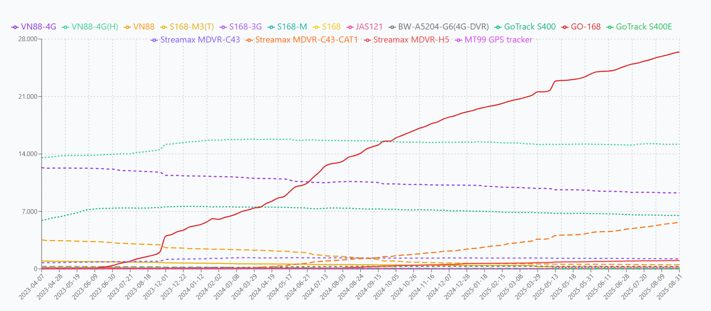

Statistic the number of errors happen in week

Statistic of device repaired by week

