HPO Assignment

Question 1: Anisotropic spin interactions

Below is an example static powder 1H spectrum containing a single environment at 600 MHz 1H NMR frequency.

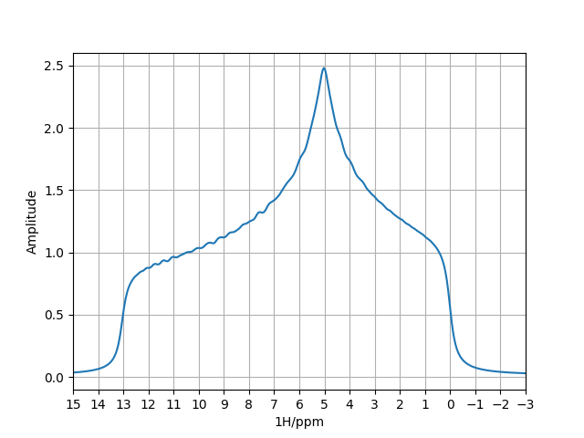

Q1.1: What anisotropic spin interaction gives rise to this lineshape.

Q1.2: What are the 3 values defining the magnitudes for the principle axes of this interaction tensor?

The same sample was spun at the magic angle to give the spectrum below.

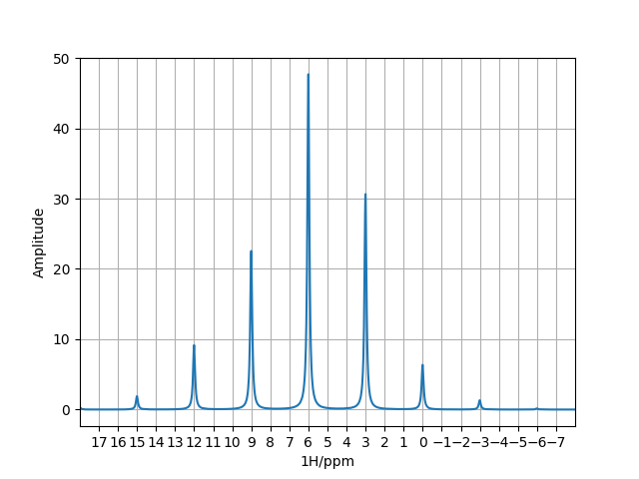

Q1.3: What frequency was the sample spinning at?

Q1.4: What magic angle spinning frequency would be required to completely remove this anisotropic interaction?

Q1.5: In solution NMR, only a single peak is observed in the spectrum. What does this tell you about how fast the rate of rotational diffusion is for such a molecule in solution? What is the chemical shift of the single peak in solution?

The following powder pattern arises for a single 1H spin direct dipole-dipole coupled to another 1H spin (not shown here) at 600 MHz 1H NMR frequency.

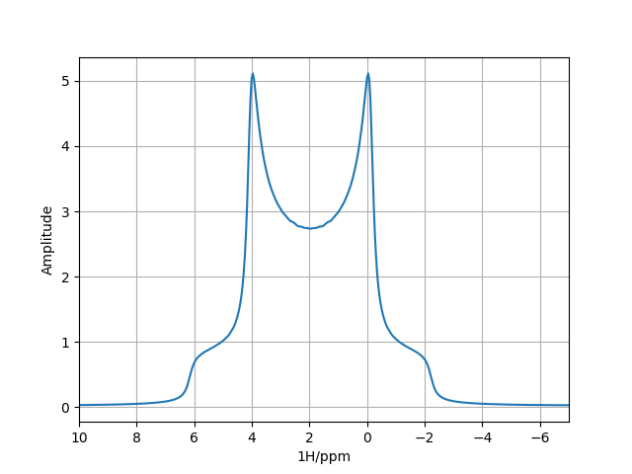

Recall the dipole-dipole coupling constant is calculated as:

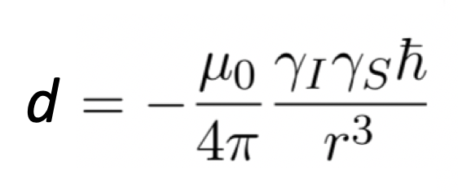

Q1.6: What is the distance between these two 1H spins?

Question 2: CP/MAS and solvent suppression

Below is a typical CP/MAS experiment for correlating H and N spins in a 2D spectrum (similar to HSQC in solution). The sample was spinning at 75 kHz MAS rate.

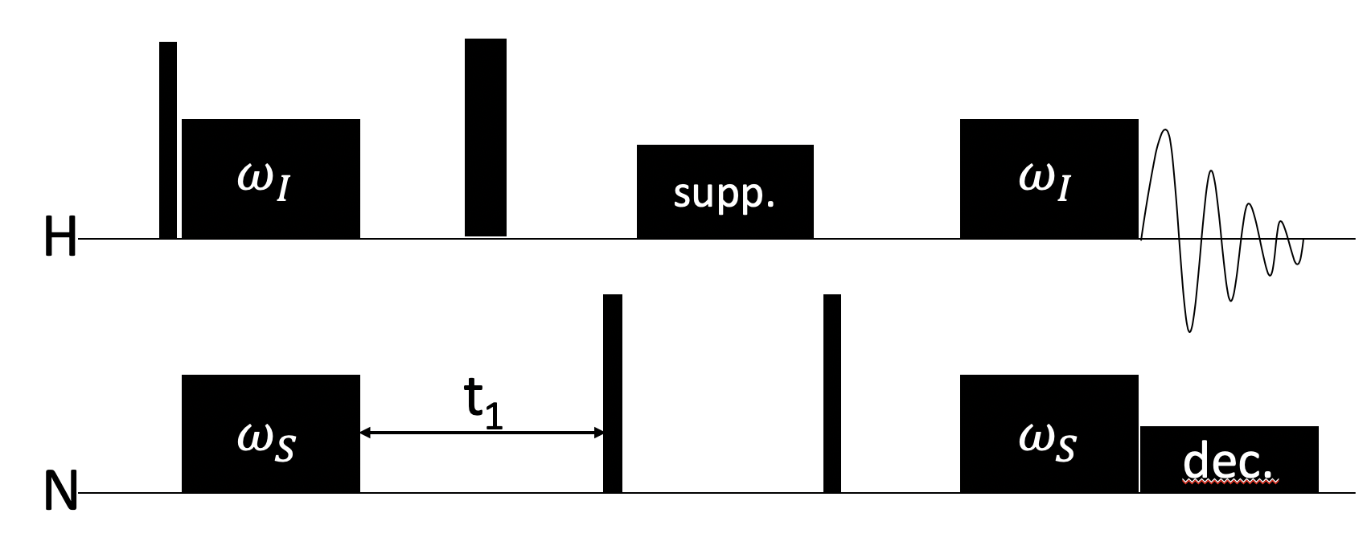

Q2.1: Given a 15N CP power of $ω_{S}$ = 45 kHz, what power is required for the n=1 double quantum condition on 1H?

Q2.2: And what 1H power would be required for the n=1 zero quantum condition?

Q2.3: Why would it not be wise to set $ω_{I}$ = $ω_{S}$ = 75 kHz? (Hint: consider the sign of transferred magnetization under zero and double quantum matching conditions)

The above CP/MAS experiment uses a continuous RF pulse labelled “supp.” to saturate the water solvent signal. Below is a theoretical 15N HSQC experiment that employs that same idea for solvent saturation (shown in red).

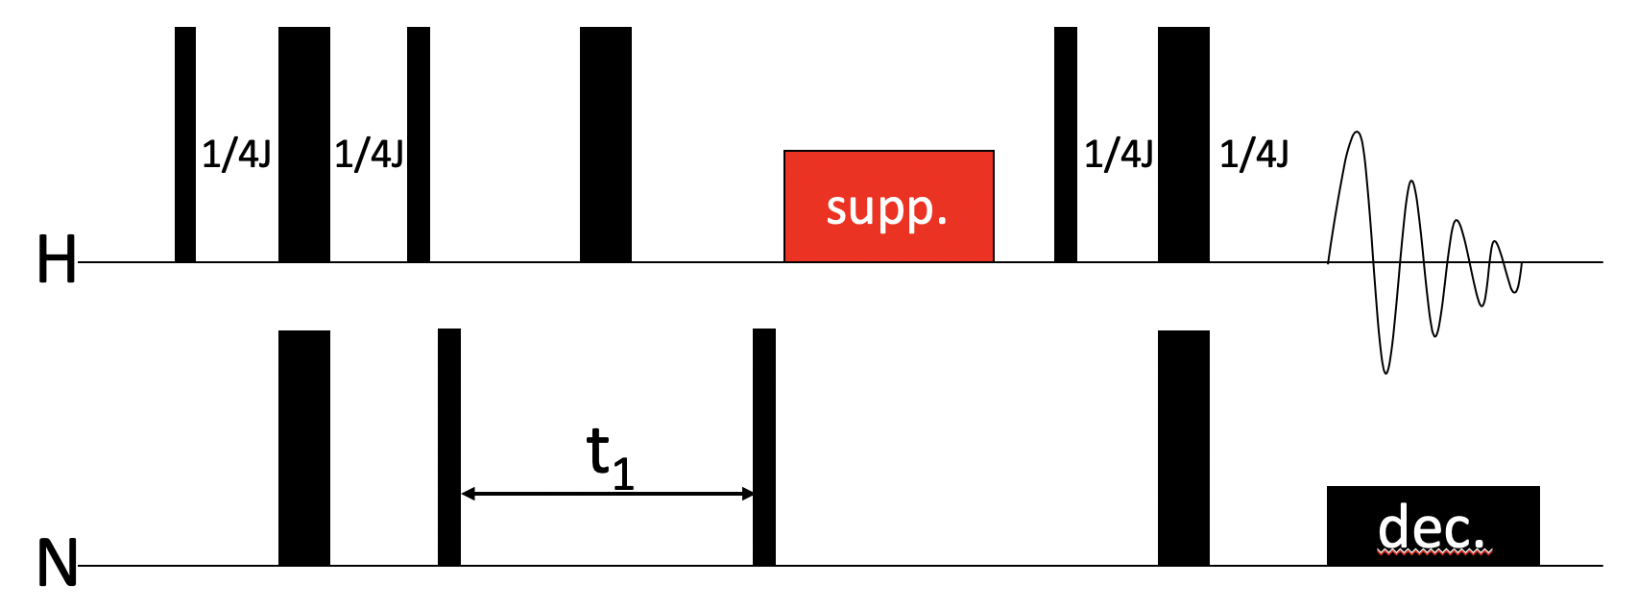

Q2.4: Would this experiment work in solution? Explain Why or why not?

Question 3: Comparing solution and solid-state NMR hardware

Incomplete averaging of anisotropic spin interactions as well as sample inhomogeneity in solid state NMR lead to broad lines (500 Hz for 1H is not uncommon). Solution NMR has excellent linewidths of less than 5 Hz for small molecules.

Q2.1: Why is the lock necessary in solution NMR, but can be omitted in solids?

Q2.2: Is tuning and matching necessary in solid state NMR? How would the spectrum appear if you omitted matching?

Q2.3: Signal to noise ratios is solution NMR spectra decrease as molecular size increases due to relaxation, meaning molecules beyond 200 kDa cannot practically be detected. Does this molecular size limit apply to solid state NMR of rotating solids?