Hyung(Henry) Park

Hcp084

RL Homework 3

Breakout-v0

1. Average Maximum Q Function vs Iterations

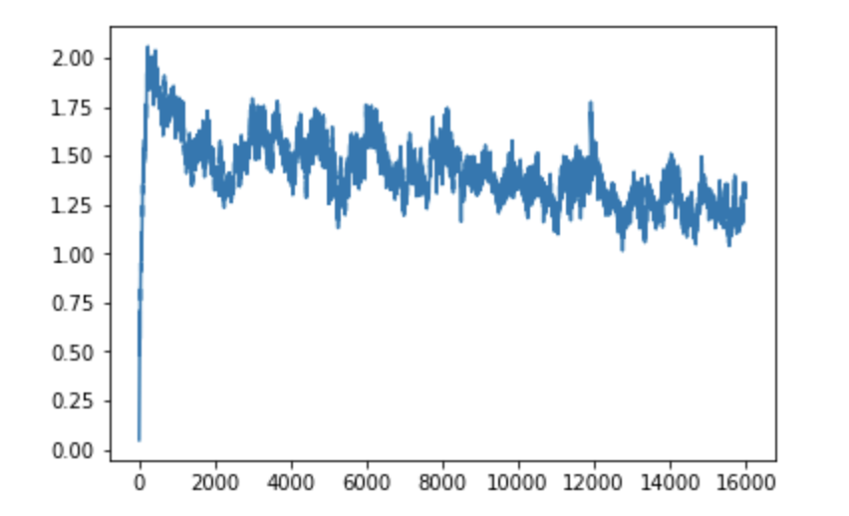

1. Sum Rewards vs 1000 games

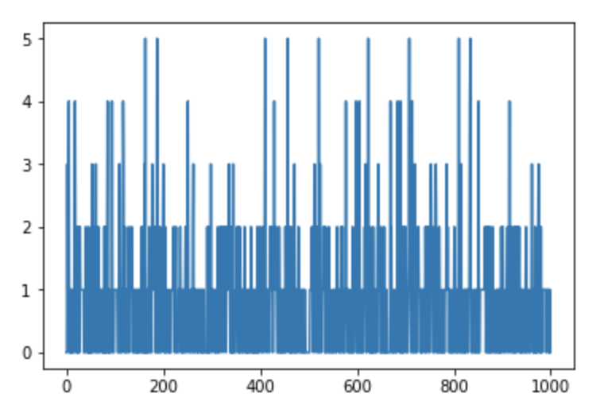

MsPacman-v0

1. Average Maximum Q Function vs Iterations

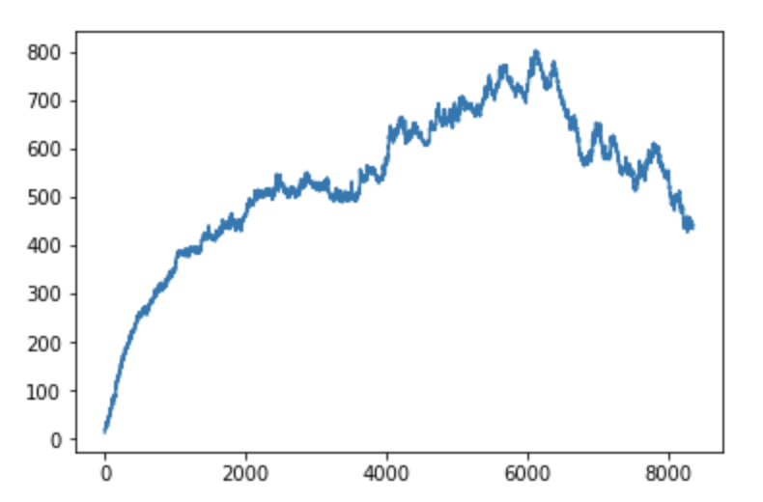

1. Sum Rewards vs 1000 games

