Henry Paul

3d Graphics acw2 report

**Contents**

**Implemented features** 2

**Textured walls with normal mapping** 2

**Bumpy cave floor and ceiling** 2

**Metal tanker** 3

**Animated burning object + rusty car wreckage** 3

**Locally deformed flying objects** 4

**Moving elephant with particle firing weapon** 4

**Particle explosions + debris** 5

**Cube mapped reflective sphere** 5

# **Implemented features**

## **Textured walls with normal mapping**

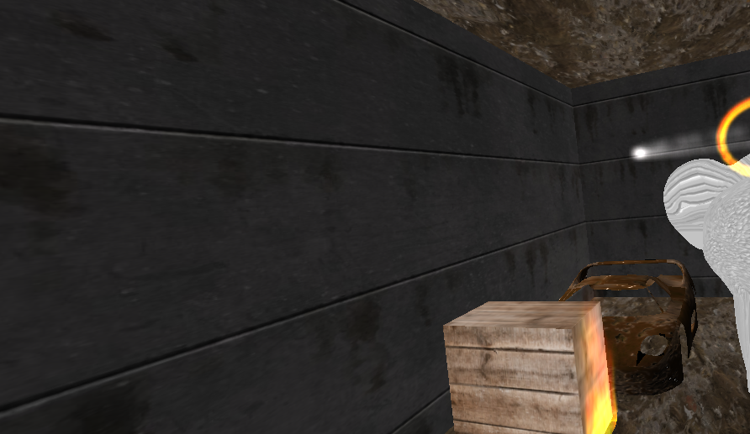Both the rear and far right wall use a texture found online as well as the appropriate normal mapping technique to give make each section of the wall stand out from the others.

## **Bumpy cave floor and ceiling**

The cave scene uses the same texture for both the floor and ceiling. Each of which including a normal map and a height map, both implemented to create a basic parallax map effect.

## **Metal tanker**

A sphere that has been transformed into a cylinder shape and placed in the middle-left area of the scene. A metal texture has been applied to the shape as well as the implementation of a per fragment lighting technique.

## **Animated burning object + rusty car wreckage**

A wooden box can be seen in the middle of the scene with a texture-based fire animation applied to its front face. The fire uses 3 textures to determine the opacity, noise, and colour of the fire animation. To the right of the box, a rusty car wreckage can be seen, with the appropriate bump mapping technique applied to it.

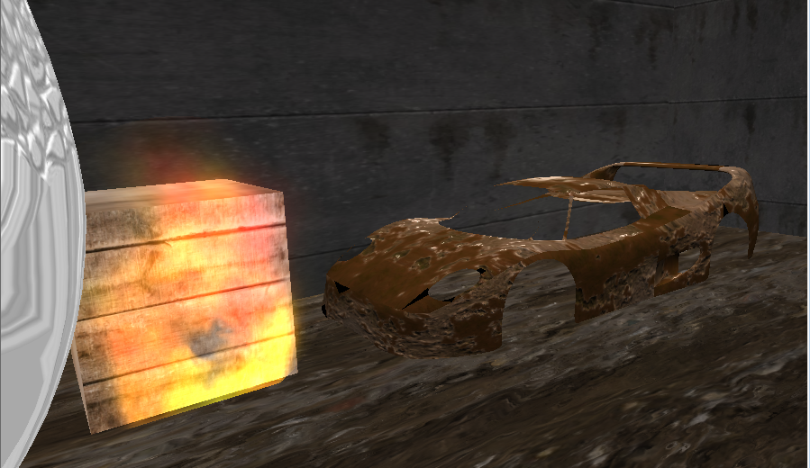

## **Locally deformed flying objects**

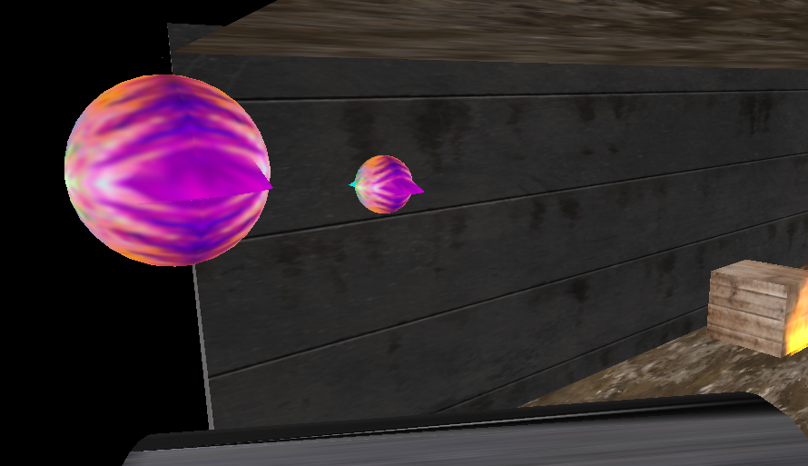Two variations of a locally deformed sphere can be seen flying through the scene. The smaller one moves more erratically than the larger one, with the wings animated at a higher speed.

## **Moving elephant with particle firing weapon**

A textured elephant can moves through the scene with a gun mounted to its back. The gun fires particles (explosive bullets) at a high frequency towards the wall it is facing.

## **Particle explosions + debris**

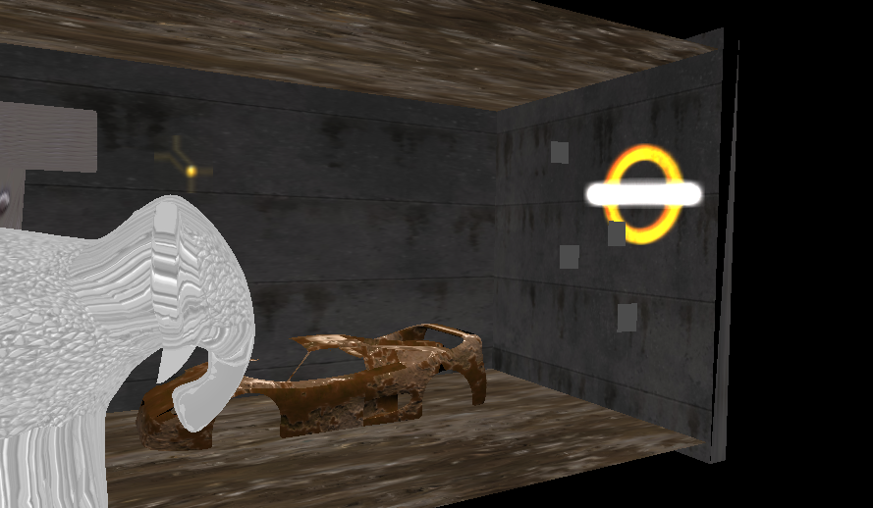As a result of the explosive bullets, an explosion effect can be seen on the targeted wall. It features fire particles moving in a ring as well as a shockwave effect. Furthermore, animated debris can be seen falling off the wall from the explosions.

## **Cube mapped reflective sphere**

Above the cave scene, a reflective sphere can be found. This uses a cube map of a street environment to simulate a reflective surface.