

Assignment Title: Lab 5

by
Henry Nguyen
henryumd@terpmail.umd.edu

By submitting this assignment, I acknowledge that I have read and agree to abide by the University of Maryland’s Code of Academic Integrity. I declare that all work within this assignment is my own or appropriately attributed.

Date Due: 9 October 2024
Date Submitted: 8 October 2024

Table of Contents
Executive Summary 2
Android Phone Analysis 3
Conclusion 9
Works Cited 10

Executive Summary
I, Henry Nguyen, a Digital Forensic Student Analyst with University of Maryland’s Advanced Cybersecurity Experience for Students, have been tasked to review and parse through data belonging to an android device. We will be utilizing an application called ALEAPP, a tool that allows us to examine image files belonging to android devices. This tool has a multitude of tools, but one thing that stands out is its sleek Gui design after loading an image file. Our ultimate task for this lab is to examine the Android device and seek information regarding a potential attack that this user conducted; in doing so, we will be able to document an image of a potential cybercrime, providing supporting imagery to affirm our findings.

Android Phone Analysis
Source File: \temp\data\misc\bootstat\factory_reset
Factory reset – When the user restores device to original settings (from factory).
This artifact might give us a clue as to whether or not the device was tampered with. In this case, any data before the date is lost.
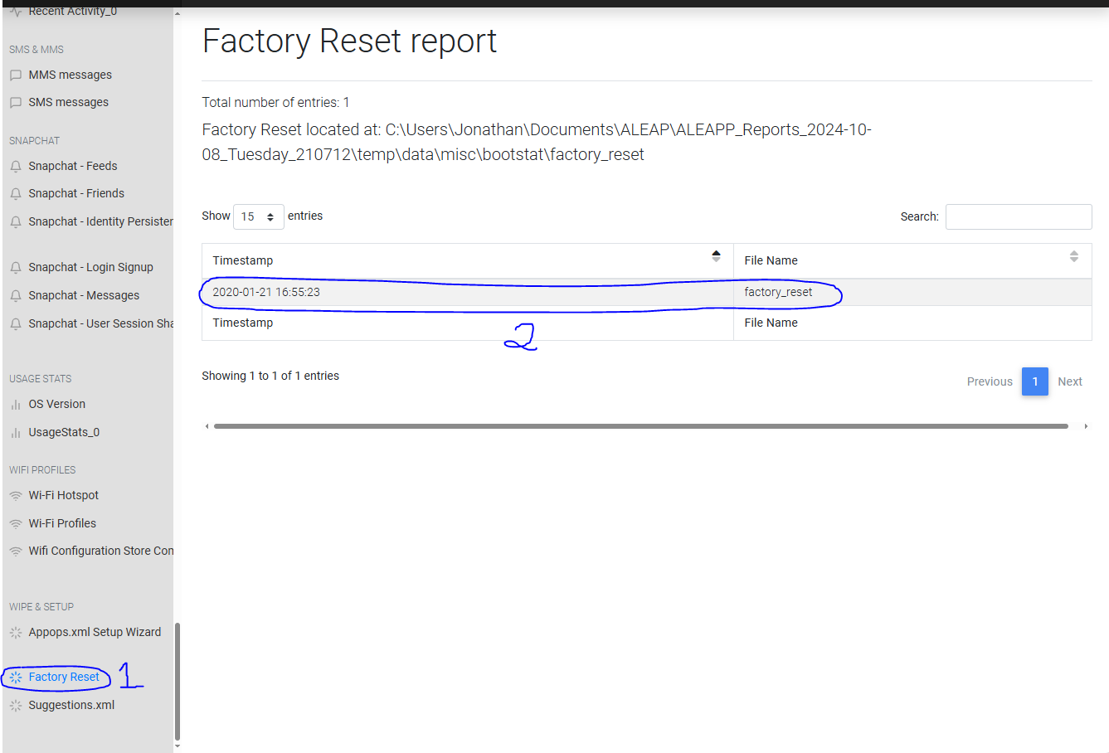
Figure 1 The last time the user performed a factory reset is 2020-01-21

Source file: \temp\data\user_de\0\com.android.providers.telephony\databases\telephony.db
Telephony.db – a regsitry of the SIM card’s details, including information on carrier, IMSI, etc…
This artifact allows us to see what particular android device the user has and a rough estimate of which area the attacker is from (could also look up phone numbers).
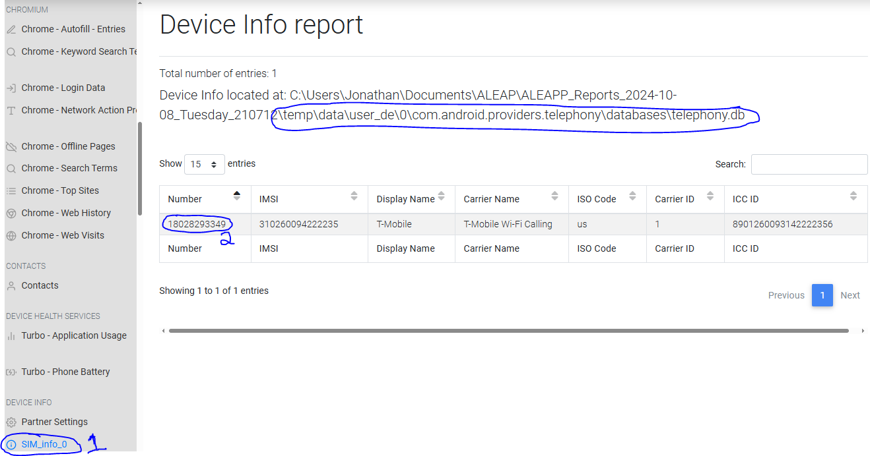
Figure 2 The following MSISDN is 18028293349

Source file: \temp\data\system\usagestats\0
Usagestats: Provide an overview of the user’s most utilized applications.
Is important for identifying any key elements or programs that the hacker might’ve used during their exploits.
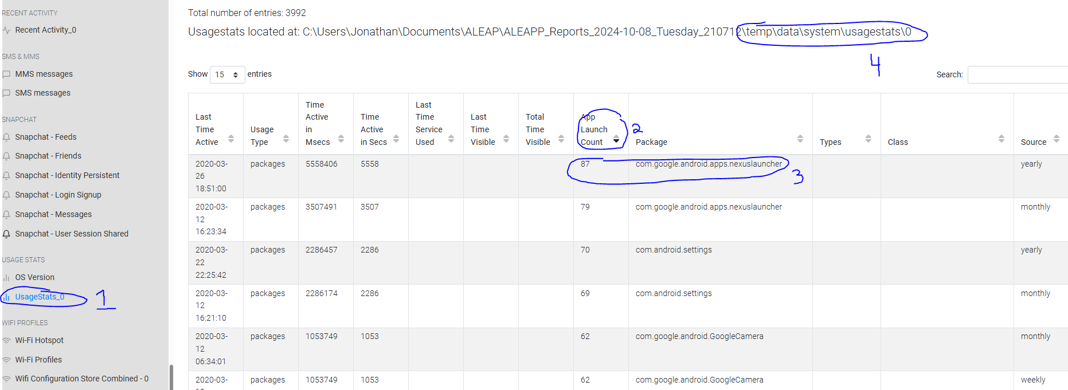
Figure 3 The user utilized Nexus, a social media application that links other social media platforms together.

Source file: \temp\data\system\usagestats\0\version
Version: Shows the version of what operating system the device is on.
Understanding which version the phone is running is important, because the hacker could use exploits to gain more utility on the phone (such as jail breaking)
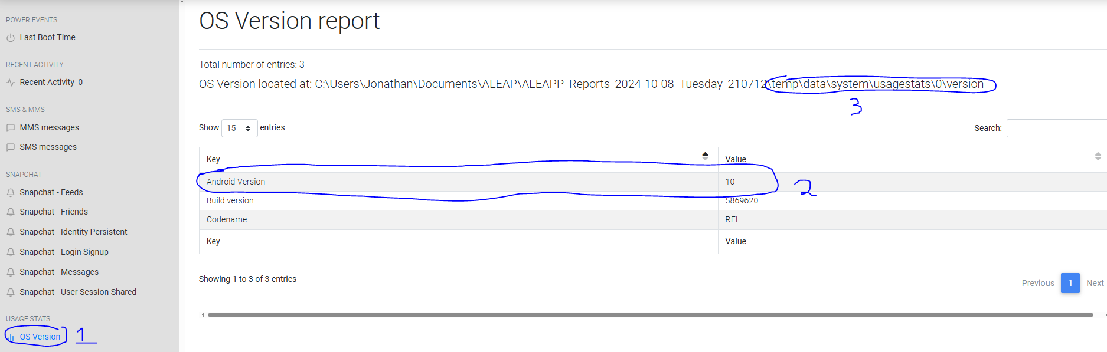
Figure 4 The version ID is 10, which represents the 17th version of the Android OS.

Source file: \data\data\com.google.android.gm\databases\bigTopDataDB.1206044692
bigTopDataDB: SQLite of Google mailing services.
This is extremely important as it gives us an overview of ALL emails that the user receives. In this case we were able to find a file transferred by Alan to Chester that looked suspicious.
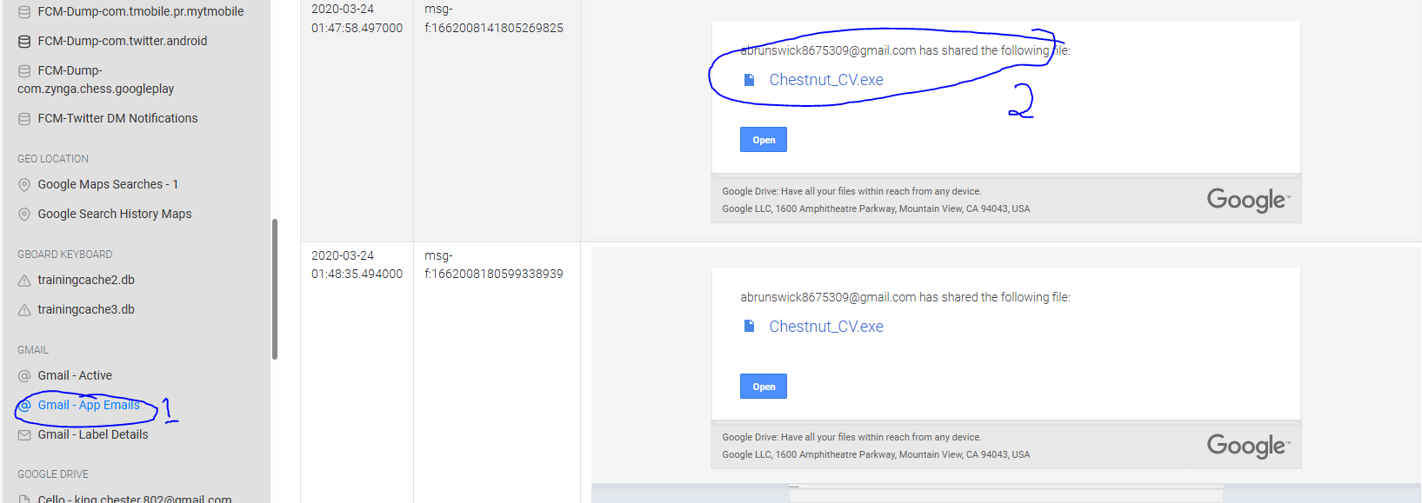
Figure 5 The malicious file is named Chestnut_CV.exe can also confirm its existence in Google Drive.

Source file: \data\data\com.snapchat.android\databases\main.db
\temp\data\data\com.termux\files\home\.bash_history
Main.db – SQL database of all messages sent. For this case it’s Snapchat’s messages.
.bash_history – stores all the commands ran on bash, through Termux (terminal emulator)
Main.db allowed us to parse through the user’s old message exchange with Alan. We were able to find that they installed Kali on their system. Further investigation led us to the base history, where we reaffirmed our findings from before and saw Kali linux tools being ran on the Android device.

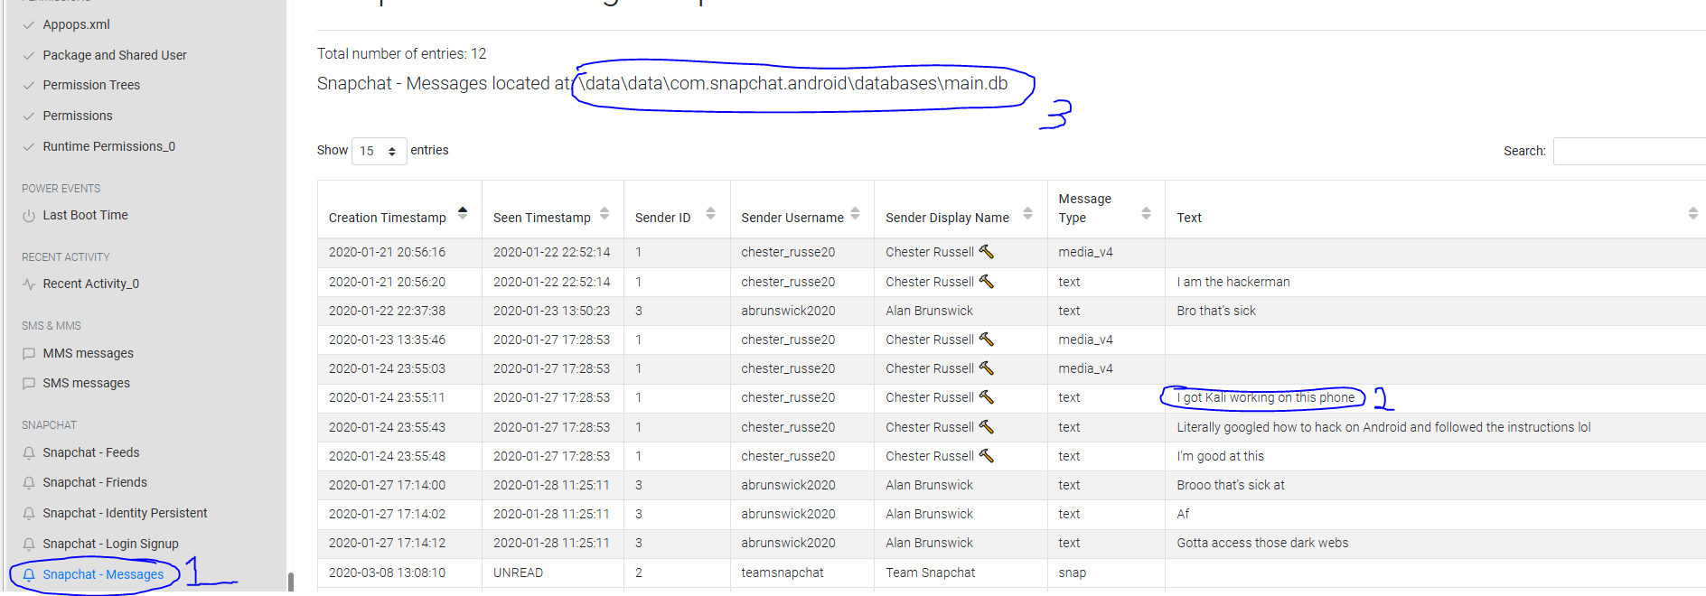
Figure 6 Kali Linux was installed based off chat
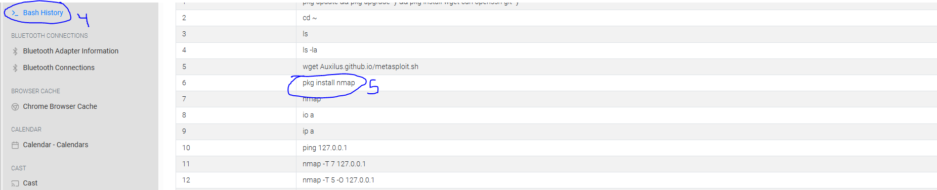
Figure 6 1 We reaffirmed our findings and found nmap being installed and utilized. A tool on Kali Linux that allows for port scanning.

Source file: \temp\data\data\com.zynga.chess.googleplay\databases\wf_database.sqlite
wf_database.sqlite – an SQLite database particularly belonging to Zynga’s chess game, showcasing all the messages exchanged on their chat system.
This is important as chatlogs could reveal potential participants in the cybercrime. In this case we were able to find an exchange made between Alan and Chester, where they talked about targeting Mallie Sae.
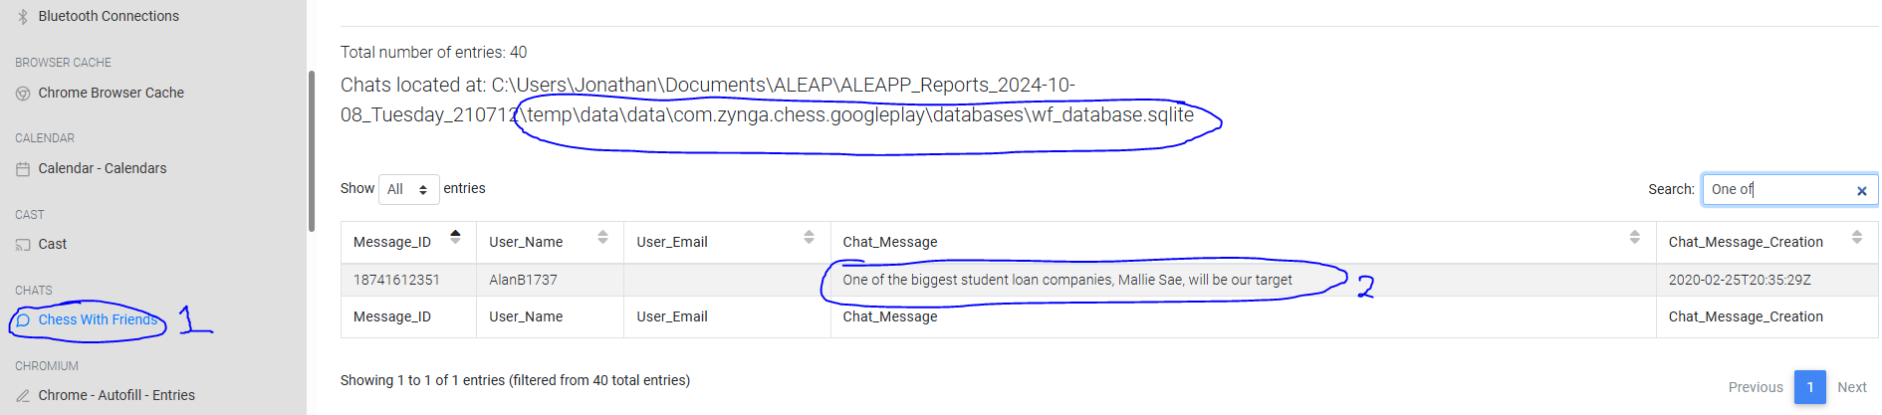
Figure 7 They hacker talks about targeting Mallie Sae

Source file: \temp\data\data\com.android.chrome\app_chrome\Default\History
History – shows the search term history of Google Chrome
Search history allows us as the analyst to parse through the user’s activities and potential activities on the device. In this case the user searched (and downloaded) magisk manager, a popular tool used to rootkit the Android device.
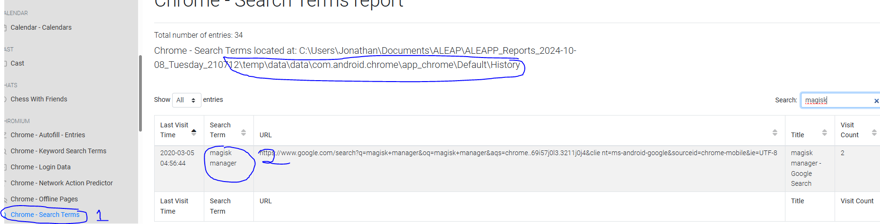
Figure 8 Rootkitting tool called Magisk

Source file: \temp\data\data\com.android.chrome\app_chrome\Default\Top Sites
Top Sites – An SQL database of all the site the user visited, through Chrome for this case.
This allows us as the analyst to depict the user’s activities on the system. Chester’s most visited site was Mallie Sae, which so happened to be the target they were gunning for. He was most likely performing reconnaissance on the site for potential vulnerabilities.
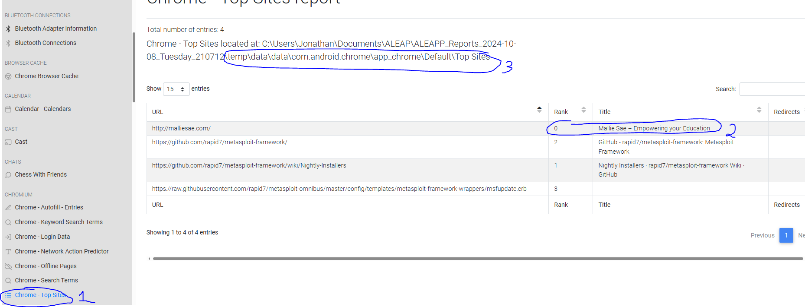

Conclusion
Utilizing the ALEAPP application we were able to create a case against Chester and Alan. This case focused on Chester, as the main malicious actor, and Alan his partner in crime. Through analyzing various artifacts within the phone, we were able to find out who the hackers were targeting, what system they were using, what file was used for the exploit, and what tools they used to conduct reconnaissance. ALEAPP has proven to be an essential tool in this investigation, allowing us to fully depict what went on within the user’s system, the steps they took towards the attack, and even their ultimate downfall (being caught and turning themselves in). This tool allowed us to create a full case on Chester and Alan, with well crafted documentation of proof of action (of the attackers).

Works Cited
Epifani, M. (2024, February 11). A first look at Android 14 forensics. https://blog.digital-forensics.it/2024/01/a-first-look-at-android-14-forensics.html
Magisk Manager. (2021, March 8). Download Magisk manager latest version 27.0 for Android 2024. https://magiskmanager.com/

