

Assignment Title: Lab 6

by
Henry Nguyen
HenryUMD@terpmail.umd.edu

By submitting this assignment, I acknowledge that I have read and agree to abide by the University of Maryland’s Code of Academic Integrity. I declare that all work within this assignment is my own or appropriately attributed.

Date Due: 16 October 2024
Date Submitted: 15 October 2024

Table of Contents
Executive Summary 2
iOS Phone Analysis 3
Conclusion 12
Works Cited 13

Executive Summary
I, Henry Nguyen, a student studying Digital Forensics, under the tutelage of Professor Johnson, was tasked with investigating an image belonging to an iPhone, using iLEAPP as our choice of analyzing tool. We have seized an iPhone that was believed to be linked with a recent cyberattack conducted on a student financial loan institution. This phone belonged to a potential suspect that has now been apprehended. We have been brought into this investigation, as the police force assigned with this cyberattack is ill-equipped with the knowledge to parse through iOS devices.

iOS Phone Analysis
\temp\iOS_Filesystem\private\var\mobile\Library\Application Support\CloudDocs\session\db\server.db
Server.db
This database artifact performs actions on one or more databases. This artifact is associated with iCloud account syncing, lending us information on how many devices are associated with this iCloud account. In this case, we only have one account associated within our investigation, that being: Alan’s Fantastical iPhone.
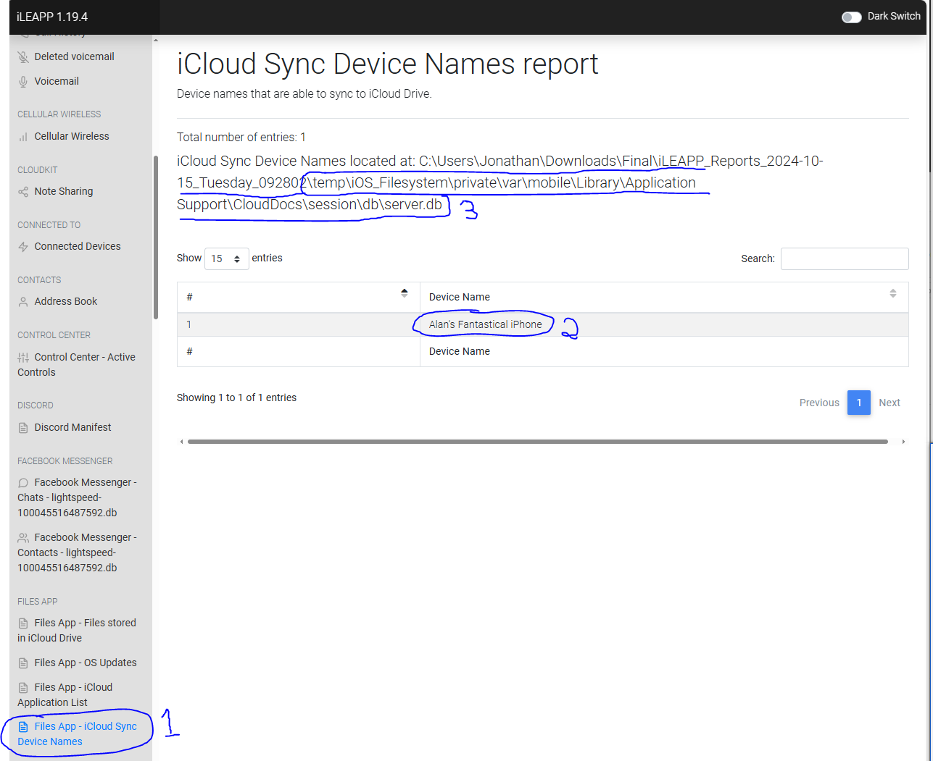
Figure 1 iCloud sync'd devices, only one device was shown. Can confirm device under 'Account Data' or ‘Device Preferences’

\temp\iOS_Filesystem\private\var\wireless\Library\Preferences\com.apple.commcenter.device_specific_nobackup.plist
com.apple.commcenter.device_specific_nobackup.plist
Property list format contains a series of key value pairs that are encoded in extensible markup language (XML). These keys are strings in this artifact it provides us information on the user’s device information and SIM card. It’s important for us to create unique identifiers for this device, and allow us to potentially identify further information, such as: contacts, SMSs, call logs, and much more.
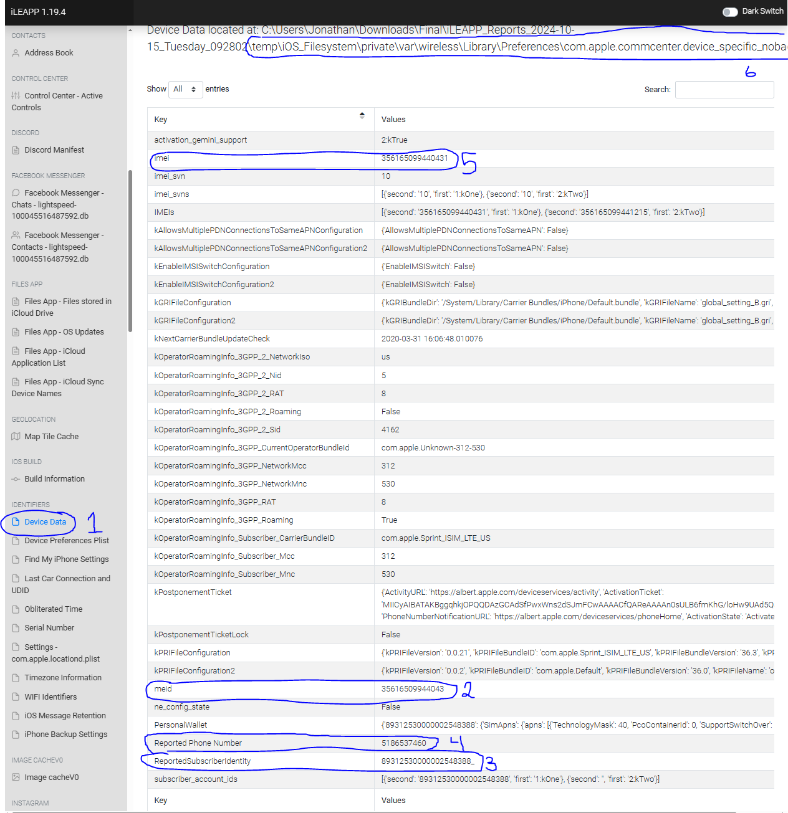
Figure 2 Various identifying information for the device and SIM
\temp\iOS_Filesystem\private\var\mobile\Library\Preferences\com.apple.mobile.ldbackup.plist
com.apple.mobile.ldbackup.plist
This plist artifact provides us information on iTunes version and backup. Important information to have, lending us an idea of how relevant our gathered information is and if there’s possible info that we’re missing that wasn’t backed up.
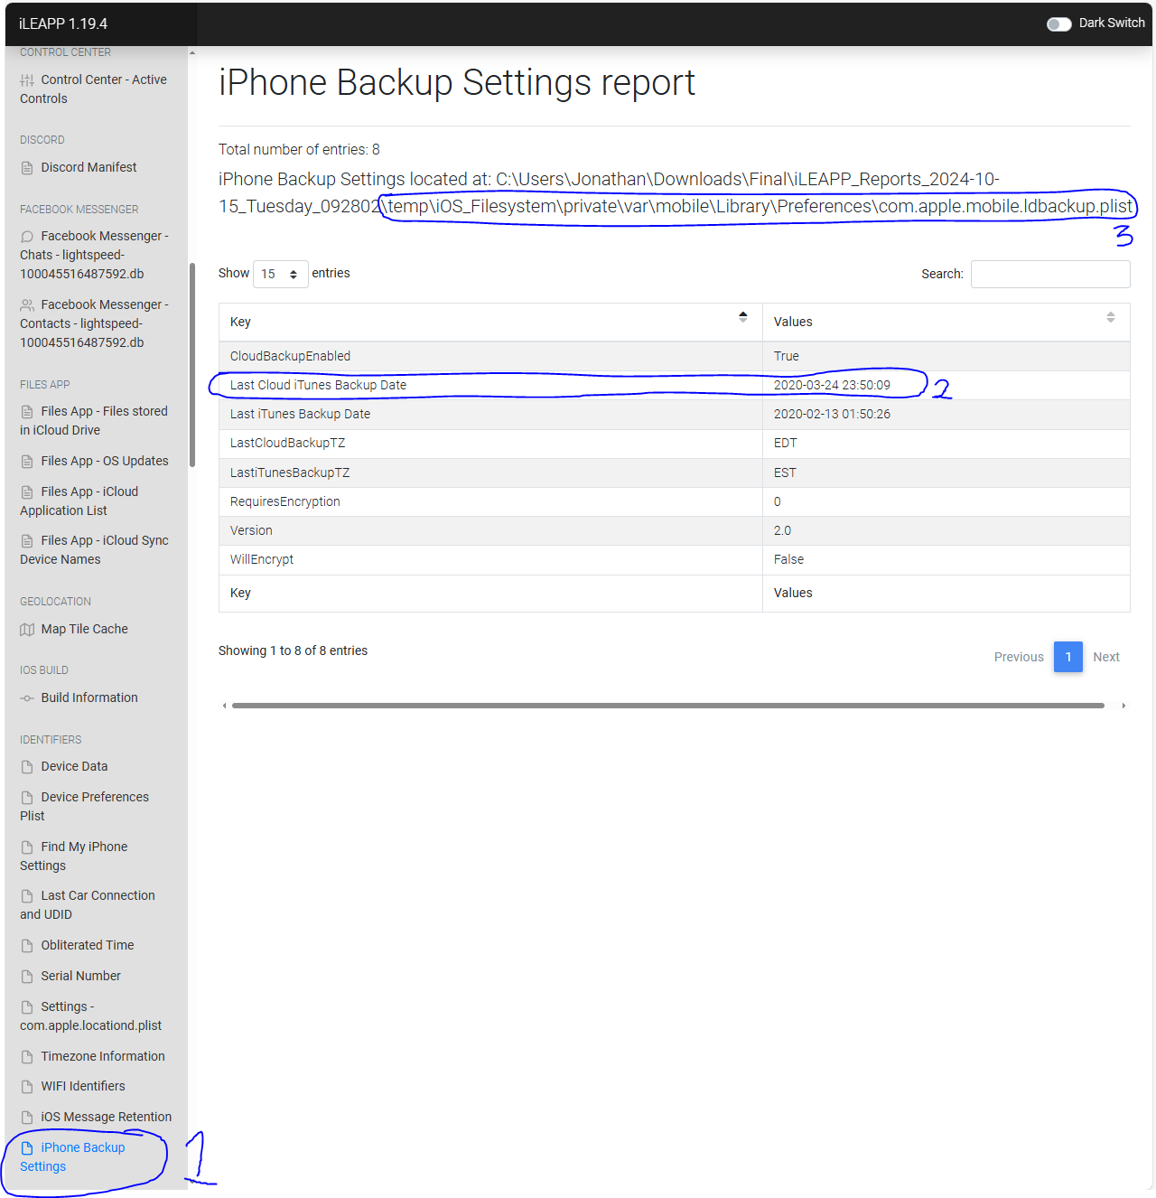
Figure 3 Last back up was made 2020-03-24 23:50:09
\temp\iOS_Filesystem\private\var\mobile\Library\MedicalID\MedicalIDData.archive
MedicalIDData.archive
.archive a collection of data transferred to a storage location, this particular artifact gives us personal identification of the person under investigation. In this case, we were able to harvest the individual’s birthday, and other health related information, which could prove to be useful in-case we need it to access other accounts or systems (as people sometimes use their birthday as passcodes).
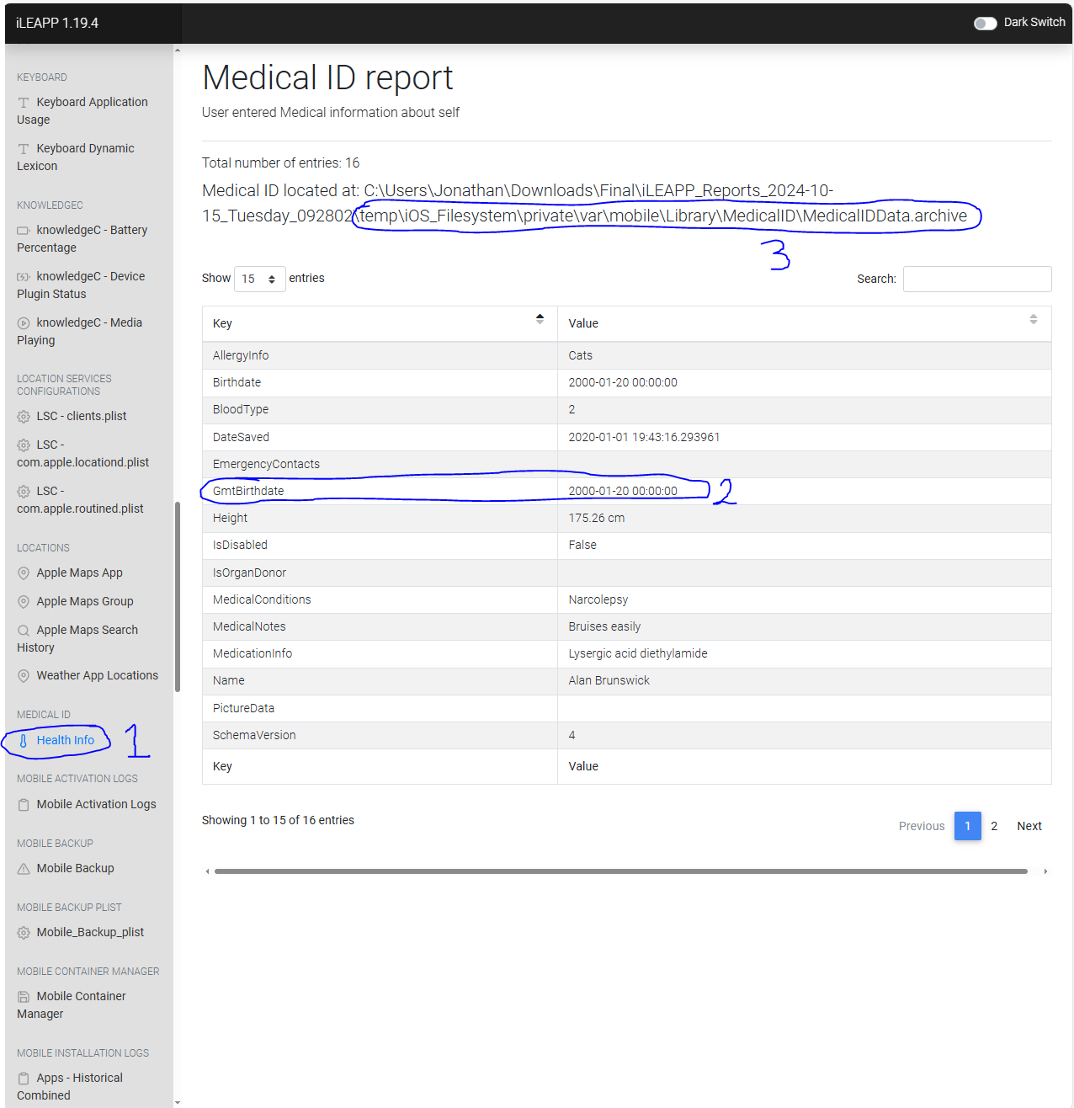
Figure 4 Birthday to be identified as Jan. 20, 2000
\temp\iOS_Filesystem\private\var\mobile\Library\Passes\Cards\ex8l7ZF9n+CLlt8OQJA7WnwUYaQ=.pkpass\pass.json
Pass.json
JavaScript object notation (JSON) text-based data that is interchangeable and is used to exchange data between web clients and servers. This artifact houses information on the user’s flights, from place of departure, stops, and destination. This is important as we could create alimony for the user based upon their whereabouts.
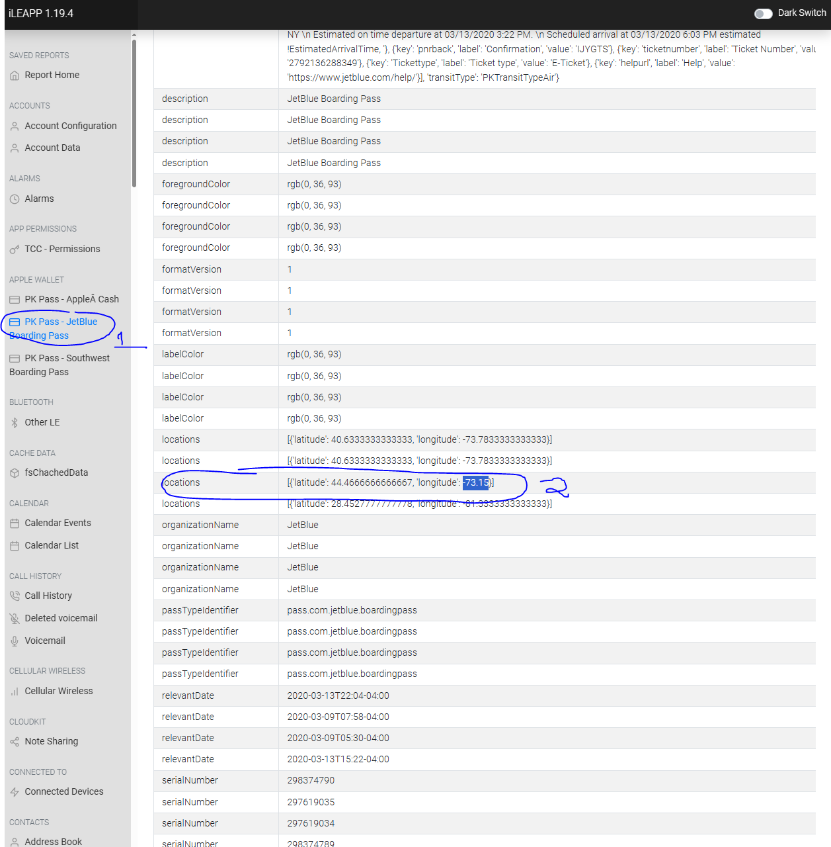
Figure 5 The user started at Florida > New York > Vermont
\temp\iOS_Filesystem\private\var\mobile\Media\iTunes_Control\iTunes\iTunesPrefs
iTunesPrefs
This artifact provides device preferences/allowed devices for the iPhone in question. This is important, as we could further identify devices that could potentially yield more information to further our investigation.
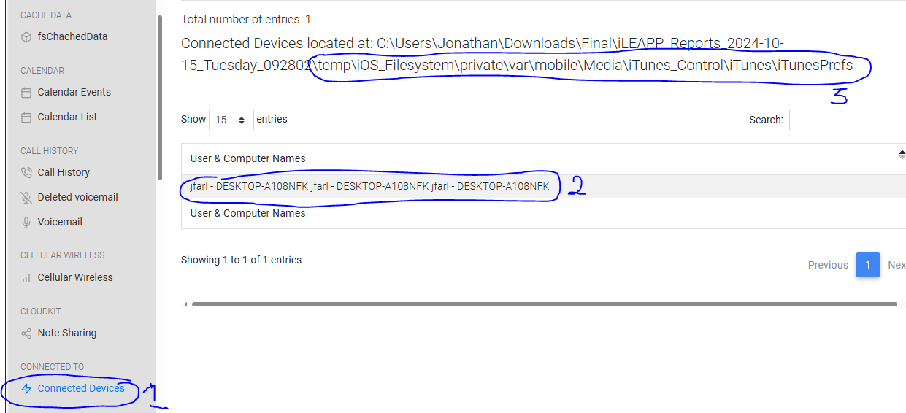
Figure 6 the user 'Allowed' connection to a Desktop

\temp\iOS_Filesystem\private\var\mobile\Library\Preferences\com.apple.mobiletimerd.plist
com.apple.mobiletimerd.plist
A plist artifact that provides us with the user’s set alarm. This could provide extremely important as the user may set special alarms to signify important dates or times, in-which they could potentially carry out their attack.
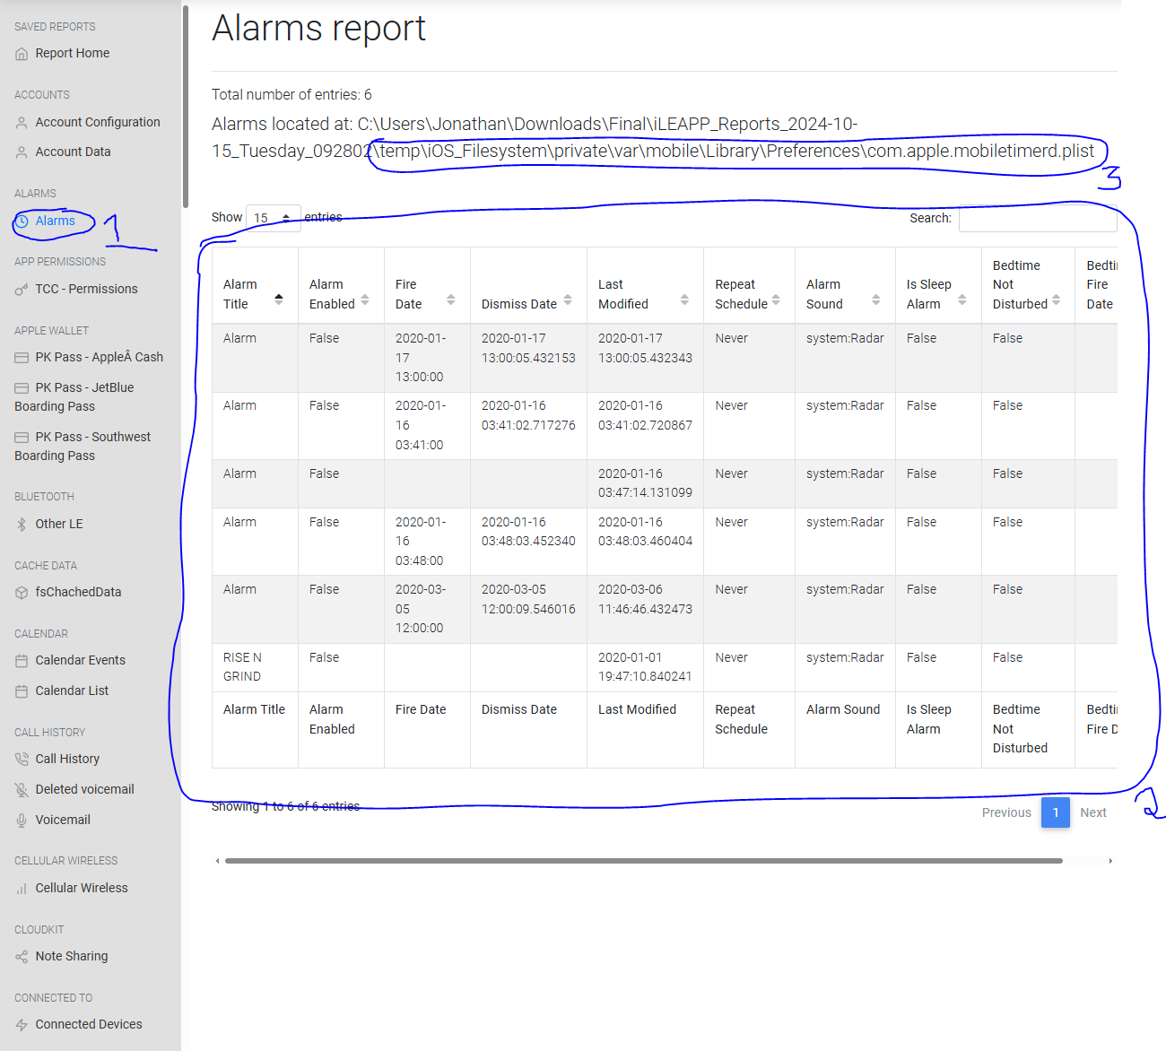
Figure 7 The user set alarms for important dates

\temp\iOS_Filesystem\private\var\mobile\Library\SMS\sms.db
Sms.db
Database containing all the messages sent via SMS on the iphone. In this case it gave us insight into what the device was used for, where the user tried utilizing substrate, a tool for jailbreaking iPhone. There are also talks of hacking and picking out a target.
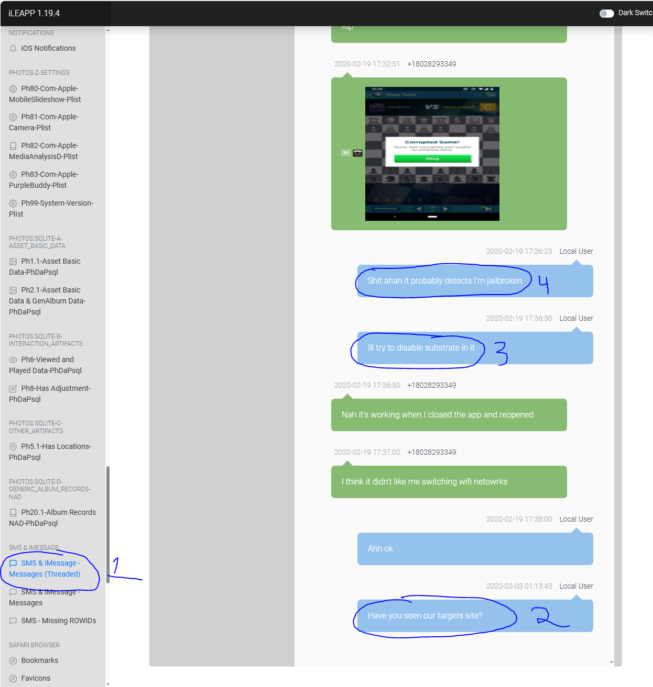
Figure 8 The user talked about hacking, jailbreaking, and picking out their potential target.

\private\var\mobile\Containers\Data\Application\F18BB20F-AD2C-4B6B-86FC-6CEAD1376EE4\Library\Caches\drivekit\users\112606459141650927338\image-fetcher-cache\main-cache\cacheV0.db
Cachev0.db
A database that contains all image files sent via chatlogs. This is important as we were able to pinpoint images sent via text, and what we found were files that contained personal information and various people’s student loan debt. Something that an individual shouldn’t have in their possession.
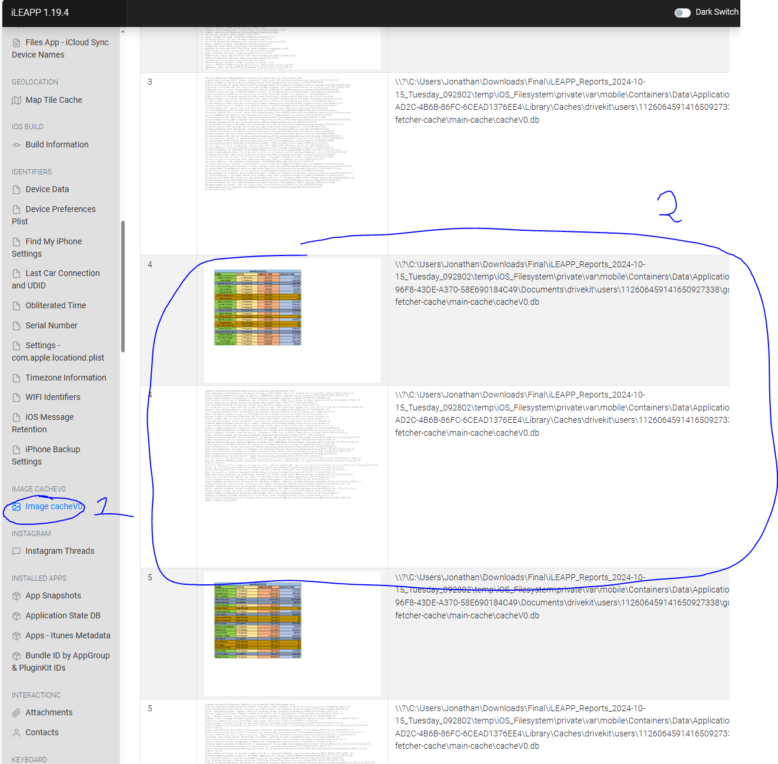
Figure 9 There were images containing private information on various people.

Conclusion
In this lab, I was able to learn how to utilize iLEAPP to parse through an iOS device image belonging to an iPhone. This tool is particularly useful as Apple is known to not collaborate with investigators. During this investigation we were able to find a lot of personally identifiable information on the user and was able to even ascertain some evidence of them holding private information, such as: social security, loan debt, and names of individuals. This lab also provided insight and a learning opportunity to understand/familiarize myself with iOS’s file structure. Overall, we were able to create an alimony of the user’s whereabouts and what the phone was used, all important information towards creating a case against this individual.

Works Cited
Apple. (n.d.). Mac OS X 10.9 artifacts location. Mac os x 10.9 artifacts location -. https://forensics.wiki/mac_os_x_10.9_artifacts_location/
Charpentier, H. (2024, February 7). What is cachev0.db and why are there only images in it?. What is cacheV0.db and why are there only images in it? https://abrignoni.blogspot.com/2024/02/what-is-cachev0db-and-why-are-there.html
Edwards, B. (2022, July 31). What is a plist file?. How To Geek. https://www.howtogeek.com/815297/what-is-a-plist-file/
Lenovo. (n.d.). What is archive? the benefits of archiving and file security. What is Archive? The Benefits of Archiving and File Security | Lenovo US. https://www.lenovo.com/us/en/glossary/what-is-alt-archive/

