  Accel Entertainment  Risk Assessment and FAIR Model | Abstract  The world of cyberspace is ever evolving. Companies who prepare for the worst are ones that find themselves ahead in the future. Within this document is a quantitative and qualitative analysis of the potential threats that Accel Entertainment may face.  Henry  Final Report

Contents
I. About This Document 3
Project Description 3
Key Terms 3
Limitations 4
Analytic Confidence 4
II. Executive Summary 4
III. Company Overview 5
IV. Qualitative Risk Analysis 7
Overview 7
Assets 7
Threat Vectors 8
Threat Actors 9
Losses 9
Scenarios 10
V. Quantitative Risk Analysis 13
Pre-mitigation Risk Analysis 13
Scenario 2 - AE Accelerator Unpatched Vulnerability 15
Scenario 3 – Phishing Attack on CFO 16
Post-mitigation Risk Analysis 17
Scenario 1 - Service Technician Inside Attack 17
Scenario 2 - AE Accelerator Unpatched Vulnerability 19
Scenario 3 – Phishing Attack on CFO 21
VI. Recommendations 22
Overview 22
Scenario 1 - Service Technician Inside Attack 22
Scenario 2 - AE Accelerator Unpatched Vulnerability 22
Scenario 3 – Phishing Attack on CFO 22
Appendix A – Potential MITRE ATT&CK Vulnerability 24
Scenario 1 - Service Technician Inside Attack 24
Scenario 2 - AE Accelerator Unpatched Vulnerability 24
Scenario 3 – Phishing Attack on CFO 24
Appendix B - Citations 26

I. About This Document

Project Description
Within this report we will delve into various cybersecurity-related risks that Accel Entertainment could potentially encounter. Accel Entertainment is the largest terminal operator in the nation, providing slot machines and related gambling devices to well-known casinos in the mid-west, as well as proprietary software that manages those systems. Given the sensitive nature of financial transactions and personal data involved in gaming operations, Accel Entertainment is a prominent target for cyber threats. This assessment aims to unmask those key vulnerabilities within their systems both physically and virtual, evaluate the potential impact of different threat scenarios, and recommend mitigative strategies to enhance the organization’s overall cybersecurity posture.

Key Terms
Common Vulnerabilities and Exposures (CVE): a publicly accessible database that identifies and catalogs various known security vulnerabilities in software.
Competitor/Rivaling Companies: companies that are in direct competition with another.
Credential Stuffing: an automated cyberattack that inserts stolen username and passwords.
Cybercriminal Groups: an organized group of hackers that seek to exploit companies usually for monetary gain.
Form 10-K: an annual report that U.S. public companies must submit, divulging various financial conditions and operations over the past fiscal year.
Hacktivists: a person who gains unauthorized access to computer files or networks with the agenda revolving around political needs.
Insider Threats: individuals within the company that pose as a contributing member to the company, but with an ulterior motive, usually do harm to the company.
Phishing: a social attack that attempts to steal money, one’s identity, or to reveal personal information.
Script Kiddies: individuals with limited knowledge of cybersecurity but can utilize preconstructed software for malicious activities.
Shodan: a platform that has accessible to various web-facing applications, such as emailing servers, web servers, and other systems hosted on the web by companies.
Social Engineering: a broad range of malicious activities with the sole threat vector being human interaction.

Limitations
This report is based upon publicly available information and generalized cybersecurity practices, as direct access to Accel Entertainment’s internal systems, proprietary software, and infrastructure was not feasible. As a result, certain assumptions have been made regarding the architecture and operation procedures of their gaming and management systems. In this report we will attempt to avoid extremes, and curate scenarios that are believable and could potentially happen based on pass events from companies like Accel Entertainment. The dynamic nature of cybersecurity threats also means that new risks may emerge beyond the timeframe of this analysis, so it’s important to note that this risk analysis will cover some potential risk, but not all.

Analytic Confidence
Our analytic confidence is moderate.
This evaluation is based on a combination of publicly available information, such as Accel Entertainment’s 10-K filings, reported breach statics from various cybersecurity industries. FAIR0based modeling techniques were utilized to estimate risk values, loss magnitudes, and even frequencies, with moderate judgment applied.
However, due to the limited transparency into AE’s internal cybersecurity architecture and controls, we’ve curated certain assumptions that were necessary to conduct our research and risk analysis. As a result, while the estimates are ground in industry trends and known vulnerabilities, the absence of insider information means we can’t fully map out of the scope of potential risk that AE faces.

II. Executive Summary
This risk assessment evaluates Accel Entertainment’s cybersecurity posture using the FAIR (Factor Analysis of Information Risk) model, focusing on three primary threat scenarios: compromise of field service technicians, exploitation of the AE Accelerator application, and phishing of senior executives responsible for cybersecurity oversight. These scenarios were picked out based upon open-source intelligence (OSINT), where we scoured the internet for relevant information that was publicly available to us.
Our quantitative FAIR analysis shows that, prior to mitigation, all three scenarios present the potential for significant financial loss, regulatory fines, and reputational damage based upon governing state laws. Mitigative efforts are utilized to circumvent some of the forementioned risk cost associated with the listed vulnerabilities, and are presented in our section that covers post-mitigation evaluations. These numerical values are speculative, but are backed by numerous research on relevant scenarios to the situation.
After applying reasonable mitigation strategies such as enforcing strict access control for technicians, securing the AE Accelerator through proper patch management and API security, and ensuring cybersecurity oversight is handled by trained personnel estimated losses across all scenarios were significantly reduced. Loss event frequencies and magnitudes were recalculated to reflect these controls, and the updated Loss Exceedance Curves (LECs) indicate a substantial improvement in risk posture.
This assessment highlights several key recommendations: enhancing technician cybersecurity training and access monitoring, instituting mandatory secure development practices for AE Accelerator, and ensuring that cybersecurity oversight rests with qualified technical leadership. If implemented, these recommendations can help reduce exposure, safeguard sensitive systems, and ensure regulatory compliance moving forward. In conclusion, while Accel Entertainment faces notable cybersecurity risks due to its business model and reliance on hybrid assets, these risks are measurable, manageable, and reducible with proactive investment in targeted security controls and organizational accountability.

III. Company Overview
Accel Entertainment, Inc., originally created in 2010, but started operating 2012, as they obtain legal framework to distribute their gambling orientated gaming models. It is currently a publicly traded company listed on the New York Stock Exchange (NYSE) under the ticker symbol ACEL. Situated in Burr Ridge, Illinois, its state of origin, Accel is a leading provider for distributed gaming solutions, specializing in the installation, maintenance, and operation of video gaming terminals (VGTs). A prime example of some of their products include slot machines, themed casino game terminals, and much more. The company primarily serves non-casino establishments such as bars, restaurants, convenience stores, and veteran fraternal organizations. Thei business model is built on long-term, exclusive serving and operational contracts with these various partnered locations.
As of the first quarter of 2025, Accel Entertainment operates over 27,180 gaming terminals across 4,391 partner locations. Their services are largely concentrated in Illinois, but strategic acquisitions have extended their reach to Louisiana and other states. The company has shown strong financial performance, reporting a staggering $324 million dollars in revenue for Q1 2025, an increase of 7.3% compared to their Q1 2024 earnings. Their earnings from the year 2024 are $1.2 billion dollars and are expected to be higher in the year 2025. Their adjusted earnings before interest, taxes, depreciation, and amortization (EBITDA) are $50 million dollars as of Q1 2025, which is also a 7% increase from previous quarter earnings of 2024.

Figure 1 The states Accel Entertainment is currently operating in
Accel employs roughly 1,500 (as of 2024) people across various departments, including Information Technology (IT), Finance, and Human Resources (HR), exact numbers are not specified. The company relies heavily on a robust IT infrastructure, utilizing cloud services for hosting applications and computers, which we will later discuss in the report, along with application performance management tools for monitoring system functionality for various terminals ran by their 27,180 terminals. Operationally, Accel depends on proprietary gaming hardware and software platforms to ensure that their machines are properly managed and to track the performance of each machine. Regular audits and physical maintenance are conducted by them.
As mentioned earlier, Accel collaborates with third-party partners, such as Azure (Microsoft) cloud service providers, software vendors, and consultants. Within this report we will be we’ve also identified their web server host being the following IP address: 52.101.11.15 which is used to host their outlook emailing server. These partners may have varying degrees of access to the company’s systems, which may potentially introduce cybersecurity and data privacy risk. Accel has also expanded its capabilities through several acquisitions of companies, such as Fairmount Holdings, the company that owns FanDuel Sportsbook & Racetrack, and gaming operators Toucan Gaming LLC.
Lastly, in-terms of their physical base of operations, they maintain multiple office and operational sites through Illinois, with their corporate and regional offices located in a facility located at Burr Ridge (main base of operations), Chicago, Peoria, Rockford, Springfield, Collinsville, Tinley Park, and Lemont. Their biggest facility being in Burr Ridge, which is a 58,00 sq. ft facility that houses service, support and sales functions, and many more essential business assets. The facilities support both administrative functions and field operations, where technicians are deployed to service their machines. As Accel continues to grow and integrate new technologies, understanding it’s internal and external organizational structure is essential for identifying cybersecurity vulnerabilities to enhance risk management, but also support future expansion for the company.

IV. Qualitative Risk Analysis

Overview
In assessing the risks for Accel Entertainment (AE), we have formulated a list of three potential cybersecurity concerns within AE’s ecosystem:
- Under LinkedIn there’s quite a number of job postings looking for new field technicians to service their devices.
- Application exploits via unpatched applications, primarily around the AE Accelerator application.
- Phishing attempts on an important figure within Accel Entertainment, that being the Chief Financial Officer and head of Cybersecurity Matthew Ellis.
We will begin to discuss the details of our findings and associate the risk with a potential magnitude of losses. The following risk could range from low to high levels of loss, and the probability of it happening is subjective to the type of risk.

Assets
Considering the vast and expansive infrastructure of Accel Entertainment, their assets span both physically and into digital domains, all of which are crucial to the company’s ability to thrive and operate as one of the nation’s leading terminal operators for the gambling-gaming industry. First and foremost, their gaming machines and terminals represent a critical asset to them, as they’re deployed over numerous locations. These devices contain proprietary software and embedded systems that control game logic, payout calculations, and performance matrix for each device (used by customers to track earnings). The machines are not only revenue-generating but are also subjected to strict regulatory compliance managed by the government entities known as Gaming Control Boards or Commissions in their respective state of operations.
Delving into specifics, AE has a proprietary app called AE Accelerator which is a customer portal developed by AE that offers location partners essential data, analytics, and insights regarding their establishment’s gaming performance. In addition to performance metrics, the platform also helps their customers track vital compliance information, such as gaming licenses and upcoming renewal dates. By centralizing all gaming and regulator data, AE Accelerator serves as a one-stop-shop for location partners. As a result of this application, and due to its nature, this application is a high-value digital asset for their business operation but is also at risk as it houses sensitive business and compliance data.
Another critical asset is field service technicians, who are responsible for installing, maintaining, and troubleshooting the company’s gaming machines across various venues and partnered establishments. These technicians have direct and unique access (where normal users don’t) to both hardware and software components of the gaming systems and are equipped with unique information that only maintenance workers would know. Some of the things they have access to may include proprietary software, configuration data, and potentially sensitive information related to customers. Their role is critical for the company to maintain positive relationships with their customers, as maintaining AE’s various terminals across states is critical for their business model. Taking into consideration service technicians, they’re a high-value asset within Accel’s operational structure.
Finally, Accel’s network infrastructure and third-party vendor relationships represent an indirect asset that carry risk. Network connectivity is necessary for device communication and data exchange, but it also exposes the company to cyber threats. Third-part partners such Azure (Microsoft), maintenance contractors (as in-house service technicians are hard to find), and consultants have varying levels of system access, which creates a larger attack surface if not carefully managed by AE, but their biggest risk in all this falls under internal assets, that being, their heads-of-cybersecurity. Taking into consideration the position of these individuals they’ll have the upmost level of privileges within the company’s IT infrastructure.

Threat Vectors
One significant threat vector for AE lies in the potential compromise of their field service technicians, either through external or internal affairs/factors. These technicians play a critical role in the company’s operational daily workflow by installing, maintaining, and troubleshooting gaming machines across numerous customer locations. They’re the prime targets for social engineering, or even something insidious, such as an insider attack (either intentionally or unintentionally) is in the realm of possibilities. Working as technicians personally in a similar field there have been plenty of moments where I witnessed technicians not following the code of conduct, which possessed major vulnerability capability. An example of this is when I witnessed an employee plugging their laptop into contracted company’s server system. This incident remained unreported and was swept under the rug. This is one of the many ways an attacker could get into AE’s proprietary systems and wreak havoc.
Another critical threat vector facing Accel Entertainment involves the potential exploitation of vulnerabilities within the AE Accelerator app. This proprietary platform is central to AE’s digital operations, providing location partners with essential gaming analytics. As such, the AE Accelerator app stores and transmits highly sensitive business data both for the customer and AE itself. If this application contains unpatched vulnerabilities, such as improper authentication mechanisms, weak encryption protocols, or exposed APIs, attackers could exploit this weakness to gain unauthorized access. Also, due to the nature of this app, which is distributed to their partners increasing this threat vector marginally as AE seeks to expand. Overall, the potential of this being a threat vector is undefinable, but we will explore the risk associated with unpatched applications, as we found that this application doesn’t follow a uniformed updating timetable. (updates come in a few weeks, then months)
An interesting and potentially concerning detail from Accel Entertainment’s 10-K filing yielded that their Chief Financial Officer (CFO), Matthew Ellis, is listed as one of the two individuals responsible for overseeing the company’s cybersecurity. This pitches an immediate red flag from a risk management perspective, when consider that the CFO does not appear to have a formal background or any in information technology or cybersecurity. Despite financial executives often playing a governance role in risk and compliance, entrusting someone without direct IT expertise or experience with such a critical role within the company introduces a significant vulnerability. Their lack of experience could lead them into falling for phishing scams, which could be utilized to install malicious payloads, spy, or even disrupt operations of AE.

Threat Actors
In this section we will cover potential threat actors, considering that Accel Entertainment has earned over $1.4 billion dollars in 2024, there’s no surprise that malicious actors will attempt to hack/exploit AE for monetary gain. The following are some potential threat actors:
- Cybercriminal Groups
- Insider Threats
- Hacktivists
- Competitor/Rivaling Companies
- Script Kiddies
Definitions of these terms could be found within the Key Terms section of the paper.

Losses
One significant potential loss that Accel Entertainment may face involves the compromise of their field service technicians. If a technician were to be compromised through social engineering methods or is an insider threat, then the resulting damage could be substantial. Operational disruption from tampered or disabled machines could result in immediate revenue loss, which we estimate could be around $100,000 to $500,000 (depending on the scope of effected machines) due to downtime and service interruptions across multiple venues. Furthermore, should this incident result in a breach of regulatory standards, then Accel could face further monetary penalties in the form of fines, such as ones located in Illinois Gaming Board (IGB), where failure to maintain proper machine security fines range from $5,000 to $50,000 (per machine), and $100,000+ for systemic compliance failures an example of such: failure to properly audit. In addition to these immediate financial impacts, the reputational damage from a publicized technician-related breach could lead to loss of partner trust and future revenue, which we estimated to range from $170,000 (based on average cost of insider attacks) to $2 million. Altogether, a compromise of a field technician could cost Accel Entertainment between $370,000 to $2,850,000+ dollars, making it a high-risk, high-impact threat vector. Also note this number could get proportionally higher, depending on the scope of the inside attack.
Another threat vector that we will explore the potential losses to is AE Accelerator application, a proprietary platform that houses sensitive performance data, compliance records, and analytical business intelligence for AE’s partner locations. If a vulnerability in this app, such as poor authentication protocols, weak encryption, or insecure APIs were to be exploited, attacker could gain access to regulated and highly classified sensitive information. The cost of such a breach could be severe. Industry benchmarks based on data collected by IBM’s 2024 Cost of a Data Breach Report estimates that AE could face $500,0000 to $3 million, depending on scale and response. In addition to this breach, AE will face regulatory penalties from gaming boards (varied by state) up to $500,000. Furthermore, a loss of trust from business partners could lead to temporary or even permanent loss of revenue, as partner locations pull AE machines out of their establishments, which we estimate to range from $250,000 to $1.5 million, based on a 5-10% drop in customer engagement. Altogether, a successful attack on AE Accelerator application could result in a loss between $800,000 and $10 million.
The last loss we will cover is considered the most severe threat vector for Accel Entertainment, and stems from a successful phishing attack targeting their Chief Financial Officer (CFO), Matthew Ellis, who we found according to the company’s 10-K filing, which shares oversight over AE’s cybersecurity operations despite having no discernible background in IT or security. Financially speaking, this scenario could result in catastrophic losses. Using MGM Resorts International’s 2019 data breach as a precedent, where they paid $45 million to settle lawsuits, a similar breach in the gambling/gaming sector could result in comparable litigation and regulation fines/penalties On top legal settlements, Accel could incur internal forensic investigation cost, which we estimate to be $500,000 to 1 million (depending on scope), mandatory notification a credit monitoring services for affected partners (people who utilized the machine, ranging from $2-5 dollars per individual and additional fines from regulatory bodies such as Illinois Gaming Board (IGB). Those fines range from $500,000 to $1 million depending on the severity. Furthermore, reputation damage and loss of trust in AE’s capabilities could result in $2 million and 5 million over the long term. In total, a phishing attack targeting the CFO could result in estimated losses exceeding $50 million, combining various factors, such as: lawsuits, compliance penalties, technical recovery, and business fallout, making this scenario the most financially taxing.

Scenarios
Asset | Threat Methods | Threat Actors | Loss Types | Loss Scale (estimated)
Field Service Technicians | -Social Engineering  -Insider Attack | -Malicious insiders  -Social engineers  -Competitors | -Operational disruption  -Regulatory fines (per machine)  -Reputational damage  -Legal costs | $370,000 to $2,850,000+  -Machine downtime: $100k-500k  -Fines 5k-100k (per machine)  -Compliance failure(100k)
AE Accelerator Application | -Exploited unpatched vulnerabilities (Medium)  -Credential stuffing (Low) | -Cybercriminal  -Hacktivists  -Advanced Persistent Threats (APT) | -Data breach  -Reputational damage  -System downtime  -Compliance penalties | $800,000 and $5 million  -Breach response: $250k-750k  -Compliance fines: $500k-$2M  -Lost partnerships: up to $10M
Chief Financial Officer | -Spear phishing (High-Severe)  -Email compromise (Medium)  -Malware injection (Medium) | -Cybercriminal groups/organizations  -Phishing Groups | -Massive data breach  -Regulatory fines  -Lawsuit settlements  -Financial Fraud  -Reputational damage | Exceeding $50 million+  -Legal settlement $45m  -Investigation $500k-1m  Reputation loss & future revenue $2m-5m
Table 1: Summarizes the potential loss of various cyberattacks.
Scenario 1 – Field Technician an Insider Attack
A prominent risk factor to consider for Accel Entertainment (AE) stems from the potential compromise of their service technicians. These individuals essentially have access to various degrees of proprietary system owned by AE with an extra caveat of having debugging tools. They are a prime target for social engineering attacks or could inadvertently become insider threats. An example, a technician could connect an unauthorized device to a secure system, where they have the option deliver a malicious payload that continually spies on user inputs (one example). Such compromise could lead to regulatory violations and tampering of gaming software/hardware. If regulators like the Illinois Gaming Board were to find noncompliance, fines could reach $5,000-$50,000 per machine.
Scenario 2 – Exploitation of AE Accelerator
AE’s proprietary platform, AE Accelerator, an important piece of software that covers a vast amount of their digital operations. Given the sensitive nature of the information that this app gathers, and how widely it is adopted by the partners, it is a high-value target for cybercriminals. If the application were to contain unpatched vulnerabilities, due to non-regulative maintenance, then flaws could potentially be exploited. For instance, if the AE Accelerator application fails to properly authenticate API requests, an attacker could perform an attack known as, Insecure Direct Object Reference (IDOR) attack. This attack operates by modifying URL parameters or API call inputs, allowing them to gain access to restricted data belonging to partners who have escalated privileges for the application.
Such an exploit could expose gaming performance metrics, compliance data, or even sensitive location license information, leading to massive privacy violation and financial consequences. The attacker could further expand these damages by offering leaks to this information or even ransom it, further publicizing the situation and causing continually reputational damage. For this specific scenario and attack, damages could range between $1m-10m dollars in accumulated damages.
Scenario 3 – Executive Phishing Leading to Data Breach
We will now explore the concerning scenario that involves phishing AE’s Chief Financial Officer (CFO), Matthew Ellis, who is also one of the individuals responsible for AE’s cybersecurity division and safety. They don’t to appear to have a formal background in information technology or cybersecurity, which is critical gap that introduces high risk of human error. Taking into consideration his position, he most likely has high-level access to various degrees of AE’s digital and physical infrastructure, so he will be a prime target for many cybercriminals. In this scenario, a threat actor could craft a spear-phishing email tailored specifically to the CFO, and to make it even more believable this email may come from an internal domain, where that attacker was able to phish a lower-level employee. So, the email appears to be coming from a trusted source and includes a malicious link to a fake login portal. The CFO interacts with the message, and the attacker now gained high-level privileges like the CFO. A similar attack happened with MGM, but on a much less complex scale where customer support was the subject of phishing, one could only image if a person with so much internal responsibility were to get compromised. The damage would be astronomical; this attack cost MGM $45 million dollars.

Severe |  |  |  |  | PHISHING CFO (Scenario 3)
High |  |  |  | AE Accelerator Exploit (Scenariot 2)
Medium |  |  | Field Tech Inside Attacker (Scenario 1)
Low
Improbable
 | Insignificant | Minor | Moderate | Major | Critical
Table 2: Heat map depicting each of the scenarios, where green is generally safe, yellow cautious, orange high chance of danger, and red immediate danger.

V. Quantitative Risk Analysis
Pre-mitigation Risk Analysis
Scenario 1 - Service Technician Inside Attack
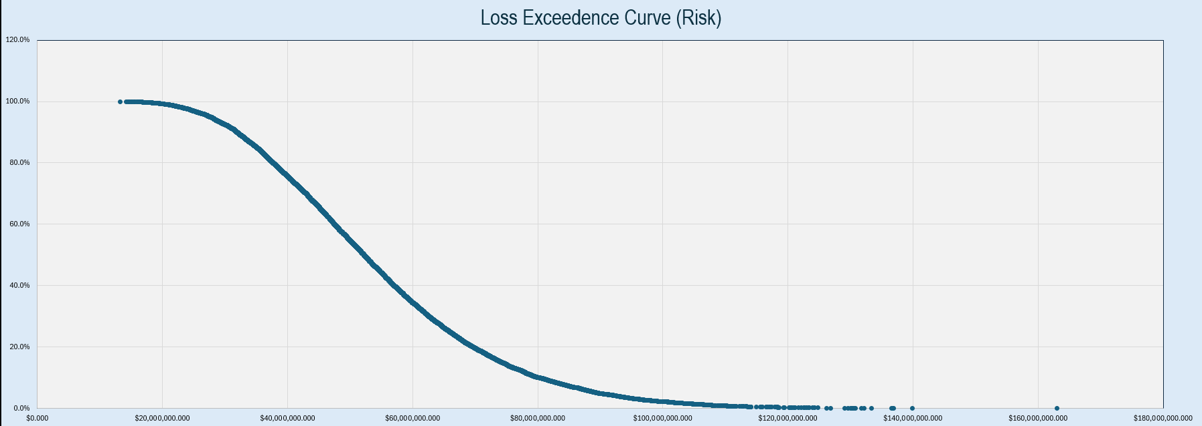
Based on the constructed Loss Exceedance Curve (LEC) for a potential insider threat scenario at Accel Entertainment, the financial impact shows a wide range of possible outcomes, with some carrying significant implications for the business. At the bare minimum there is an expected loss of $13 million if AE falls victim to an inside attack. Moving up the scale, the 10th percentile loss is $32 million, indicating there’s a 90% chance that any insider threat even would exceed this amount.
The average expected loss is 54.5 million, where AE could face substantial combined losses from productivity disruption and legal dissatisfaction. The 90th percentile sits at 80.3 million, where there’s a 10% chance that this loss could exceed this value. Lastly, the maximum projected loss is $163 million, which represents the worst scenario.
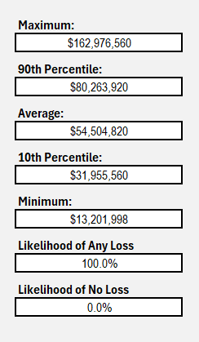
As we continue to climb further down the percentiles, the likely hood of that amounted loss substantially decreases. For example, at the average percentile its occurrence is at 50%, meaning our expected value for losses is at $22.25m dollars.
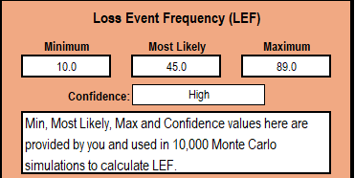
For our Loss Event Frequency numbers, we used information found on Insider Threat Statics (2025), where they state the highest number of reported cases within the relative industry is 89 for insider attackers. Starting with that number we gradually went down based on percentages to create our average and minimum.

Scenario 2 - AE Accelerator Unpatched Vulnerability
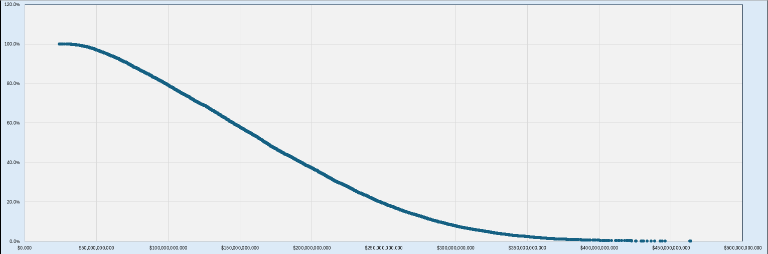
Sitting at our maximum loss, AE stands to lose $468.5m, but the expected value is much lower ($4.6m roughly). There’s a minimum loss of $23.6m due to various fines and regulations that AE will most likely have to face due to such an attack, and major lawsuits as customers seek reimbursement.
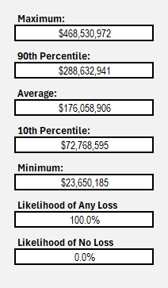
Our pre-mitigation expected value average sits around $88m, an alarming number but representative to the sensitive nature of the data AE’s Accelerator application holds. Exploits could result in astronomical fines, as the gambling/gaming industry is extremely strict.
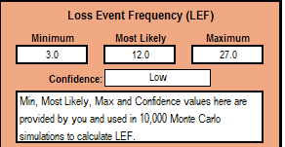
LEF numbers came from an article called Vulnerability Exploitation (2024-25), where they stated 33 attackers targeted enterprise-focused technologies like AE Accelerator application. This number was slightly adjusted to lower numerical values to account for the notoriety of AE to general populace.

Scenario 3 – Phishing Attack on CFO
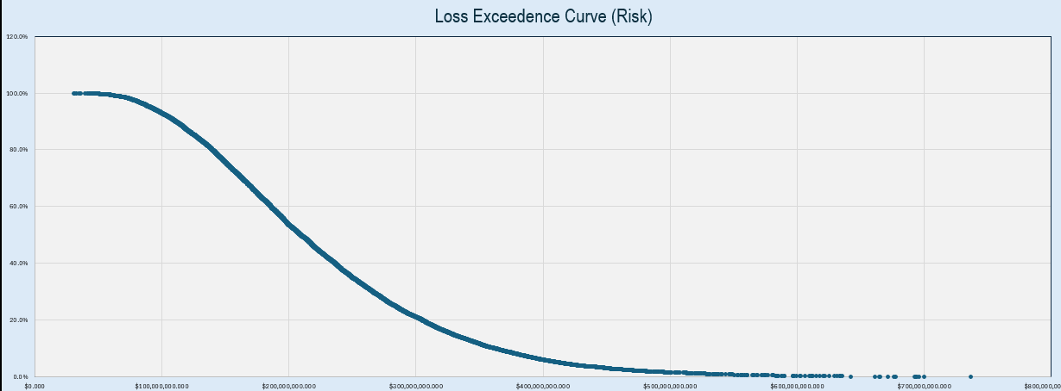
In Scenario 3, where a phishing attack successfully targeted the CFO of Accel Entertainment, the pre-mitigation LEC reveals the potential impacts. At the bare minimum if such an attack was successful AE would lose $31m, on average they would lose$ 226m, and at the maximum $736.36 million. This is proportionally higher than MGM’s losses as this event targets a high-ranking individual within AE with high privileges.

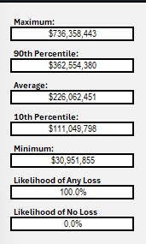
Our average expected value loss is around $113m.
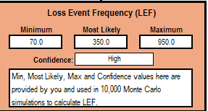
These numerical values were taken from the amount of social engineering attacks that targeted casinos within Las Vegas. The values were expanded to represent a wider area, as Las Vegas is just a small city comparatively to what AE covers in its day-to-day operations.

Post-mitigation Risk Analysis
Scenario 1 - Service Technician Inside Attack
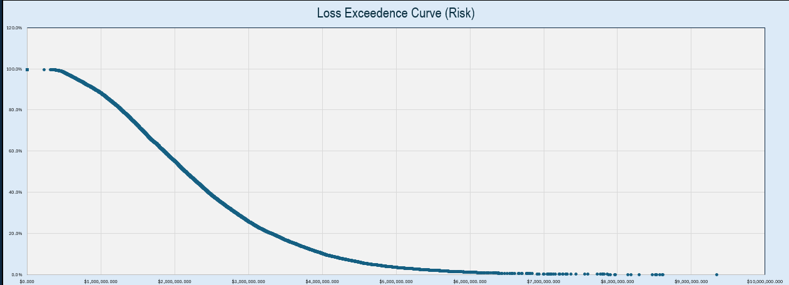
Following the implementation of security controls we can reduce the risk of insider threats. Post-mitigation analysis shows that the maximum potential secondary losses now peak at around $9.3m, representing a considerable drop from pre-mitigation levels. The average secondary loss is estimated to be around %2.3 million, with the 10th percentile falling to $922k, indicating that in most scenarios’ damages would be substantially lower due to improved incident response plans.

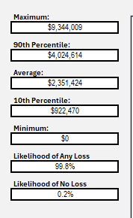
Looking at the average cost we have a 50% chance of paying $2.35million dollars, with an expected value of $1.22m dollars. This is the stark difference between our previous expected losses, indicating strong mitigative measures will reduce our monetary risk.
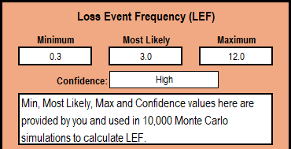
Due to mitigative efforts we were able to reduce our Loss Event Frequency (LEF) numbers to lower amounts. This is due to extreme measures of vaxing new technicians that are entering AE and also reducing the number of subcontractors that help to service equipment for AE. Overall decreasing the attack surface astronomically

Scenario 2 - AE Accelerator Unpatched Vulnerability
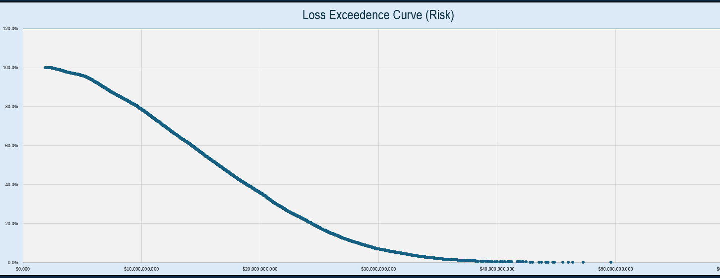
Looking at the loss exceedance curve we have a minimum loss of $1.9m, indicating a potential exploit where regulators were notified about. Majority of this cost stems from forensic and legal costs. $17.2m reflects a moderate breach where multiple stakeholders (partners/customers) were affected, resulting in moderate fines and brand damage. Lastly, we have $49.6m where the worst-case scenario happened despite our mitigative efforts.
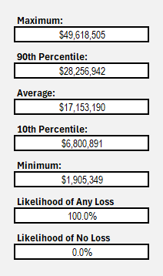
On average, we have a expected value loss of $8.55m.
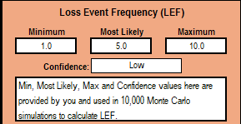
These numerical values reflect the application being patched on a consistent basis. Although this isn’t a sure way to remove all vulnerabilities, regular patches reduce the number of known vulnerabilities that hackers could exploit.

Scenario 3 – Phishing Attack on CFO
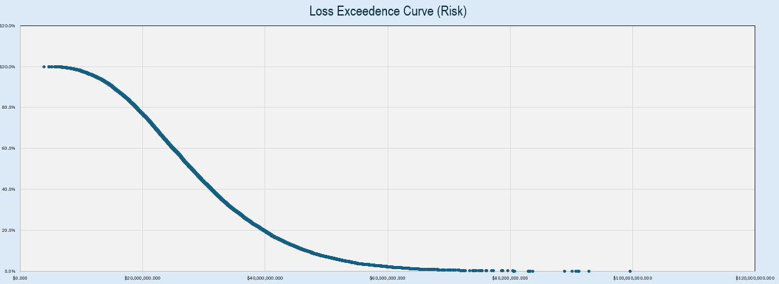
After mitigation, the estimated financial exposure shows a significant decrease in potential losses across all percentiles. The minimum expected loss is $3.9m, an almost 90% drop from the pre-mitigation evaluation. Most notably we have a maximum loss of $99.6m, which is a stark difference from $736m.
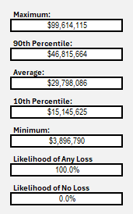
Our expected value loss hovers around $7.5m.
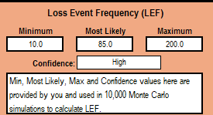
These numbers consider mitigative efforts to prevent phishing, such as cybersecurity training seminars to prevent phishing and spotting scams like emails.

VI. Recommendations
Overview
Accel Entertainment faces a range of various cyber risks, ranging from low risk to severe risk, these attacks are insider threats, application vulnerabilities, and phishing attacks targeted at high-value individuals. To effectively reduce these possible risks that have astronomical monetary detriments, a multi-layered defense strategy approach is necessary. This includes improving internal controls, patching and regular updates for application, and establishing solid cybersecurity leadership and social engineering prevention courses. They help to ensure that Accel Entertainment’s virtual and physical landscape is protected from potential threats.
Scenario 1 - Service Technician Inside Attack
- Technician Activity Logging: A centralized system that logs and monitors technicians’ actions in real time. I.e. a technician is operating on a machine that communicates back to a centralized system. The system’s previous state is saved as a copy, and the new updated version (post technician visit) is also uploaded, allowing for a centralized admin to view changes.
- Security Awareness Training: Training program that shows technicians the Dos and Donts when operating on AE’s systems. This also covers potential social engineering attempts and things to look out for while on the job.
- Background Checks: Enhance vetting procedures during hiring.

Scenario 2 - AE Accelerator Unpatched Vulnerability
- Patch Management: Establish a fixed routine to patching system (preferably every month) based on an article done by Zudu.
- Zero Trust Architecture for Apps Access: Only verified users and devices can interact with critical components.
- Quality Assurance Check-ups: Regular code review, where developers review the code of the application to ensure no bugs are present.
- Bug Bounty Programs: Allow individuals to find and report bugs on AE Accelerator, providing a monetary reward for those that do.

Scenario 3 – Phishing Attack on CFO
- Appointing a Chief Information Security Officer: Assign a leader with a strong background in cyber risk management, compliance, and security.
- Phishing Simulation Campaigns: In-house or contracted campaigns where fake phishing emails are sent to catch employees. Employees who fall for these campaigns must take cybersecurity related training.
- Multi-factor authentication (MFA) for Executives: Executives must have multiple systems in place to verify their identity.
- Distribution of Power: No one person should have complete and absolute control over AE’s infrastructure.
- Incident response Playbook: A clear escalation process in the case of a cybersecurity emergency.

Appendix A – Potential MITRE ATT&CK Vulnerability

Scenario 1 - Service Technician Inside Attack
Tactic | Technique | MITRE ID | Description
Initial Access | Hardware Additions | T1200 | Attackers use physical devices (e.g., USB or rogue hardware) on a target system.
Persistence | Valid Accounts | T1078 | Compromised or misused technician credentials provide ongoing access.
Lateral Movement | External Remote Services | T1133 | Use of VPN, RDP, or remote tools to access internal systems.
Defense Evasion | Account Manipulation | T1098 | Creation or modification of accounts or privileges for stealth.

Scenario 2 - AE Accelerator Unpatched Vulnerability
Tactic | Technique | MITRE ID | Description
Execution | Process Injection | T1055 | Code injected into a legitimate AE process.
Initial Access | Exploitation for Client Execution | T1203 | Malicious input like SQL injection.
Defense Evasion | Input Injection | T1190 | Malicious input passed into the application to bypass controls
Collection | Data from Info Repositories | T1213 | Extracts partner data or analytics from AE accelerator
Exfiltration | Exfiltration Over Web Service | T1567.992 | Stolen data transmitted through AE app.

Scenario 3 – Phishing Attack on CFO
Tactic | Technique | MITRE ID | Description
Initial Access | Phishing | T1566 | Target CFO email
Defense Evasion | Email Spoofing | T1585 | Fake internal domain email address
Credential Access | Credential Phishing | T1566 | Harvest CFO login credentials through fake website application
Persistence | Account Manipulation | T1098 | Admin account altered for continually persistence within the system

Appendix B - Citations
Accel Entertainment . (2022, December 31). Accel Entertainment, Inc. Acel-20221231. https://www.sec.gov/Archives/edgar/data/1698991/000169899123000010/acel-20221231.htm
Bonach, E. (2025, May 5). Accel Entertainment Reports Record First Quarter Revenue and Strong Operating Results. Accel Entertainment. https://ir.accelentertainment.com/news/news-details/2025/Accel-Entertainment-Reports-Record-First-Quarter-Revenue-and-Strong-Operating-Results/default.aspx
Buchan, J. (2024, December 2). How often should you update your app?. Zudu. https://zudu.co.uk/blog/how-often-should-you-update-your-app/#:~:text=While%20there’s%20no%20one%2Dsize,and%20small%20UI%2FUX%20improvements.
DCFMODELING. (n.d.). Accel Entertainment, Inc. (ACEL): History, ownership, Mission, How It Works & Makes Money. DCF, SWOT, CANVAS, PESTEL, BCG Editable Templates. https://dcfmodeling.com/blogs/history/acel-history-mission-ownership#:~:text=Year%20established,(VGT)%20market%20in%20Illinois.
Enzoic. (2024, August 28). Insights from IBM’s 2024 cost of a data breach report. Enzoic. https://www.enzoic.com/blog/ibms-2024-cost-of-a-data-breach/#:~:text=The%20cost%20of%20a%20data,during%20and%20after%20a%20breach.
Kenwith. (2025, March 12). Secure applications with Zero trust. Microsoft Learn. https://learn.microsoft.com/en-us/security/zero-trust/deploy/applications
Macrotrends. (n.d.). Accel entertainment number of employees 2018-2024: Acel. Macrotrends. https://www.macrotrends.net/stocks/charts/ACEL/accel-entertainment/number-of-employees
Nelson, N. (2025, April 29). Vulnerability exploitation is shifting in 2024-25. Dark Reading. https://www.darkreading.com/vulnerabilities-threats/vulnerability-exploitation-shifting-2024-25
Shodan. (n.d.). 52.101.11.15. Shodan. https://www.shodan.io/host/52.101.11.15
Smith, G. (2024, December 10). Insider threat statistics: (2025’s most shocking trends). StationX. https://www.stationx.net/insider-threat-statistics/
Syteca. (2024, February 19). Insider threats exposed: Financial Consequences & Legal Case Studies. LinkedIn. https://www.linkedin.com/pulse/insider-threats-exposed-financial-consequences-legal-case-vn4gf/

