**Routines/Modules needed for CFW**

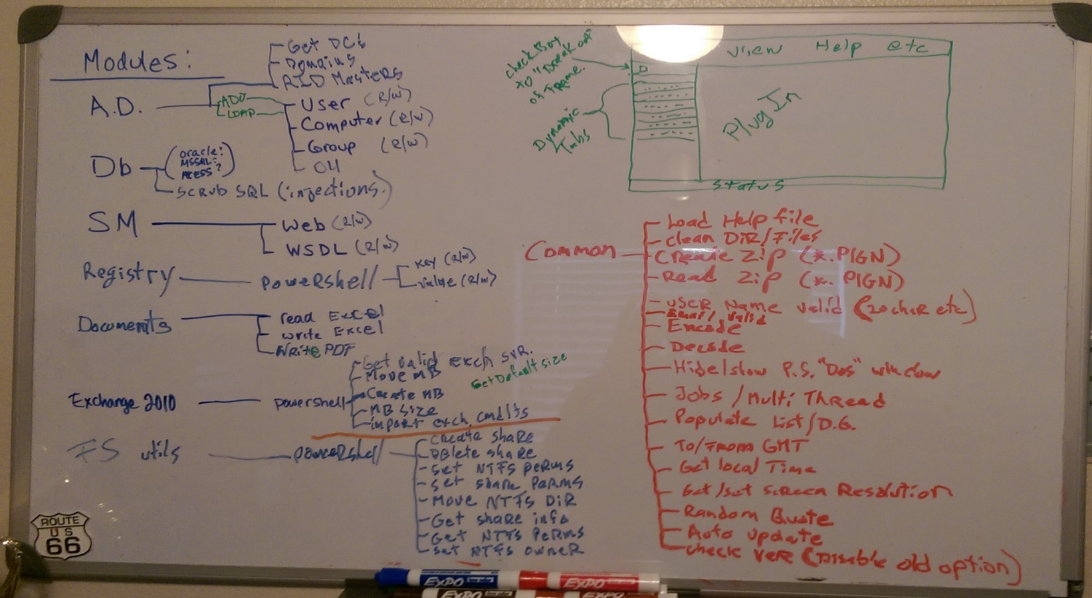

1. Common
   1. Load Help File
   2. Clean Dir/Files
   3. Create Zip (*.plgN)
      1. In Documents.ps1
   4. Read zip (*.plgN)
   5. VerifyUserName (20 char, etc)
   6. VerifyEmail
   7. Encode
   8. Decode
   9. Hide/Show PS “Dos” Window
      1. In Display.ps1
   10. Jobs / Multi Threading
       1. In Jobs.ps1
   11. Populate List/DataGrid
   12. To/From GMT/UTC
   13. GetLocalTime
   14. Get/Set Screen Resolution
   15. Random Quote/Word
   16. AutoUpdate
   17. CheckVer (Disable Old Option)
2. Active Directory
   1. Get DCs
   2. GetDomains
   3. GetRIDMaster
   4. ADO
      1. Check if exist (User/Computer/Group/OU)
      2. R/W User
      3. R/W Computer
      4. R/W Group
      5. OU
   5. LDAP
      1. Check if exist (User/Computer/Group/OU)
      2. R/W User
      3. R/W Computer
      4. R/W Group
      5. OU
3. DataBase
   1. Scrub SQL (injections)
   2. Oracle
   3. MSSQL
   4. MSAccess
4. Service Manager
   1. R/W Web
   2. R/W WSDL
5. Registry
   1. R/W Key
   2. R/W Value
6. Documents
   1. Read Excel
   2. Write/Create Excel
   3. Write/Create PDF
   4. ?Word?
7. Exchange
   1. 2010
      1. Get Valid Exch Svr
      2. Move MB
      3. Create MB
      4. Get MB Size
      5. Get Default Size
      6. Import Exch cmdlets
   2. 2003
      1. Create MB
      2. Move MB
      3. Get MB Size
8. FileOperations.ps1
   1. PowerShell
      1. Create Share
      2. Delete Share
      3. Get Share Info
      4. Set Share Perms
      5. Set NTFS Perms
      6. Move NTFS Dir
      7. Get NTFS Perms
      8. Set NTFS Owner
   2. Remote into System