Analyzing and Comparing Different Data Driven Methods for Hydrological Forecasting

Self Study Report

Henry Hughes

4A Civil Engineering

May 2023

534 Crimson Court

Oshawa ON L1J 8E2

May 16, 2023

Dr. Brush

Associate Chair, Undergraduate Studies

Department of Civil and Environmental Engineering

University of Waterloo

Waterloo, ON, N2L 3G1

Dear Dr. Brush:

This report, entitled " Analyzing and Comparing Different Data Driven Methods for Hydrological Forecasting" was prepared as my 3A work term report. The purpose of this report is to gain additional understanding into how levels of hydrological discharge can be forecasted by using data driven methods, rather than physical methods, which, throughout history, are much more common.

This self-study report was prepared during my Co-op at Walter P Moore. While the report is a sole self-study, I would like to thank Professor John Quilty for allowing me to work with his team, which does similar research into how machine learning can help quantify uncertainty in hydrological forecasting.

This report focuses on the numerical methods that are multiple linear regression, and extreme learning machines. While not being the most complicated mathematical tools that can be utilized for this type of analysis, these methods are not too challenging to apply, and allow for standard datasets to be used without much difficulty.

This report was written entirely by me and has not received any previous academic credit at this or any other academic institution. I received no outside help with the report.

Sincerely,

Henry Hughes  
ID# 20792437

Analyzing and Comparing Different Data Driven Methods for Hydrological Forecasting

Self Study Report

Henry Hughes

4A Civil Engineering

May 2023

# Summary

The aim of the Summary is to convey the main points of a report to senior management personnel who are not usually involved in technical details. For this reason, it is sometimes labeled Executive Summary. It should be written last and must be written in full sentence form while avoiding too much jargon or heavy details. The Summary may be thought of as a mini report of about 250 words (3-4 paragraphs) that must be able to be read and understood in isolation from the main body of the report. It must not exceed one page and should include the scope and purpose of the report (including background/rationale); the technical approach taken, which might include a discussion of the alternatives considered and the major technical findings; and the principal conclusions and recommendations. It must not include tables and figures or a direct reference to tables, figures, and sections contained in the main report.

# Acknowledgements

I wish to thank Professor John Quilty for allowing me to be a part of his research team, which has inspired me to write about this topic.

# **Table of Contents**

Summary ii

Acknowledgements iii

Table of Contents iv

List of Tables v

List of Figures v

List of Appendices v

1.0 Introduction 1

1.1. General 1

1.2. Background 1

1.3. Scope and Objectives 1

2.0 Literature Review 2

2.1. What is a Literature Review 2

2.2. How to Conduct a Literature Review 2

3.0 Application Problem 4

4.0 Self Study Requirements 4

4.1. Length of Self Study Reports 4

4.2. Structure 5

4.3. Formatting and Styling 6

4.3.1. Font and Spacing 6

4.3.2. Margins and Page Numbers 6

4.3.3. Units (SI) 7

4.3.4. Figures 7

4.3.5. Tables 10

4.3.6. Equations 11

4.3.7. Software and Spellcheck 12

4.4. Citations and References 12

4.4.1. Journal Papers 13

4.4.2. Books 13

4.4.3. Technical Reports 14

4.4.4. Electronic Sources 14

4.4.5. Referencing for Figures and Tables 15

5.0 Additional Resources 17

6.0 Conclusions 17

7.0 Summary and Recommendations for Future Studies 18

References 19

# List of Tables

**Table 1:** Sample Table 11

# 

# List of Figures

[**Figure 1:** Sample summary page 8](https://d.docs.live.net/f862fc93b3e30293/Documents/WKRPT-Self_Study_Template-Draft_5.docx#_Toc69464568)

[**Figure 2:** Sample of a Table of Contents with more than three appendices and lengthy lists of tables and figures 9](https://d.docs.live.net/f862fc93b3e30293/Documents/WKRPT-Self_Study_Template-Draft_5.docx#_Toc69464569)

[**Figure 3:** Example of a table included in a work report. It should be noted that the table is presented immediately after it is first introduced in the text. 10](https://d.docs.live.net/f862fc93b3e30293/Documents/WKRPT-Self_Study_Template-Draft_5.docx#_Toc69464570)

[**Figure 4:** Example of an equation layout in a work report 11](https://d.docs.live.net/f862fc93b3e30293/Documents/WKRPT-Self_Study_Template-Draft_5.docx#_Toc69464571)

**Figure 5:** Example of a citation for a figure and data taken from a published source 16

[**Figure 6:** Example of a citation for a table taken from a published source 16](https://d.docs.live.net/f862fc93b3e30293/Documents/WKRPT-Self_Study_Template-Draft_5.docx#_Toc69464573)

# 

# List of Appendices

**Appendix A:** Explanation of Symbols Used for Marking Work Report Grammar. 20

**Appendix B:** Avoiding Common Grammar Errors 21

**Appendix C:** Proofreading Checklist 22

**Appendix D:** Writing Tips 23

**Appendix E:** Literature Review Samples 24

Please note that these sections are only required if you are including many (greater than 10) figures, or tables.

# Introduction

## General

The background, purpose, and scope of the report are outlined in this section. When writing your report, you do not have to follow the exact structure (sections) provided in this template. The intention of this document entitled “Self-Study Guidelines and Template” is to illustrate what is required in the report, as well as formatting recommendations. Your report meet the length requirements set within this document and organized in a way that makes sense for the information you are presenting.

## Background

This section, the Background, provides necessary information for readers to know prior to being introduced to the scope and objectives. The first component of the main section must be the Introduction. The purpose of the Introduction is to provide background and rationale for the report andestablish the general scope, significance, and context of the problem addressed by the report. The Introduction should conclude with a brief statement that conveys information about the contents of the body of the report. Avoid providing excessive detail and convey only what is needed to understand the problem and the solutions.

## Scope and Objectives

In this section, you should specify what is the scope and breadth of engineering analysis and/or design conducted in the self-study report. The Scope and Objectives’ section should include the overall theme of the literature review as well as the problem application section. For example, “*The topic of XYZ and its effect on ABC was reviewed and the knowledge acquired was used to analyze/design and solve problem A.*” Note that when you are introducing the scope and overall them that it does not need to be formatted in italics, as in the previous sentence, nor should it only be limited to a single sentence. Your scope will typically vary between five to ten lines.

# Literature Review

## What is a Literature Review

A literature review is a commentary on the state-of-the-art of a particular field or topic. It should provide an overview of 1) the questions being asked in the field by the industry and researchers, 2) what has been observed and reported, and by whom, 3) the prevailing theories and hypotheses, and 4) identify appropriate and useful methods and methodologies for your topic. However, it is not just a list of references or direct quotes. You must paraphrase. Identify and comment on the key themes and trends, compare and contrast findings, and assess where the weaknesses and knowledge gaps are. A literature review can be organized chronologically, thematically, or methodologically. The literature review must include a minimum of 10 credible sources, and must be at least 1,500 words.

## How to Conduct a Literature Review

The first step is to define the focus for your literature review. Narrowing down the scope of your topic to a specific idea, concept, or problem can be a difficult process but it is crucial. In the end, you should be able to clearly describe your topic using five to ten key words. This will not only help your search for relevant materials, but it will also help in defining the application problem later on.

The second step is to search for relevant materials. A minimum of ten credible sources should be cited. The word “credible” is stressed because not all references are equal. Books, peer reviewed journal articles and conference papers, historical records, reports, statistical information, theses, and dissertations can all provide verifiable information that add authority to your report whereas information from personal sources or some online sources such as blogs and forums may be subjective or irrelevant.

The following is not an exhaustive list but research papers in journals from the following publishers are generally reliable: the [American Society of Civil Engineers](https://ascelibrary.org/journals) (ASCE), [Elsevier](https://www.elsevier.com/catalog?producttype=journals), [NRC Research Press](https://uofwaterloo-my.sharepoint.com/personal/dlacroix_uwaterloo_ca/Documents/Work%20Reports%20-%20CEE%20UW/CEE%20WKRPT/Work%20Report%20Guidelines/Self-Study/NRC%20Research%20Press), and [Taylor and Francis](https://uofwaterloo-my.sharepoint.com/personal/dlacroix_uwaterloo_ca/Documents/Work%20Reports%20-%20CEE%20UW/CEE%20WKRPT/Work%20Report%20Guidelines/Self-Study/Taylor%20and%20Francis). Here is a [list](https://beallslist.net/standalone-journals/) of predatory journals which have questionable peer review processes, and hence, should be avoided. Please refer to the [UW Library Website](https://lib.uwaterloo.ca/web/index.php) for tips on finding resources and helpful guidance on conducting research.

Once you have found some potentially relevant materials, you must critically evaluate them. Consider factors such as:

* Author credentials – are they an expert in the field? Are they affiliated with a reputable organization?
* Is the publication current or has the knowledge moved on?
* For journal articles, is it peer reviewed?
* Who is the intended audience?
* Does it cite relevant literature?
* Is it an objective fact-based viewpoint?
* Is it logically organized and clear to follow?
* Will the particular study inform your problem application?

Finally, synthesise the information that you have collected. The literature review should provide the background information and knowledge needed to understand and help solve the problem in the application section.

# Application Problem

Since work term reports are required to be technical documents focusing on the solution of an engineering analysis and/or design problem, you are required to apply the knowledge gained from the literature review to a real or hypothetical problem as defined in your scope. The application problem must be closely related to the main topic and sufficiently constrained so that only the knowledge acquired from the literature review and your existing knowledge is needed to develop a solution. This section should provide a detailed technical description of the problem and demonstrate mastery of the chosen topic through a clearly structured solution approach, and a discussion on how the solution compares to existing work in the literature.

Some ideas for the application problem include resolving a problem considered in the references in the literature review using a different methodology, extending an existing analysis or design, or conducting your own analysis or design using case studies or open data. The following open databases can be excellent resources: [Open Canada](https://open.canada.ca/en/open-data), [Registry of Open Data on AWS](https://registry.opendata.aws/), [Harvard Dataverse](https://dataverse.harvard.edu/), and [DataCenterHub](https://datacenterhub.org/). Forging or making up data is not permitted under any scenario. In any case, the solution process must incorporate the knowledge you gained from the literature review. The technical content of the application component is assessed similarly to traditional technical work reports.

# Self Study Requirements

## Length of Self Study Reports

The text of the main section of work term reports, from the beginning of the Introduction to the Conclusions, should be within the range of 3000 to 5000 words, excluding tables and figures. Reports that are shorter or longer than this size may be rejected. For Self-Study work reports, the literature review must be at least 1500 words.

## Structure

Self study report should be organized in the following sequence.

Front cover – no page number

Letter of Submittal – no page number

Title Page – considered to bei, but not indicated

Summary (or Executive Summary) – page ii

Acknowledgments (optional) – page iii, if included

Table of Contents – page iii or iv, depending on whether acknowledgements are included

List of Tables – page iv or v, depending on the length of the list and whether acknowledgments are included

List of Figures – page iv or v, depending on the length of the list and whether acknowledgments are included

List of Appendices (if appropriate) – page iv or v, depending on the length of the list and whether acknowledgments are included

Introduction - page 1

Background

Scope

Literature review

Application

Problem statement

Analysis/Design

Conclusions

Recommendations (optional)

References

Glossary (optional)

Appendices (optional)

## Formatting and Styling

Tables and Figures should be numbered consecutively throughout the report (1, 2, 3, 4, etc.). Headings or captions for tables are placed above the table while those for figures are placed below the figure. Additionally, make sure that you are introducing the figure or graph using a sentence or two before the actual graph.

### Font and Spacing

Reports should be typed using double (2X) line spacing, using 12-point Times New Roman. Bold type font should not be used to emphasize words within the text, although bold headings are acceptable.

Except for the Summary, Table of Contents, Lists of Tables and Figures, References, and Acknowledgements, you should not start each section on a new page. That is, beginning with the Introduction, each section should follow immediately after the previous one. Large blank spaces should not be left between sections of the main body. However, if the text is block formatted with no indentation of the first lines of the paragraphs, as these guidelines are, an extra space should be inserted between paragraphs.

### Margins and Page Numbers

A minimum width of 25 mm should be used for the top, bottom, and right margins. All text should be aligned with the left margin and justified, except for indented quotes.

Pages must be numbered. The numbers are to be located at the bottom of the page and can be placed in the middle of the page or in the right-hand corner. The numbering must be consistent throughout the report. Pages for the introductory sections of a report should be numbered using lower-case Roman numerals. The first page to be numbered with an Arabic numeral is the first page of the Introduction section.

### Units (SI)

The International System (SI) of units should be used throughout the report. If the British (or Imperial) system of units is used during the work term, then SI equivalents must be quoted in parentheses immediately following the Imperial units.

### Figures

The current section serves two purposes: 1) to demonstrate how a figure should be referenced, and 2) to demonstrate the expected, or similar, formatting of key components comprising the report. Figure 1 shows a representative Summary with its key elements.

Figure 2 shows a representative table of content with all of its key elements. Note that separate list of tables, figures, and appendices are required. 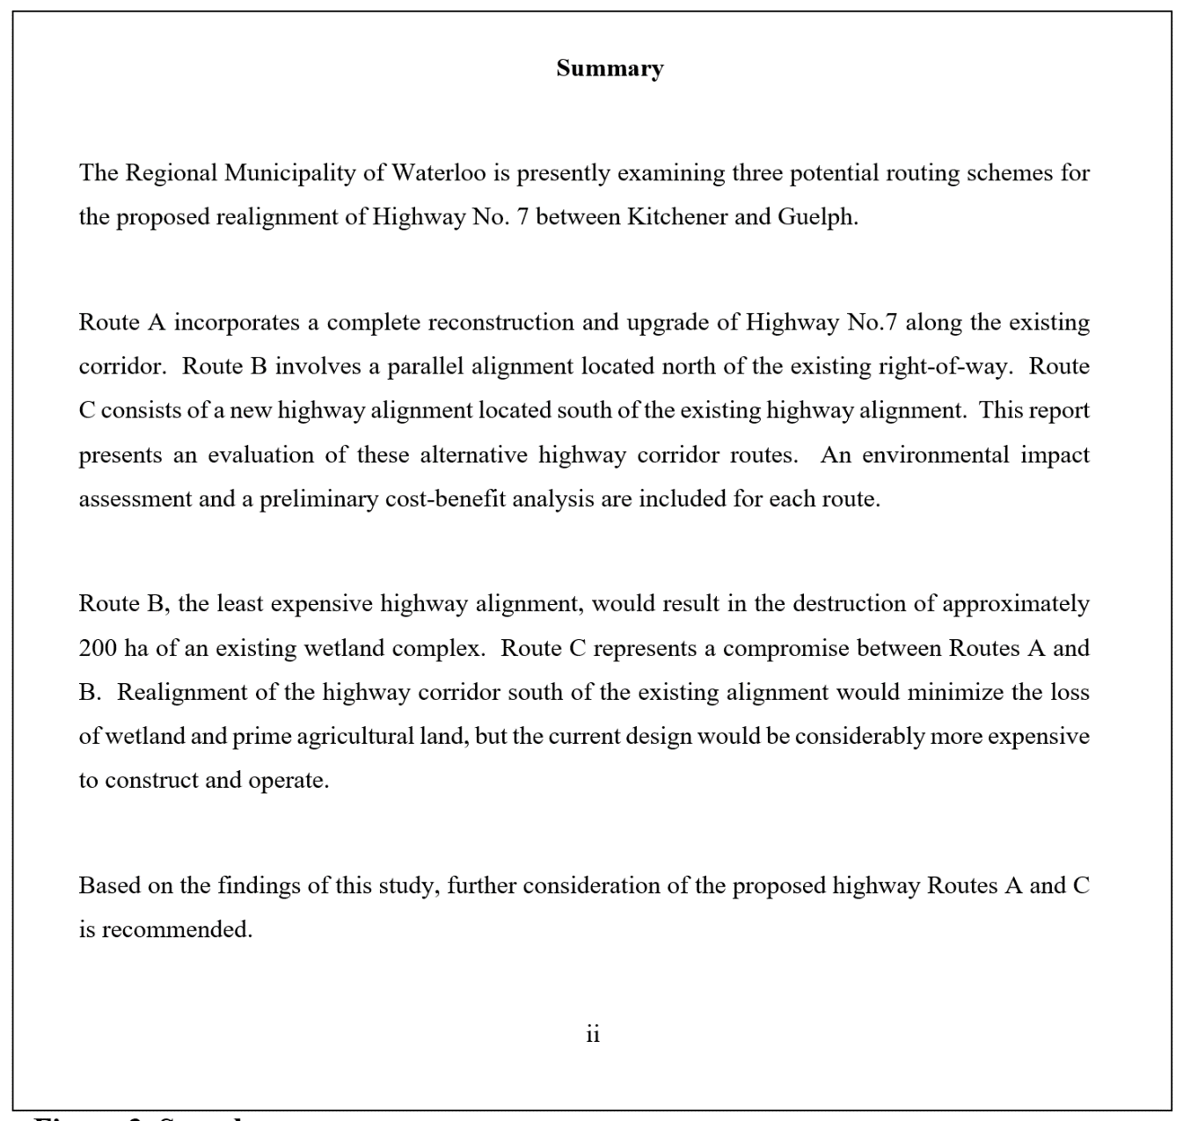

**Figure 1:** Sample summary page

**Figure 2:** Sample of a Table of Contents with more than three appendices and lengthy lists of tables and figures

When presenting tables, or figures, it is always required to first introduce the table by providing a short description of what it presents while also referencing it. Figure 3 shows a screen capture of how tables should be introduced and formatted. Note that tables should never be presented as figures (e.g., Fig. 3), even if reproduced from another report, and is only presented in the current form to illustrate formatting expectations.

**Figure 3:** Example of a table included in a work report. It should be noted that the table is presented immediately after it is first introduced in the text.

### Tables

Table 1 is an example of a possible table that you might include in your report. Note that this table is for illustration purposes only. Table 1 is a decision matrix, not all successful reports require a decision matrix. Do not generate alternatives for the sake of generating alternatives. Furthermore, note how Table 1 was reproduced into a table and properly referenced.

**Table 1**: Sample Table

|  |  |  |  |  |  |
| --- | --- | --- | --- | --- | --- |
| Proposed Alternative | All Design Objectives Achieved | Suitable for Site | Impacts on Environment | Cost Effectiveness | Recommended for Conceptual Design |
| No Action | No |  |  |  | No |
| Replacement in Kind | No |  |  |  | No |
| Multiple Culverts | No |  |  |  | No |
| Bottomless Culverts | Yes | Moderate | Moderate | Moderate | Yes |
| Embedded Culverts | Yes | High | Low | Moderate | Yes |
| *Reproduced from “Mckillop 2020” | | | | | |

### Equations

Equations that are referred to later in the text should be numbered with right-justified Arabic numerals in parentheses. Number equations consecutively throughout the report (1, 2, 3, 4, etc.). Figure 4 illustrates the typical placement of an equation within a report. If the equation is referred to after it has been introduced, refer to it using the same notation used for figures and tables (e.g. “Equation 1”). Text, letter

**Figure 4:** Example of an equation layout in a work report

### Software and Spellcheck

Work term reports should be prepared on computer software that is accessible to the author during an academic term so that corrections may be readily undertaken. The use of an electronic spell-checker is expected. Note, however, that the Canadian version is expected if it differs from the U.S. version.

## Citations and References

Citations and references are meant to give authority to the contents of the report and to direct the reader to more details. General references not cited in the report should not be included in the reference list.

An important principle in citing published literature is that an individual reading a report should readily be able to obtain the reference materials. As much as possible, avoid citing obscure papers, course notes and personal communications, for example, as these may not be accessible to a reader of a report. You can give credit to these sources of information in your letter of submittal or the acknowledgments.

There are several alternative styles of documentation. This work report follows the American Psychological Association (APA) style, which is summarized in both Hacker (1996) and Buckley (2003). These books also include discussions of citations and references. These books are available in the University of Waterloo Bookstore or the library. Other references are available in section PE 1408 of the Dana Porter Library.

The following report excerpts (in italics) demonstrate common examples that show how references to literature should be cited in the text and incorporated in the reference list.

### Journal Papers

*Lafontaine (1988) has measured wind loads on very tall exhaust stacks in the mining areas of the Sudbury region.*

or

*Several authors have measured wind loads on tall exhaust stacks in the mining areas of the Sudbury region (Lafontaine, 1988; Yung, 1982), and these measurements have been used to establish design wind loads.*

The reference list would then contain the following:

Lafontaine, P.W. (1988). Wind load measurements on smelter exhaust stack in the Sudbury region. *Journal of Wind Engineering*, 17(5), 171–183.

Yung, F. S. (1982). Drag coefficients for large structures. *Journal of Structural Engineering*, 21(3), 99-103.

Italics are used to emphasize the document title used in a library search because authors of individual papers published in journals are not listed in library catalogues.

### Books

*McCarthy (1988) describes the analytical method that is most commonly used for slope stability analysis of the marine clays in the St. Lawrence Valley.*

The reference list would then contain the following:

McCarthy, D.F. (1988). *Essentials of Soil Mechanics and Foundations: Basic Geotechnics*. Prentice Hall, Englewood Cliffs, NJ.

### Technical Reports

*Geometric design standards for major arterial roads are specified by the Ontario Ministry of Transportation (Highway Design Branch, 1992).*

The reference list would then contain the following:

Highway Design Branch. (1992). *Geometric Design Standards for Ontario*. Ministry of Transportation of Ontario, Downsview, ON.

### Electronic Sources

Electronic sources are relatively new, and many suggestions for methods of referencing them are available. The department has selected the following guidelines. The important consideration is that the reader needs to be able to access your sources. Items are to be cited in the text with the author and date as usual. For example,

*Nutall (1999) has published a different opinion of MP3.*

This item would appear in the list of references as follows:

Nutall, C. (25 September 1999). It's on MP3 but I like it. http://news.bbc.co.uk/hi/english/sci/tech/newsid_443000/443086.stm (retrieved 9April 2000).

The objective of referencing is to direct the reader to the original source. The URL and the search engine with key words are used to locate the new reference. If the author is not identified, use the name of the company or organization that posted the web site. Use the date last updated as the date of publication. If there is no date listed, use the date you accessed the site. The date of access is important to include in any case because the web page may have changed since you used it, and the reader may not be able to find the information without knowing the date.

### Referencing for Figures and Tables

All data, figures, diagrams, photographs and tables that are not your own must be cited. Even figures, diagrams and tables that you modify or adapt from another source must be cited accordingly. Failure to properly cite material that is not your own may result in a violation of academic integrity for plagiarism.

The reference or citation for the figure, photograph or table should be placed within the figure or table caption. Examples are shown in Figure 5 and Figure 6. The references cited in your figure/table captions must be included in your list of references and should formatted in the same manner as described in Sections 7.1 through 7.4 depending on the reference type.

It should be noted that formal publication of your work, for example in a book, journal paper or conference proceedings, may also require you to obtain copyright permission from the original publisher or author of the source material, even when that material is properly cited. Guidelines for copyright requirements will be specified by the book, journal or conference publisher.

**Figure 5:** Example of a citation for a figure and data taken from a published source

**Figure 6:** Example of a citation for a table taken from a published source

# Additional Resources

To aid in your writing many additional resources have been prepared. Please use these documents available on Piazza, and Learn, to avoid common mistakes and improve your communication to achieve the best possible mark.

**Appendix A** contains an explanation of symbols that may be used when marking grammar. This document goes over many grammar mistakes that are made when writing a report. Additionally, it showcases incorrect and than the corrected mistakes.

**Appendix B**, common grammar mistakes. This document goes over many different grammar mistakes and provides several strategies on how to avoid these mistakes. There is also more advice for proper punctuation, word choice, and correcting awkward sentences.

**Appendix C**, proof reading checklist. This document contains a list of 15 things that are simple to check to help with your grammar. This checklist is recommended to be apart of your proofreading.

**Appendix D**, writing tips. Contains several tips, including which tense to use, and formatting. Contains more information on referencing, tables, figure and letter of submittal.

**Appendix E**, sample literature review. Appendix E contains two sample literature reviews, they are to serve as a reference as to what a literature review of the ten credible sources be. While they may not follow the guidelines recommended in this document, please use them to help form your understanding of literature reviews.

# Conclusions

Conclude the report with a short summary of the current state-of-the-art on the topic, conclusions from your application problem, and provide recommendations for future study based on questions or issues that remain and any flaws that exist in the literature.

The conclusions should only contain statements that follow logically from the content of the report. The aim is to reinforce the findings of the report. New information should not be presented in the conclusions section, and it should not refer directly to components of the main body of the report, nor contain tables, figures, or references. For example, "The temperature effects, analyzed on page 6 showed that ......." is unacceptable. Bulleted or numbered lists should be avoided.

# Summary and Recommendations for Future Studies

The Recommendations contain statements about additional work that might be required. For example, "Insufficient data were available for this study to establish conclusively the temperature effects, and a sequence of laboratory strength tests is recommended." Conclusions are required for your Work Report; however, the recommendations are not always necessary. Conclusions and Recommendations can be combined into one section.

# References

Andrews, G.C. and Ratz, H.C. (1996).  *Introduction to Professional Engineering* (5th ed.). University of Waterloo, Waterloo, ON.

Buckley, J. (2003). *Checkmate: A Writing Reference for Canadians*. Nelson Canada, Scarborough, ON.

Mckillop, B. (2020, December). *ENVE 100* *Alternative design solutions.* [PowerPoint slides]

Trotter, B. (2020). *Guidelines for Writing Work Term Reports.* (Version 3.4). University of Waterloo, Waterloo, ON.

(2020). *Guidelines for Writing a Self Study Work Term Report.* University of Waterloo, Waterloo, ON.

**Appendix A:** Explanation of Symbols Used for Marking Work Report Grammar

Please see separate document on Learn/Piazza.

Appendix B: Avoiding Common Grammar Errors

Please see separate document on Learn/Piazza.

Appendix C: Proofreading Checklist

Please see separate document on Learn/Piazza.

Appendix D: Writing Tips

Please see separate document on Learn/Piazza.

Appendix E: Literature Review Samples

Please see separate document on Learn/Piazza.