ES218 Project – Peer review

Make sure to read the following guidelines before proceeding:

* You will clone the author’s repo to your local folder. Then you will create a new branch to that repo called *feedback_<your name>* where you will add/commit two Word documents (outlined later in these instructions).
* You as the reviewer will need to check that all the packages used in the project’s script are installed on your computer. You will know if a package is missing from your computer if the RMD file fails to knit (the error message should be self-explanatory).
* Inline feedback will be done in a Word knitted version of the Rmd file. You can knit to Word using   
  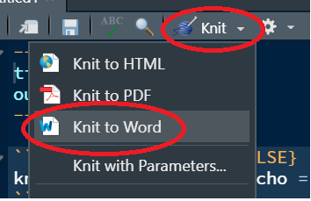  
  Note that feedback pertaining to figure size and layout should be based off of the HTML knitted output and not the Word knitted output
* When completed, commit this Word document and the knitted Word file (with feedback) to the author’s github repo.

1. Author whose project you are evaluating:

Henry Toumlin

1. Evaluate each criterion on a score from 1 to 5 (5 being best):

|  |  |  |
| --- | --- | --- |
| Criterion | Description | Score  ( 1 to 5 ) |
| Complexity of analysis | * Was the analysis thorough? * Did the nature of the analysis involve complex coding procedures? * Did the author go above and beyond what was expected?  (note that a score of 5 should be assigned judiciously) | 4.5 |
| Reproducibility | * Was the “knitting” of the Rmd file error free? **(if the knitting process produces an error, 3 points should be automatically deducted)** * Were all warnings and messages suppressed from the output? | 5 |
| Presentation  &  Code quality | * Was the document carefully constructed with properly sized figures? * Were the code chunks clear and properly commented? * Were all loaded packages used as intended by the author? | 4.5 |
| Discussion | * Did the author clearly layout a narrative? * Were the figures and analyses appropriate for what the author was trying to convey? | 5 |

1. Provide thoughtful and constructive feedback.
   1. *Presentation – The only thing I would recommend for this is to move plots ahead of text and center the title and other bits of information.*