DATA605 Discussion 13

Henry Otuadinma

21/11/2019

#### Find the total area enclosed by the functions f and g:

$f(x)=2x^{2}+5x−31$, $ g(x) = x^2 + 4x - 1$

Solution

##### using R to put up functions f and g for the computations:

f <- function(x) {2*x^2+5*x-3}  
g <- function(x) {x^2+4*x-1}

curve(f, -3, 3)  
curve(g, -3, 3, add=TRUE)

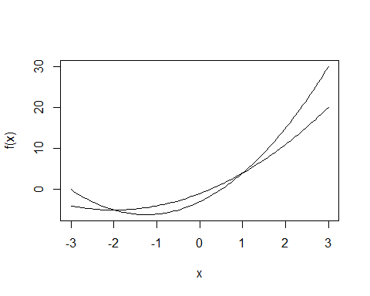

##### Looking for the value where the point of intersection falls below 0:

(rootF <- uniroot(function(x) f(x) - g(x) , c(-5000,-0.01), tol=1e-8))

## $root  
## [1] -2  
##   
## $f.root  
## [1] 1.776357e-15  
##   
## $iter  
## [1] 29  
##   
## $init.it  
## [1] NA  
##   
## $estim.prec  
## [1] 8.680272e-09

##### What is the root of the function:

rootF$root

## [1] -2

##### Looking for the value where the point of intersection is above 0:

(root0 <- uniroot(function(x) f(x) - g(x) , c(0.0001, 5000), tol=1e-8))

## $root  
## [1] 1  
##   
## $f.root  
## [1] 2.112702e-09  
##   
## $iter  
## [1] 29  
##   
## $init.it  
## [1] NA  
##   
## $estim.prec  
## [1] 5.000001e-09

##### What is the root of the function:

root0$root

## [1] 1

#### Therefore, the area between the curves will be g minus f at x(-2, 1)

##### integrating for g

(areaG <- integrate(g, lower = -2, upper = 1))

## -6 with absolute error < 9.9e-14

##### integrating for f

(areaF <- integrate(f, lower = -2, upper = 1))

## -10.5 with absolute error < 1.4e-13

##### compute difference between g_area and f_area

areaG$value - areaF$value

## [1] 4.5