CS105 Exam 1 Name: __________________________

Circle the number of the 12 problems you want me to grade.
If you circle 13 or more, or you don't circle any, I will choose the worst 12.
If a question is unclear, please ask.

Bits to Words, Languages and Operating Systems

1. How many different numbers can 3 bits represent? ______

2. Fill in the blanks (2). 1 ASCII character = __ hex digits = __ bits

3. List 3 things that operating systems do. ___________________
___________________
___________________
4. Fill in the blanks (2).
_________ Language | _________ Language
Needs to be converted into machine code to run  Translation is done all at once | Needs to use a special program to run  Translation is done line by line

5. Fill in the blanks (2).
_________ Language | _________ Language
Machine readable  Can be run by a machine  Processor specific | Human readable  Can be programmed by people  Processor specific

Programming and Code

6. List three primitive data types. ________________
________________
________________

7. What must an expression do? _______________________________________

8. What does a statement do? _______________________________________

9. A function definition must define what two things? __________________
__________________

10. What are arrays for (in general)? _______________________________________

Algorithms

11. When analyzing algorithms, what quantity does n measure?
________________________________________

12. When analyzing algorithms, what quantity does O(n), O(logn), or any big-O function measure?
_________________________________________

13. Why is binary search slower than linear search when we just want to search an unsorted array once?
___________________________________________________________________

14. Traverse the following tree using depth-first search.
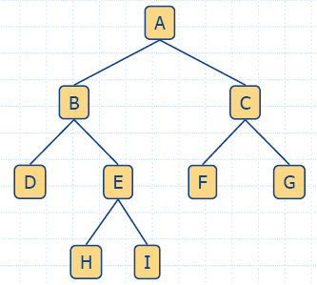

Nodes visited: ____A, B,_____________________

15. Describe the brute force search algorithm.
_______________________________________________________________________

Extra Credit

You will not lose points for attempting these questions. Each is worth half a problem in the main exam.

1. Why do computer scientists write, study, and compare algorithms on a problem like searching, when given an array, we can visually and easily determine whether it contains some item?

2. Describe a realistic example in which you would use a graph search or graph traversal (BFS, DFS, or Dijkstra). State what are the nodes, edges, edge weights, the starting point, end point, and the overall goal. Do NOT use the looking-for-your-keys example or anything like it.

