00

EDUCATION

2012-2013 **Bachelor of** **Information System (SI)**

STMIK NUSA MANDIRI

My Certificate : <https://db.tt/7dYUjEUb>

My Transcripts : <https://db.tt/u4nZpa6t>

2008-2011 **Associate Degree of Information System (D3)**

Bina Sarana Informatika

**HENDRA SANUSI**

**Consultant HRIS System Asst. Manager**

Work Experiece



hendra.sanusi@gmail.com



+62-8567-9771-77



Perum. Permata Rubby 2 Blok A17



Rawageni, Cipayung, Depok

<https://hensax.github.io/>

2012-Now **Iforte Payment Infrastructure, PT**

Software Engineer

Job Desk

* in charge of project focused on debit payments complying with SNAP(Standard Nasional Open Api) regulations, and integrating with banks or aggregator payment in Indonesia
* In charge of project focused on disbursement / fund transfer complying with SNAP regulation, and integrationg with banks or aggregator payment in Indonesia.
* In charge of development dashboard Front end with react typescript.
* In charge of creating user management service with RBAC.
* In charge to creating gateway merchant dan internal

2012-2022 **Realta Chakradarma, PT**

Consultant IT of HRIS System, as Asst. Manager

Job Desk

* Leading whole team to make sure all process on schedule
* Conduct business and user requirement analysis
* Supervise Projects to create plan, organize team, Investigate, evaluate and create report project.
* Coordinate with user business requirement and programmer team in software development project
* Do basic design with system workflow, use case, ER-Diagram
* Conduct regular reviews of systems and generating report on efficiencies and improvement areas
* Perform install & setting HRIS systems, UAT, Training and Guiding
* Conduct in code to create reporting and formula payroll payment and tax.



ABOUT ME



Full stack developer backend and frontend in payment gateway company with SNAP (Standard Nasional Open API) Bank Indonesia Regulation.

Experience in Business Analyst and Project Manager, HRIS System.



SKILL

* Full stack Developer
* Project Manager
* Business Analyst
* HRIS System Consultant

Program :

* BackEnd :
  + Golang RESTful APIs & gRPC
  + Javascript
  + Java Spring
* Frontend :
  + React.ts
  + Vue.js
* Database :
  + MS Sql, PostgreSql, MySql
  + Mongodb
* Msg Broker :
  + Kafka & RabitMq
* CI/CD :
  + Docker, Jenkins, Kubernetes



* HRIS SYSTEM

Purpose : Payroll and PPh21 Tax Calculation

Feature : Personnel Modul, Payroll Modul, Tax Pph21 Calculation

Description :

This application developed with my colleagues, I made this application to help user HR in Company for calculation of salaries and taxes. My role here is as a Business Analyst, Backend and Front End developer. This project was completed in 4 months.

Portofolio

* DashBoard

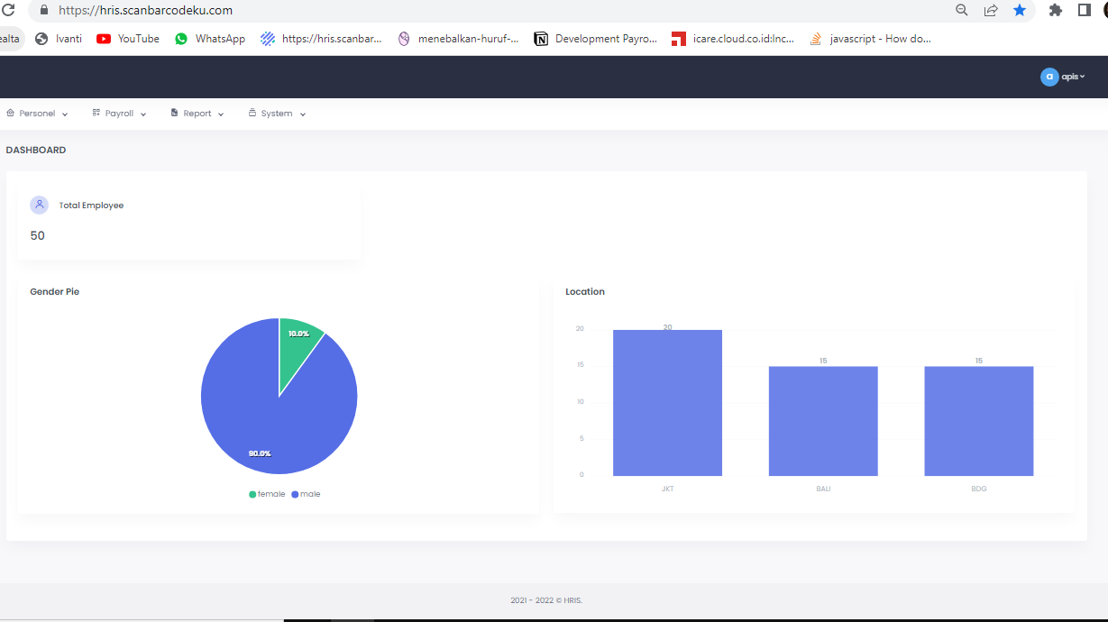

* Personnel Master

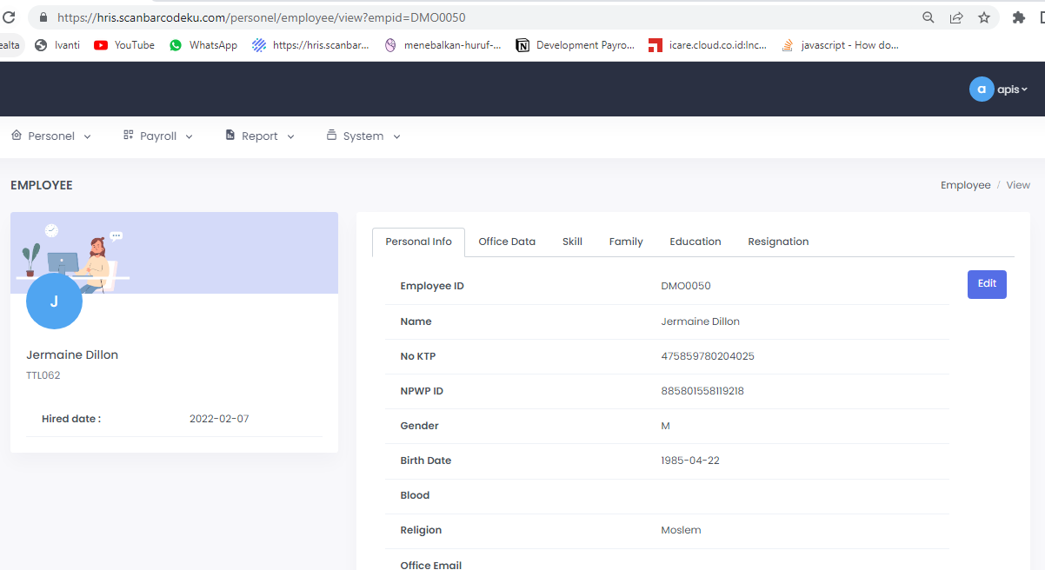

* Payroll Modul

