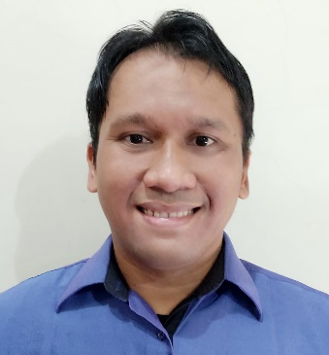00

EDUCATION

2012-2013 **Bachelor of** **Information System (SI)**

STMIK NUSA MANDIRI

My Certificate : <https://db.tt/7dYUjEUb>

My Transcripts : <https://db.tt/u4nZpa6t>

2008-2011 **Associate Degree of Information System (D3)**

Bina Sarana Informatika

**HENDRA SANUSI**

**Consultant HRIS System Asst. Manager**

Work Experiece



hendra.sanusi@gmail.com



+62-8567-9771-77



Perum. Permata Rubby 2 Blok A17



Rawageni, Cipayung, Depok

<https://hensax.github.io/>

2012-Now **Realta Chakradarma, PT**

Consultant of HRIS System, as Asst. Manager

Job Desk

* Leading whole team to make sure all process on schedule
* Conduct business and user requirement analysis
* Supervise Projects to create plan, organize team, Investigate, evaluate and create report project.
* Coordinate with user business requirement and programmer team in software development project
* Do basic design with system workflow, use case, ER-Diagram
* Conduct regular reviews of systems and generating report on efficiencies and improvement areas
* Do training, install & setting HRIS systems and SQL server
* Do create DML formula (insert, update, delete), Function, Store Procedure in SQL server, for formula in HRIS system

2009-2012 **Brawijaya Women & Children Hospital**

Finance Staff

Job Desk

* Manage Petty Cash and Cash on Bank
* Manage AP Payment
* Daily Audit income report to cashier team

Ex : EDC Machine report , cash on cashier

* Manage Billing / invoicing and AR Payment

2007-2008 **PT Gloria Origita Cosmetics (Purbasari)**

Accounting Staff

Job Desk

* Manage AP and AR Payment
* Invoicing & Incentive / bonus calcuation
* Stock Audit



ABOUT ME



Professional HRIS System Consultant with 10 years experiences, involved in system analysis and design program, SQL queries, and database normalization.

Experience in Project Manager and Business Analyst

Have knowledge in accounting and finance with 3 years experiences.

Have knowledge in programming as backend development



* Business Analyst
* Project Manager
* Expert TaxPPh21 Employee
* Finance & Accounting

Code :

* DB SQL Server, PostgreSQL
* NodeJS as Back End programer
* Java - with spring Framework
* Vue JS
* PHP

SKILL

Certificate



* Certificate of Accouting from Ikatan Akuntansi Indonesia (IAI)
* Certificate of Brevet Pajak A dan B