SPARK Front End
Deployment Guide

Revision History
Author | Revision Number | Date
holyness(Hentry Martin) | 1.0 | 2015/7/7

Deployment Instructions 3
1. Organization of Submission 3
2. Application Setup 3
3. Verification 6

Deployment Instructions

Organization of Submission
App :
Contains the soure code of the application
Inside app folder, each module is segregated such like createNewSurvey,Login etc
Video_demo :
Contains the video demo about this application
deployment_guide :
Contain this document.
change_log :
Contains the change logs
Assets
Contains the assets like styles, images, icons etc

Application Setup
Place the submission in any server and run. Since the json files and xml files are used for the data binding you may encounter cross origin error in chrome if didn’t deploy in the server.
In order to test this in android smartphones, you may install paw server in your mobile and place the submission in the html folder of paw root folder.
Start the server and navigate to the url to check the application

Verification
Home page header section,
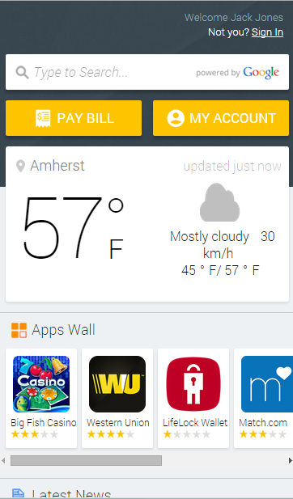

Latest news section in home page,
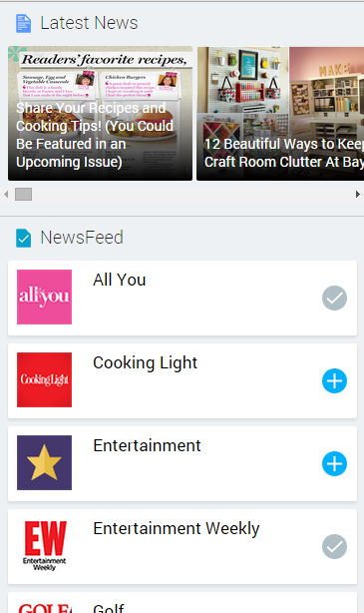

Footer area of header,
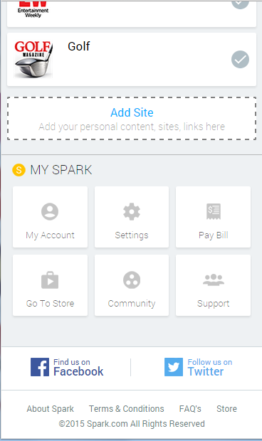

Weather details top,
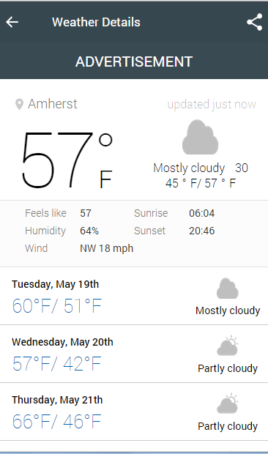

Weather details bottom,
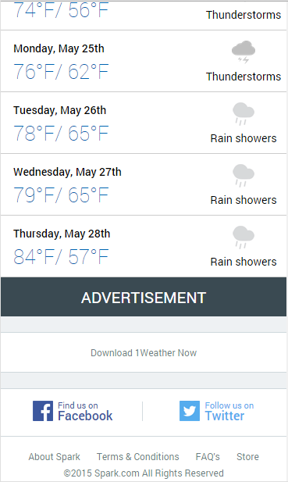

News source details page top,


News source details bottom,

All top news,

Story details view,


Story details bottom,
