Mathematical Calculator and Personal Pocket CGPA Calculator
Submitted by
Name: Hephzibah Titilayomi Adegboro
Matric Number: 241206022
Department: Software Engineering
Faculty: Computing
Course code: COS 202
Course Title: Computing Programming II
Lecturer: Dr OO Ajayi
Date: 5th July, 2026

INTRODUCTION
This practical assignment was carried out using the python programming language. The objective was to develop two interactive programs:
- A mathematical calculator
- A Personal Pocket CGPA Calculator
The program demonstrates the use of Python programming concepts such as variables, input/output statements, arithmetic operators, loops, and selection control statements ( if, elif, and else).

OBJECTIVES
The objectives of this assignment are:
. To understand the basics of Python programming.
. To apply arithmetic operations in solving mathematical problems.
. To develop an interactive calculator.
. To implement decision-making using selection control statements.
. To calculate students’ CGPA automatically using Python.

Software Used
. Python
. Visual Studio Code (VS Code)
. GitHub

PROGRAM 1: MATHEMATICAL CALCULATOR
Description
The Mathematical Calculator is a menu-driven program that allows users to perform basic arithmetic operations.
Operations Performed
. Addition (+)
. Subtraction (-)
. Multiplication (*)
. Division (/)
. Floor Division (//)
. Exponent (**)
. Modulus (%)
. Clear
. Exit (OFF)

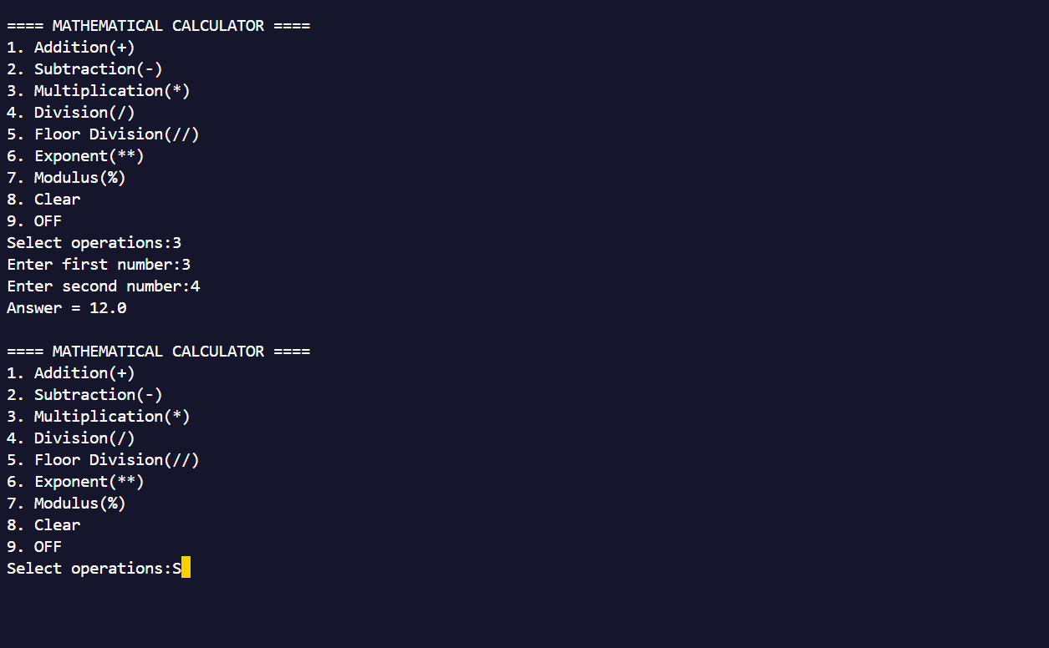

PROGRAM 2: PERSONAL POCKET CGPA CALCULATOR
Description
The Personal Pocket CGPA Calculator calculates a student’s CGPA based on the course unit and score entered by the user.
The program assigns grades according to the university grading system that computes the Quality Points before calculating the final CGPA.
Score Grade Grade Point
70-100 A 5
60-69 B 4
50-59 C 3
45-49 D 2
40-44 E 1
0-39 F 0

Formular Used
Quality Point = Grade Point * Course Unit
CGPA = Total Quality Points + Total Course Units

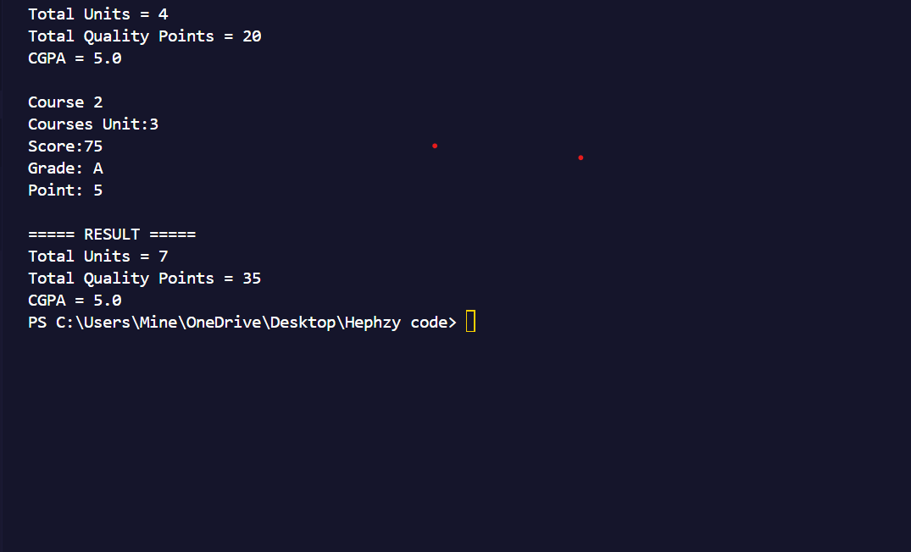

CHALLENGES ENCOUNTERED
Some of the challenges encountered during this practical include:
. Understanding the program logic
. Handling invalid user input
. Preventing division by zero
. Correctly calculating the CGPA
These challenges were overcome through testing and debugging.

Conclusion
This assignment improved my understanding of Python programming and strengthened my ability to use selection control statements, loops, arithmetic operations, and user input to develop interactive applications. It also enhanced my practical knowledge of using GitHub for storing and managing programming projects.

