- Create the above table “Billing” with given datatype and insert records in the table. (Insert one duplicate record)

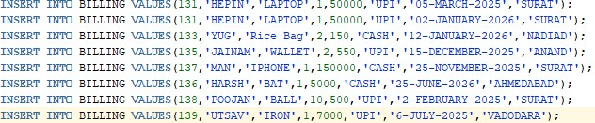
CODE:
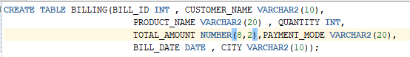

OUTPUT:
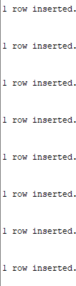

- Update the total amount of product “Rice Bag”.

CODE:
OUTPUT:

- Display all Billing data in ascending order of bill_id and descending order of customer_name.
CODE:
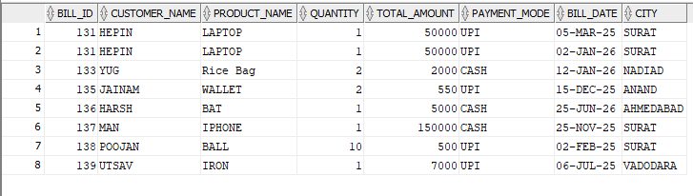
OUTPUT:

- Delete a bill whose quantity is below 1.
CODE:

OUTPUT:
- Select bills whose payment_mode is ‘UPI’.

CODE:
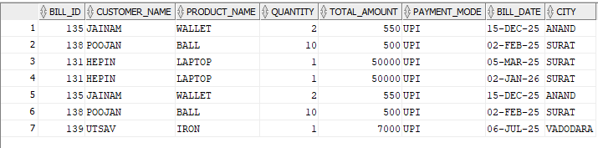
OUTPUT:

- Display the count of total bills for each city.

CODE:
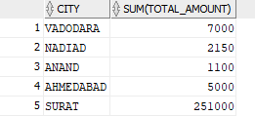
OUTPUT:

- Select customers whose name starts with ‘M’ and ends with ‘A’.
CODE: OUTPUT:

9. Select bills whose bill_ids are 131,133,135,137,139. Display first 7 records from Billing table
CODE:
OUTPUT:

