Software Testing Assignment

* Module 04
* **What is priority?**

=> Priority is defined as the order in which a defect should be fixed. Higher the priority the sooner the defect should be resolved.

Defects that leave the software system unusable are given higher priority over defects that cause a small functionality of the software to fail.

**Priority of Types :-**

**Low:** The Defect is an irritant but repair can be done once the more serious Defect has been fixed.

**Medium:** During the normal course of the development activities, defects should be resolved. It can wait until a new version is created.

**High:** The defect must be resolved as soon as possible as it affects the system severely and cannot be used until it is fixed.

* **What is severity?**

=> Severity is defined as the extent to which a particular defect can create an impact on the software. Severity is a parameter to denote the implication and the impact of the defect on the functionality of the software.

**Types of Severity :-**

**Critical:** This defect indicates complete shut-down of the process, nothing can proceed further.

**Major:** It is a highly severe defect and collapses the system. However, certain parts of the system remain functional.

**Medium:** It causes some undesirable behavior, but the system is still functional.

**Low:** It won’t cause any major break-down of the system.

* **Bug categories are…**

=> A software bug is a problem, failure, error, or fault that results in a computer or software system crashing or failing.

A software bug is a flaw, error, or fault in a computer system or program that causes it to perform incorrectly or unexpectedly or produce unintended results.

Software bugs are divided into three board categories, under which we have several types of bugs. Bugs are classified by-

1) Nature.

2) Priority.

3) Severity.

* **Advantage of Bugzilla.**

=> The Advantages of Bugzilla are:

* it is an open-source widely used bug tracker;
* it is easy in usage and its user interface is understandable for people without technical knowledge;
* it easily integrates with test management instruments;
* it integrates with an e-mailing system;
* it automates documentation.

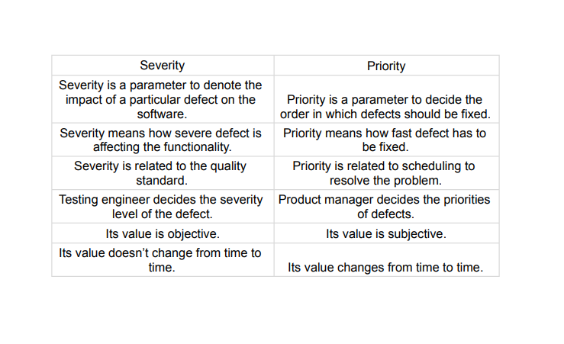

* **Difference between priority and severity.**