  L1 FA24

Q1:

Software Requirements Specification

for

DTFPT – DAO TAO FPT
Version 1.0 approved
Prepared by
Nguyen Quang Gia Khoi – DE190016
FPT University Da Nang Campus
18/7/2025

Q2:

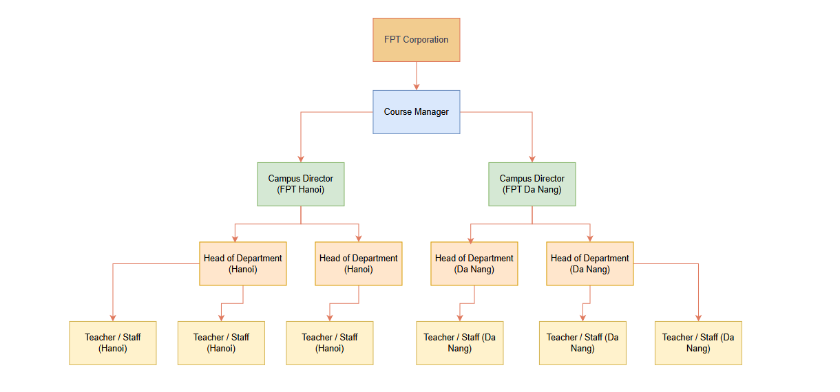 Q3:
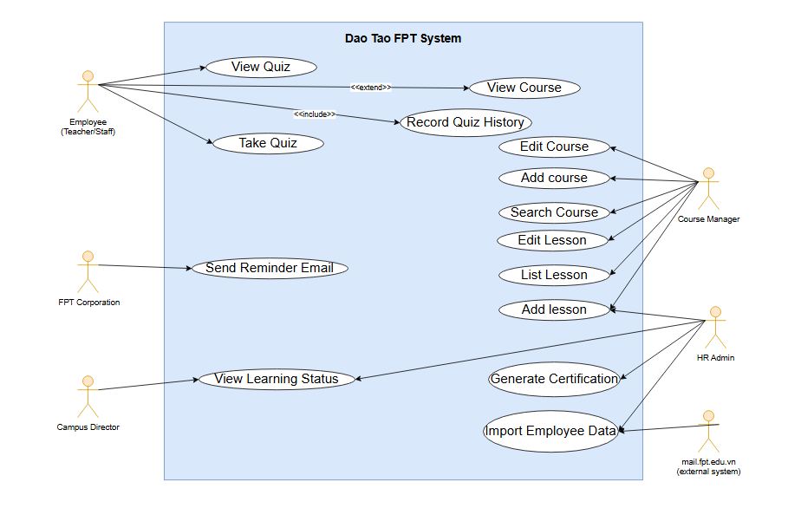
Q4:
UC ID and Name: | UC-1 Add Lesson
Created By: | giakhoiquang@gmail.com | Date Created: | 18/07/2025
Primary Actor: | Course Manager | Secondary Actors: | HR Admin
Trigger: | Course Manager selects an existing course and chooses to add a new lesson
Description: | - The Course Manager is logged in to the DTFPT system.  - The course to which the lesson will be added already exists.  - The Course Manager has permission to modify the course.
Preconditions: | - A new lesson is successfully created and linked to the selected course.  - The lesson becomes visible to authorized roles for further actions (e.g., editing, adding quizzes)
Post conditions: | - A new lesson is successfully created and linked to the selected course.  - The lesson becomes visible to authorized roles for further actions (e.g., editing, adding quizzes).
Normal Flow: | 1. Course Manager logs in.  2. Navigates to Course Management.  3. Selects a course from the list.  4. Clicks "Add Lesson" button.  5. Fills in the lesson title, description, and optional resources.  6. Clicks "Save".  7. System stores the lesson and confirms success.
Alternative Flows: | A1: Course Manager leaves required fields empty → System shows validation errors.  A2: Course Manager clicks “Cancel” → System discards changes and returns to course page.
Exceptions: | E1: Network interruption → System shows error and allows retry.  E2: Server/database error → System logs the issue and notifies the Course Manager with an error message.
Priority: | High
Frequency of Use: | Frequently, especially before a new course starts
Business Rules: | - Lesson name must be unique within its course.  - Only Course Managers are allowed to add lessons.  - Each lesson must have a title and be linked to a course.
Other Information: | The lesson can later be edited, and quizzes can be added by the same or other authorized users.
Assumptions: | The system is online, the user has appropriate rights, and the course data is not corrupted.

Q5:
a. Most important non-functional requirement: Performance
No | Description
1 | The DTFPT system must respond to course page requests (including course listing and viewing lessons) in less than 2 seconds for 95% of users.
2 | The system must be able to support at least 10,000 concurrent users during peak working hours

b. Second most important non-functional requirement: Availability
No | Description
1 | The DTFPT system must be available at least 99.5% of the time per month, excluding planned maintenance.
2 | The system must have automatic recovery and error logging so that critical services are restored within 10 minutes after unexpected failures.

