  L1 FA24

Q1:

Software Requirements Specification

for

DTFPT – DAO TAO FPT
Version 1.0 approved
Prepared by
Nguyen Quang Gia Khoi – DE190016 y
FPT University Da Nang Campus
18/7/2025

Q2:

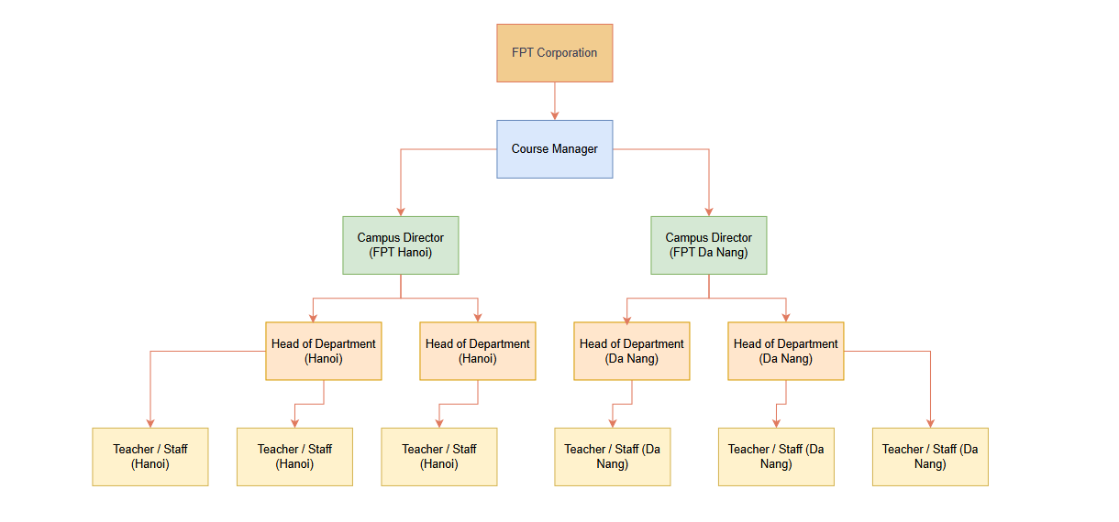 Q3:
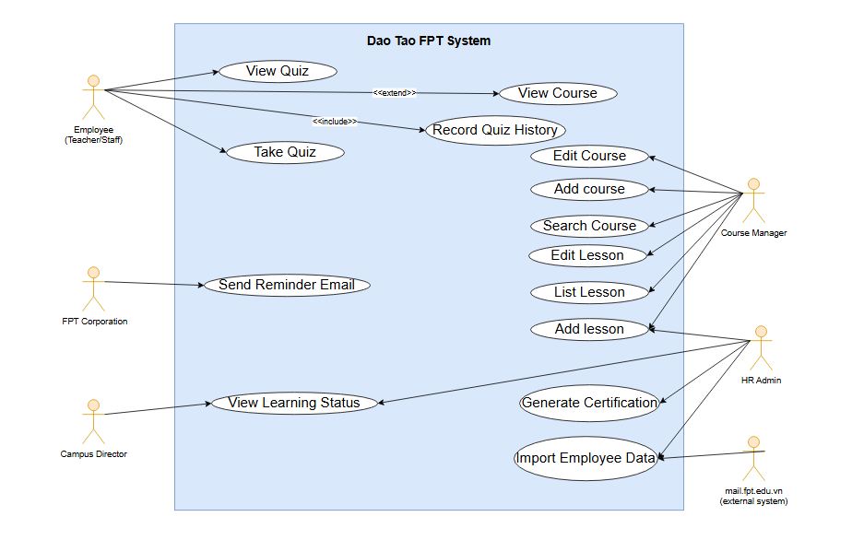

Q4:

< Student must replace this line, answer of Q4 by filling the content into the below table that reflects this exam paper. NOTE: Student must remove the guideline in and after the (….).>
UC ID and Name: | (0.1 point) the UC – 1 [blank space and the use case name require in the exam paper here.]
Created By: | (0.1 point) The name of your email account. | Date Created: | (0.1 point) The date that you take the exam.
Primary Actor: | (0.2 point) the name of the actor that initiates usage of this use case. | Secondary Actors: | (0.2 point) The name of the actor that uses the data of the primary actor.
Trigger: | (0.3 point) the events that occur and then this use case will run.
Description: | (0.1 point)
Preconditions: | - … (0.3 point) The preconditions that must be true or must be done before this use case can run.  - …
Post conditions: | - …. (0.3 point) Describe the things must be done after the actors interact with this use case.  - ….
Normal Flow: | - …….(0.6 point) Describe the sequence of steps in normal case that must be performed by the actors or the system responses.  - …….  - …….  - …….  - ……
Alternative Flows: | - …. (0.6 point) Describe the sequence of steps in different case that can be performed by the actors or the system responses.  - ….  - ….  - ….  - ….
Exceptions: | - …..(0.3 point) Describe the sequence of steps that can be handled or implemented in case of any exceptions.  - …  - …
Priority: | (0.1 point) Priority will make a better plan when implementing.
Frequency of Use: | (0.1 point) The more frequency of use, the more important it is
Business Rules: | (0.2 point) All things in software are related to data. The business rules should be specific so that they can be designed and coded
Other Information: | (0.1 point) It may be description of quality here for more info.
Assumptions: | (0.1 point) The assumptions on the data are related to this use case.

Q5:
< Student must replace this line and the answer of Q5 must be in detail and specific number, explaining the source of number or the way to calculate the numbers of 2 non-functional requirements for DTFPT system>

