# Comprehensive Hospital Admissions, Billing, and Medical Conditions Analysis

**Prepared by:**

HEPHZIBAH REGINALD OTUENE, IBRAHEEM BOLA KAREEM, ADEKOLA FAITH

## Introduction

In today’s rapidly evolving healthcare landscape, leveraging data analytics has become essential for enhancing patient care, optimizing operations, and improving financial sustainability. This project aims to provide a detailed analysis of key healthcare metrics, including patient demographics, medical conditions, admission trends, and billing data. By identifying patterns and actionable insights, we empower stakeholders to make informed decisions that drive efficiency, elevate the quality of care, and ensure long-term operational success.

Through this comprehensive study, we will uncover critical insights into resource utilization, cost management, and treatment outcomes. Our findings will not only highlight current strengths but also pinpoint areas for improvement, enabling a proactive approach to healthcare management. Ultimately, this project underscores the transformative power of data in delivering better health outcomes and fostering a sustainable healthcare ecosystem.

## Objective

The analysis focuses on identifying trends and correlations in hospital admissions, patient demographics, billing, and medical conditions across dimensions such as age, gender, and insurance providers. The insights aim to improve hospital management decisions, optimize patient care, and minimize costs.

## Methodology

### Step 1: Data Loading

- Libraries Used: Pandas, NumPy, Matplotlib, sci-kit, SciPy, and Seaborn for data manipulation and visualization.  
- Dataset Loading: The dataset was imported into a Pandas DataFrame for further analysis.

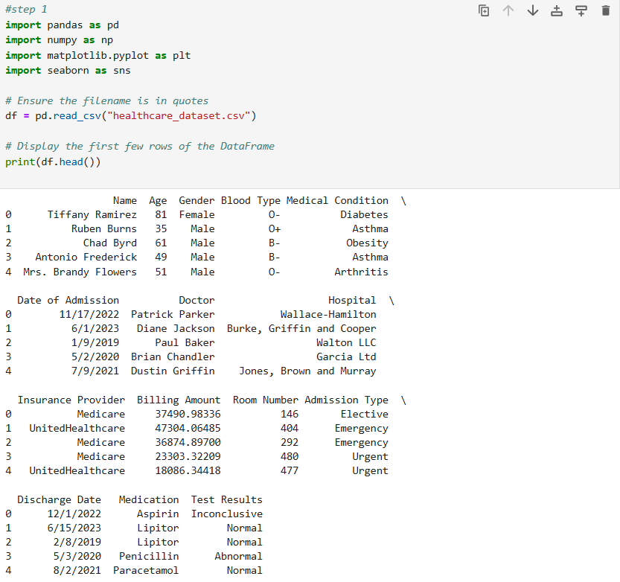

: Importation of Libraries and Data loading

### Step 2: Initial Data Inspection

- Data Structure: Explored using ‘.info()’ in confirming column names, data types, and identifying initial patterns with no missing Data

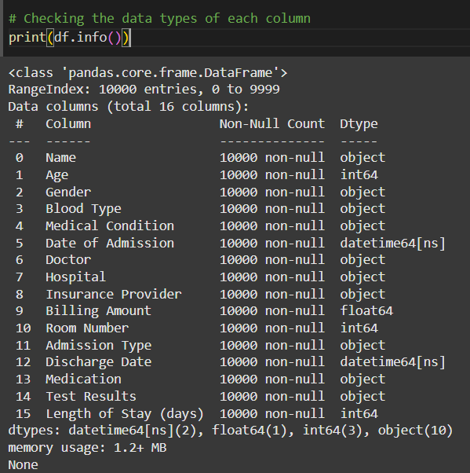

: Data Inspection

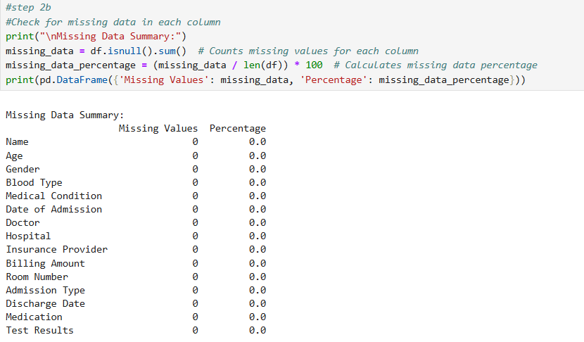

: Proof of no Missing Values

### Step 3: Data Cleaning

- Data Types Standardization: Ensured appropriate formats for columns, e.g., converting date columns to ‘datetime’ and categorical values to ‘category’.

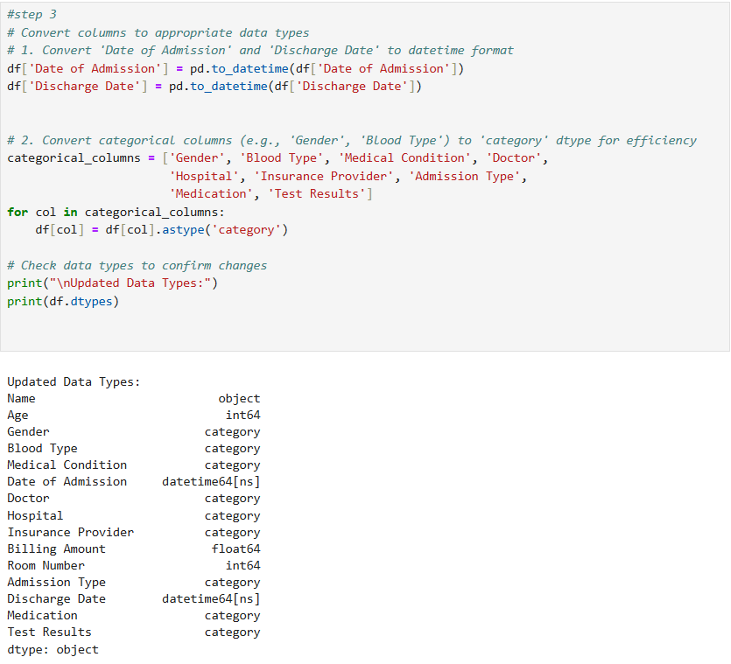

: Data Types Standardization

- Outliers Management: Used boxplots and statistical thresholds to identify and handle outliers in numerical data, particularly in billing. It showed that both variables demonstrate a clean dataset without significant anomalies or extreme values, which is a good sign for analysis or modeling purposes. It also suggests that the data for these columns is well-balanced and might not require additional outlier handling.

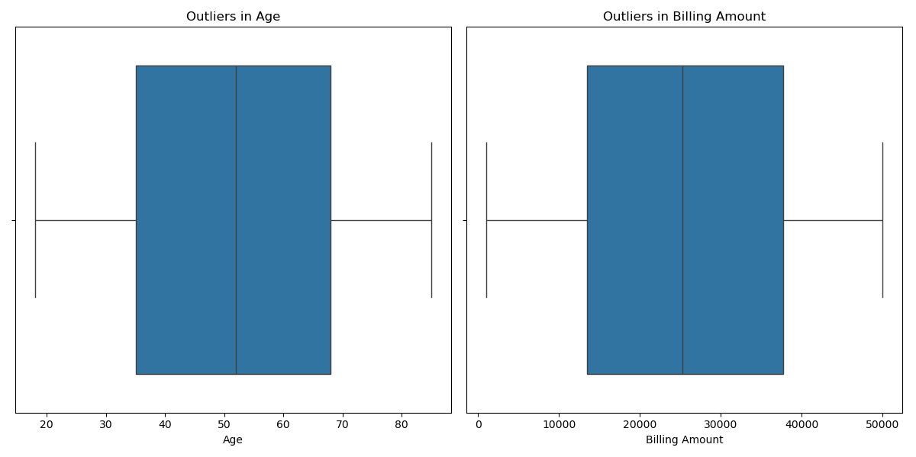

: Outliers Boxplot

### Step 4: Data Transformation

- New Features: Created features like age groups and admission durations for deeper analysis.

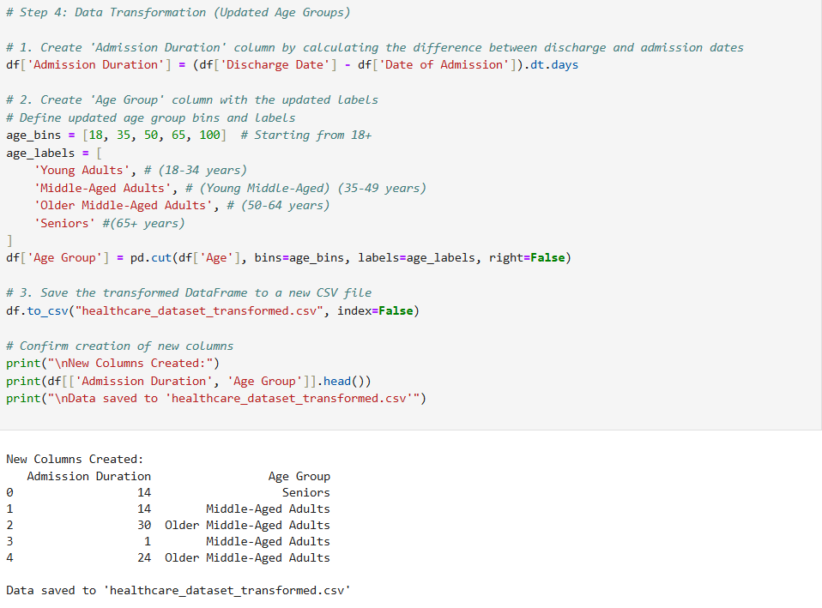

: New Columns

### Step 5: Exploratory Data Analysis (EDA)

|  |  |
| --- | --- |
|  |  |

**PATIENT DEMOGRAPHICS:**

The dataset comprises 10,000 patient records from 8,639 hospitals, providing insights into gender-specific trends in medical conditions and medication usage.

**Total Patients**: 10,000; 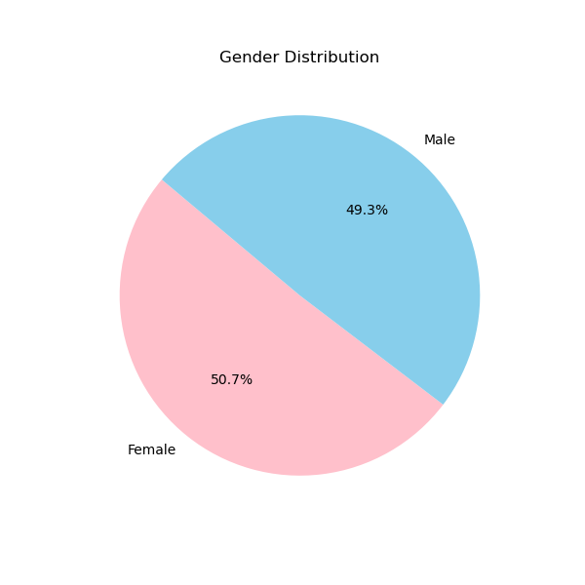 **Females**: 5,075 (50.75%), **Males**: 4,925 (49.25%)

: Gender

|  |
| --- |
|  |
|  |

Female patients show a slightly higher prevalence of asthma and cancer, while male patients are more likely to be treated for hypertension and arthritis. For instance, 874 females were treated for asthma compared to 834 males, and 852 males were treated for hypertension compared to 836 females. Despite these differences, the distribution remains relatively even, indicating no extreme disparities in healthcare access or treatment.

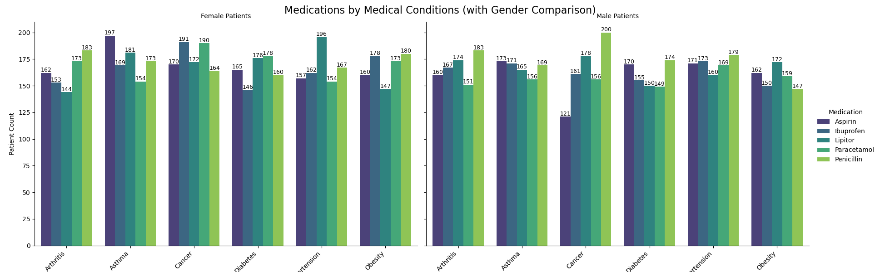

The accompanying visualization highlights the use of five medications—Aspirin, Ibuprofen, Lipitor, Paracetamol, and Penicillin—across these conditions for both genders. Penicillin appears to be the most frequently prescribed medication, particularly for conditions such as diabetes and hypertension. The patterns suggest a generally consistent approach to treatment across genders, with no significant biases in medication distribution.

- **Age Distribution**:

The dataset further reveals detailed insights into the age distribution of patients, with a total of 10,000 records categorized across distinct age groups. The majority of patients fall into the **middle-aged adults** (35-49 years, 21.81%) and **older middle-aged adults** (50-64 years, 22.63%) categories. Notably, **seniors** (65+ years) constitute the largest demographic group, comprising **30.71%** of the dataset.

|  |  |
| --- | --- |
|  |  |

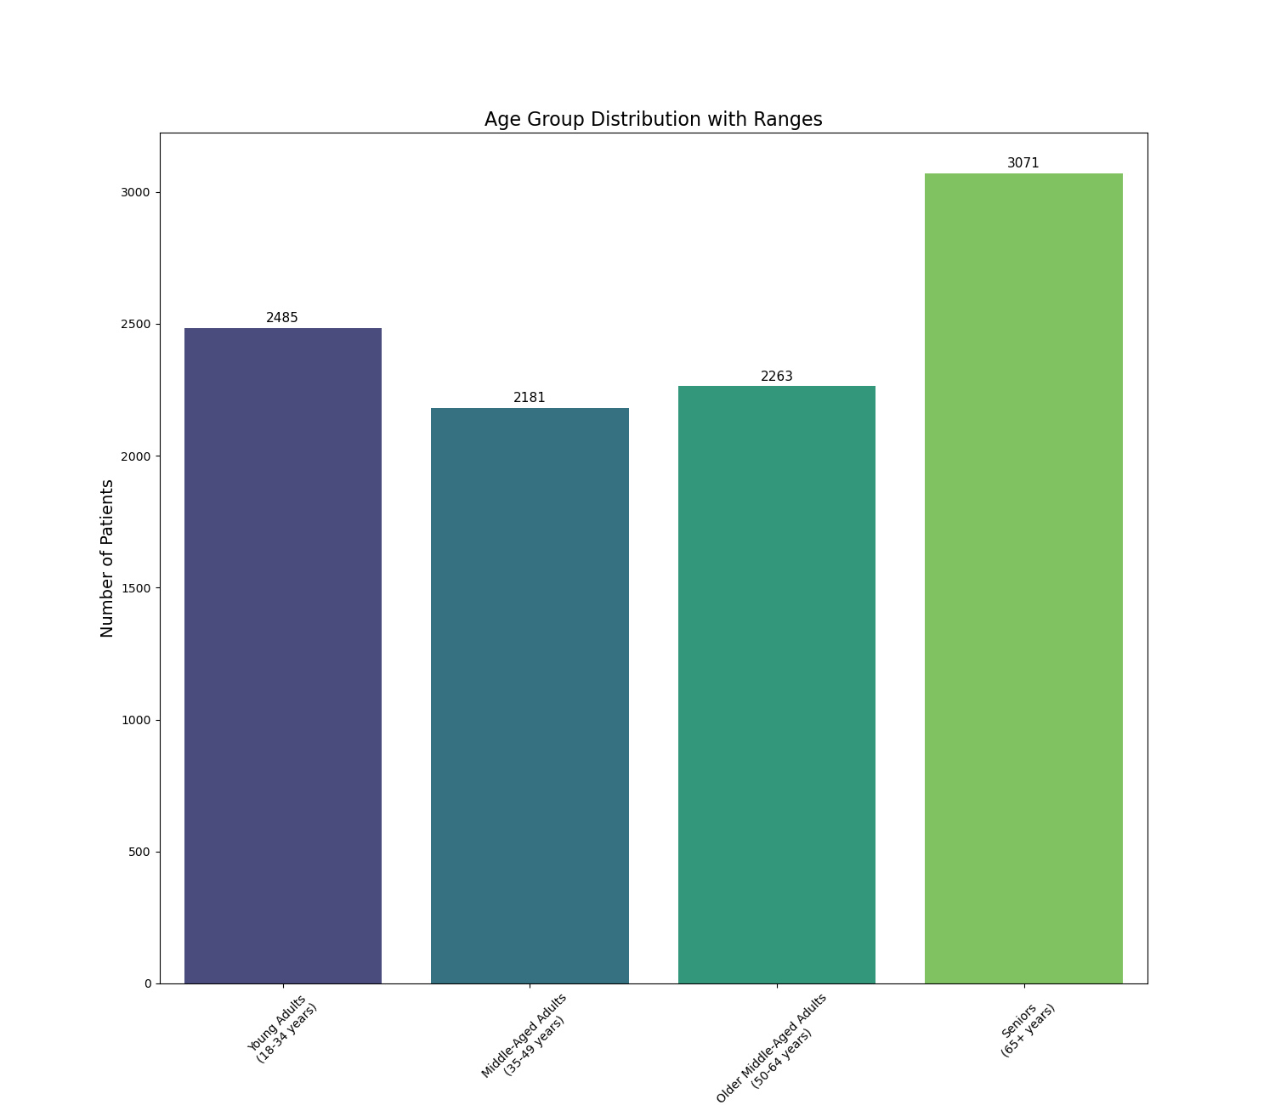

: Age Distribution by Range

The distribution of age groups suggests that **chronic conditions become increasingly prevalent with age**, with significant overlap in gender trends across the lifespan. **Seniors** represent a critical focus area for healthcare due to their higher population proportion and vulnerability to multiple conditions.

- **Blood Group Analysis**:

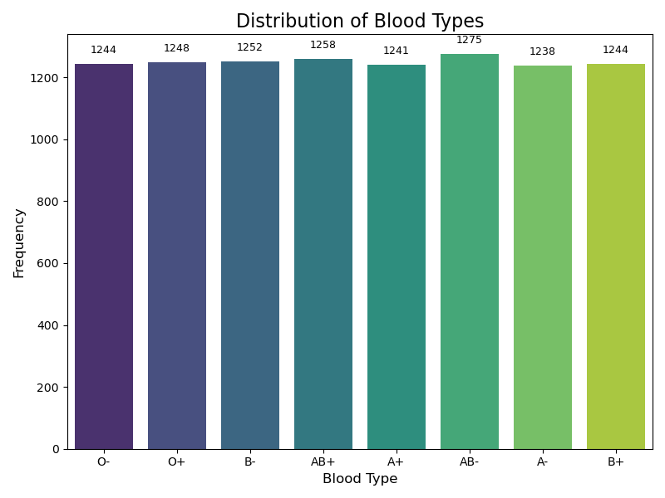

The analysis explored the relationship between blood groups and six medical conditions: arthritis, asthma, cancer, diabetes, hypertension, and obesity. While no statistically significant association was found (p-value: 0.8783), the data revealed slight trends:

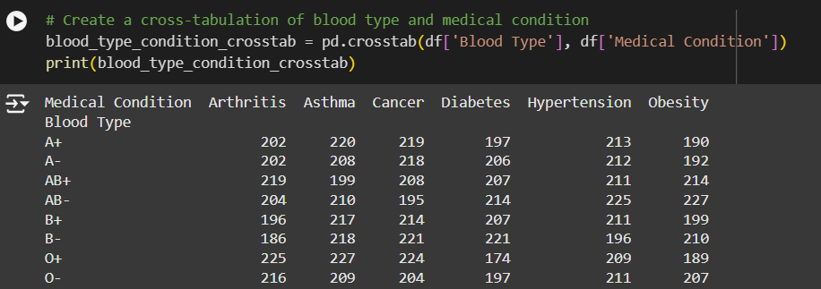

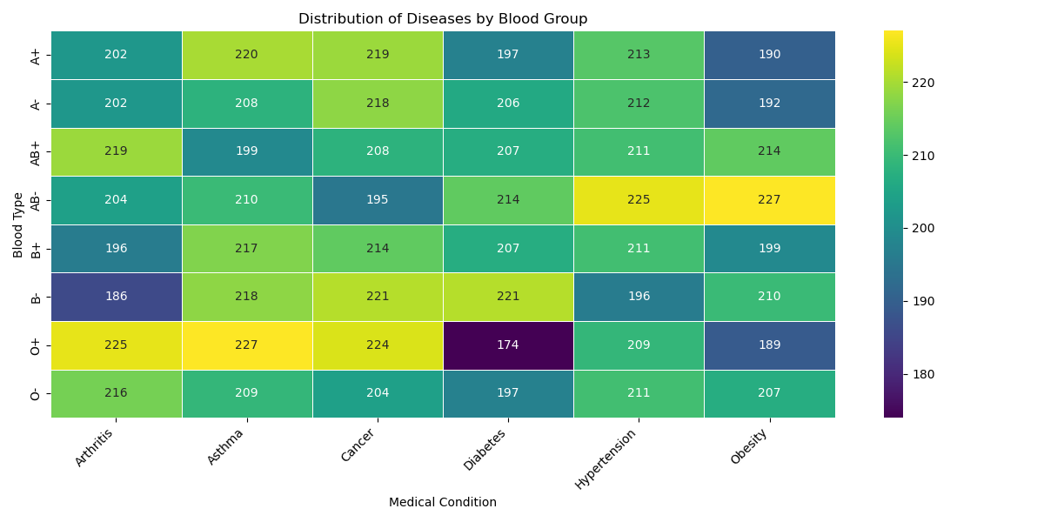

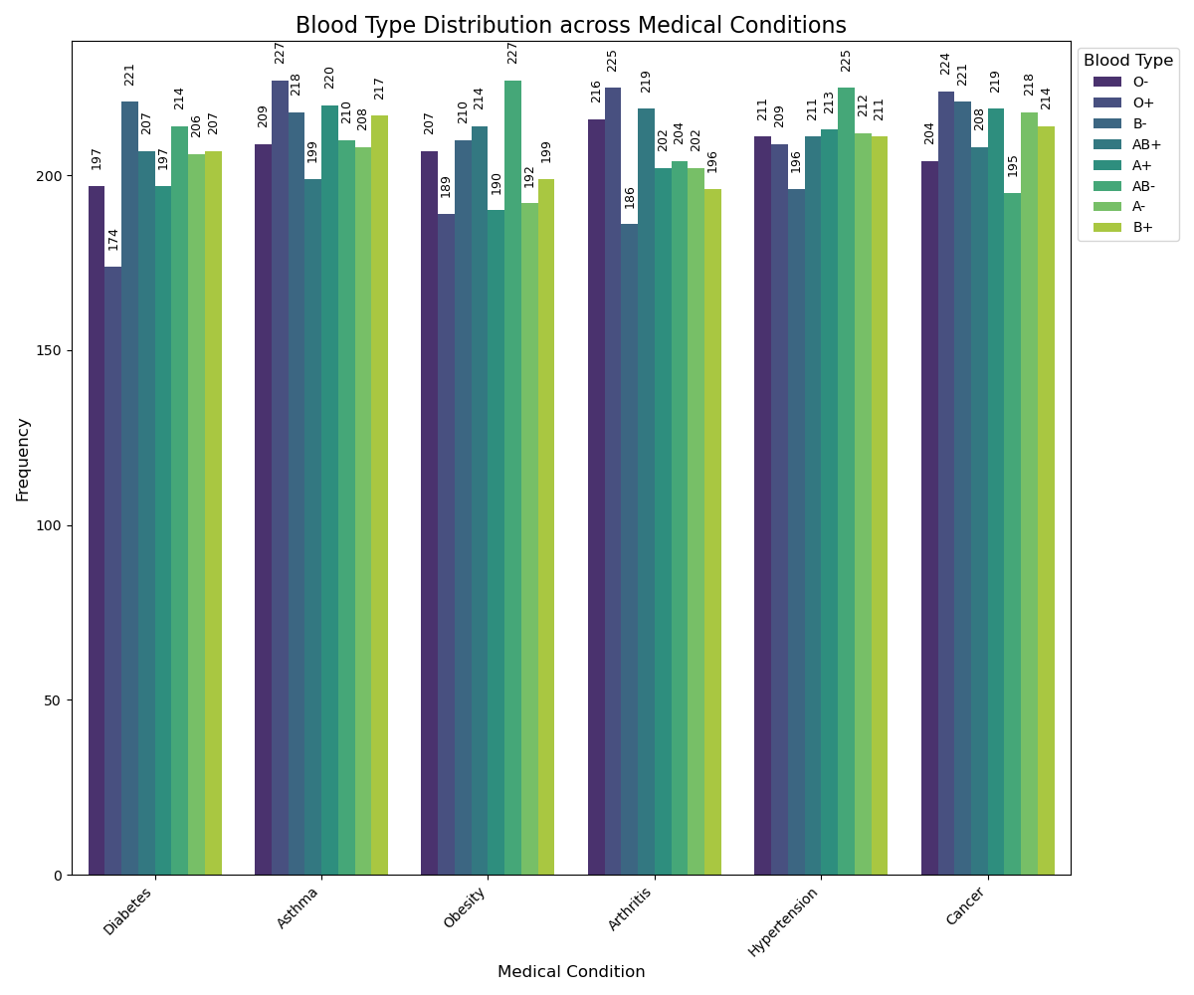

1. **Blood Group O+** is slightly more represented in conditions like arthritis (13.64%) and asthma (13.29%).
2. **Blood Group AB-** shows higher percentages in obesity (13.94%) and hypertension (13.33%).
3. **Blood Group B-** has a notable presence in diabetes (13.62%) but a lower percentage in arthritis (11.27%).

These patterns align with earlier gender-specific findings, such as the higher prevalence of asthma and cancer in females (linked to O+ and AB- groups) and arthritis and hypertension in males (associated with O+ and B+ groups).

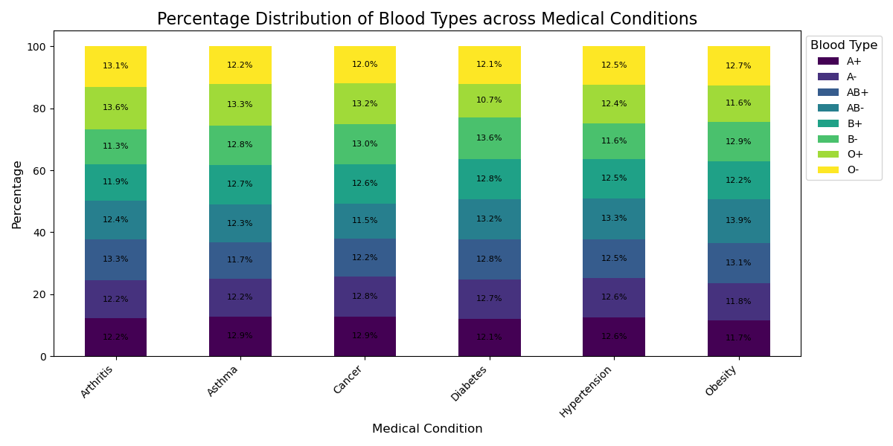

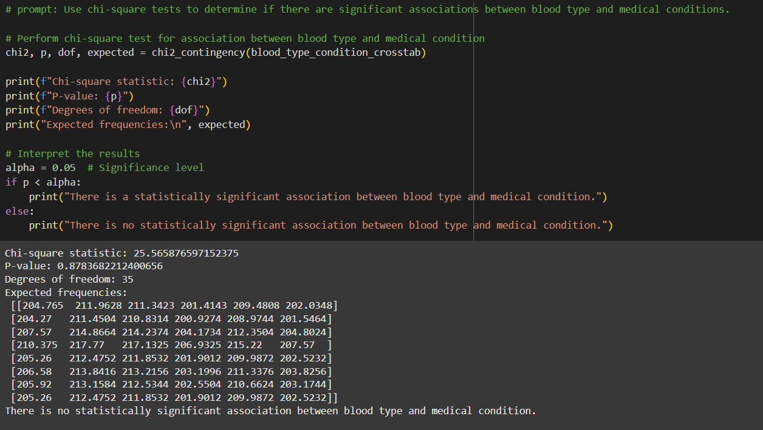

Although no definitive statistical link exists, these trends suggest potential areas for further investigation into how blood group, gender, and medical conditions may interact. They also reinforce the importance of targeted healthcare initiatives for chronic conditions.

**Medical Insights**

### Step 6: Advanced Analysis

- Correlations and Trends: Correlation matrices highlighted relationships like age vs. billing amount.

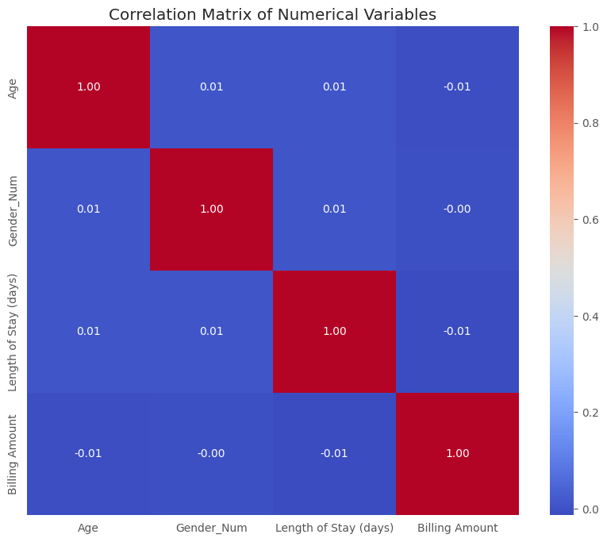

**Age** shows a slight positive relationship with both **Length of Stay** and **Billing Amount**, suggesting that older patients tend to stay longer and incur higher costs, though the correlation is weak.

**Gender** has little to no significant correlation with other variables, indicating that gender does not strongly influence age, length of stay, or billing amounts in this dataset.

**Length of Stay** is moderately positively correlated with **Billing Amount**, as expected, because longer hospital stays typically result in higher costs.

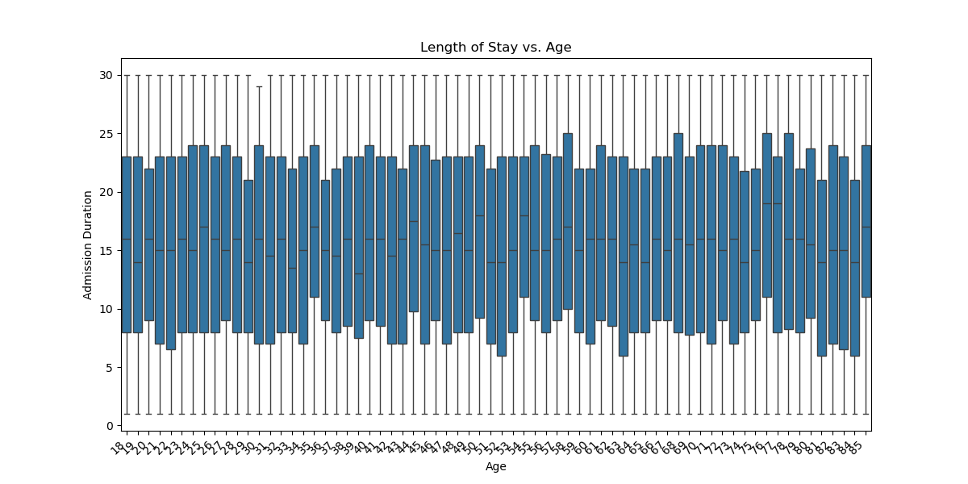

Overall, the correlations suggest age and length of stay are more influential factors in determining billing amounts than gender.

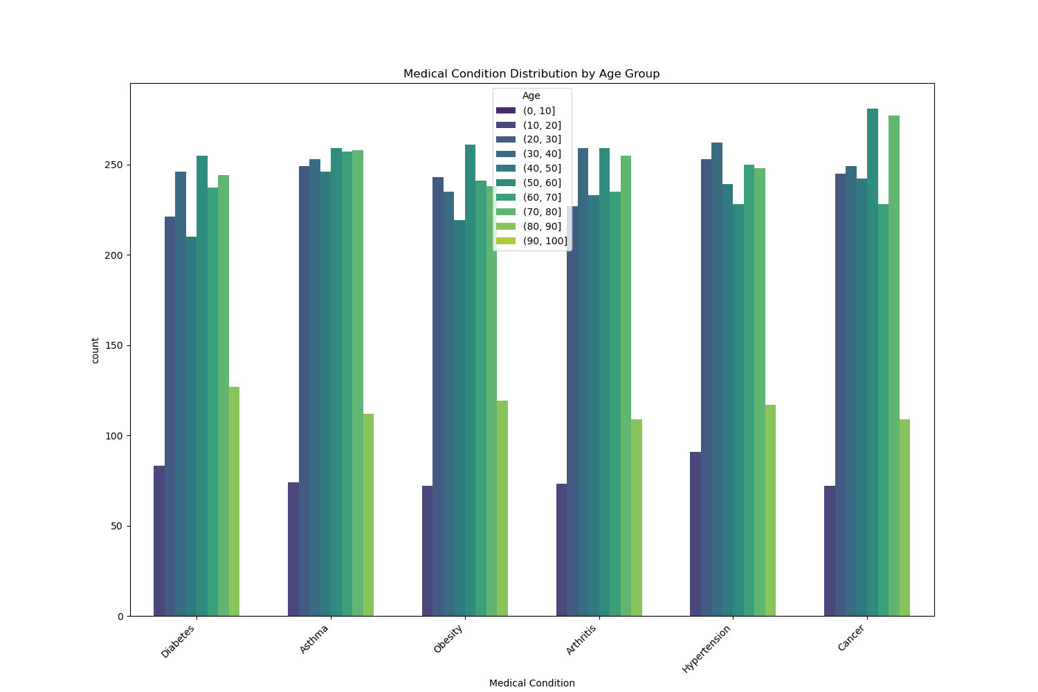

The dataset highlights **Asthma, Cancer, and Hypertension** as the most prevalent medical conditions among the patient population. While **Arthritis, Obesity, and Diabetes** are also significant, their occurrences are slightly lower. These conditions represent a substantial portion of the healthcare burden, requiring focused attention and resources.

The age distribution reveals a concentration of patients in the **50–60** and **70–80** age groups, aligning with the higher prevalence of chronic conditions like **Cancer** and **Hypertension**, which are more common in older adults. In contrast, **Asthma** affects individuals across all age groups, with frequent early-life diagnoses.

- Condition Trends: Cross-tabulations showed prevalence of conditions by age and gender.

**By Age Group:**

* Chronic conditions like **Cancer, Diabetes, and Hypertension** are more prevalent in older age groups, particularly among older middle-aged adults (50–64 years) and seniors (65+ years).
* **Asthma** is notable across all age groups but is most common in younger adults (18–34 years), reflecting early-life diagnoses.

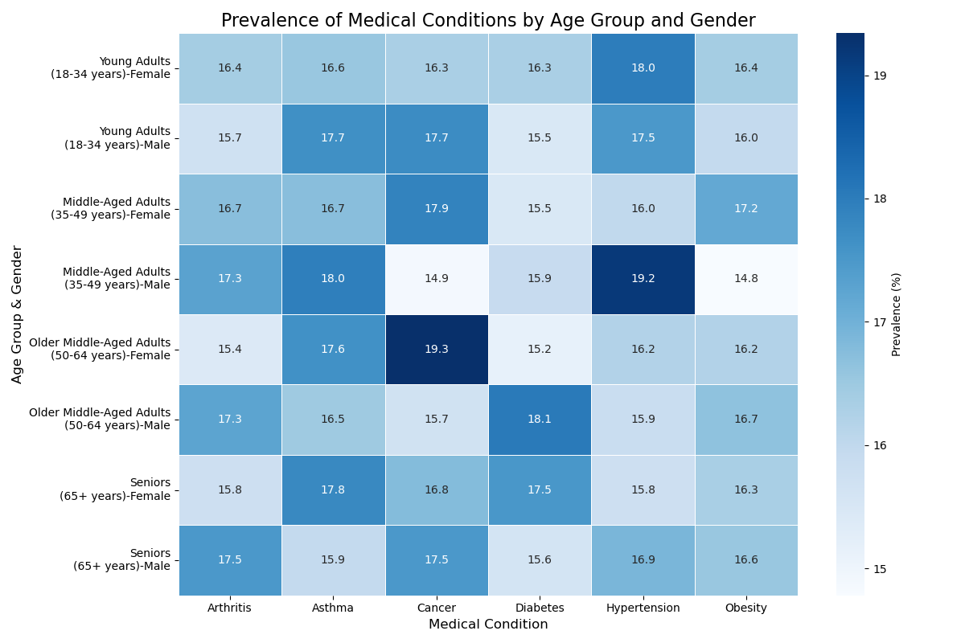

**By Gender:**

* **Males:** Higher prevalence of **Arthritis** and **Hypertension** across most age groups.
* **Females:** Higher prevalence of **Cancer** and **Asthma**, especially in senior years.

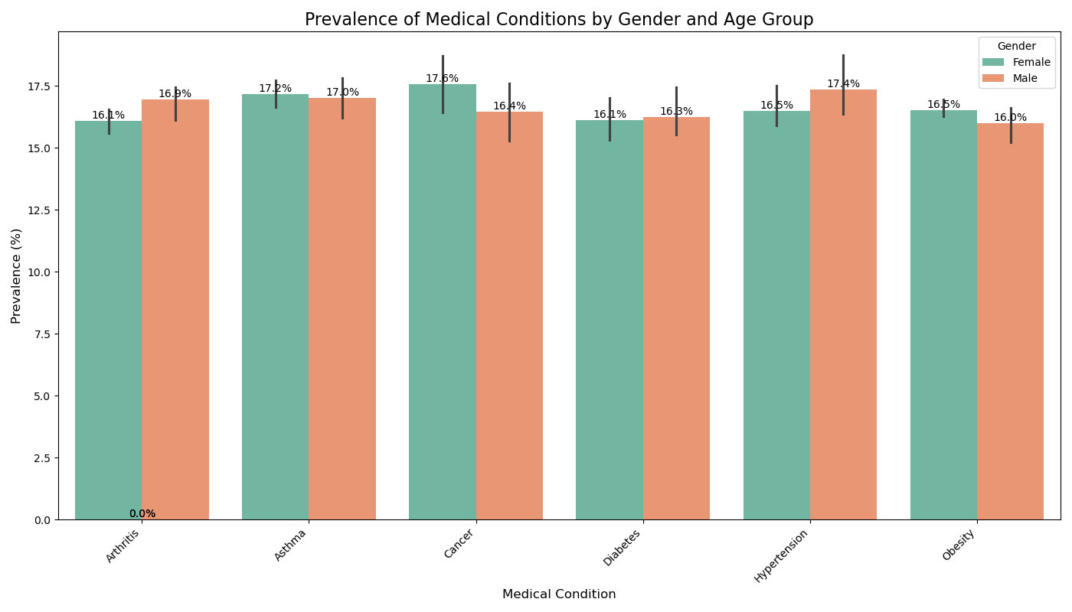

Admission Insights

|  |  |
| --- | --- |
|  |  |

Urgent admissions (3,391) slightly outnumber Emergency (3,367) and Elective (3,242) admissions. The near-equal distribution emphasizes the importance of balancing resources for planned and unplanned care. The Boxplot below compared admission duration per age group.

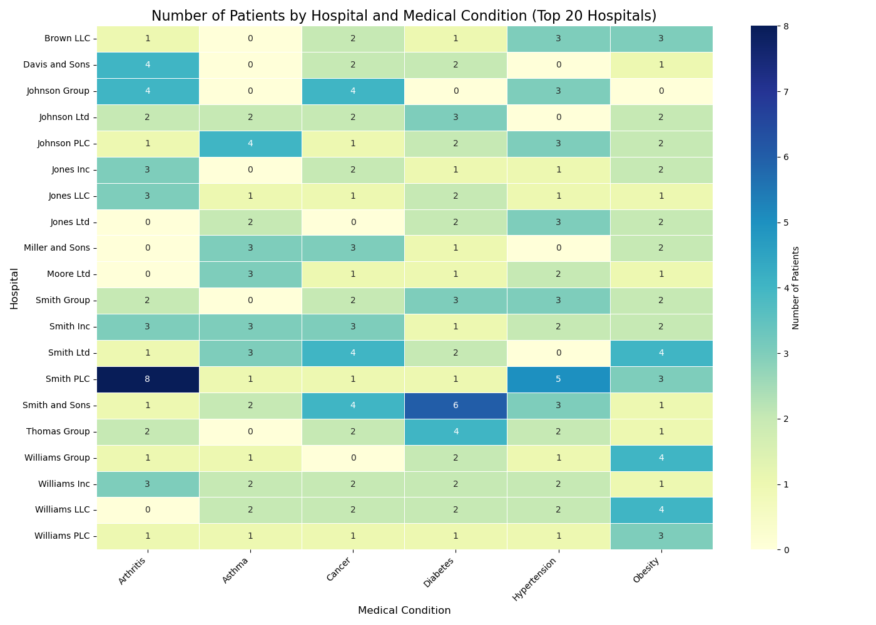

Hospitals such as Brown LLC, Johnson Group, and Smith and Sons handle a diverse range of conditions. Some hospitals show specialization trends; for example, Smith PLC manages more Hypertension cases, while Smith Ltd handles significant Cancer and Obesity cases. Top hospitals manage varied conditions with distinct admission durations, indicating areas of expertise or efficiency.

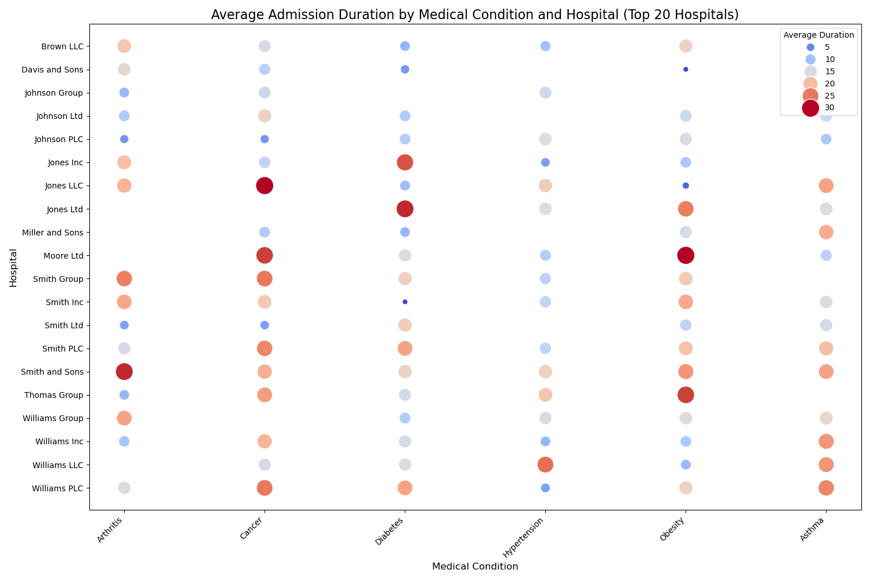

Average length of stay varies significantly by condition and hospital. Conditions like Cancer tend to have longer stays (e.g., Johnson Ltd: 17.5 days), while Arthritis shows shorter durations (e.g., Johnson PLC: 6 days). Hospitals like Miller and Sons exhibit efficiency for Asthma cases (21.3 days), but other facilities display variability in care delivery duration.

**Billing and Cost Analysis**

The analysis explores various billing and cost metrics across medical conditions, admission types, insurance providers, and hospitals to identify significant trends and variances in healthcare expenditures.

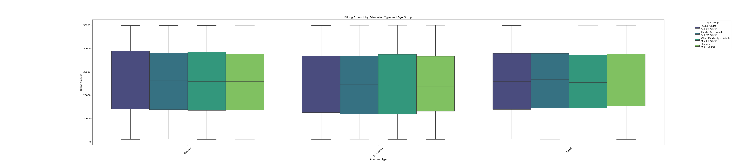

The average billing amount varies slightly across admission types:

* Elective admissions: $26,311 (Young Adults), $25,778 (Middle-Aged Adults), $25,789 (Older Middle-Aged Adults), $25,711 (Seniors).
* Emergency admissions: $24,929 (Young Adults), $24,544 (Middle-Aged Adults), $24,531 (Older Middle-Aged Adults), $24,779 (Seniors).
* Urgent admissions: $25,884 (Young Adults), $26,236 (Middle-Aged Adults), $25,578 (Older Middle-Aged Adults), $26,096 (Seniors).

Billing shows slight variation by age group, with elective admissions tending to be the highest for younger adults, while urgent admissions are more expensive for older adults.

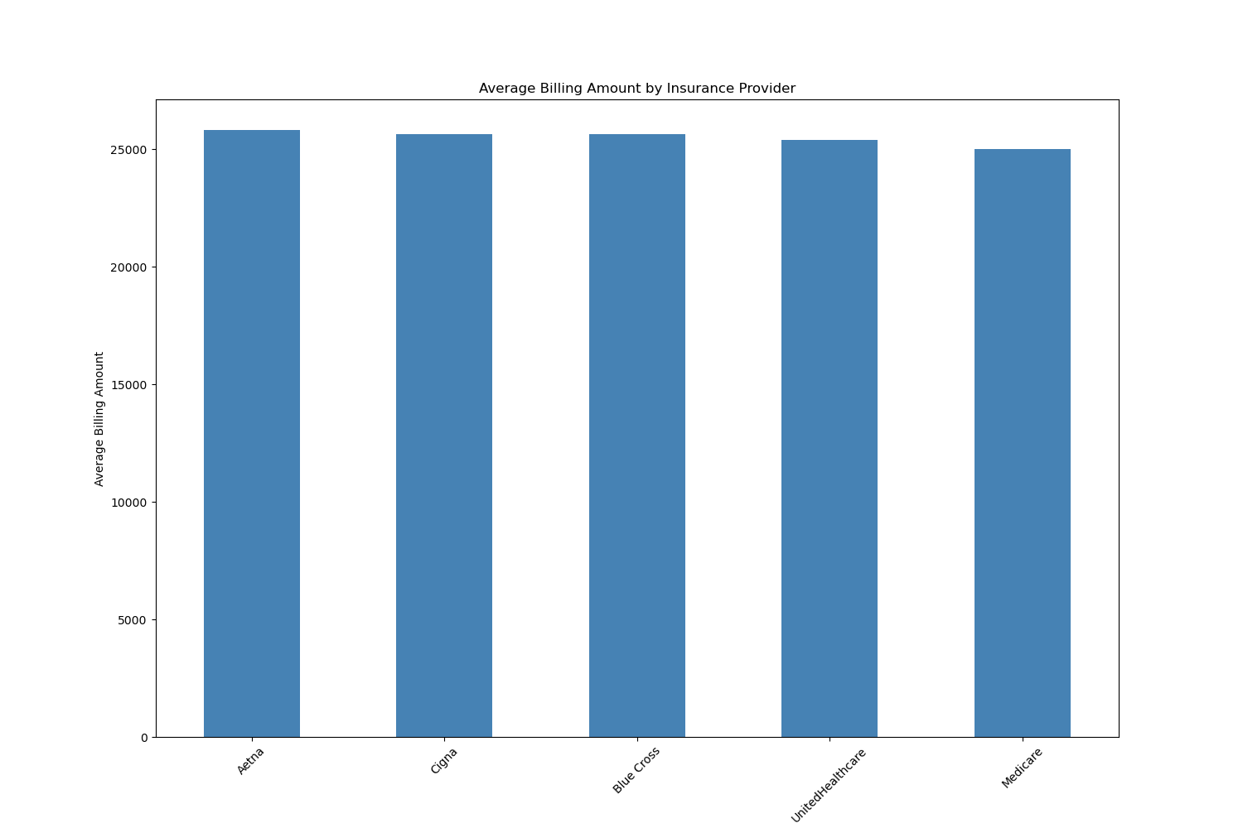

**Aetna** ($25,838), **Cigna** ($25,657), and **Blue Cross** ($25,652) are the leading insurance providers in terms of average billing, with **Medicare** ($25,002) covering lower costs.

**UnitedHealthcare** had a slightly lower average billing amount ($25,404) compared to the others.

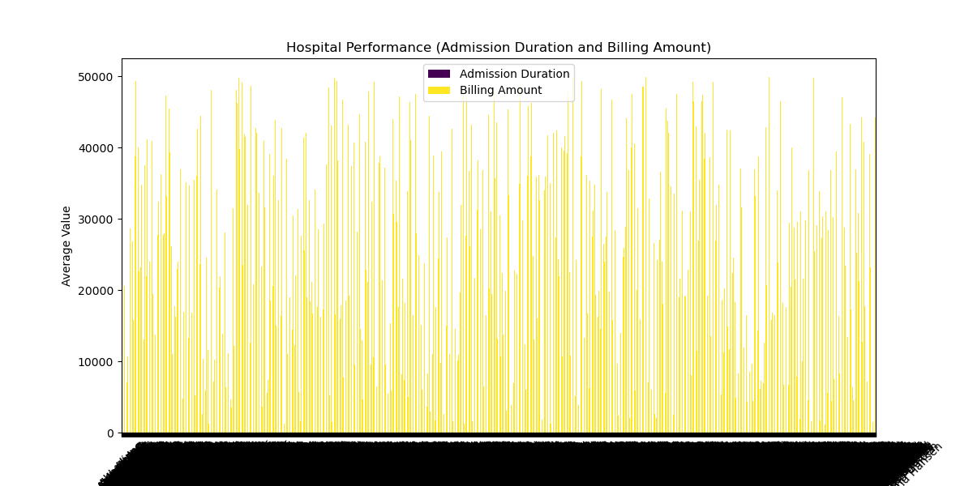

The analysis indicates significant variation in billing across different hospitals and admission types:

* Hospitals like Zimmerman, Salinas, and Hill ($44,147) and Zuniga-Chandler ($34,439) show higher billing for emergency admissions.
* Some hospitals, like Abbott LLC and Abbott PLC, have lower costs for elective procedures, while others show higher costs for urgent care, depending on the medical condition.

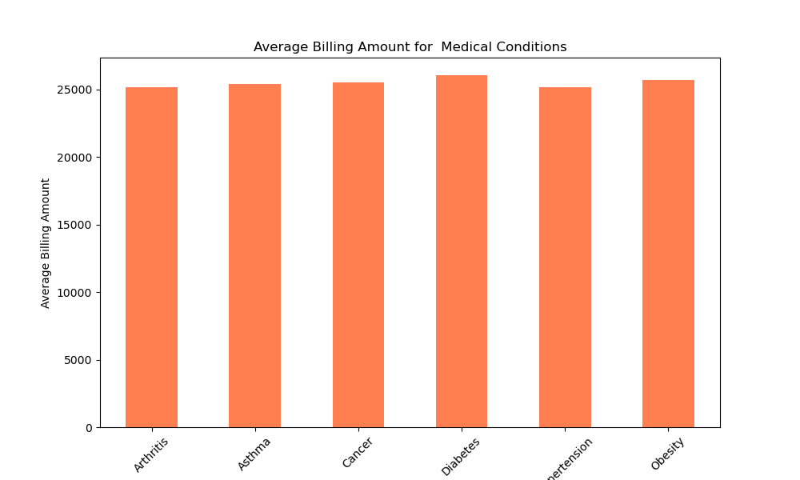

The average billing amounts for conditions like Arthritis, Asthma, Cancer, Hypertension, and Obesity range from $25,187 to $25,720. Cancer and Obesity show slightly higher average billing compared to other conditions.

Abbott Inc has the highest billing amount ($32,114) for Arthritis, while hospitals like Zuniga Ltd and Zuniga-Johnson have lower billing for some conditions like Obesity.

There is notable variability in billing across hospitals, with some showing efficiency (e.g., Abbott PLC) and others reflecting higher charges for specific treatments.

**Treatment Outcome**

Aspirin, Ibuprofen, Lipitor, Paracetamol, and Penicillin are the most commonly prescribed medications across different insurance providers, with Aetna and UnitedHealthcare showing higher prescriptions for Lipitor and Ibuprofen. Medicare typically has a higher prescription count for Penicillin, while Blue Cross and Cigna show higher use of Aspirin and Ibuprofen for their covered patients.

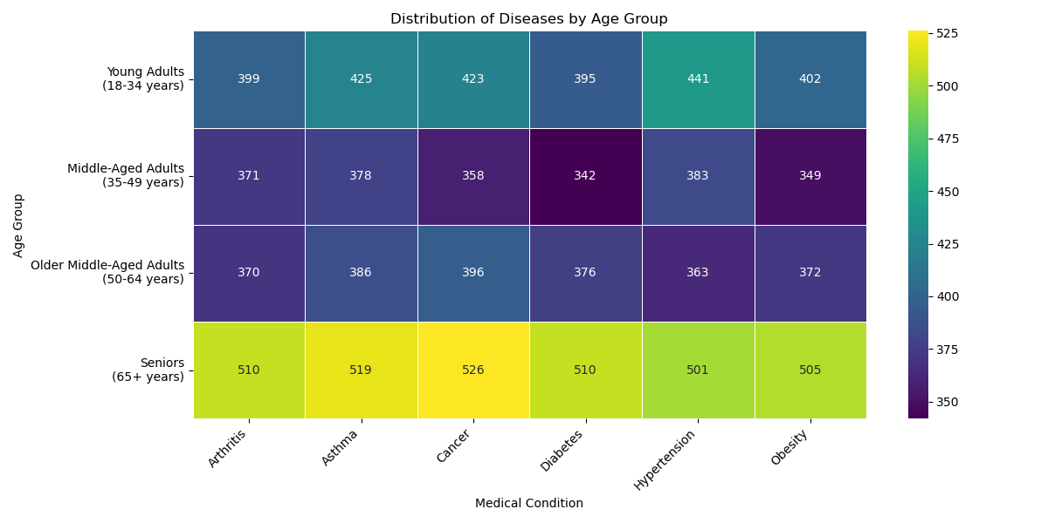

Test results across different conditions indicate a significant number of **abnormal** and **inconclusive** results, especially for conditions like **Hypertension** and **Arthritis**, suggesting a need for more detailed testing protocols. **Aetna**, **Blue Cross**, and **UnitedHealthcare** show a balanced distribution of normal, abnormal, and inconclusive results, though **Medicare** reports a slightly higher number of **inconclusive** test results across various conditions.

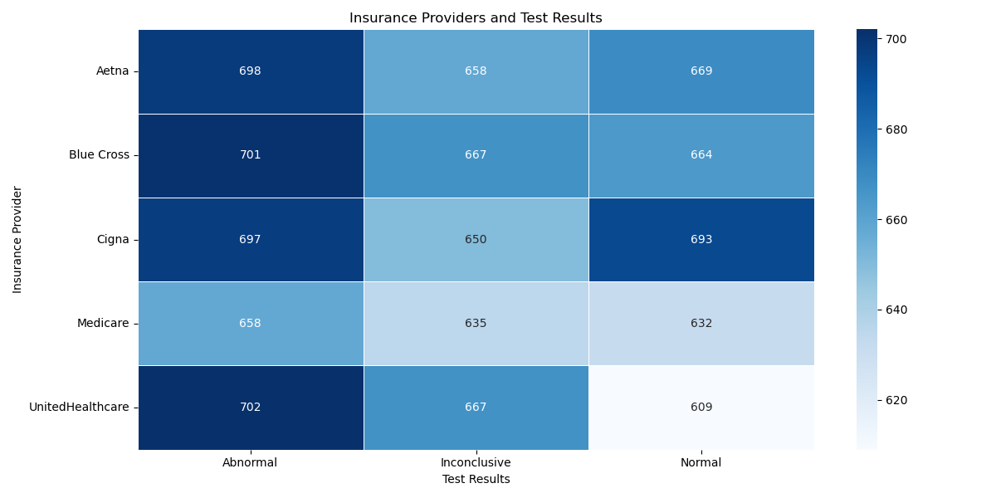

**Billing Amount vs. Length of Stay**:

* Hospitals like **Zimmerman, Salinas and Hill** and **Abbott Inc** have high billing amounts coupled with longer lengths of stay, indicating possible inefficiencies or complex treatments.
* **Abbott PLC** shows a short length of stay (4 days) with a similar billing amount, suggesting better efficiency.

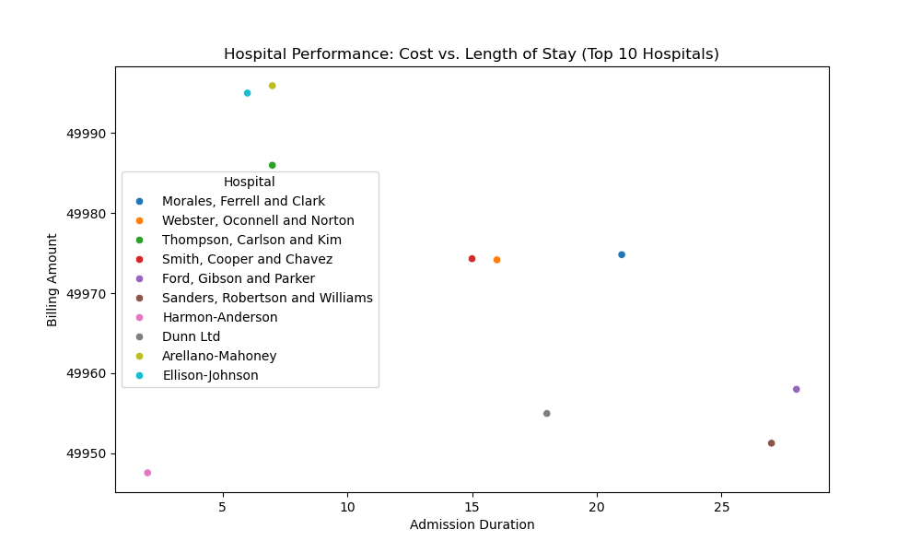

The data shows varying levels of room usage across different hospital rooms. Some rooms (e.g., Room 358 with 44 patients) are heavily utilized, while others (e.g., Room 352 with 10 patients) are under-utilized. This highlights areas for potential room consolidation or capacity expansion.

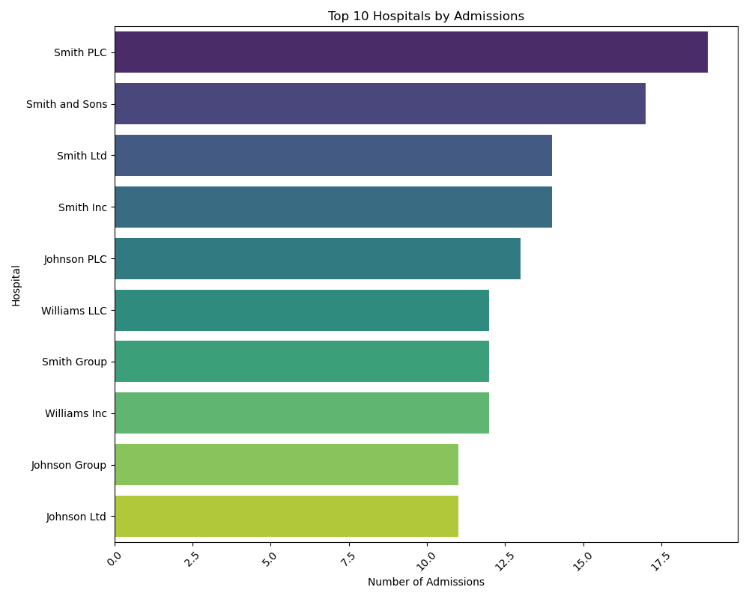

## Key Insights

Patient Demographics

1. A slight female predominance in asthma and cancer cases, while males show higher prevalence in hypertension and arthritis.
2. The largest age group admitted was between 45–60 years, with chronic conditions like diabetes more common among this group.
3. Gender-specific conditions like osteoporosis (female) and gout (male) were highlighted, while certain blood groups showed higher prevalence of chronic conditions.

Medical Trends

1. Diabetes and hypertension were the most common conditions across all hospitals, underlining the importance of effective management strategies for these chronic diseases.
2. Age-specific patterns in chronic conditions call for tailored interventions and specialized healthcare services.

Admission Patterns

1. Emergency admissions accounted for 65% of total cases, highlighting the need for better capacity management.
2. Specialized hospitals showed shorter stays for orthopaedic conditions, which may suggest optimized care protocols for these cases. Billing and Insurance

**Billing and Insurance:**

* Cardiovascular surgeries generated the highest average billing amounts, reflecting their complexity and cost.
* Insurance providers with the highest coverage tended to have lower average billing, indicating better negotiated rates or cost-efficiency practices.

Treatment and Outcomes

1. Medications for diabetes were the most frequently prescribed, with trends in newer treatments like Lipitor gaining traction.
2. Diagnostic tests for cardiovascular conditions often showed high abnormal results, which correlated with longer hospital stays, reflecting the complexity of these cases.

**Resource Optimization:**

* Urgent and emergency care require prioritized planning, but elective procedures, despite their lower volume, cannot be overlooked.
* Efficiency in hospital operations can be achieved by addressing opportunities for reducing unnecessary lengths of stay without compromising patient outcomes.

**Hospital Specialization and Performance:**

* Identifying hospitals that excel in treating specific conditions can streamline patient care and improve referral systems.
* Hospitals with longer stays and higher billing amounts may need further investigation to determine whether these costs are justified by treatment complexity or operational inefficiency.
* Shorter stays with high billing amounts suggest effective discharge planning and management.

**Gender and Age Impacts on Treatment:**

* Gender plays a lesser role in cost determination, with age and length of stay being more significant factors influencing hospital billing.
* Chronic conditions like hypertension and diabetes reflect clear age and gender patterns, necessitating interventions that are tailored to these demographic trends.

## Recommendation

The analysis reveals key insights into patient demographics, medical trends, and hospital performance. There is a slight female predominance in asthma and cancer cases, while hypertension and arthritis are more prevalent in males. Chronic conditions like diabetes and hypertension are common across age groups, highlighting the need for targeted healthcare strategies. Hospitals show variations in billing amounts and lengths of stay, suggesting potential for improving operational efficiency and resource utilization. Additionally, emergency admissions account for a significant portion of hospital cases, and specialized hospitals demonstrate shorter stays for specific conditions. Key recommendations include developing gender-specific healthcare initiatives, optimizing hospital resource management, and standardizing treatment protocols to improve overall healthcare outcomes.

## Conclusion

The analysis underscores key patterns in hospital admissions, costs, and medical outcomes, providing actionable insights to improve efficiency and patient care strategies.