Using skywalking-3.2.6 with code: https://github.com/hepyu/bird master (only use lbs-service, lbs-web, and only use necessary jars), as base reference.
Command:
java -javaagent:/app/3rd/skywalking-agent/skywalking-agent.jar -jar -XX:MetaspaceSize=256m -XX:MaxMetaspaceSize=256m -Xms6000M -Xmx6000M -Dspring.profiles.active=pro com-bird-lbs/com-bird-lbs-web/target/com-bird-lbs-web-1.0-SNAPSHOT.jar
of course, I should start lbs-service(motan-provider) in another machine.

(1).jdk8 version: 1.8.0_65-b17
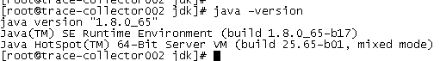
Top.res.Delta: 415M
With skywalking:
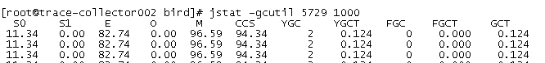
Without skywalking:

(2).jdk8 version: 1.8.0_181-b13 (newest minor version of 1.8)
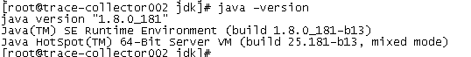
Top.res.Delta: 429M
With skywalking:
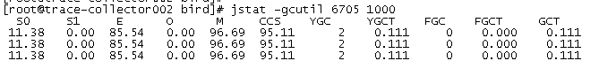
Without skywalking:
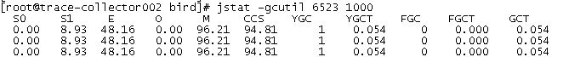

(3).Jdk9 version:
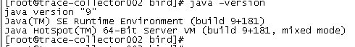
Top.res.Delta: 420M
With skywalking:
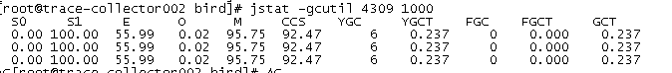
Without skywalking:

(4).jdk10 version:
Top.res.Delta: 499M
With skywalking:
Without skywalking:
