选择：最新版本8.0

<https://dev.mysql.com/downloads/repo/yum/>

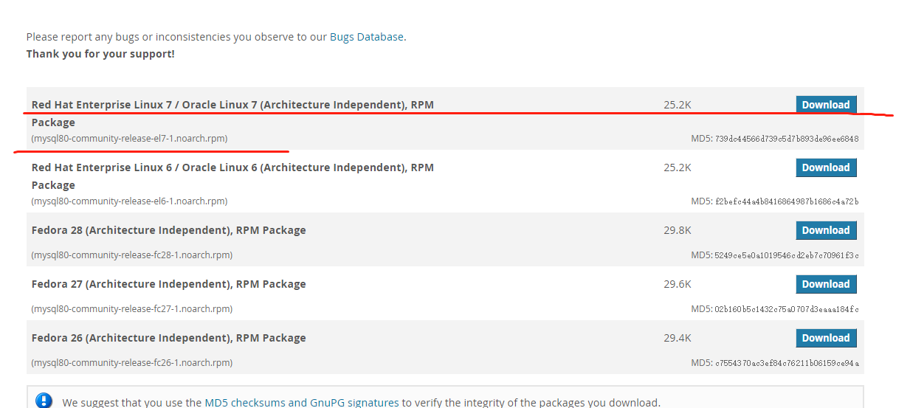

下载后：

yum localinstall mysql80-community-release-el7-1.noarch.rpm

然后：

[root@iZ253ayhxa9Z ~]# yum repolist enabled | grep "mysql.*-community.*"

mysql-connectors-community/x86_64 MySQL Connectors Community 51

mysql-tools-community/x86_64 MySQL Tools Community 63

mysql80-community/x86_64 MySQL 8.0 Community Server 17

然后：

yum install mysql-community-server

启动:

systemctl start mysqld

或者

service mysqld start

grep password /var/log/mysqld.log

2018-07-22T12:11:15.081010Z 5 [Note] [MY-010454] [Server] A temporary password is generated for root@localhost: ,Zfliyt7bNyN

我们知道root密码是Zfliyt7bNyN.

然后登陆:

mysql -uroot -pZfliyt7bNyN -hlocalhost

如果提示：

ERROR 1045 (28000): Access denied for user 'root'@'localhost' (using password: YES)

这样操作:

systemctl stop mysqld

mysqld-debug --user=mysql --skip-grant-tables --skip-networking &

mysql -u root mysql

set password for root@localhost = password('root');//8之前可以这样，但8不行了

ALTER USER 'root'@'localhost' IDENTIFIED WITH mysql_native_password BY 'root';//8需要这样设置

如果还报Access denied.先flush privileges;

但是提示：

ERROR 1819 (HY000): Your password does not satisfy the current policy requirements

这个其实与validate_password_policy的值有关。

validate_password_policy有以下取值：

| Policy | Tests Performed |
| --- | --- |
| 0 or LOW | Length |
| 1 or MEDIUM | Length; numeric, lowercase/uppercase, and special characters |
| 2 or STRONG | Length; numeric, lowercase/uppercase, and special characters; dictionary file |

默认是1，即MEDIUM，所以刚开始设置的密码必须符合长度，且必须含有数字，小写或大写字母，特殊字符。

有时候，只是为了自己测试，不想密码设置得那么复杂，譬如说，我只想设置root的密码为123456。

不那么麻烦：设置满足要求的pwd

ALTER USER 'root'@'localhost' IDENTIFIED WITH mysql_native_password BY 'Zfliyt7bNyN11Zfliyt7bNyN$';

重启mysql:

systemctl stop mysqld

systemctl start mysqld

mysql -uroot -pZfliyt7bNyN11Zfliyt7bNyN$登陆成功.