结构目录
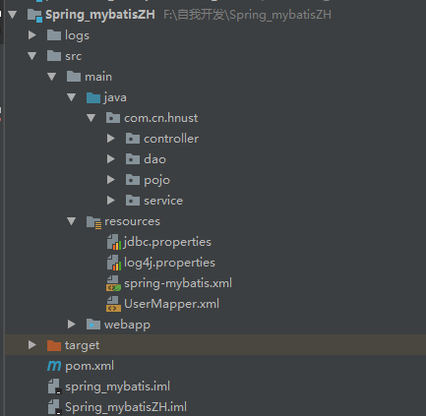

二、配置文件

jdbc.properties
driver=com.mysql.jdbc.Driver
url=jdbc:mysql://localhost:3306/test
username=root
password=root
#定义初始连接数
initialSize=0
#定义最大连接数
maxActive=20
#定义最大空闲
maxIdle=20
#定义最小空闲
minIdle=1
#定义最长等待时间
maxWait=60000

log4j.properties
log4j.rootLogger=INFO,Console,File
#定义日志输出目的地为控制台
log4j.appender.Console=org.apache.log4j.ConsoleAppender
log4j.appender.Console.Target=System.out
#可以灵活地指定日志输出格式，下面一行是指定具体的格式
log4j.appender.Console.layout = org.apache.log4j.PatternLayout
log4j.appender.Console.layout.ConversionPattern=[%c] - %m%n
#文件大小到达指定尺寸的时候产生一个新的文件
log4j.appender.File = org.apache.log4j.RollingFileAppender
#指定输出目录
log4j.appender.File.File = logs/ssm.log
#定义文件最大大小
log4j.appender.File.MaxFileSize = 10MB
# 输出所以日志，如果换成DEBUG表示输出DEBUG以上级别日志
log4j.appender.File.Threshold = ALL
log4j.appender.File.layout = org.apache.log4j.PatternLayout
log4j.appender.File.layout.ConversionPattern =[%p] [%d{yyyy-MM-dd HH\:mm\:ss}][%c]%m%n

spring-mybatis.xml
<?xml version="1.0" encoding="UTF-8"?>
<beans xmlns="http://www.springframework.org/schema/beans"
xmlns:xsi="http://www.w3.org/2001/XMLSchema-instance" xmlns:p="http://www.springframework.org/schema/p"
xmlns:context="http://www.springframework.org/schema/context"
xmlns:mvc="http://www.springframework.org/schema/mvc"
xsi:schemaLocation="http://www.springframework.org/schema/beans
http://www.springframework.org/schema/beans/spring-beans-3.1.xsd
http://www.springframework.org/schema/context
http://www.springframework.org/schema/context/spring-context-3.1.xsd
http://www.springframework.org/schema/mvc
http://www.springframework.org/schema/mvc/spring-mvc-4.0.xsd">
<!-- 自动扫描 -->
<context:component-scan base-package="com.cn.hnust" />
<!-- 引入配置文件 -->
<bean id="propertyConfigurer"
class="org.springframework.beans.factory.config.PropertyPlaceholderConfigurer">
<property name="location" value="classpath:jdbc.properties" />
</bean>
<bean id="dataSource" class="org.apache.commons.dbcp.BasicDataSource"
destroy-method="close">
<property name="driverClassName" value="${driver}" />
<property name="url" value="${url}" />
<property name="username" value="${username}" />
<property name="password" value="${password}" />
<!-- 初始化连接大小 -->
<property name="initialSize" value="${initialSize}"></property>
<!-- 连接池最大数量 -->
<property name="maxActive" value="${maxActive}"></property>
<!-- 连接池最大空闲 -->
<property name="maxIdle" value="${maxIdle}"></property>
<!-- 连接池最小空闲 -->
<property name="minIdle" value="${minIdle}"></property>
<!-- 获取连接最大等待时间 -->
<property name="maxWait" value="${maxWait}"></property>
</bean>
<!-- spring和MyBatis完美整合，不需要mybatis的配置映射文件 -->
<bean id="sqlSessionFactory" class="org.mybatis.spring.SqlSessionFactoryBean">
<property name="dataSource" ref="dataSource" />
<!-- 自动扫描mapping.xml文件 -->
<property name="mapperLocations" value="classpath:UserMapper.xml"></property>
</bean>
<!-- DAO接口所在包名，Spring会自动查找其下的类 -->
<bean class="org.mybatis.spring.mapper.MapperScannerConfigurer">
<property name="basePackage" value="com.cn.hnust.dao" />
<property name="sqlSessionFactoryBeanName" value="sqlSessionFactory"></property>
</bean>
<!-- (事务管理)transaction manager, use JtaTransactionManager for global tx -->
<bean id="transactionManager"
class="org.springframework.jdbc.datasource.DataSourceTransactionManager">
<property name="dataSource" ref="dataSource" />
</bean>
</beans>

UserMapper.xml

<?xml version="1.0" encoding="UTF-8" ?>
<!DOCTYPE mapper PUBLIC "-//mybatis.org//DTD Mapper 3.0//EN" "http://mybatis.org/dtd/mybatis-3-mapper.dtd" >
<mapper namespace="com.cn.hnust.dao.IUserDao">
<select id="selectByPrimaryKey" resultType="com.cn.hnust.pojo.User">
select * from user_t where id = #{userId}
</select>
<select id="selectAll" resultType="com.cn.hnust.pojo.User">
select * from user_t
</select>
</mapper>

TestMyBatis
@RunWith(SpringJUnit4ClassRunner.class) //表示继承了SpringJUnit4ClassRunner类
@ContextConfiguration(locations = {"classpath:spring-mybatis.xml"})
public class TestMyBatis {
private static Logger log = Logger.getLogger(TestMyBatis.class);
private static java.util.logging.Logger logger = java.util.logging.Logger.getLogger(TestMyBatis.class.getName());
@Resource
private IUserService userService = null;
@Test
public void test1() {
User user = userService.getUserById(5);
logger.info(JSON.toJSONString(user));
}
@Test
public void test2() {
List<User> user = userService.GetUserAll();
logger.info(JSON.toJSONString(user));
log.info(JSON.toJSONString(user));
}
}

