结构目录
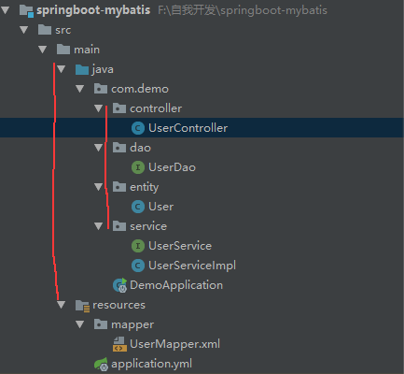

配置文件

application.yml
#默认使用配置
#spring:
# profiles:
# active: dev
#公共配置与profiles选择无关
mybatis:
typeAliasesPackage: com.demo.entity
mapperLocations: classpath:mapper/*.xml
---
#开发配置
spring:
#profiles: dev
datasource:
url: jdbc:mysql://localhost:3306/test
username: root
password: root
driver-class-name: com.mysql.jdbc.Driver
# 使用druid数据源
type: com.alibaba.druid.pool.DruidDataSource

UserMapper.xml
<?xml version="1.0" encoding="UTF-8" ?>
<!DOCTYPE mapper PUBLIC "-//mybatis.org//DTD Mapper 3.0//EN" "http://mybatis.org/dtd/mybatis-3-mapper.dtd" >
<mapper namespace="com.demo.dao.UserDao" >
<resultMap id="BaseResultMap" type="com.demo.entity.User" >
<id column="id" property="id" jdbcType="INTEGER" />
<result column="user_name" property="userName" jdbcType="VARCHAR" />
<result column="password" property="password" jdbcType="VARCHAR" />
<result column="age" property="age" jdbcType="INTEGER" />
</resultMap>
<sql id="Base_Column_List" >
id, user_name, password, age
</sql>
<select id="selectAll" resultMap="BaseResultMap">
select
<include refid="Base_Column_List" />
from user_t
</select>
<select id="selectByPrimaryKey" resultMap="BaseResultMap" parameterType="java.lang.Integer" >
select
<include refid="Base_Column_List" />
from user_t
where id = #{id,jdbcType=INTEGER}
</select>
<delete id="deleteByPrimaryKey" parameterType="java.lang.Integer" >
delete from user_t
where id = #{id,jdbcType=INTEGER}
</delete>
<insert id="insert" parameterType="com.demo.entity.User" >
insert into user_t (id, user_name, password,
age)
values (#{id,jdbcType=INTEGER}, #{userName,jdbcType=VARCHAR}, #{password,jdbcType=VARCHAR},
#{age,jdbcType=INTEGER})
</insert>
<insert id="insertSelective" parameterType="com.demo.entity.User" >
insert into user_t
<trim prefix="(" suffix=")" suffixOverrides="," >
<if test="id != null" >
id,
</if>
<if test="userName != null" >
user_name,
</if>
<if test="password != null" >
password,
</if>
<if test="age != null" >
age,
</if>
</trim>
<trim prefix="values (" suffix=")" suffixOverrides="," >
<if test="id != null" >
#{id,jdbcType=INTEGER},
</if>
<if test="userName != null" >
#{userName,jdbcType=VARCHAR},
</if>
<if test="password != null" >
#{password,jdbcType=VARCHAR},
</if>
<if test="age != null" >
#{age,jdbcType=INTEGER},
</if>
</trim>
</insert>
<update id="updateByPrimaryKeySelective" parameterType="com.demo.entity.User" >
update user_t
<set >
<if test="userName != null" >
user_name = #{userName,jdbcType=VARCHAR},
</if>
<if test="password != null" >
password = #{password,jdbcType=VARCHAR},
</if>
<if test="age != null" >
age = #{age,jdbcType=INTEGER},
</if>
</set>
where id = #{id,jdbcType=INTEGER}
</update>
<update id="updateByPrimaryKey" parameterType="com.demo.entity.User" >
update user_t
set user_name = #{userName,jdbcType=VARCHAR},
password = #{password,jdbcType=VARCHAR},
age = #{age,jdbcType=INTEGER}
where id = #{id,jdbcType=INTEGER}
</update>
</mapper>

DemoApplication
@SpringBootApplication
@MapperScan("com.demo.dao")
public class DemoApplication {
public static void main(String[] args) {
SpringApplication.run(DemoApplication.class, args);
}
}

