TOO GOOD TO GO — MEXICO MARKET ENTRY REPORT
Prepared for internal expansion planning | Author: Yenam Dossou
Includes 3‑country screening (Mexico, UAE, Côte d’Ivoire) and demand visuals for Mexico City (CDMX)

Executive Summary
Decision: Enter Mexico via direct expansion, piloting in Mexico City (CDMX), with secondary cities Guadalajara, Monterrey, Puebla, and Querétaro once KPIs are met. The addressable merchant base and high smartphone adoption create favorable unit economics; household food waste levels and macro context support demand for value‑priced “Surprise Bags.”

1. Three‑Country Screening
We initially assessed Mexico, United Arab Emirates (UAE), and Côte d’Ivoire across impact potential, market depth, and digital readiness. Highlights:
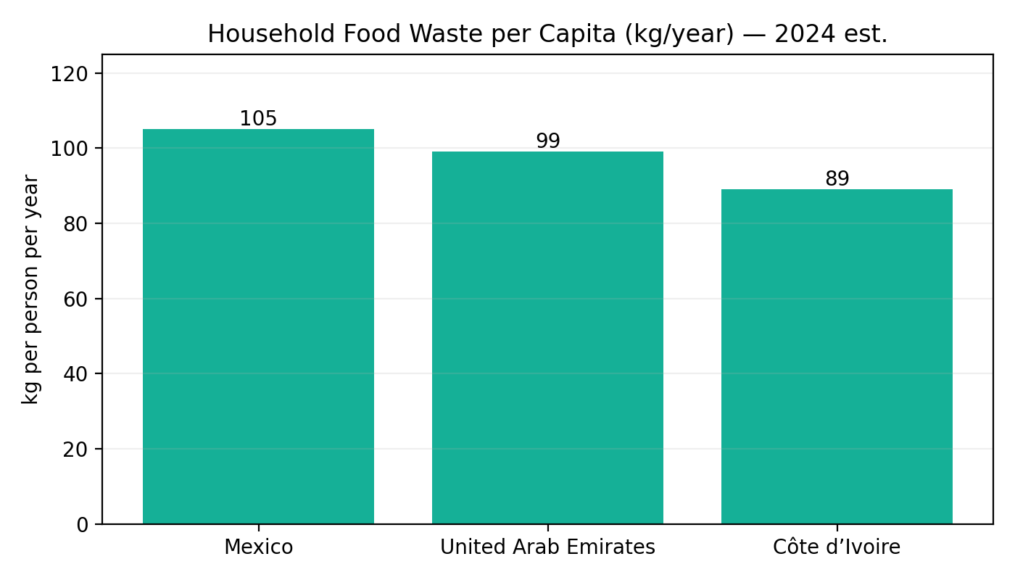
Fig. 1 — Household food waste per capita (kg/year). Source: WorldPopulationReview (compiled from UNEP Food Waste Index 2024); UNEP Food Waste Index 2024.
- • Mexico shows high per‑capita household food waste (~105 kg/year) and very large urban agglomerations where surplus and demand meet.
- • UAE has substantial hospitality-driven surplus and strong ESG pressure on hotels/caterers to measure and reduce waste; data‑rich reporting aligns with our value proposition.
- • Côte d’Ivoire presents social impact potential and growing urban food businesses, but purchasing power and digital infrastructure suggest sequencing it after Mexico.

2. Why Mexico (CDMX First)
2.1 Demand & Supply Signals
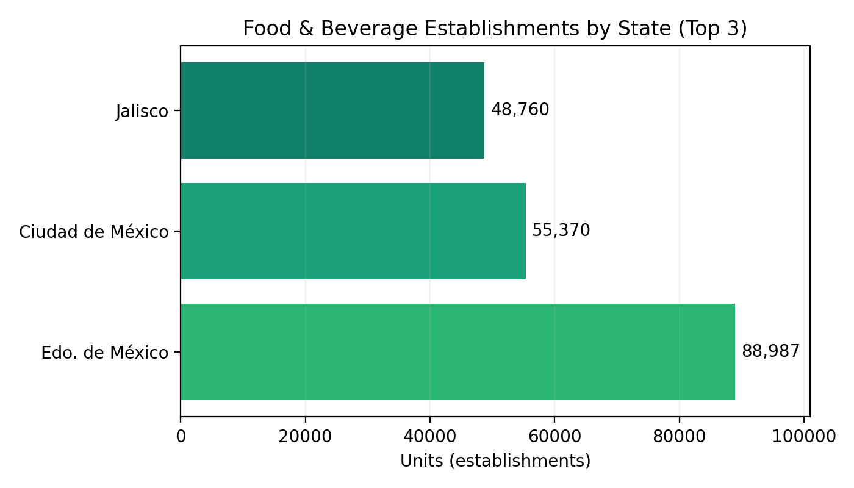
Fig. 2 — Food & beverage establishments — top states. Source: Data México (DENUE, May 2025).
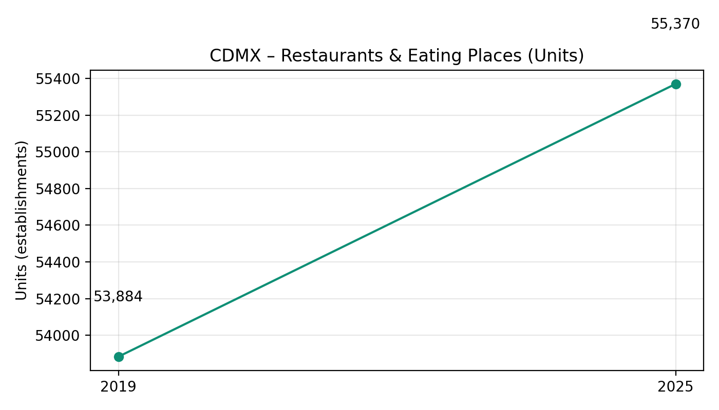
Fig. 3 — CDMX restaurants & eating places (units), 2019 vs 2025. Source: INEGI Censos Económicos 2019 (CDMX); Data México (DENUE, May 2025).
2.2 Digital Readiness: Smartphone penetration in Mexico reached ~95.7% of active mobile lines (Q3‑2024), enabling an app‑only model and cost‑efficient acquisition through TikTok/Instagram/Maps.
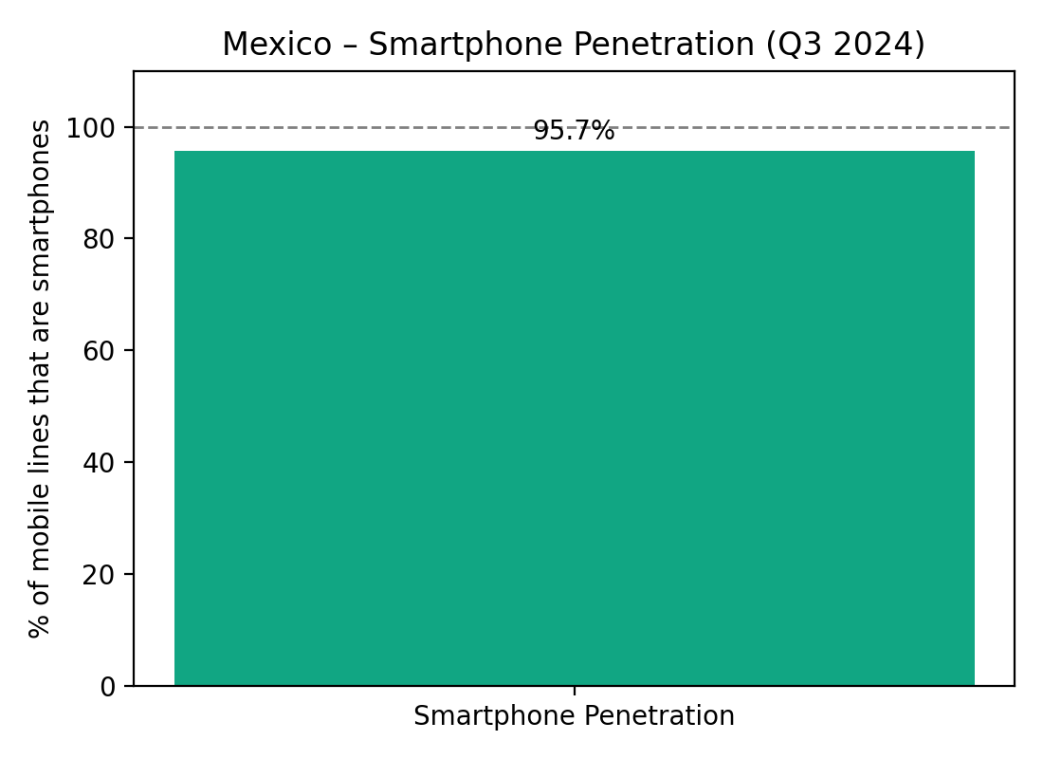
Fig. 4 — Smartphone penetration (Q3‑2024). Source: The Competitive Intelligence Unit (The CIU).
2.3 Pricing Context: Food inflation is moderate, supporting value messaging (“Salva comida. Salva dinero.”).
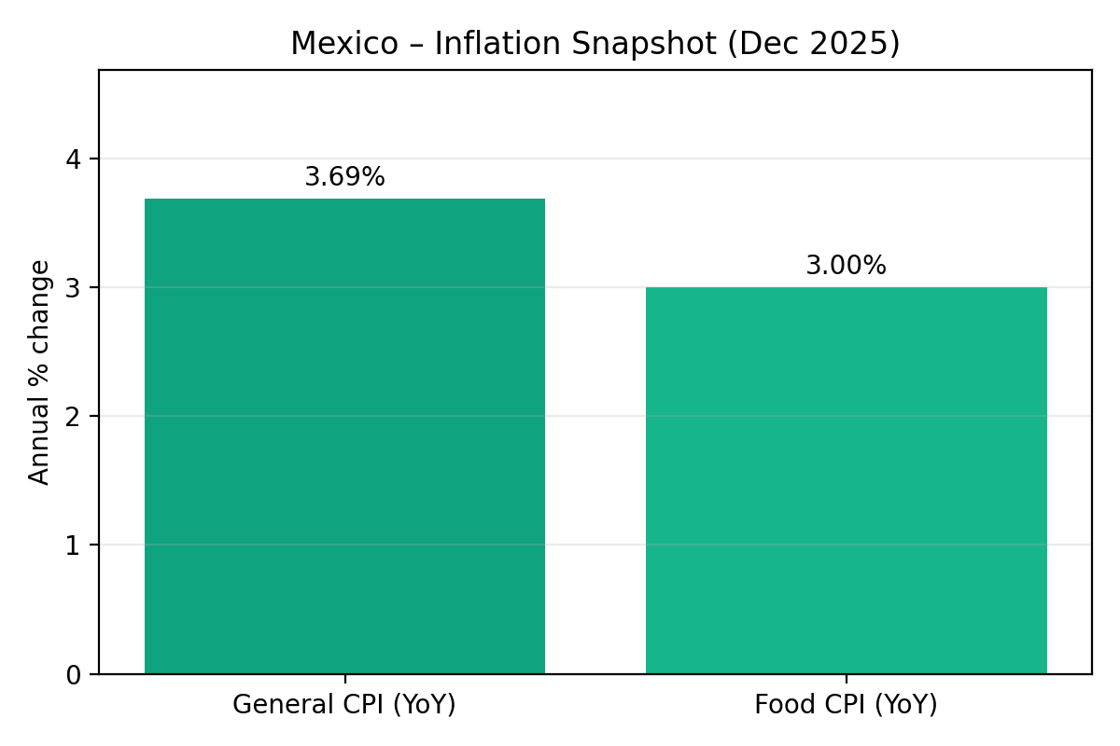
Fig. 5 — Inflation snapshot (Dec 2025). Source: INEGI CPI; INEGI via TradingEconomics (Food CPI).
2.4 Potential User Base (Metro CDMX) — top‑down
Metro population: ~22,752,000. Assuming 80% aged 15+ and 95.7% smartphone adoption among adults → Potential app‑ready adults ~17,418,931.
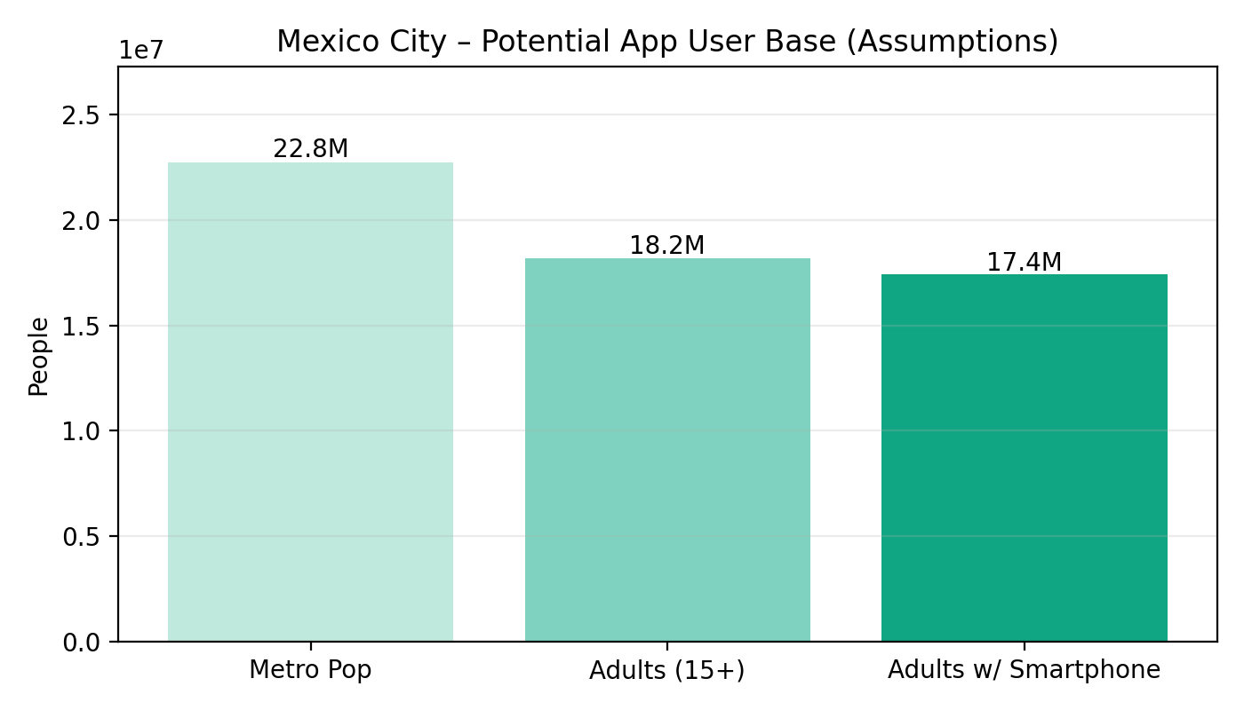
Fig. 6 — Potential app user base (assumptions stated). Sources: Macrotrends (metro population 2025); The CIU (smartphones).

3. Entry Model & Launch Strategy
Entry Model — Direct expansion. We keep control of brand, ops standards, and data to scale nationally. Launch phases: (1) Pilot in CDMX; (2) Secondary cities (Guadalajara, Monterrey, Puebla, Querétaro); (3) Nationwide once KPIs are met.

4. Marketing Strategy & Brand Adaptation
Tone & Localization: Friendly, community‑oriented, optimistic. Key lines: “Salva comida. Salva dinero.” / “Comida buena, precio justo.” / “Juntos contra el desperdicio.”
- Channels: TikTok, Instagram Reels, Google Maps listings, WhatsApp Business for merchant support; campus ambassadors (UNAM, IPN, Tec de Monterrey); NGOs; in‑store QR; street teams; PR with sustainability angle.

5. Logistics, CX & Compliance
Operating model: TGTG does not handle food. App reservations, fixed pickup windows, no delivery. Merchant onboarding, dashboard, pickup guidelines, branded materials. Compliance guidance aligned to NOM‑051 and safe handling of near‑expiry products.

6. Cost of Installation & Local Setup (CDMX)
Category | Estimated Cost (USD)
Local team (first 6 months) | 30,000–45,000
Marketing launch | 15,000–25,000
Merchant kits | 3,000
Legal + accounting | 3,000–6,000
Office (optional) | 1,000 / month
Travel & meetings | 2,000
Contingency | 5,000
Total estimated investment: $60,000–$90,000 for a strong launch in CDMX.

7. Demand & Adoption — Year‑1 Scenarios (CDMX)
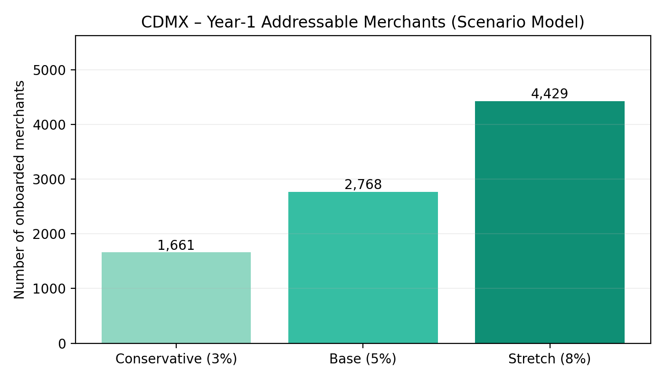
Fig. 7 — Onboarded merchants scenarios from CDMX base (DENUE May 2025).
Scenario | Onboarded merchants (count)
Conservative (3%) | 1,661
Base (5%) | 2,768
Stretch (8%) | 4,429
Use these to size sales headcount, merchant kits, and CAC/LTV targets. (Assumptions documented; adjust as needed.)

8. Local Suppliers & Partnerships
- Target merchants: bakeries, cafés, restaurants, supermarkets (Soriana, Chedraui, La Comer), hotels & buffets. Source locally for printed materials, kits, promos, event logistics to reduce cost and support local SMEs.

9. Differentiation
- • Global brand trust & stronger national‑chain partnerships
- • Superior app technology & user experience
- • Community‑driven mission and ESG reporting (CO₂ saved, meals rescued) for merchants

10. Key Risks & Mitigations
- • Merchant churn → Mitigation: data‑backed coaching, pickup‑window optimization, featured placement incentives.
- • Quality at pickup → Mitigation: templated prep & labeling, rating triggers, spot checks.
- • Regulatory changes → Mitigation: local counsel; template SOPs aligned to NOM‑051.

11. KPIs for Pilot
- • Active merchants (M) & net adds/week
- • Surprise Bags listed vs. sold (%) and daily sell‑through
- • NPS at pickup; order issue rate (%)
- • Rescued meals & CO₂e avoided

12. Timeline (Indicative)
- Month 0–1: legal, pilot merchant LOIs, city team hiring
- Month 2: merchant onboarding sprint, campus & street activation
- Month 3–4: PR + supermarket/hotel chains; iterate pickup windows
- Month 5–6: reach Base scenario; prep Guadalajara/Monterrey launch

13. Country Notes (for the three markets)
Mexico — Why the project fits: High food‑waste levels in cities, very large and dense merchant base in CDMX and key states, high smartphone adoption, and moderate inflation support the value proposition and scale‑up logic.
United Arab Emirates — Why considered: One of the highest per‑capita food‑waste contexts in the region; strong ESG pressure and measurable waste‑reduction programs in hotels/catering; ideal for enterprise partnerships in later phase.
Côte d’Ivoire — Why considered: Urban food businesses + social impact; sequence after Mexico to allow product/ops fit for more informal systems and mobile‑money led adoption.

Conclusion
Mexico is a high‑potential market. With direct expansion, localized branding, strong partnerships, and a structured rollout, TGTG can establish leadership in anti‑food‑waste services in Mexico. Start with CDMX, hit Base scenario by Month‑6, then expand to Guadalajara and Monterrey.

References (Key Sources)
• UNEP — Food Waste Index Report 2024 (global scale, methodology)
• WorldPopulationReview — Country food‑waste per‑capita table (compiled from UNEP)
• Data México (Secretaría de Economía) — DENUE May 2025 restaurant/eating places counts
• INEGI — Censos Económicos 2019 (CDMX establishments); CPI dashboard
• Macrotrends — Mexico City metro population 2025
• The Competitive Intelligence Unit (The CIU) — Smartphone penetration Q3‑2024
• TradingEconomics (INEGI source) — Mexico food CPI (Dec 2025)

