TOO GOOD TO GO — MEXICO MARKET ENTRY REPORT (Expanded)
Prepared for internal expansion planning | Author: Yenam Dossou
Includes: Company overview & current state + strengthened Mexico vs UAE/CI rationale

0. About Too Good To Go (TGTG) — What We Do & Where We Are
Purpose: help businesses sell unsold, still-good food to consumers at a reduced price through “Surprise Bags”, lowering waste, saving consumers money, and creating measurable CO₂e impact. Business model: marketplace app connecting consumers with merchant pickup windows; no delivery; no direct food handling. Impact KPIs: meals rescued and estimated CO₂e avoided.
Current state (high level): operating across Europe & North America with playbooks for large metros (dense merchant clusters + high smartphone adoption + national-chain partnerships).
Product pillars:
- • Merchant Experience — onboarding, listing, pickup windows, analytics/impact dashboard
- • Consumer Experience — app discovery, reservation, map pickup, ratings
- • Trust & Safety — food-safety guidance, standards, dispute resolution

Executive Summary
Decision: Enter Mexico via direct expansion, piloting in Mexico City (CDMX), then Guadalajara, Monterrey, Puebla, Querétaro once KPIs are met. Mexico offers demand density, smartphone ubiquity, and merchant depth for rapid proof and scale.

Why Mexico Over UAE & Côte d’Ivoire — Decision Rationale
• Demand density & merchant depth (fast onboarding, efficient routing). (See Figs. 2–3.)
• Digital acquisition efficiency: ~95.7% smartphone penetration → app-only CAC advantages. (Fig. 4.)
• Consumer value sensitivity with moderate current food CPI → strong value messaging. (Fig. 5.)
• Speed-to-proof vs. UAE (enterprise-heavy ESG cycles) and Côte d’Ivoire (informality and payments). (Fig. 7.)
• Sequencing: validate in Mexico, then take enterprise/ESG learning to UAE and social-inclusion workflows to Côte d’Ivoire.

1. Three‑Country Screening
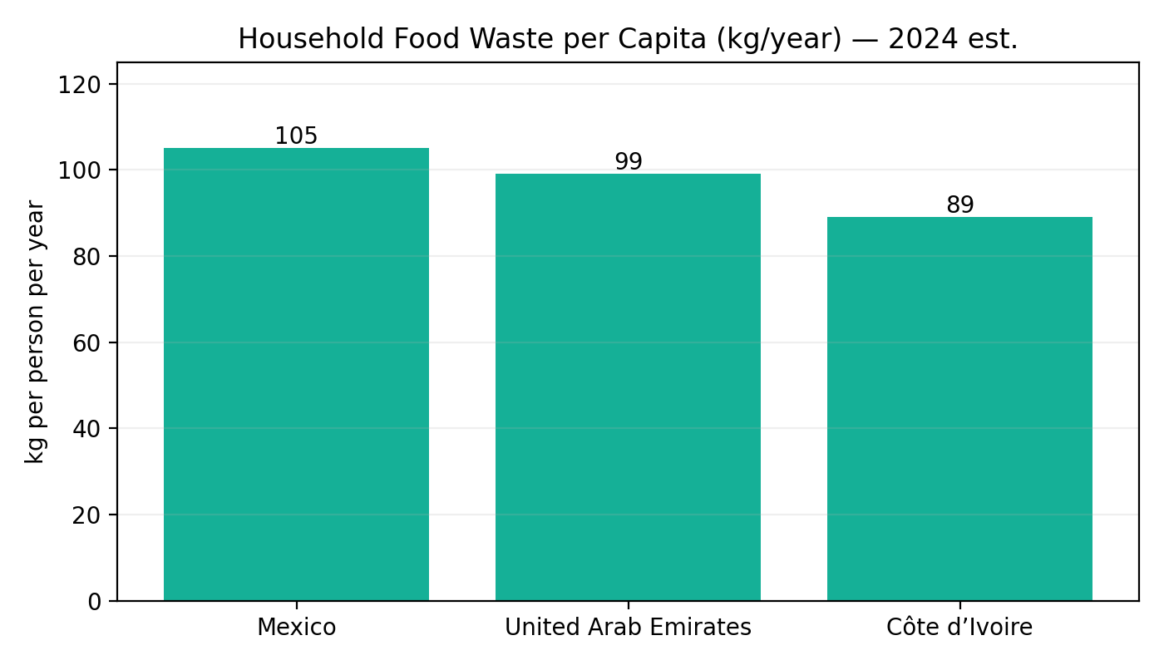
Fig. 1 — Household food waste per capita (kg/year).

2. Why Mexico (CDMX First)
2.1 Demand & Supply Signals
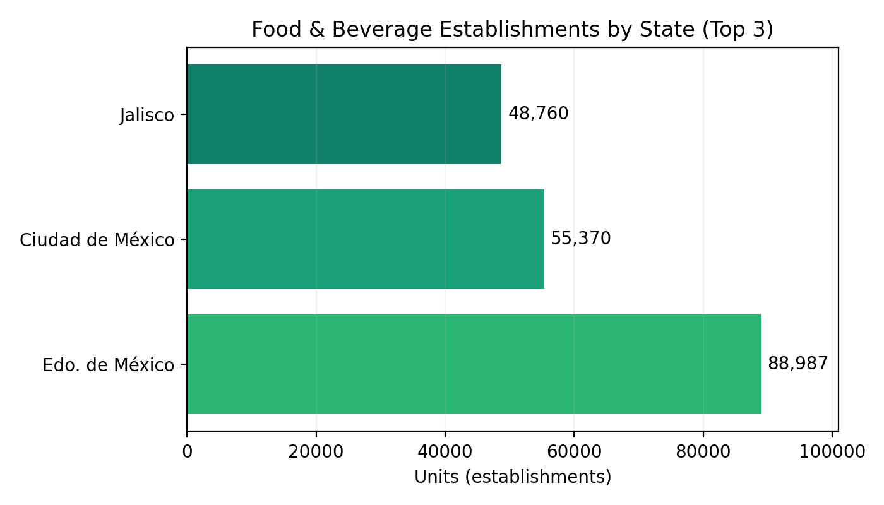
Fig. 2 — Food & beverage establishments — top states.
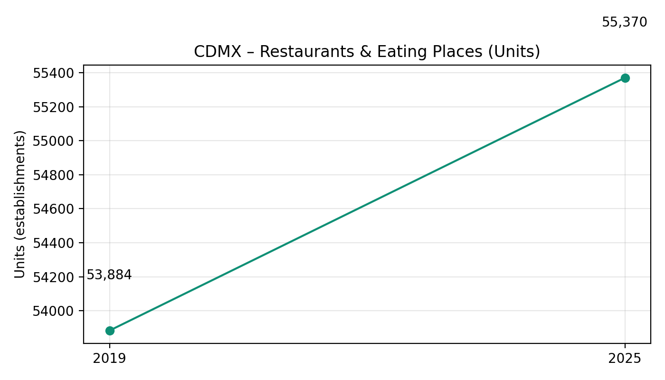
Fig. 3 — CDMX restaurants & eating places (2019 vs 2025).
2.2 Digital Readiness
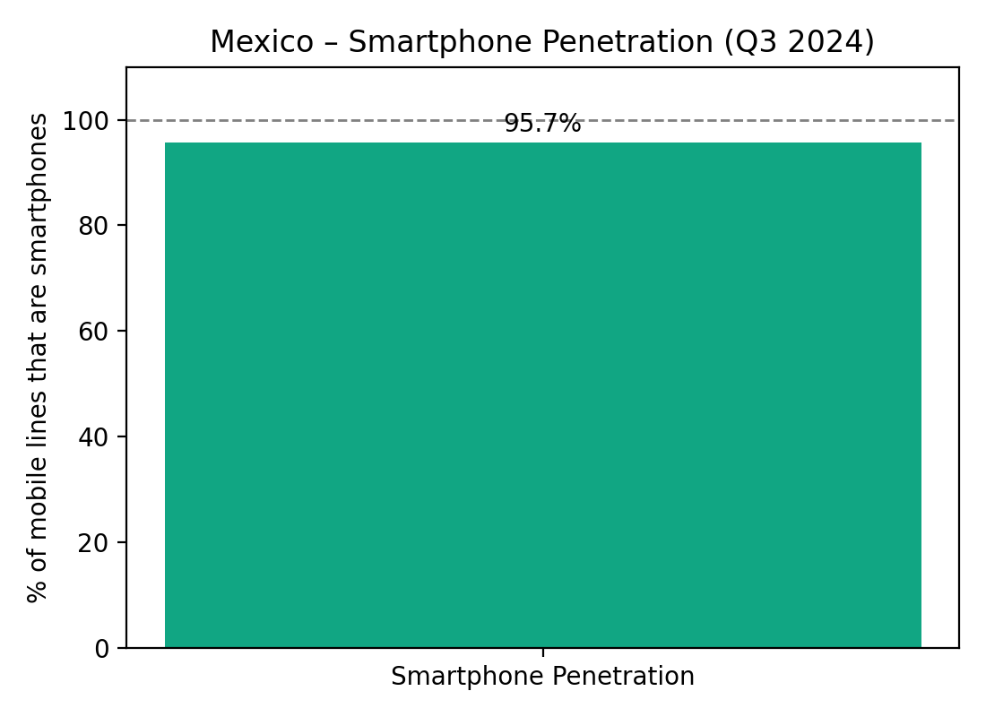
Fig. 4 — Smartphone penetration (Q3‑2024).
2.3 Pricing Context
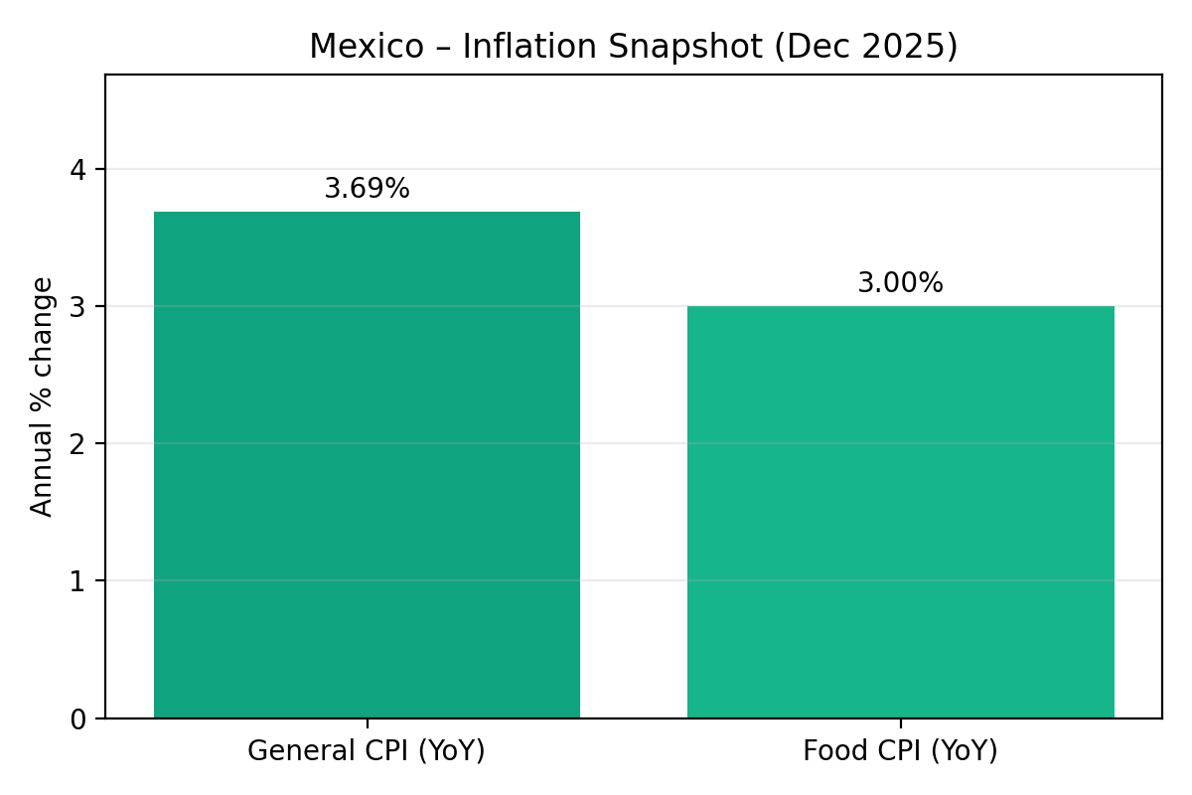
Fig. 5 — Inflation snapshot (Dec 2025).
2.4 Potential User Base (Metro CDMX)
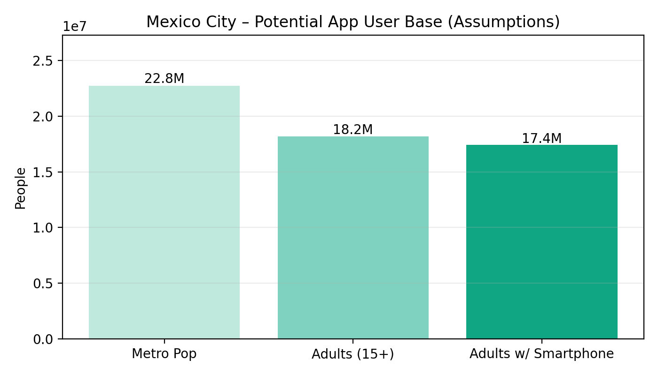
Fig. 6 — Potential app user base (assumptions).

3. Entry Model & Launch Strategy
Direct expansion; CDMX pilot → secondary cities → national rollout.

4. Marketing Strategy & Brand Adaptation
Localized tone, community activation, creator-led social, and Maps/QR mechanics.

5. Logistics, CX & Compliance
Pickup-only model; NOM‑051 aligned merchant guidance.

6. Cost of Installation & Local Setup (CDMX)
Total estimate: $60,000–$90,000.

7. Demand & Adoption — Year‑1 Scenarios (CDMX)
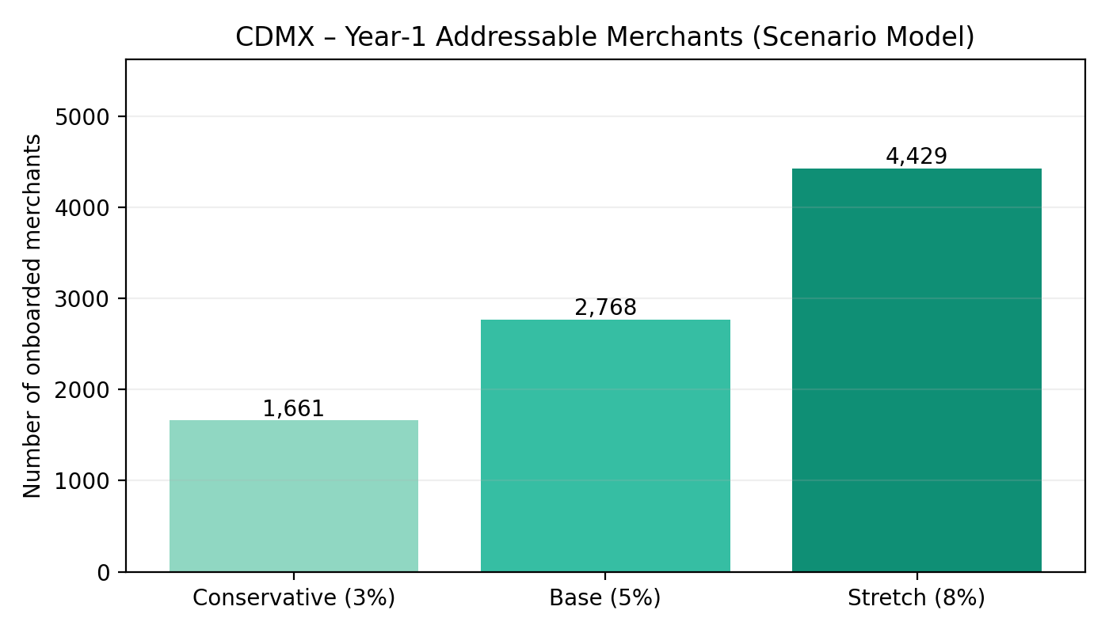
Fig. 7 — Onboarded merchants scenarios.

8–13. Partnerships | Differentiation | Risks | KPIs | Timeline | Country Notes | References
See prior version; retained content with updated intro and rationale.

