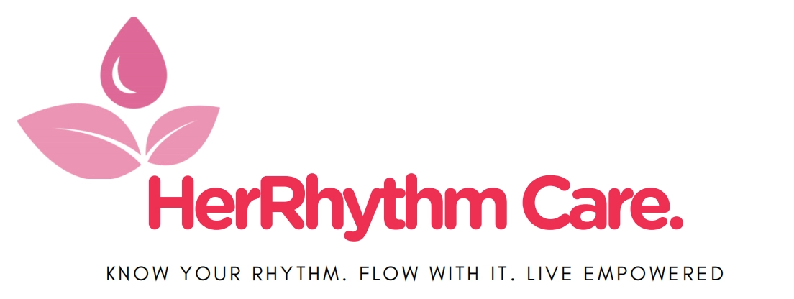

KNOW YOUR RHYTHM.
A GUIDE TO MENARCHE

Menarche is defined as your first period or first menstrual bleeding.

“You are ready. You are supported. This is the beginning of your rhythm.”

1. Welcome to Your Rhythm
Hi there! You are about to learn about something every girl and woman goes through. It's called a period, and it is a normal, healthy part of growing up.
You might feel curious, a little nervous, or both. That's okay. This guide is part of your Rhythm, and it walks you through everything, step by step, in plain and simple words.
At HerRhythm Care, we believe every girl deserves to begin her rhythm with confidence, joy, and unshakeable self-belief. This guide helps you learn, feel cared for, find comfort, and feel supported, starting before your first period even arrives.

Remember
• A period is normal. Every woman in the world has one.
• There is no reason to feel embarrassed.
• You can always ask a trusted adult for help.

2. Before It Begins: Your First Period Starts Long Before you experience it
Here is the most important thing to know in this whole guide: Menarche, your first period, does not start the day you bleed. It starts months, sometimes years, before that. Your body has already been getting ready, quietly, in its own rhythm.
Puberty is not one event. It's a journey that unfolds over one to three years. Your first period is one moment inside that journey, not the starting line. By the time it arrives, your body has already been preparing for a while.
Here are the signs your body may already be showing you, in the order they usually appear:
- You have started growing taller, faster than before. Often the earliest sign, sometimes a year or more before your first period.
- Your breasts have started to develop. This usually begins next.
- You notice hair growing under your arms or between your legs.
- You notice a clear or whitish fluid in your underwear. This is called discharge.

The Clearest Signal: Discharge
• Discharge is your body's closest, clearest signal that your first period is near.
• It usually shows up 6 to 12 months before your first period.
• It is completely normal. It means your body is doing exactly what it should.
• If you notice it, that is your cue: it's time to prepare, not to worry.

What To Do With This Information
• Pack your kit before it happens, not after. Keep it in your school bag or a small pouch you carry.
• Talk to a trusted adult now, while there's no pressure, not in a rush later.
• Keep track of these changes. Noticing them early means nothing will catch you by surprise.
3. What Is a Period?
Inside your body, you have an organ called the uterus. Every month, your uterus builds a soft, cushiony lining, just in case your body needs it one day to grow a baby.
If a baby does not begin growing that month, your body does not need the lining anymore. So your body lets it go. The lining leaves your body through a small opening between your legs, called the vagina, over a few days. This is your period.
A period usually lasts 3 to 7 days. It happens about once a month, so it is also called your “menstrual cycle,” or as we call it your rhythm.
4. Why Does This Happen?
Periods happen because your body is growing up. As you get older, your body starts making hormones. Hormones are like tiny messengers that tell your body it is time to grow and change.
These changes get your body ready for the future, in case you choose to have a baby one day, many years from now. Your period does not mean anything is wrong. It means your body is working exactly the way it should, in its own rhythm.

5. Your Period Kit
It helps to be ready, and now you know why: the signs come first. Your Menarche Kit gives you a head start. Keep it in a small bag at home, in your school bag, and anywhere else you spend a lot of time:
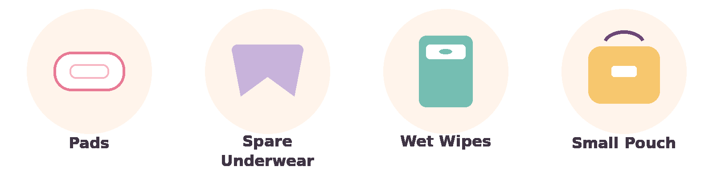
- Pads: these stick to your underwear and catch the blood. Great for beginners.
- Spare underwear: in case you need a fresh pair.
- Wet wipes: for extra freshness on the go.
- A DigniBag: your own small pouch to keep everything together and private, wherever you are.
There are other products too, like tampons and menstrual cups. Pads are the easiest to start with. You and a trusted adult can decide together what works best for you, when you are ready.

6. How to Use a Pad, Step by Step (Do this with mum/trusted caregiver)
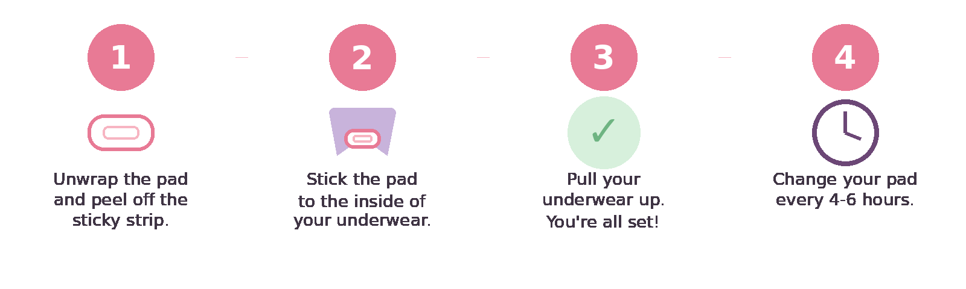
- Unwrap a clean pad and peel off the paper strip covering the sticky side.
- Press the sticky side onto the inside of your underwear, in the middle.
- If your pad has side wings, fold them around the edges of your underwear.
- Pull your underwear back up. You're ready to go about your day.
- Change your pad every 4 to 6 hours, even on lighter days. This keeps you clean, fresh, and comfortable.
- Wrap the used pad in its wrapper or some toilet paper, then put it in the bin. Never flush a pad down the toilet.
7. Keeping Clean During Your Period
Staying clean during your period is simple. Your body actually cleans itself on the inside, so you only ever need to wash the outside area, called the vulva. Here is how:
- Wash your hands first, with soap and water.
- Use warm water to gently rinse the outside area, between your legs.
- Wipe or wash from front to back. This stops germs from spreading.
- Use a mild, unscented soap if you like, but water alone works fine. Never put soap inside your vagina.
- Pat the area dry with a clean towel.
- Change into a clean pad and clean underwear.
- Wash your hands again when you finish.

Important
• The vagina cleans itself from the inside. You never need to wash inside it.
• Never use douches, scented sprays, or scented wipes inside or near the vagina. They can cause irritation or infection.
• A mild smell is normal. If you notice a strong or unusual smell, itching, or pain, tell a trusted adult or doctor.

8. Comfort Corner: Easing Cramps and Discomfort
Periods can bring cramps, tiredness, bloating, or a change in mood. That is your body working hard, and it deserves some gentle care in return. HerRhythm Kit includes a few comfort essentials for exactly these moments:
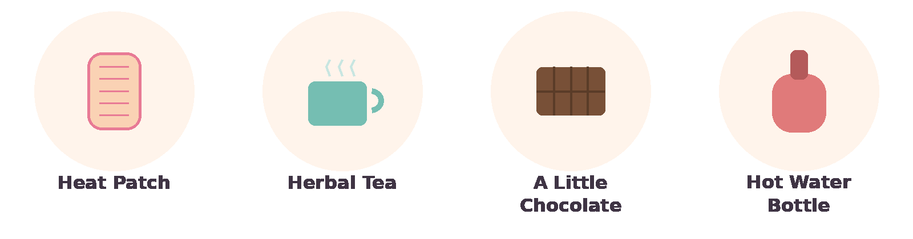
- Herbal tea: ginger, peppermint, or chamomile can help settle cramps and bloating.
- A little chocolate: dark chocolate is rich in magnesium, which helps relax muscles and ease cramps. A small treat that genuinely helps.
- Hot water bottle: perfect for curling up with at home.
- Rest and gentle movement: both help. A short walk or stretch can ease cramps just as much as lying down.

9. How Am I Feeling? HerRhythm's Emotion Wheel
Your hormones can affect your feelings, not just your body. In the days before or during your period, you might feel more tired, more emotional, or a little grumpy, and that is completely normal.
Sometimes big feelings are hard to put into words. HerRhythm's Emotion Wheel can help. Follow these three steps:
Step 1: Notice | Step 2: Name | Step 3: Care
Pause and check your body. Is your chest tight? Are your shoulders tense? Do you feel like crying or like snapping at someone? Your body often notices a feeling before your mind names it. | Look at the wheel below. Start at the middle ring and pick the core feeling closest to what you're feeling. Then look at the outer ring for a more exact word. Naming a feeling makes it easier to handle. | Decide what would help. Maybe it's telling a trusted adult how you feel, writing it in a journal, resting, or simply taking a few deep breaths. There is no wrong feeling, only ways to care for it.

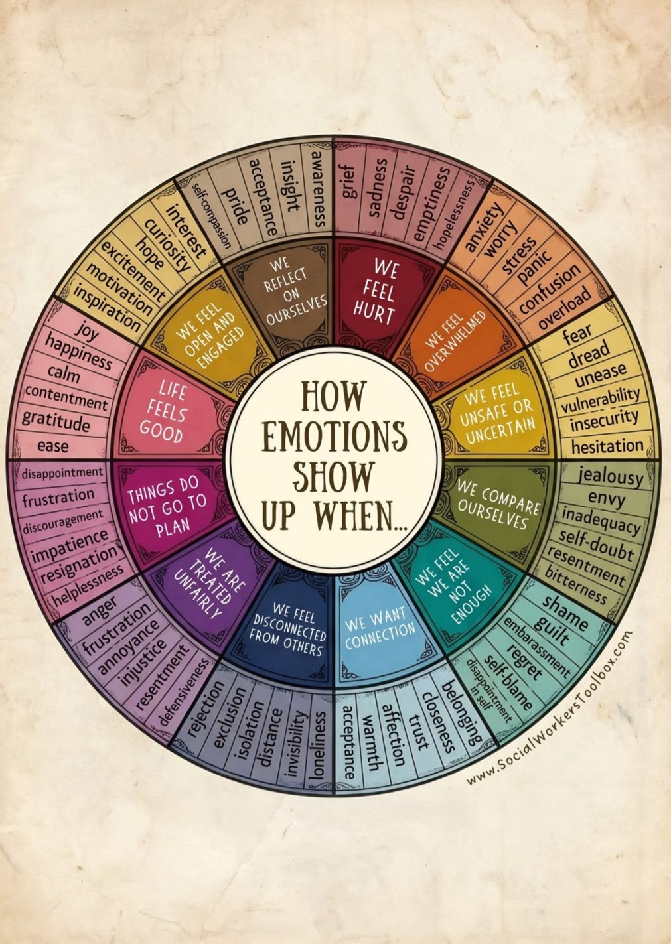

Try it now: pick one word from the wheel that matches how you feel today, and tell someone you trust, or write it down.

10. Telling Someone: What to Say
Knowing you can tell a trusted adult is one thing. Finding the words in the moment is another. If you don't know how to start, here are a few openers you can use exactly as they are, or make your own:

If your period has started
• “I think I just got my period. Can you help me?”
• “Something happened and I need pads. Can we talk somewhere private?”

If you're noticing early signs, before it starts
• “I noticed some changes in my body. Can we talk about it?”
• “I think my period might be coming soon. Can you help me get ready?”

If something feels wrong
• “My period feels really painful, more than usual. Can you help me?”
A trusted adult can be a parent, guardian, older sister, aunt, school nurse, or teacher, anyone who makes you feel safe. There is no wrong way to start this conversation, and no wrong time to have it.

11. Do's and Don'ts
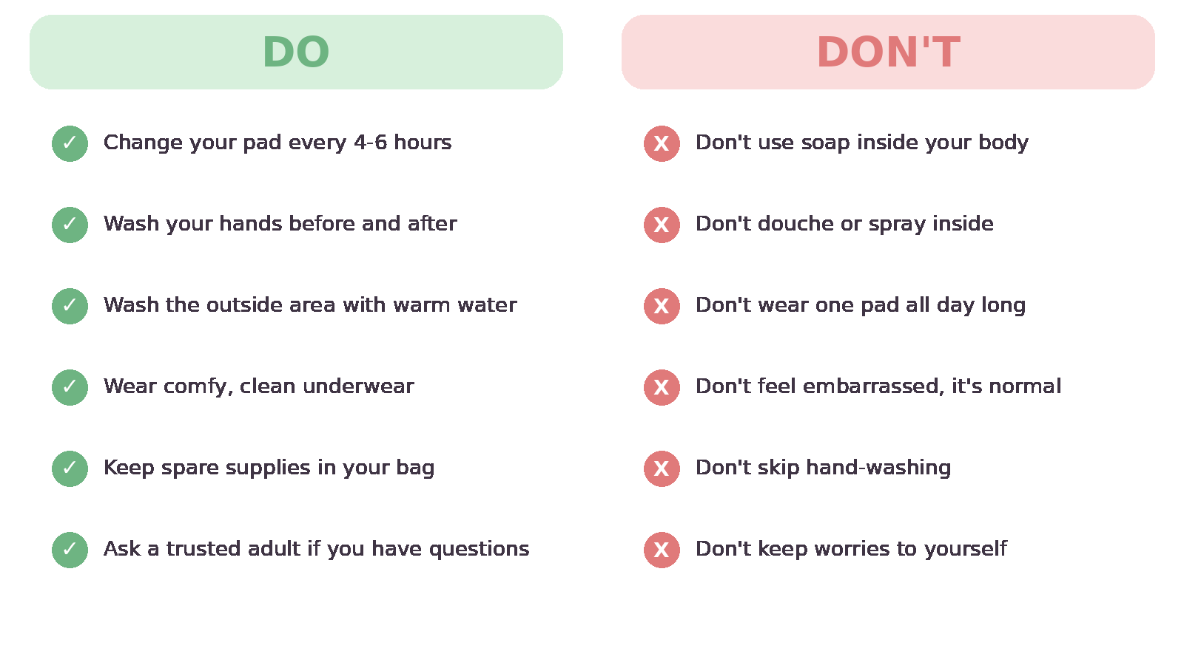

12. Did You Know? Fun Facts
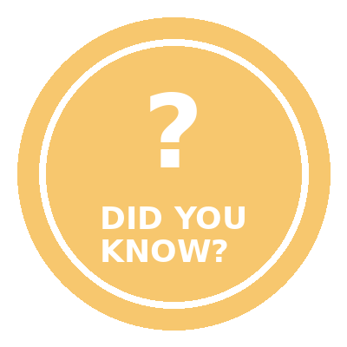 | - About 800 million people on Earth are having a period on any given day.  - The word “menstruation” comes from an old word meaning “month,” because periods follow a monthly pattern, or rhythm.  - Your uterus is about the size of your fist, even though it does such a big job.  - Period blood is a mix of blood and tissue from the uterus lining. It is not dirty, and it does not mean you are hurt.

13. Myth Busters
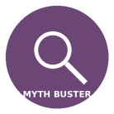
MYTH  Periods are dirty or unclean. | FACT  A period is a normal body process, just like breathing or digestion. It is not dirty.

MYTH  You can't play sports or exercise on your period. | FACT  You can run, jump, and play sports during your period. Moving your body can even help with cramps.

MYTH  Everyone gets their first period at the same age. | FACT  Every body has its own timing. Most girls start between ages 10 and 15, and that is completely normal.

MYTH  You should feel embarrassed and hide it completely. | FACT  A period is nothing to be ashamed of. It is fine to talk about it with people you trust.

14. You Are Never Alone
Every experience we own is built on a simple promise: you should never have to face your period alone. That means trusted adults, a caring community, and even other girls you've never met.
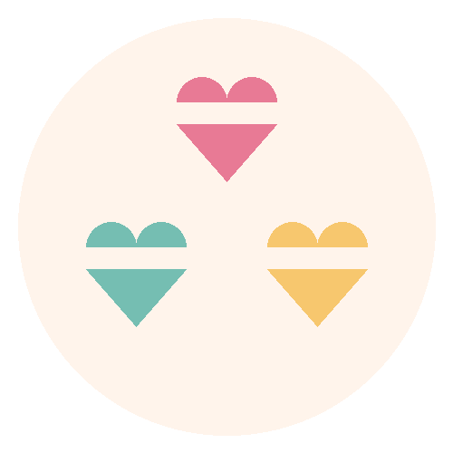
When your family chose HerRhythm , it did more than prepare you. HerRhythm partners with schools and communities so that another girl, one who could not otherwise afford pads, gets a kit of her own too. Your rhythm helps someone else find hers.
Reach out to a trusted adult or doctor if:
- Your period lasts longer than 7 days.
- You need to change your pad more than once every 1 to 2 hours.
- You have very strong pain that does not ease up with rest or a warm patch.
- You notice a strong or unusual smell, itching, or irritation.
- You have not started your period by age 15, even with no signs at all.
- You simply have questions or want to talk. That is always a good enough reason.

15. Quick Reference Chart
Earliest sign | Growth spurt, often a year or more before
Clearest near-term sign | Discharge, 6 to 12 months before
Average age | 10 to 15 years old
Average length of a period | 3 to 7 days
How often it happens | About once a month
How often to change a pad | Every 4 to 6 hours
How to clean | Warm water, outside area only, front to back
For cramps and mood | Heat patch, herbal tea, dark chocolate, rest, gentle movement
Naming a feeling | Notice it, name it on the Emotion Wheel, care for it
Telling someone | Use one of the opener scripts in Section 10
Can I swim or play sports? | Yes, any time
Who can I talk to? | A parent, caregiver, older sister, school nurse, or doctor

You are growing up, and you are doing great.

As your rhythm continues month after month, HerRhythm's Rising Moon Experience will be there to walk beside you.

Know Your Rhythm. Flow With It. Live Empowered.

