

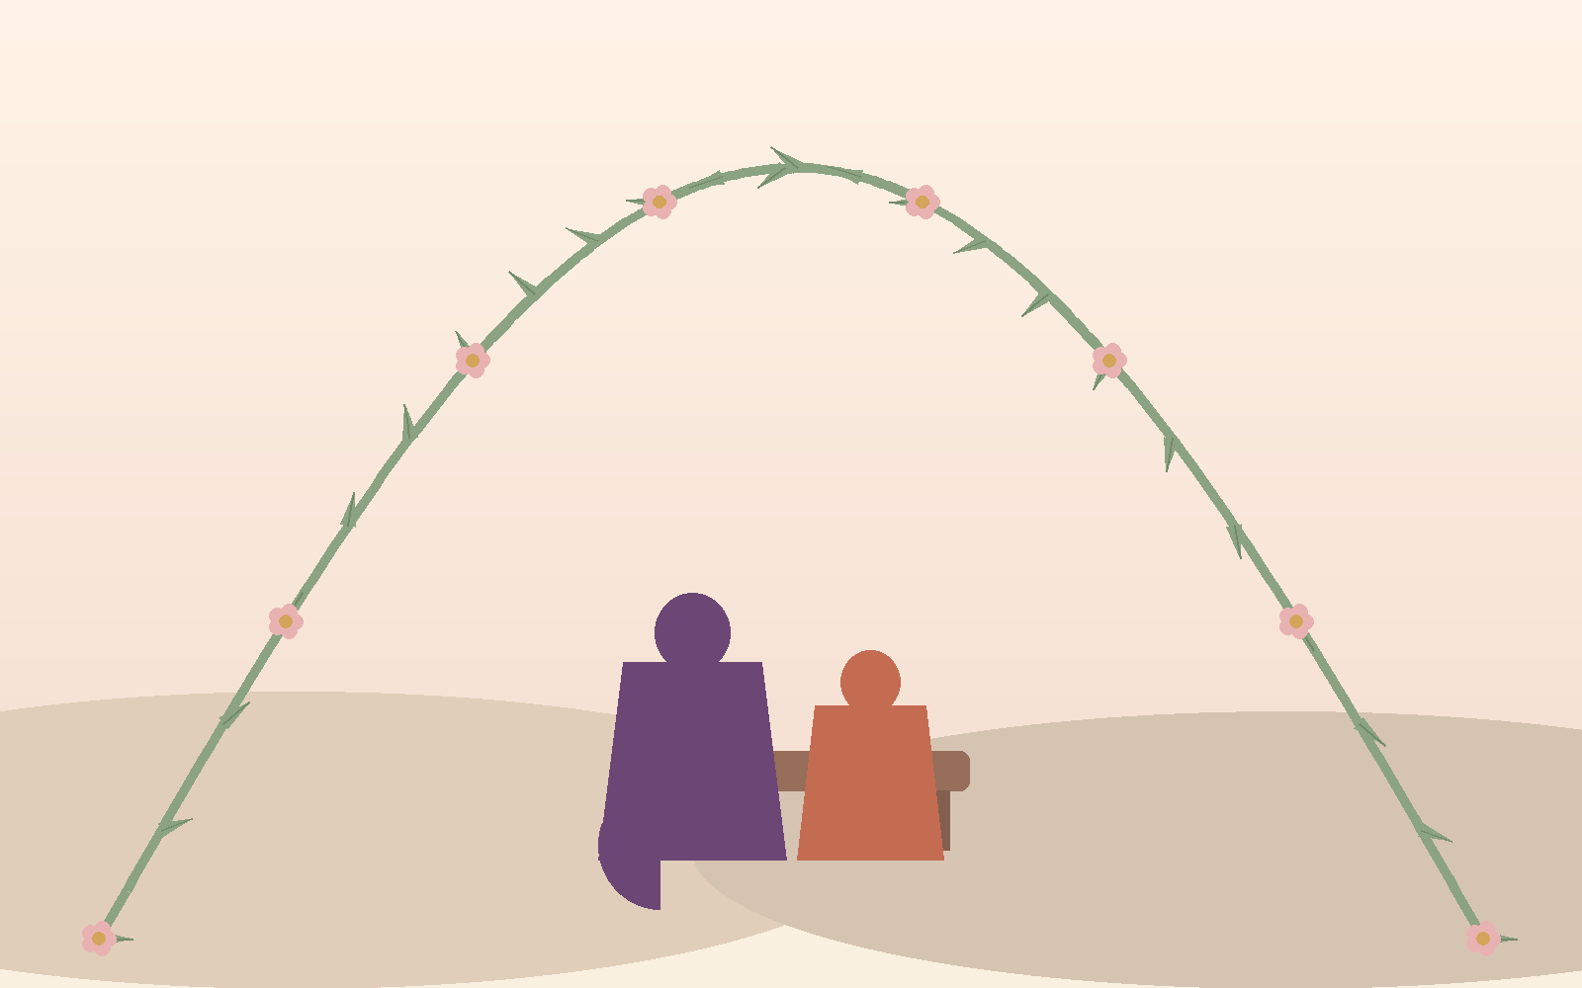
HerRhythm Care presents
Walking Beside Her
A Mother's Guide to Her Daughter's First Period
Supporting her first period with confidence, compassion, and connection.
“She may not remember every word you say, but she'll always remember how you made her feel.”

“
This isn't a pamphlet. It's a note from one woman to another.

We are the women behind HerRhythm Care, and most of us remember our own first period more clearly than we'd like to admit. The shaking hands. The whispered question to a friend instead of a mother. The relief, or the silence, that followed when we finally told someone.
This guide is not about the company. It is about motherhood.
It's about remembering what your own first period felt like, whatever that feeling was. It's about wishing, as so many of us have, that someone had been sitting beside you when it happened.
You are that someone for her now.
With warmth,
From the team at HerRhythm Care
Before You Begin

You already know what a period is. You've had one, likely for twenty, thirty, forty years by now. So let's be honest about something: this guide is not here to teach you about menstruation.
It's here for a different, harder question. Not "what is a period," but "how do I make sure my daughter's first one feels different from mine?"
Maybe your own first period was met with silence, or a slap of understanding no one explained, or a whispered rule about what girls don't do this week. Many of us grew up in homes and communities where periods were something to manage quietly, not something to talk about openly. That's not a failure of the mothers who came before us. It's simply what they were given to work with.
You get to give her something different. Not because you know more biology than your mother did, but because you're willing to say the words out loud, in daylight, without shame in your voice.
A little about how this guide works:
- Read it before her first period arrives, if you can. Even ten minutes helps.
- You don't need to cover everything in one sitting. This is a relationship, not a checklist.
- Each section ends with a “Mother's Moment,” a small, low-pressure way to connect with her, on your own timeline.
- There is space at the back of this guide for your own reflections, and a blank page for a letter to her. Keep it. One day it will mean more than either of you can imagine right now.

1. Before Her First Period
 | Recognizing the Signs  Most girls show signs of puberty a year or more before their first period. You may already have noticed some of these without naming them:
- Breast development, often the earliest sign
- A noticeable growth spurt
- New body odor
- Hair growth under the arms or between the legs
- A clear or whitish discharge in her underwear
- Curiosity about her body, or sudden self-consciousness about it
- Mood changes that seem to arrive from nowhere
None of this means something is wrong. It means she is growing, exactly as she should. Your daughter isn't changing overnight. She has been changing for months, quietly, and now her body is getting ready to show you.
Mother's Moment
Share one thing you remember noticing about your own body when you were her age.

2. The First Conversation
 |  | It's Not About Teaching. It's About Connecting.  You don't need the perfect biology lesson. You need her to feel safe bringing this to you, today and every month after. Small shifts in language make a big difference:
Instead of... |  |  | Try...
"Don't worry." |  |  | "I'm here for you."
"You're a woman now." |  |  | "You're growing, and that's something to be proud of."
"It's just part of life." |  |  | "You can ask me anything, any time, and if I don’t know, we can learn together.”
"We don't really talk about this." |  |  | "This is something we can talk about, whenever you need to."
"Did you start yet?" |  |  | "How are you feeling about your body these days?"

If your own family never had this conversation with you, you may feel like you're improvising without a script. You are, and that's alright. The goal isn't a perfect script. It's a daughter who never has to wonder whether this topic is welcome in your home.
Mother's Moment
Practice saying one of the “Try” lines out loud, even alone in the mirror, before you say it to her.

3. What She's Probably Feeling
 | The Question Behind the Question  Girls rarely say “I'm scared.” Instead, you'll hear things like:
- “Is this normal?”
- “Will everyone know?”
- “Did I do something wrong?”
- “I don't want to go to school.”
Each of these questions is really asking one thing: am I still okay? Your answer, in words and in your reaction, is what she will remember.
Her Menarche Guide includes something called the Emotion Wheel, a simple tool that helps her notice a feeling, name it, and decide what would help. You don't need to memorize it. Just know it exists, and ask her about it: “Did you try the feelings wheel yet? What did you find?” That question alone tells her you're paying attention to more than just her pads.
Mother's Moment
Ask her, “What's one thing you're a little worried about, and one thing you're a little excited about?” Then just listen.

4. Her First Period Kit, Together
 | Unbox It Like a Gift, Not a Manual  Her Menarche Kit includes pads, wet wipes, comfort items like a heat patch, and a DigniBag to carry it all discreetly. Go through it with her, item by item, almost like opening a gift together:
- Pads: show her how one sticks to underwear, and how often to change it (every 4 to 6 hours).
- wipes: explain these are for confidence, not emergencies, everyone likes to feel fresh.
- Heat patch or hot water bottle: let her know cramps are common, and that comfort is allowed, not something to push through silently.
- The DigniBag: this is hers. Let her decide where she keeps it, and reassure her that needing it is nothing to hide.
If you can, let her practice opening and using a pad once, at home, before she ever needs to do it at school. Confidence is built in small rehearsals, not in the moment of panic.
Mother's Moment
Pack her school emergency pouch(Dignibag) together, and let her choose what goes in it.

5. Did You Know?
 | A Few Things Worth Knowing

Girls whose mothers talk openly about periods often carry less fear and shame into adulthood, and are more likely to pass that openness on to their own daughters one day.
Your daughter may remember your reaction to her first period longer than she remembers the period itself. A calm, warm response becomes part of her story.
Some girls go quiet after their first period. Others become emotional, or tearful, or seem completely unbothered and want to move on immediately. Every reaction is normal. There is no correct way to feel.
Talking about periods openly at home does not make girls “grow up too fast.” It gives them the language to advocate for their own comfort and health for the rest of their lives.

6. Helping Her Build Confidence
 | Small Habits, Lifelong Confidence  Confidence with periods is built the same way any skill is built: through small, repeated, low-stakes practice.
- Packing her own emergency pouch before school
- Learning to track her cycle on a calendar or app, so surprises become predictable
- Practicing changing a pad at home, unhurried
- Knowing three trusted adults she could turn to if you are not immediately available
- Understanding basic hygiene: warm water, front to back, no need to wash inside
- Knowing that asking for help, from you, a school nurse, or a friend, is a sign of strength, not failure
Each of these is a small victory. Celebrate them as such, rather than waiting for a single big “talk” to cover everything at once.
Mother's Moment
Celebrate her first period, or her first month of managing it well, with a favorite meal or a quiet outing, just the two of you.

7. Common Questions
 |  | Quick, Clear, Reliable Answers
Is irregular bleeding normal at first? |  |  | Yes. It can take up to two years for a cycle to settle into a predictable rhythm. Irregular timing alone is rarely a concern in the first year or two.
How long should a period last? |  |  | Usually 3 to 7 days, though this can vary, especially early on.
Can she play sports? |  |  | Yes, any time, on any day of her cycle. Movement can even ease cramps.
What products should she use first? |  |  | Pads are the simplest starting point. Tampons and menstrual cups are options for later, once she's comfortable and curious.

8. When to Seek Medical Advice
 | Calm, Not Alarming  Most first periods need nothing more than the support in this guide. A doctor's visit is simply worth arranging if you notice:
- Bleeding that soaks a pad every 1 to 2 hours for several hours in a row
- A period lasting longer than 7 days
- Pain strong enough to stop her from going to school or daily activities
- No period at all by age 15+
- Signs of puberty with no period by age 16 to 17
- Anything that simply doesn't feel right to either of you
None of these are emergencies to panic over. They are simply reasons to check in with a doctor, the same way you would for any other part of her growing body.

9. Let's Talk Together
 |  | Better Questions, Open More Doors  The way you ask shapes what she's willing to share. A few swaps worth trying:
Instead of... |  |  | Try...
"How was school?" |  |  | "How are you feeling in your body today?"
"Did you change your pad?" |  |  | "Is there anything you need?"
"Are you okay?" |  |  | "Tell me about today."
"You'll understand when you're older." |  |  | "Let's figure this out together, right now."
These aren't scripts to memorize word for word. They're a direction: toward curiosity instead of interrogation, and toward her feelings instead of just the facts.
Mother's Moment
Ask her what she wants you to know about this stage of her life, and let her answer without correcting or adding to it.

What Comes Next

You're Not Done, You're Just Getting Started
This guide covers her first period, but HerRhythm’s journey doesn't stop here.

Over the next kits, she moves through Becoming You, a curriculum built in stages, cycle basics, hygiene, mood, cycle tracking, myths, and more.

Every third kit ends in a certificate for her, a marker of real progress, not just a delivery.

You're on this path with her, not just watching from the side. Walking Beside Her continues too. A second guide unlocks around her third certificate, when her needs shift from instruction to independence.

A third one arrives in Rising Moon, when your role moves from managing her period to trusting her with it.

You don't have to do this alone either. HerRhythm connects mums to a small community of other mothers walking the same road, women who've had the same 3am worry, the same awkward first conversation.
A place to ask the questions you don't want to ask alone.
And when she earns her first certificate, you'll get something too, a small acknowledgment that you did the harder job. You showed up first.

11. Your Daughter Is Growing
 | “  She still needs hugs. She still needs reassurance. She still needs your patience.
Puberty doesn't mean she needs you less. It means she needs you differently.
There will be days she wants to talk for an hour, and days she wants to shut her door and be left entirely alone. Both are normal. Both are still her trusting that you'll be there when she's ready to open it again.
You are not losing the little girl who used to climb into your lap. She is becoming someone new, and she is bringing that little girl along with her, whether either of you can see it clearly yet or not.
12. Mum's Reflection
 | A Page for You, Not Her  No one else needs to read this page. Write freely, in pencil or ink, whenever you have a quiet moment.
I remember how my first period...

The advice I wish someone had given me...

The woman I hope my daughter becomes...

 | Dear Daughter,

Written by you.
Keep it safe, for her, for later.

