Assignment 2: Developing a Tomato Ontology Using Protégé
Documentation and Technical Reference

Student number 20074237
Tibor Molnar
Repository: github.com/hera191/tomato-ontology

Table of Contents
2
1. Workbook 4
1.1 Structure — Classes and Subclasses 4
1.2 Relationships 5
1.3 Data Properties 6
2. Emulation Task 7
3. Extension Tasks 9
3.1 Subclass Assignment 9
3.2 Disjointness Constraints 9
3.3 Cardinality Restriction 10
4. Reasoning 11
4.1 Issues Identified 11
4.2 Reasoner Results — HermiT 1.4.3.456 12
5. SPARQL Queries 12
5.1 Prefixes 12
5.2 Query 1 — List All Tomato Varieties and Their Colour 13
5.3 Query 2 — Find All Dishes and the Tomato Varieties They Use 14
5.4 Query 3 — Find All Individuals That Are Instances of Food 15
5.5 Query 4 — Find Varieties Grown in What Climate and Season 15
5.6 Query 5 — Find All Hungarian Dishes and Their Cooking Method 16
6. Linked Data 17
6.1 How It Could Be Reused 17
6.1.1 Open from the Web in Protégé 17
6.1.2 Other Ontologies Can Import This Ontology 18
6.1.3 The Ontology Can Be Published 18

Table of Figures
Figure 1: Object properties 5
Figure 2: Data properties 6
Figure 3: Classes and SubClasses 7
Figure 4: Individuals 7
Figure 5: Disjoint 9
Figure 6: Cardinality Restriction 10
Figure 7: Error Picked up by reasoner 11
Figure 8: Reasoner CLI clean output 12
Figure 9: Query1 13
Figure 10: Query2 14
Figure 11: Query3 15
Figure 12: Query4 16
Figure 13: Query5 17
Figure 14: Ontology loaded from github pages 18
Figure 15: Hosted ontology on Github 19

1. Workbook
This section describes the ontological structure of the Tomato Ontology, including the class hierarchy, object relationships, and data properties used to model tomato varieties, dishes, and growing conditions.

1.1 Structure — Classes and Subclasses
The ontology is structured using OWL (Web Ontology Language) and follows a hierarchical class model rooted at owl:Thing. The following class hierarchy defines the main conceptual categories:
owl:Thing
├── Food
│ └── Fruit
│ └── Tomato
├── TomatoVariety
├── Dish
└── GrowingCondition

The Food class captures the broader food domain, with Fruit as a subclass of Food and Tomato as a subclass of Fruit. The classes TomatoVariety, Dish, and GrowingCondition are top-level classes used to represent specific types of tomato varieties, culinary dishes, and environmental growing conditions respectively.

1.2 Relationships
The following object properties define the semantic relationships between individuals in the ontology. Note: the property gownUnder is intentionally spelled as such due to an earlier coding error that was preserved for consistency across the codebase.
Note: 'gownUnder' is a deliberate retained typo — it should be read as 'grownUnder'. See also Section 5.
Tomato > hasVariety > TomatoVariety
e.g. Tomato_001 > hasVariety > Roma_Tomato

Dish > usesTomato > TomatoVariety
e.g. Bruschetta > usesTomato > Roma_Tomato

TomatoVariety > gownUnder > GrowingCondition
e.g. Roma_Tomato > gownUnder > Outdoor_Condition

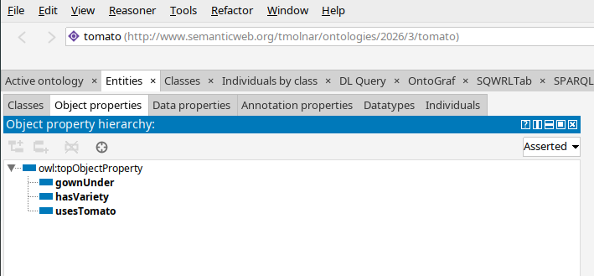Figure 1: Object properties

1.3 Data Properties
The following data properties are used to annotate individuals within the ontology with typed literal values (e.g., strings, integers, booleans):
- climate
- colour
- cookingMethod
- cuisine
- dishName (e.g. Bruschetta)
- flavor
- harvestDate
- isOrganic
- pH
- season
- size
- soilType
- tomatoID
- usesTomato
- varietyName
- weight

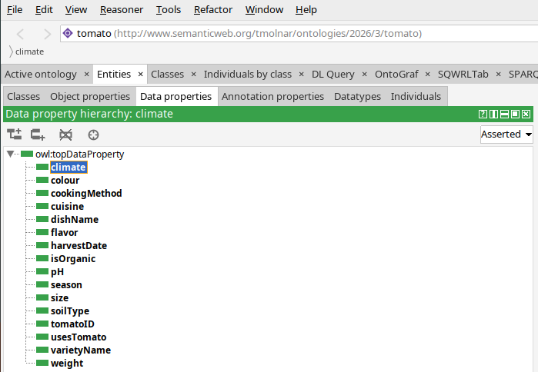Figure 2: Data properties

2. Emulation Task
The emulation task involved reconstructing a baseline ontology structure with the following components:
- 6 classes, 2 of which are subclasses
- 3 object properties
- 21 individuals
- 3 object properties

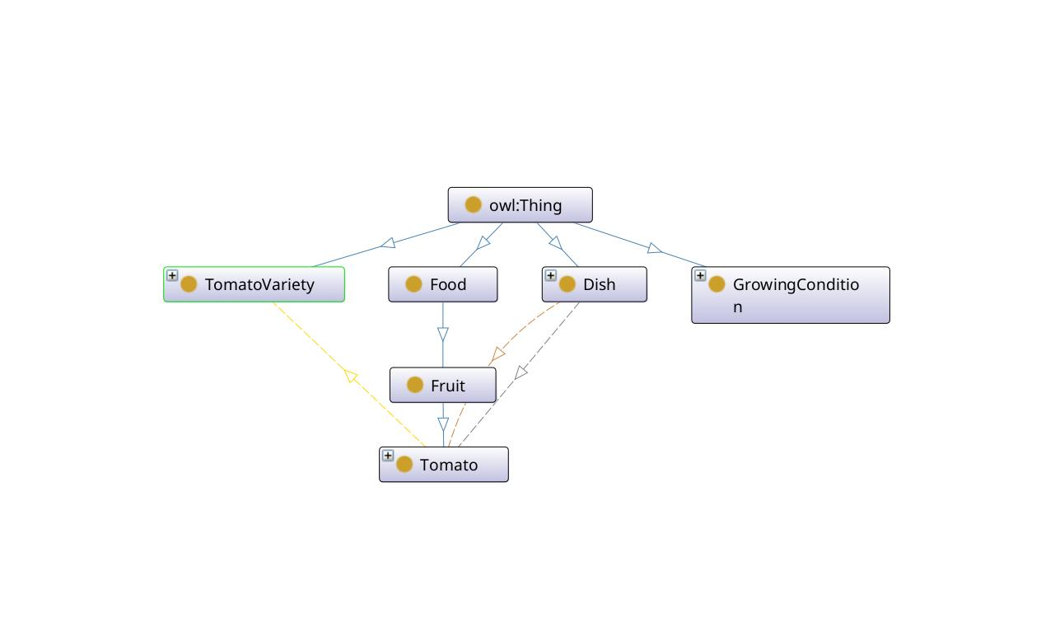Figure 3: Classes and SubClasses

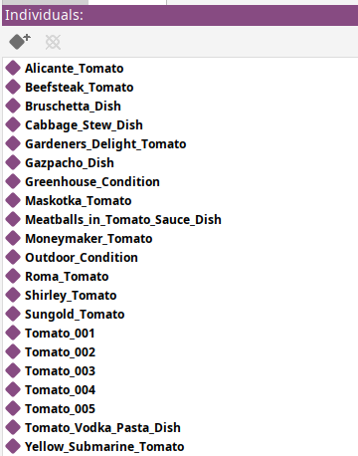Figure 4: Individuals

3. Extension Tasks
The following extensions were applied to the base ontology to enrich its expressivity and enforce semantic constraints:

3.1 Subclass Assignment
Individuals were assigned to the Tomato subclass, linking them to specific instances within the Food > Fruit > Tomato hierarchy.

3.2 Disjointness Constraints
Disjointness axioms were defined between the following classes to prevent class overlap:
- Dish cannot be a TomatoVariety
- Dish cannot be a GrowingCondition

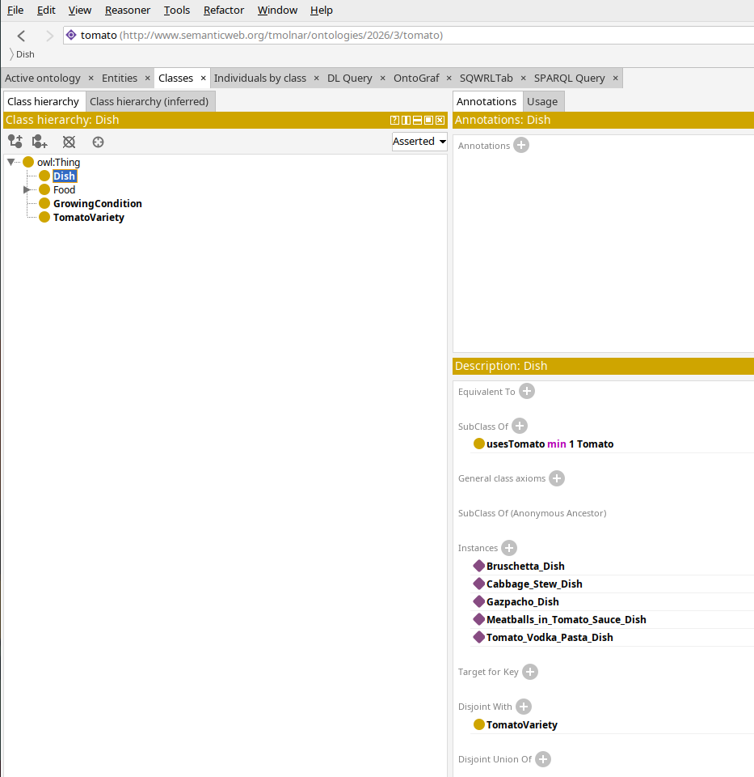Figure 5: Disjoint

3.3 Cardinality Restriction
A minimum cardinality restriction was placed on the Dish class:
usesTomato min 1 Tomato

This constraint ensures that every individual of the Dish class must reference at least one Tomato variety via the usesTomato object property. This enforces the intuitive requirement that every dish must use at least one tomato.
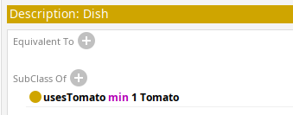Figure 6: Cardinality Restriction

4. Reasoning
OWL reasoning was applied to the ontology using the HermiT reasoner (version 1.4.3.456). Reasoning was instrumental in identifying inconsistencies in the ontology, such as incorrect data types used for certain individuals.

4.1 Issues Identified
- Incorrect data type used for certain individual property values (e.g. string assigned where xsd:integer or xsd:boolean was expected)
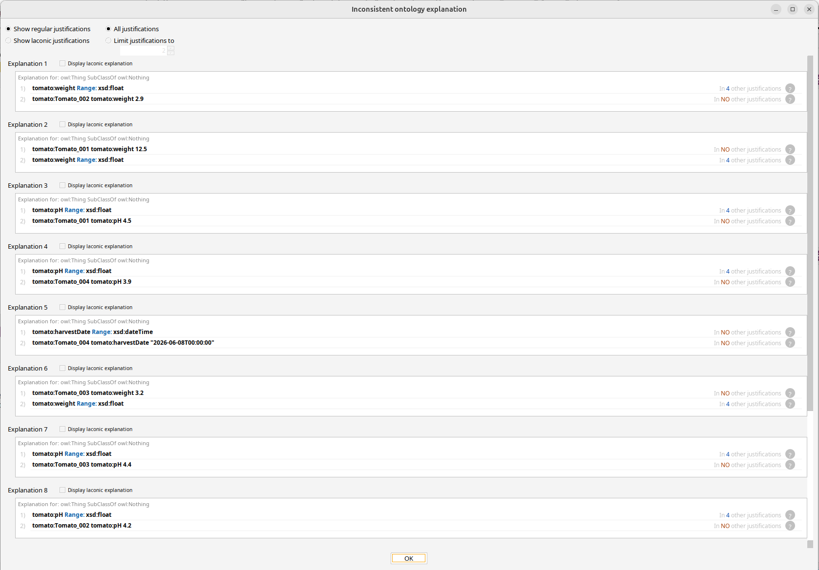Figure 7: Error Picked up by reasoner

4.2 Reasoner Results — HermiT 1.4.3.456

After corrections, the reasoner completed successfully with the following output:
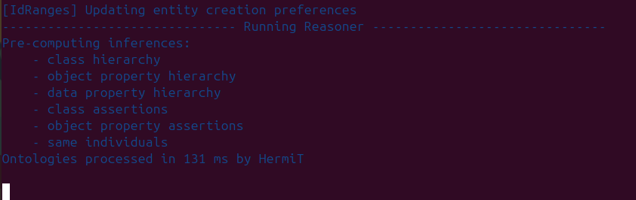Figure 8: Reasoner CLI clean output

5. SPARQL Queries
SPARQL (SPARQL Protocol and RDF Query Language) queries were used to interrogate the ontology. All queries use the following common prefix declarations. Note: the property gownUnder (used in Query 4) is an intentionally preserved typo from an earlier coding error.

5.1 Prefixes
PREFIX rdf: <http://www.w3.org/1999/02/22-rdf-syntax-ns#>
PREFIX owl: <http://www.w3.org/2002/07/owl#>
PREFIX rdfs: <http://www.w3.org/2000/01/rdf-schema#>
PREFIX xsd: <http://www.w3.org/2001/XMLSchema#>
PREFIX tomato: <http://www.semanticweb.org/tmolnar/ontologies/2026/3/tomato#>

5.2 Query 1 — List All Tomato Varieties and Their Colour
This query retrieves all individuals of the TomatoVariety class and returns their name and colour data properties, ordered alphabetically by name.
SELECT ?variety ?name ?colour
WHERE {
?variety rdf:type tomato:TomatoVariety .
?variety tomato:varietyName ?name .
?variety tomato:colour ?colour .
}
ORDER BY ?name

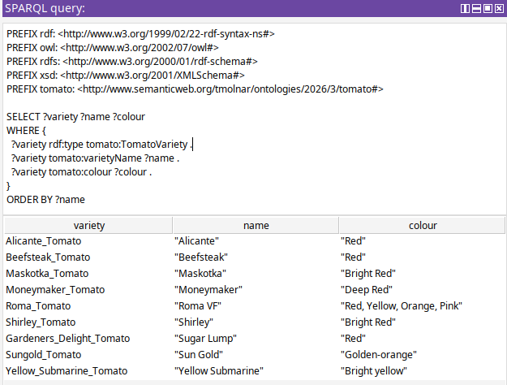Figure 9: Query1

5.3 Query 2 — Find All Dishes and the Tomato Varieties They Use
This query traverses the usesTomato object property to retrieve all Dish individuals along with the names of the tomato varieties they reference.
SELECT ?dish ?dishName ?variety ?varietyName
WHERE {
?dish rdf:type tomato:Dish .
?dish tomato:dishName ?dishName .
?dish tomato:usesTomato ?variety .
?variety tomato:varietyName ?varietyName .
}

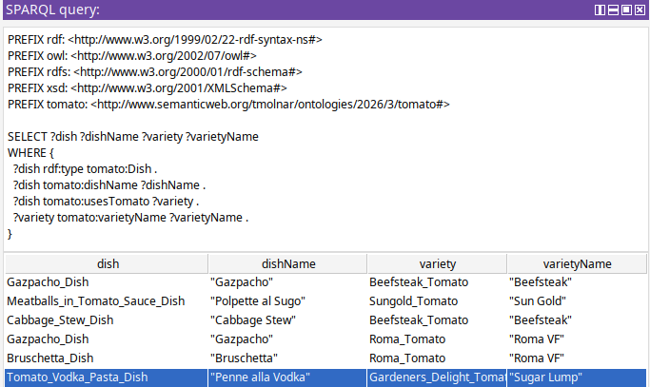Figure 10: Query2

5.4 Query 3 — Find All Individuals That Are Instances of Food
This query uses a transitive subclass path (rdfs:subClassOf*) to find all individuals belonging to the Food class or any of its subclasses, including Fruit and Tomato.
SELECT ?individual ?type
WHERE {
?type rdfs:subClassOf* tomato:Food .
?individual rdf:type ?type .
}

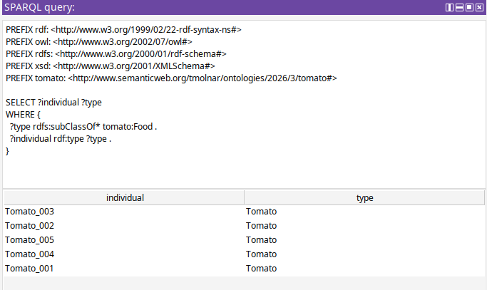Figure 11: Query3

5.5 Query 4 — Find Varieties Grown in What Climate and Season
Note: 'gownUnder' below is an intentional retention of an earlier coding error — it is equivalent to 'grownUnder'.
This query uses the gownUnder object property to join TomatoVariety individuals with their associated GrowingCondition individuals, then retrieves climate and season data.
SELECT ?variety ?varietyName ?climate ?season
WHERE {
?variety rdf:type tomato:TomatoVariety .
?variety tomato:varietyName ?varietyName .
?variety tomato:gownUnder ?condition .
?condition tomato:climate ?climate .
?condition tomato:season ?season .
}
ORDER BY ?varietyName

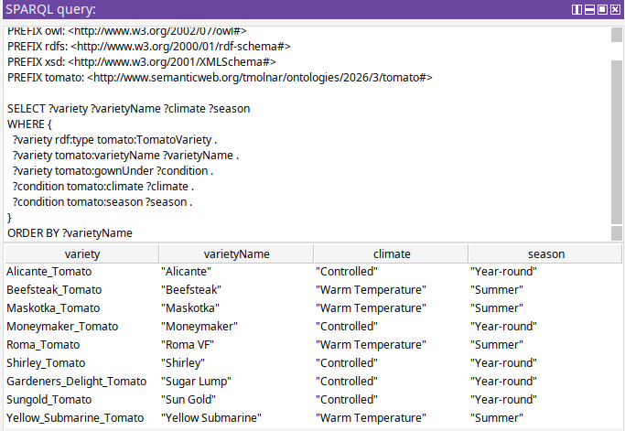Figure 12: Query4

5.6 Query 5 — Find All Hungarian Dishes and Their Cooking Method
This query filters Dish individuals by the cuisine data property value 'Hungarian' and returns their names and cooking methods.
SELECT ?dish ?dishName ?cookingMethod
WHERE {
?dish rdf:type tomato:Dish .
?dish tomato:dishName ?dishName .
?dish tomato:cuisine "Hungarian" .
?dish tomato:cookingMethod ?cookingMethod .
}

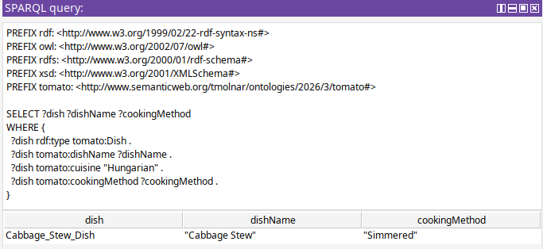Figure 13: Query5

6. Linked Data
This section describes how the Tomato Ontology can be reused, imported, and published as part of the broader Linked Data ecosystem. Linked Data principles allow ontologies to reference and be referenced by other datasets on the web, supporting interoperability and knowledge reuse.

6.1 How It Could Be Reused

6.1.1 Open from the Web in Protégé
The ontology can be loaded directly into Protégé from its GitHub-hosted URL. To do so, navigate to:
File > Open from URL..
> Select RDF/XML file format if prompted

The following output is produced during the loading process:
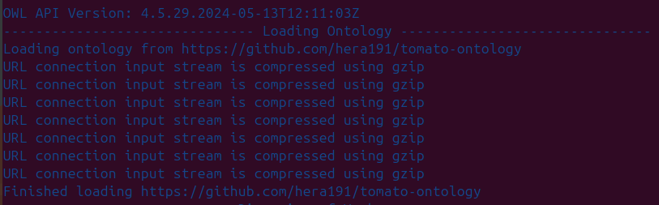Figure 14: Ontology loaded from github pages

6.1.2 Other Ontologies Can Import This Ontology
Third-party ontologies may import the Tomato Ontology in order to:
- Extend it with additional classes or properties
- Use existing Tomato Ontology classes (e.g. TomatoVariety, Dish) as subclasses within a larger food-domain ontology
- Reference the ontology's individuals as part of a broader knowledge graph

This approach supports modular ontology design, allowing the Tomato Ontology to serve as a reusable building block within larger systems.

6.1.3 The Ontology Can Be Published
The ontology is publishable as Linked Data by hosting the RDF/XML file at a stable, dereferenceable URI. The current GitHub repository (github.com/hera191/tomato-ontology) serves this purpose. For production Linked Data deployment, the ontology could be hosted with content negotiation support, enabling both human-readable and machine-readable representations to be served from the same URI.

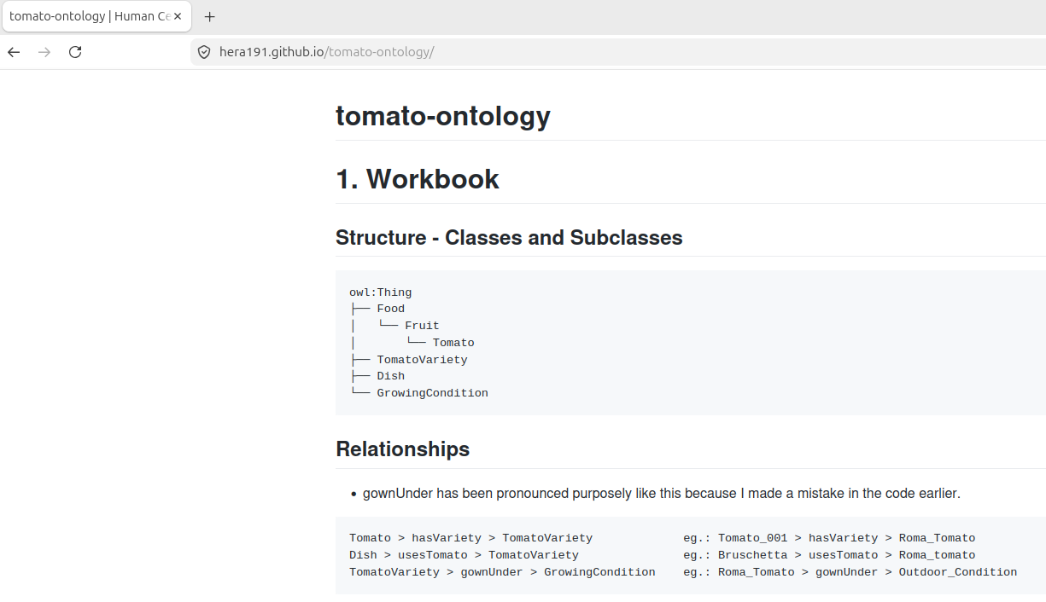Figure 15: Hosted ontology on Github

