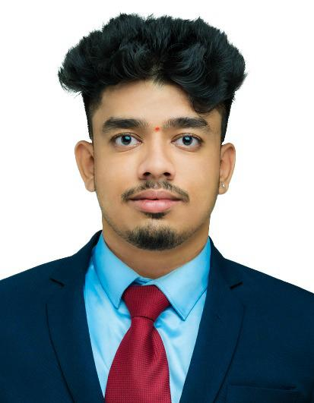**Heramba R Naik**

[heramba74@gmail.com](mailto:heramba74@gmail.com)

+91 9380051027

LinkedIn: <https://www.linkedin.com/in/heramba-r-naik-6127542b0>

GitHub: <https://github.com/heramba0128>

Siddhanaik road near Rama mandir Kundapura Udupi, Karnataka-576201



## **SUMMARY**

I am an Information Science student passionate about UI/UX design, web development, and IoT. I strive to create intuitive digital experiences and smart, connected systems through innovative, user-focused solutions. Committed to continuous learning, I aim to deliver impactful projects that align with emerging tech trends.

## **EDUCATION**

|  |  |  |
| --- | --- | --- |
| **Bachelor of Engineering- Computer Science & Engineering**  Mangalore Institute of Technology & Engineering | 2022-Present | CGPA: **6.12** |
| **Senior Secondary (12th) – DPUE** | 2021-2022 | Percentage: **70.1** |
| **Secondary School (SSLC) – KSEEB** | 2019-2020 | Percentage: **72.16** |

## **SKILLS**

|  |  |
| --- | --- |
| **Languages** | **:** C, Java |
| **Interfaces** | **:** HTML, CSS |
| **Database** | **:** MySQL |
| **Tools** | **:** Visual Studio Code, Figma |

## **INTERNSHIP**

**InnoByte Services | Web Developer Intern**

**Technologies:** HTML, CSS, JavaScriptRedesigned the King Sukh Guest House website to enhance user experience with a modern, responsive interface and interactive features.

**Internpe | UI/UX Design Intern**

**Technologies:** Figma (Auto Layout, Constraints, Frames, Prototyping, Components, Plugins, Smart Guides).Designed UI/UX for a tea shop menu, e-commerce platform, and personalized content curation app with a focus on usability and visual appeal.

## **PROJECT**

|  |  |
| --- | --- |
| **College Bus Tracking System and RFID-Based Hydraulic Door System** | December 2024 – Ongoing |

**Technologies:** RFID, GPS, Microcontrollers, Hydraulic System, Embedded C, UI Software.  
Developed an integrated system combining RFID-based student authentication, real-time GPS bus tracking, and automated hydraulic door control to enhance safety and convenience.

|  |  |
| --- | --- |
| **Smart Cap for Blind People** | Nov 2023 – Jan 2024 |

**Technologies:** Sensors, AI Algorithms, GPS, Embedded Systems.  
Designed a wearable assistive device that uses sensors, AI, and GPS to provide obstacle detection and real-time navigation support for the visually impaired.

|  |  |
| --- | --- |
| **Charging EV Vehicles Using Solar** | June 2023 - Aug 2023 |

**Technologies:** Solar Panels, Inverter, Battery Storage, EV Charging System.  
Developed a sustainable system to charge electric vehicles using solar energy, with DC power converted to AC through inverters and excess energy stored in batteries.

**UI Design Projects (RCB Website, Portfolio, Shopping App, Login Page)**

**Technologies:** Figma (Auto Layout, Prototyping, Components)

Designed intuitive UIs using Figma for RCB website, portfolio page, shopping app, and login screen.  
Focused on responsive design, visual hierarchy, and user engagement across all interfaces.

**Hostel Food Management System**

**Technologies:** HTML, CSS, JavaScript  
Built a simple web app for students to submit daily meal counts, reducing food wastage.  
Included meal schedules, forms, and feedback sections for efficient food planning.

**Ambulance Tracker Application**

**Technologies:** HTML, CSS, JavaScript, GPS (planned)  
Developed a prototype app to track nearby ambulances using GPS-based driver-user coordination.  
Separate login for drivers and users; real-time tracking planned in future upgrades.

## **COURSES & VIRTUAL EXPERIENCE PROGRAMS**

* **Postman API Fundamentals Student Expert,** offered by COSH NITK
* **Advanced Microsoft Excel,** online non-credit course by Infosys Springboard
* **The Complete Oracle SQL Bootcamp**, online non-credit course by Udemy
* **RPA Developer Foundation V2021** by UiPath, 2023

## **TECHNICAL ACTIVITIES & ACHIEVEMENTS**

* Participated in **TEDx_MITE**, held at MITE, Moodbidre – 2023
* Participated in **“Y20 Talks on Cyber Security in India: Opportunities and Challenges”**, AIET Shobhavana Campus, Mijar – August 2023*.*
* Participated in **“Hands-on Experience on Arduino UNO”** Workshop, MITE – May 2024.
* Represented **“Smart Cap”** start-up at **NAIN-IDEATHON 2024**, organized by MITE-FIRST –October 2024
* Represented the college in **VTU-level Kabaddi Tournaments** (twice) as Captain.
* Participated in **VTU-level Handball and Volleyball** competitions.
* Participated in **State-level Kabaddi and Wrestling** competitions.

.