**5. Run the simulation and press the button. Explains what happens. Include a screenshot.**

"Great Cow Basic" is a BASIC language developed for PIC microcontrollers. Great Cow Basic is designed to make programming with these microcontrollers easier.

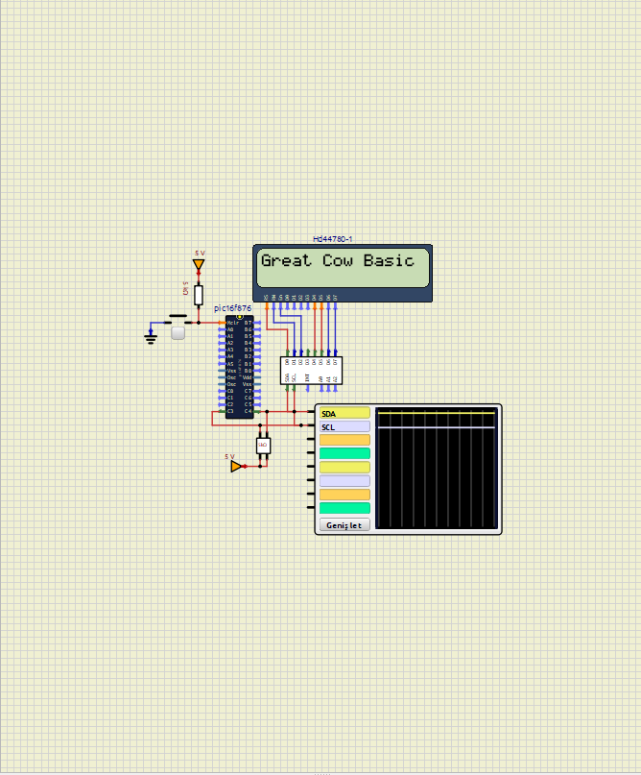

"Start Test Display On" refers to a feature of the "simullDE" program. This expression refers to displaying and activating a screen for testing purposes. This phrase notifies users that a particular test mode has started and test results will be displayed

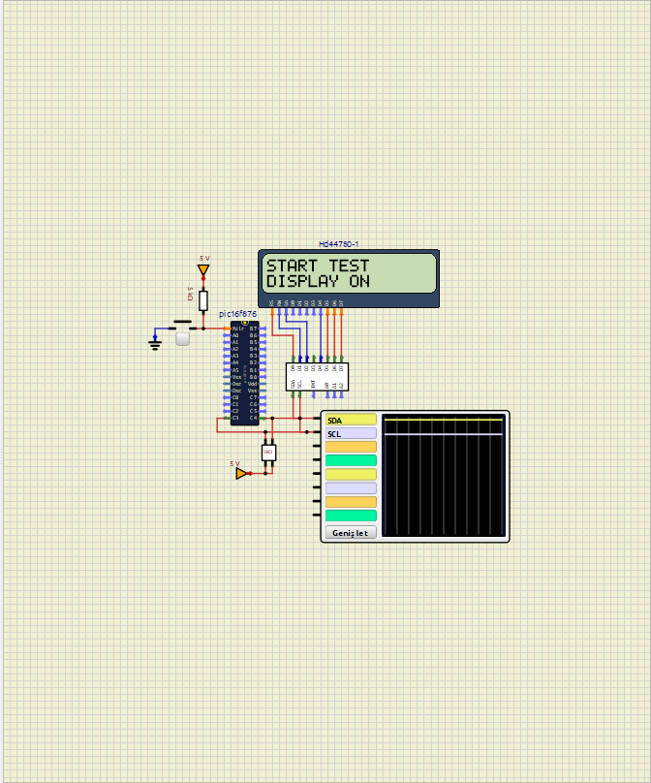

The phrase "Cursor on" indicates that, in a text-based user interface, a text cursor is visible and can be positioned by the user.

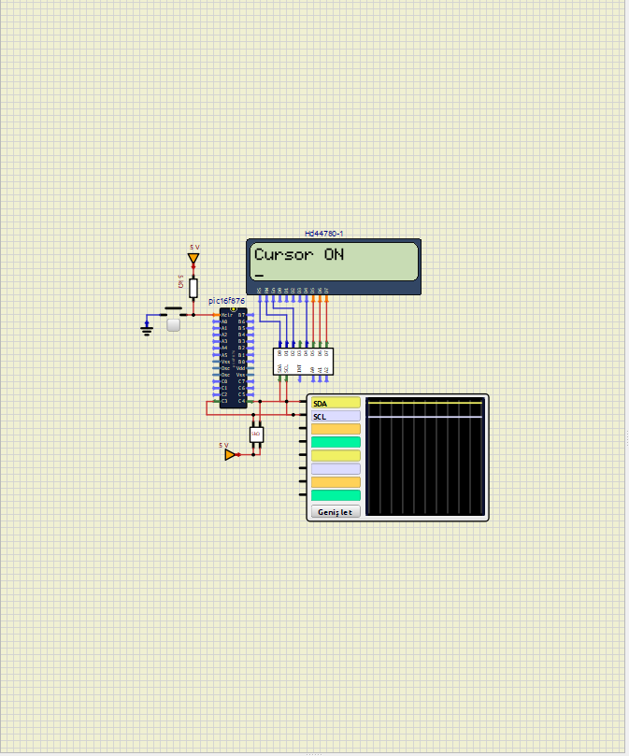

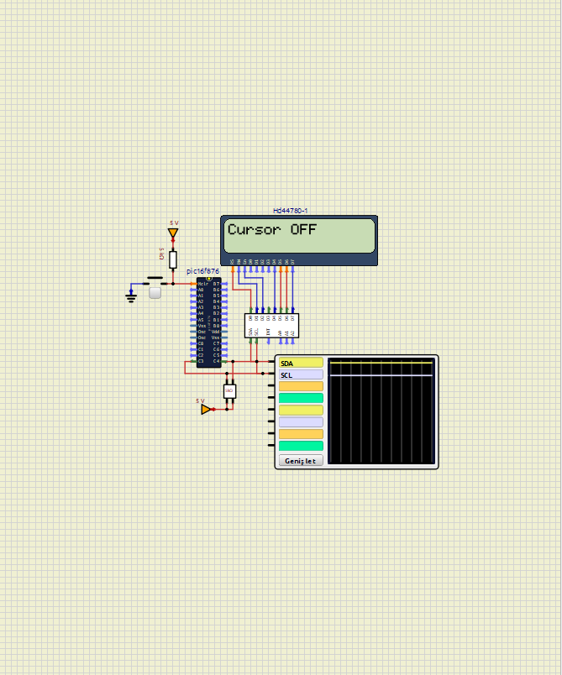The phrase "Cursor off" indicates that the cursor in a text-based section is made invisible in the user interface of the "simullDE" program. This statement means that the cursor will not be shown to the user when there is no text input or editing from the user.

The phrase “Flash on” refers to a certain object and element being flashed in the user interface in a particular noticeable way. When this phrase is used in the "simullDE" program, it indicates that a particular element is flashed to draw attention or highlight it to the user.

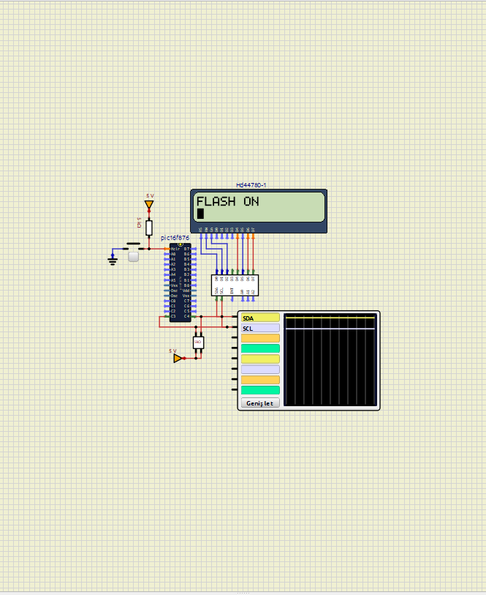

The phrase "Flash off" indicates that an element or object in the user interface of the "simullDE" program has ceased to flash in the previous way and is no longer flashing.

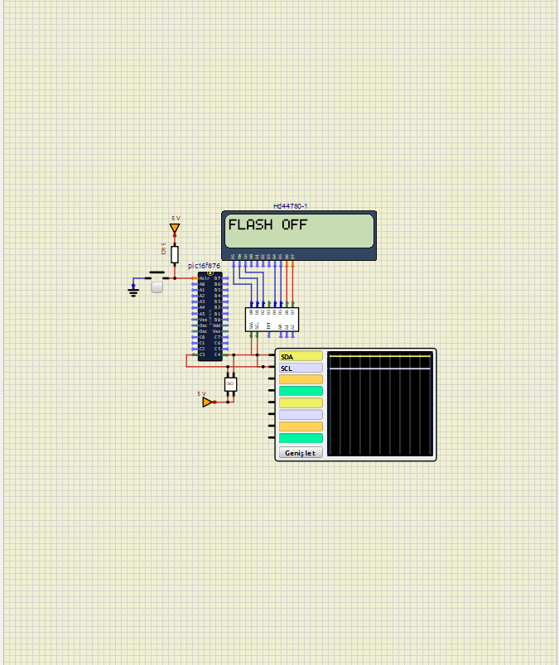

The expression "Cursor and flash on" is an expression used in the "simullDE" program, indicating that two features are enabled in the user interface of the program.

"Cursor on": Indicates that the cursor is visible during text entry or editing. The user enters the text field or can edit the text.

"Flash on": Indicates that a specific element flashes conspicuously. This is used to indicate to the user that a particular item is important or an action needs to be taken.

This phrase indicates both that the cursor is visible and that a particular element is blinking in the user interface.

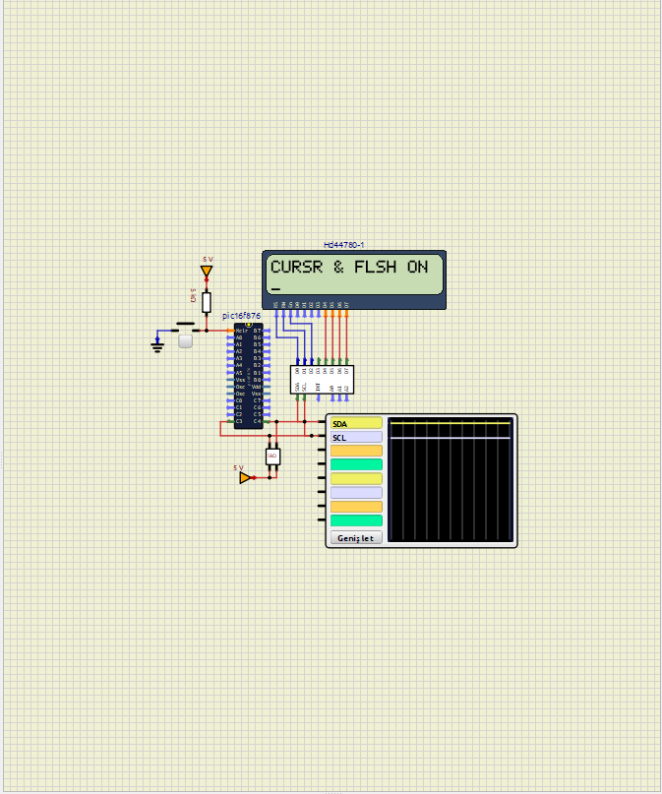

The expression "Cursor and flash off" is an expression used in the "simullDE" program and indicates that two features are disabled in the user interface of the program.

"Cursor off": Indicates that the cursor is invisible during text entry or editing. The user can no longer log into the text field and edit the text.

"Flash off": Indicates that the flashing effect of a specific element is stopped. This is used to indicate to the user that a particular item is no longer important or no action is required.

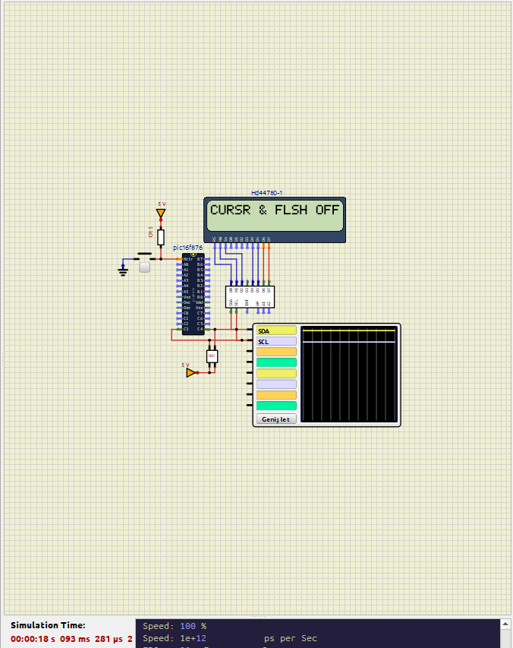This phrase indicates both that the cursor has become invisible in the user interface and that the blinking effect of a particular element has ended.

The term "Flashing display" refers to an image on the screen of the "simullDE" program that is highlighted by a flashing or flashing effect. This term is used when a visual and text element needs to be eye-catching or highlight a particular situation.

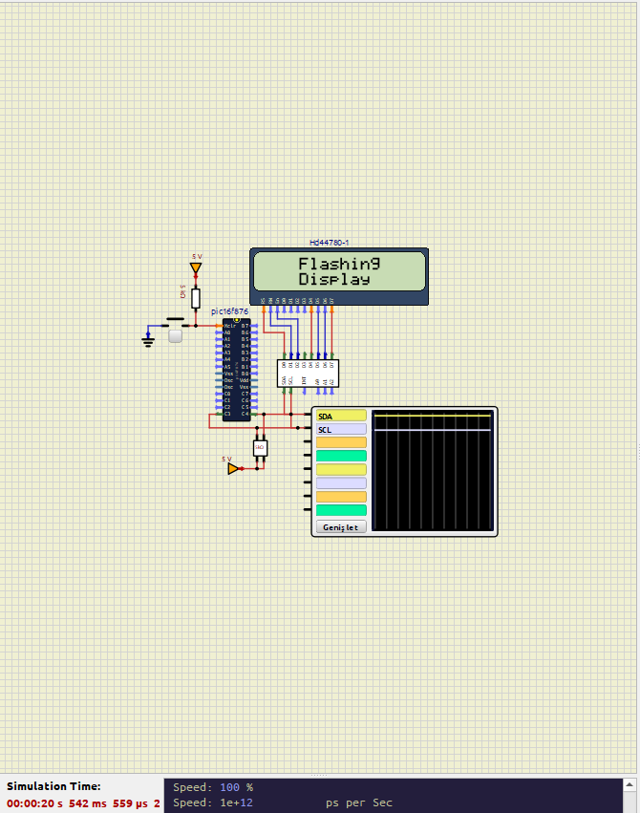

"Display & backlight. for 5 sec" indicates that the display and backlight will be activated for 5 seconds in the "simullDE" program.

Display: The screen will display a specific message or information.

Backl. (Backlight): The backlight will be activated to make the screen easier to read.

For 5 sec: Indicates that this situation will continue for 5 seconds.

This type of expression is used to temporarily activate the display and backlight, especially during a simulation or to give specific information to the user.

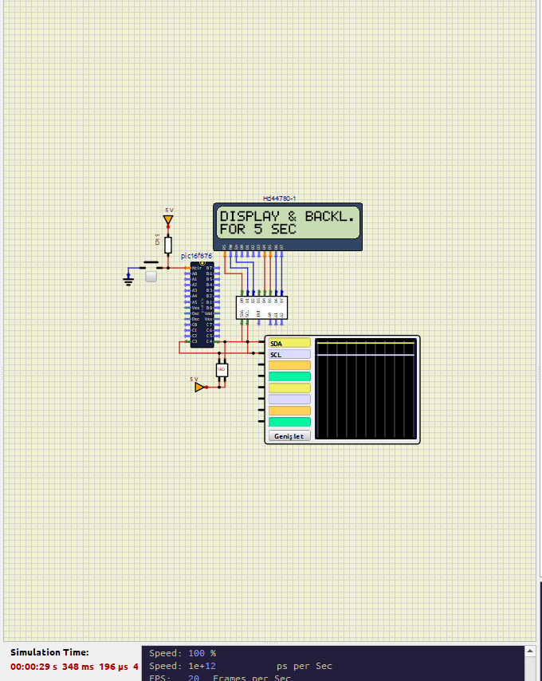

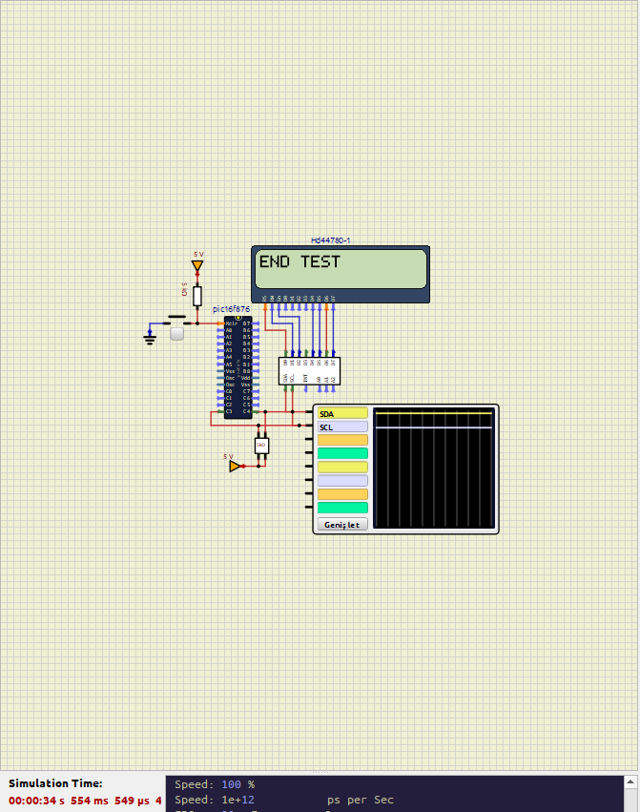The phrase "end test" indicates that a test or simulation process in the "simullDE" program has ended. This statement indicates that the test the user is running has been completed and the testing phase is now over.

**6. Below is a section of Assembly Language code. Look up what each of the commands bcf, movlw, movwf, call, clrf, decfsz, goto and nop mean in assembly language from the manual for the microcontroller, which is on the website. Try to guess what this code does.**

**Command Meanings**

1.Clear bit:

bcf SYSLCDTEMP, 1: Clears bit 1 in the SYSLCDTEMP register

2.Send a byte to LCD:

movlw 1: Loads the value 1 into the W register.

movwf LCDBYTE: Moves the value 1 into the LCDBYTE register.

call LCDNORMALWRITEBYTE: Calls the subroutine LCDNORMALWRITEBYTE to write the byte stored in LCDBYTE to the LCD.

3.Delay:

movlw 4: Loads the value 4 into the W register.

movwf SysWaitTempMS: Moves the value 4 into the SysWaitTempMS register.

clrf SysWaitTempMS_H: Clears the SysWaitTempMS_H register.

call Delay_MS: Calls the subroutine Delay_MS to create a delay based on the value in SysWaitTempMS.

4.Send another byte to LCD:

movlw 128: Loads the value 128 into the W register.

movwf LCDBYTE: Moves the value 128 into the LCDBYTE register.

call LCDNORMALWRITEBYTE: Calls the subroutine LCDNORMALWRITEBYTE to write the byte stored in LCDBYTE to the LCD.

5.Microsecond delay loop:

movlw 66: Loads the value 66 into the W register.

movwf DELAYTEMP: Moves the value 66 into the DELAYTEMP register.

DelayUS1: Label for the delay loop.

decfsz DELAYTEMP, F: Decrements DELAYTEMP, skips the next instruction if zero.

goto DelayUS1: Jumps back to the DelayUS1 label if DELAYTEMP is not zero.

nop: No operation

6.Return from subroutine:

return: Returns from the current subroutine.

**SUMMARY**

Clearing a specific bit in the SYSLCDTEMP register is typically done to reset or initialize a specific function or state.

Sending values to the LCD involves loading values into registers and calling subroutines to write these values to the LCD.

The delay loop is used to introduce a precise delay in microseconds.

This code is written to send specific commands to initialize or reset the LCD display and provide the necessary delays for the LCD to process those commands.

**7. Research online: what is I2C? Write 1 paragraph to explain. Give two real world examples.**

In SimulIDE, an open-source real-time electronics simulator, I2C (Inter-Integrated Circuit) is a communication protocol used to connect low-speed devices like microcontrollers, sensors, and EEPROMs within the simulator. It allows multiple devices to communicate with each other over a two-wire interface, which consists of a serial data line (SDA) and a serial clock line (SCL).

Key Features of I2C in SimulIDE:

Two-Wire Interface: I2C operates using two lines—SDA (data line) and SCL (clock line)—which facilitates bidirectional data transfer between devices.

Multiple Devices: The protocol supports multiple devices on the same bus.

Master-Slave Configuration: In I2C communication, devices are either masters or slaves. The master device initiates communication, sends clock signals, and controls the data flow.

Data Transfer: Data is transferred in sequences of 8-bit bytes. Each byte is followed by an acknowledgment bit. The master controls the data transfer process, including the start and stop conditions.

**Real-World examples**

1. Real Time Clock and Microcontroller

Used to keep time and date information, in clocks, calendars or timer applications.

It connects via 12c protocol. The microcontroller receives time and date information from the clock module.

2. Digital Temperature Sensor and Microcontroller

It is frequently used for temperature measurement in home devices.

It connects via 12c protocol. Arduino reads temperature data from the sensor and sends this data to a display.