COMPS202F Lab 06
Q1 (Sample quiz, marks not counted)
Remember to submit after finishing each part.

1. Download the file "Quiz.jar" from OLE "Sample Quiz" and put it in a folder (in which you will find a copy of your Java source file after you have written them). Open a command window and type
"java –jar Quiz.jar" to execute the program.
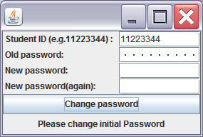
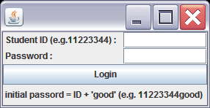
2. You need to login with your student id (e.g. 11223344) to do the quiz.

If you have not logged in before, your initial password is your student id + "good" (e.g. 11223344good) and you are required to change it. Please remember your new password.

main window
question window

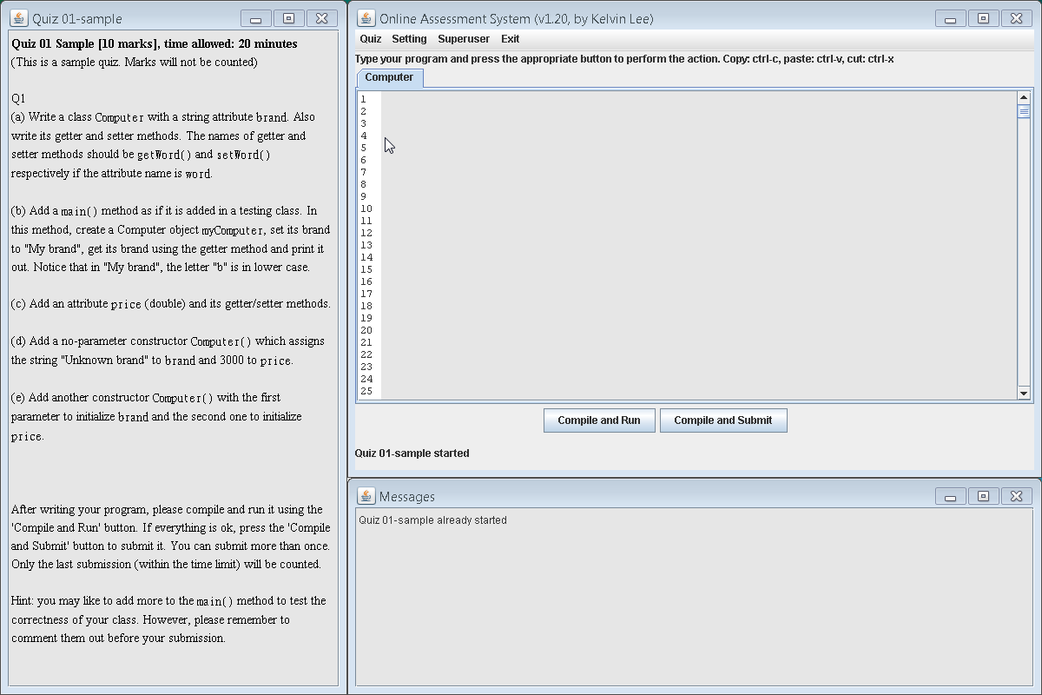
3. If everything is fine, the "main window" on the right side appears. From the "Quiz" pull-down menu, please choose the item "Quiz 01-sample". The "question window" appears and you can type your program on the main window.

4. After finishing one part (e.g. part (a)), press the "Compile and Submit" button to save your work and submit it to the server to check its correctness. You can see the score immediately and messages will appear in the "output window". You can submit more than once and only the last one is counted.
output window

5. You are not allowed to look at any other materials, including books, notes, Web sites, etc. Remember to put your source code and .class files in the same folder as the file Quiz.jar.

[In the real quiz, you need to submit your answers within the time limit specified in the question. ]

Q2 Revision

Your tutor will talk about the answers of previous labs, common mistakes, important points, etc.

