|  |  |  |  |  |  |  |
| --- | --- | --- | --- | --- | --- | --- |
| **EQUIPAMENTO** | **PONTÊNCIA MÉDIA**  **1-TABELA** | **HORAS DE USO(DIA)** | **KHW(MÊS)** | **HORAS(MÊS)** | **VALOR** | **PERCENTUAL** |
| **COMPUTADORES(DELL 3080)** | **260** | **11** | **17,16** | **66** | **R$ 14,41** | **22,6%** |
| **COMPUTADORES(DELL 7040)** | **240** | **11** | **15,84** | **66** | **R$ 13,31** | **20,8%** |
| **COMPUTADORES(DELL 7060)** | **360** | **11** | **23,76** | **66** | **R$ 19,96** | **31,3%** |
| **COMPUTADORES(DELL 3060)** | **260** | **11** | **17,16** | **66** | **R$ 14,41** | **22,6%** |
| **MAUSE** | **2** | **11** | **0,132** | **66** | **R$ 0,11** | **0,2%** |
| **TECLADO** | **3** | **11** | **0,198** | **66** | **R$ 0,17** | **0,3%** |
| **SCANNER** | **12** | **11** | **0,792** | **66** | **R$ 0,67** | **1,0%** |
| **MONITOR DELL 21,5 POL** | **14,1** | **11** | **0,9306** | **66** | **R$ 0,78** | **1,2%** |
| **TOTAL** |  |  |  |  | **R$ 63,82** | **100,0%** |



**IFAM**



**IFAM**

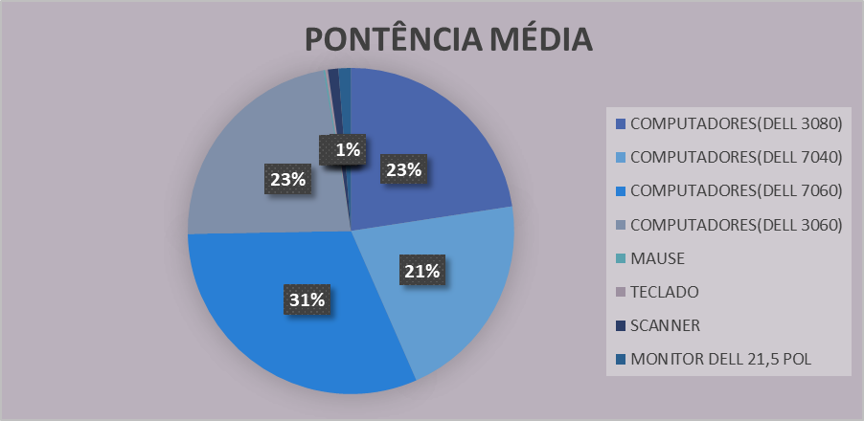

**2-GRÁFICO**