**5 Titles**

**Members:**

**Rose Ann Balladares**

**Micole Marie Dioma**

**Kevin Grajo**

**Donard Ytienza**

**Title: Centralized Hospital Management Records System**

**Rationale:**

The general aim of this system is to provide reliable Centralized Hospital Management Records System for patients and doctors to easily access the profile. Each information or data of the patients are given even he/she undergo through other hospitals hence it will also help them to minimize the expenses and time may consume. Specifically, this system may access through online by the hospitals and see the profile for those patients who are registered to this system. Hospitals are the primary focus of the system where patients are the primary beneficiary to avoid unnecessary things. The use of this system will be base on the agreement of both parties.

**Statement of the Problem:**

As the number of patients grows and the diseases to be cured on the other hand the doctor doesn’t even know the background health of the patient. These may also cause problem when giving remedies to the disease person when he/she have a health history or inherent diseases. Additionally, if the patient change her/his doctor every other month or year, so, he/she will undergo for some interview or tests again that will cause expenses and time consuming.

**Methodology:**

This System will be develop base on the Object Oriented languages such as PHP, JAVA and JAVA script, that is best fit for the system. For better understanding on how the system will be develop, the diagram below will show the processes on how the output will be produce.

**Waterfall Model**

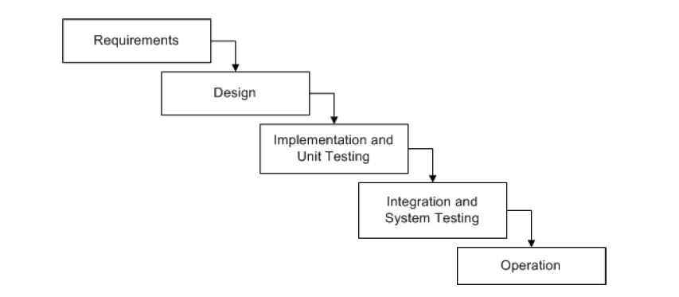

**Expected Output:**

The system will probably improve transactions in the hospital where doctors are aware for those and don’ts.

**Title: Shopee Shop Online**

**Rationale:**

The objectives of the system is to help the business in providing an increase of sales thru developing an Online System. The Shopee Shop presents a different aspect in terms of developing the study, including on how it will meet the expectations of the customer and business owners to monitor their daily income. There is a positive outlook to the business owners where they could minimize their expenses due to the lack of space for the products, lack of employee and equipment’s. It also includes creating an expandable database consisting of products to order it online andset up computer software that can be used to access the database

**Statement of the problem:**

Since its inception, small businesses relied the way costumer goes to them where sometimes their place get burden. Another thing is the lack of space at the store that make costumers uncomfortable. It will also help reduce costumer expenses and time. To improve this, we will offer efficient and effective kind of system which is a big help for all customers and business owners.

**Methodology:**

In developing a system we will be reviewing some other theories as our method to make it unique and user-friendly. It include programming languages that will suit to this system where relied on to the Object Oriented Programming Languages. But as a partial methods to be use I think Joint Application Development (JAD) is good whereas allow users to be involve.

**Joint Application Development (JAD)**

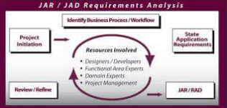

**Expected Output:**

To satisfied the need and meet the expectations of the customer.

**Title: Study Online**

**Rationale:**

Study Online solutions are an important part of the learning & development landscape, with combining technological and traditional learning methods frequently or sometimes. Combining more than one learning method into a solution is no longer unusual. Study Online has been shown to accelerate student learning by engaging students, improving time on task, expanding access to content, and extending learning beyond the traditional classroom experience. For teachers, Study Online provides actionable data that can be used to deliver more targeted, effective instruction to personalize learning for all students. The purpose of the Study Online is to improve the timeliness and accuracy of teaching strategy.

**Statement of the problem:**

The Study Online components could possibly minimize the accessibility concerns for the following students or person who cannot meet in the traditional classroom. Home-schooled students with instruction in subjects their parents feel unable to teach. Handicapped or hospitalized students who cannot travel to the traditional classroom. A person who wants to go to school but have a responsibility to do his/her job. This System helps them to study while working. In these cases they may access it anytime and anywhere. The use of various multi-media could help them employ their skills with the help of this idea.

**Methodology:**

The System was implemented by the other schools which we want to do here in province. It was our bases for the system’s project before we are going to develop or implement it. The Programming Language to be uses are those Object oriented Languages. The process to be include:

**Waterfall Method**



**Expected Output:**

Study Online possesses the ability to collect and organize digital content material. Electronic content and resources can substitute for the information found in textbooks, or the electronic copies of textbooks can be downloaded onto computers and laptops, thus eliminating the cost of purchasing textbooks and the physical and problematic concerns. The delivery of textbook information in an electronic format seems ideal for Study Online.

**Title: Reliable Online Clearance**

**Rationale:**

This study is pressing after semestral break and summer vacation ends. It in the signing clearance, students need to comply with their requirements as a prerequisite of the signing clearance. If hey are not able to take their clearance in completion, they are not able to enroll for the next school year. But problem is they need to fall in a long long line to have a sign to different people wth a position and time and consuming. Today’s technology can make it easier. This is the reason why we come up to this idea and students are familiar with the use of computers which help them for their studies.

**Statement of the problem:**

Each student always encounter of signing clearance every end of the semester. Probably it takes time for signing of clearance. The aim of this study is to provide a good quality system that could help each student minimize time and cost. Also, not to waste time in falling in line that cause flood of expanded students in the place.

**Methodology:**

This idea was based on our observation as a student. It will be developing according to its purpose and the functionalities, it will came from students who will be interviewed for some information. Php and JavaScript are one of those programming languages to be used.

**Rapid Application Development (RAD)**

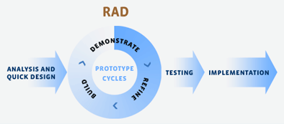

**Expected Output;**

**Title:**

**Rationale:**

**Statement of the problem:**

**Methodology:**

**Expected Output;**