MOBILE AND WEB - LAB 4

Student 1: Dileep Kumar
Student ID: 16261222
class ID: 8
Student 2: Herbert Chepsoy
Class ID:31
Lab Id: 8

GitHub Link: https://github.com/Dileep1111/MobileWebLab4

YouTube Link: https://youtu.be/jRnI5WKGcLo

Lab Assignment:
Create an android application having following features:
1.Service: Use at least two hardware features like Location or Sensors or Media or Camera etc...
2.API: Use any of the Machine Learning/ Social Media related API (Except the one used in ICP3)
3.Storage: Use either firebase or open SQLite or file storage
4.Layout: Use at least one Grid Layout
5.UI/UX Design: The app should have a good UI/UX

Approach:
Step1: Create a login and register page using firebase auth.
Step2: Implementing a grid layout as we used grid layout to arrange home page.
Step3: A Camera application which will analyze the image display its score
Step4: A map layout which shows the location and display longitude and latitude which entered in text form.

First, we have to create a Firebase project. Add Firebase to the android app , added package name and downloaded google-services.json file.

Next, Add the SDK
buildscript {
// ...
dependencies {
// ...
classpath 'com.google.gms:google-services:4.2.0' // google-services plugin
}
}
allprojects {
// ...
repositories {
// ...
google() // Google's Maven repository
}
After building the application we get our mail details in Firebase.

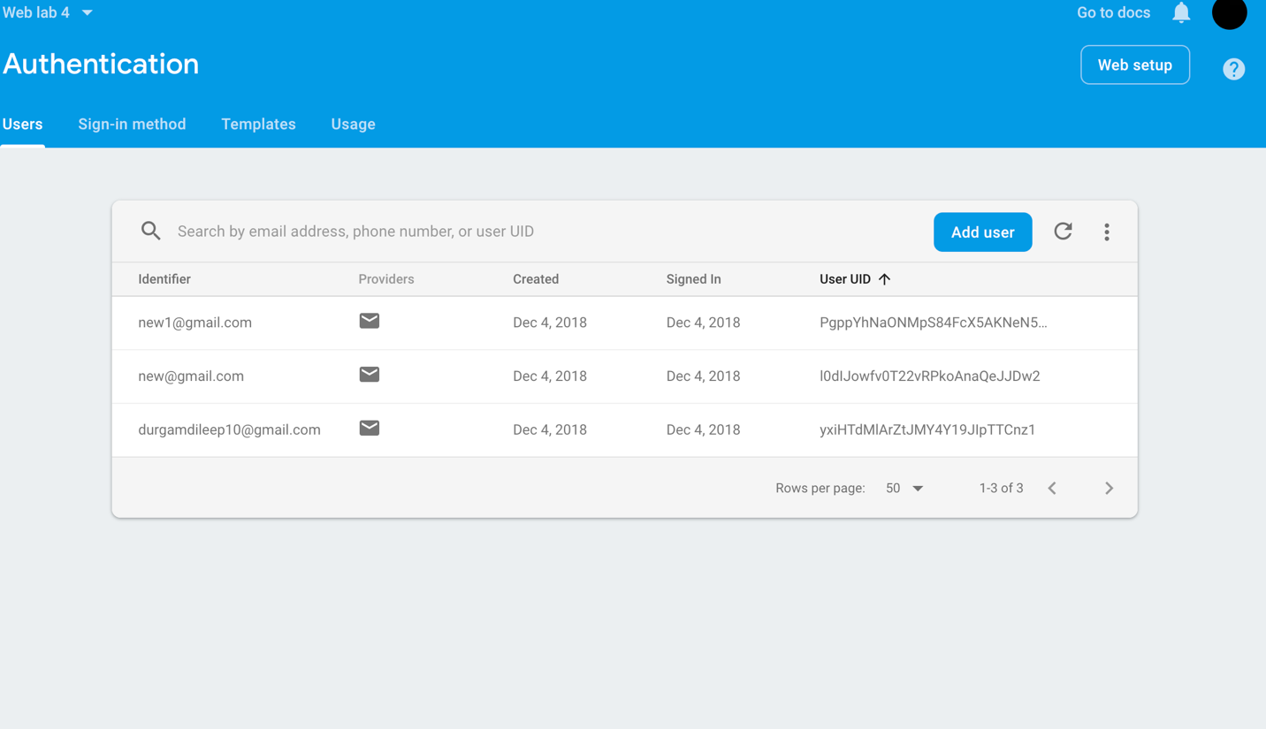

Xml file for seeking permissions for accessing locations.

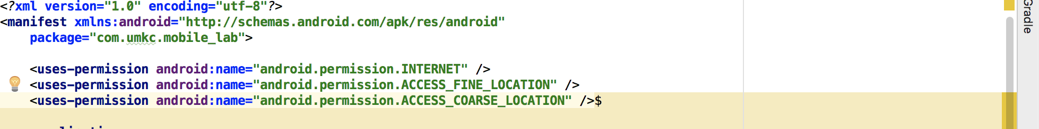

Camera layout:

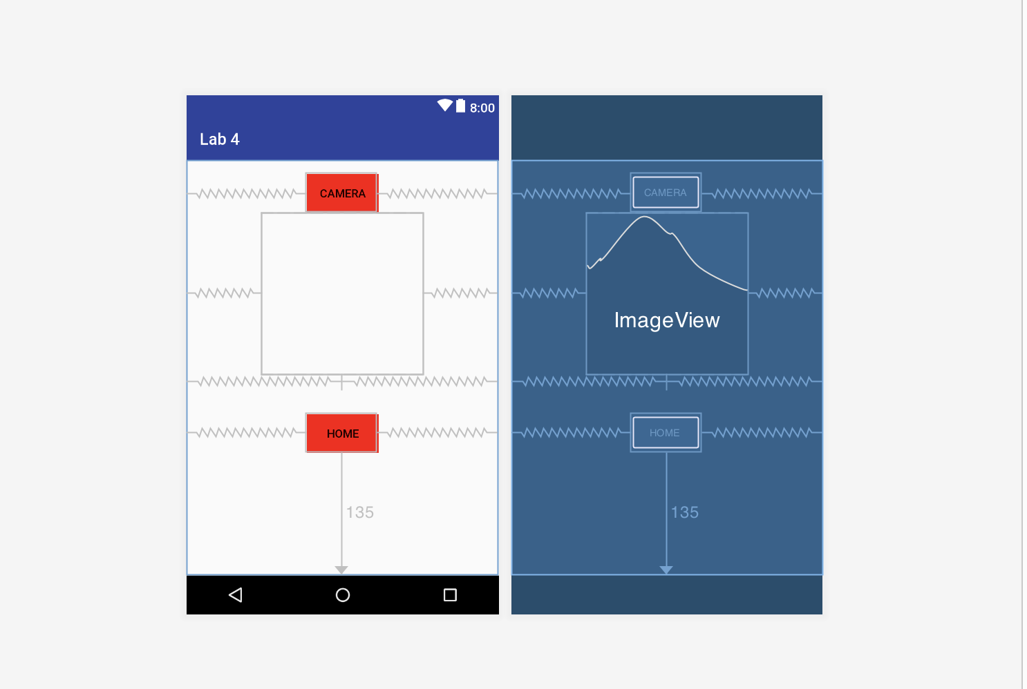

We Implemented Grid layout in Home page, for arranging maps, camera, and logout buttons.

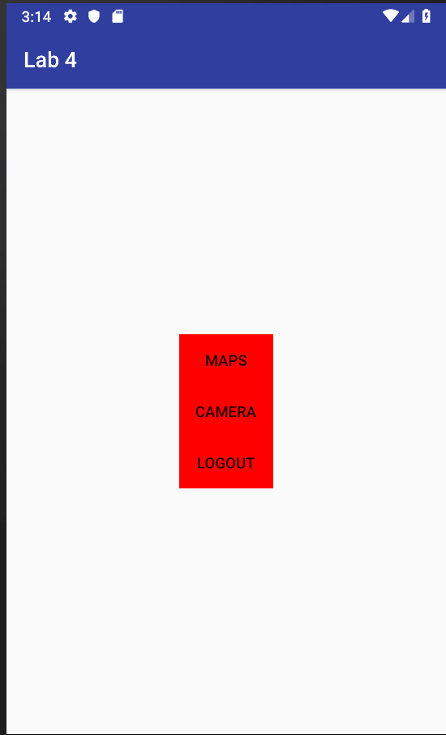

Code of grid layout.xml

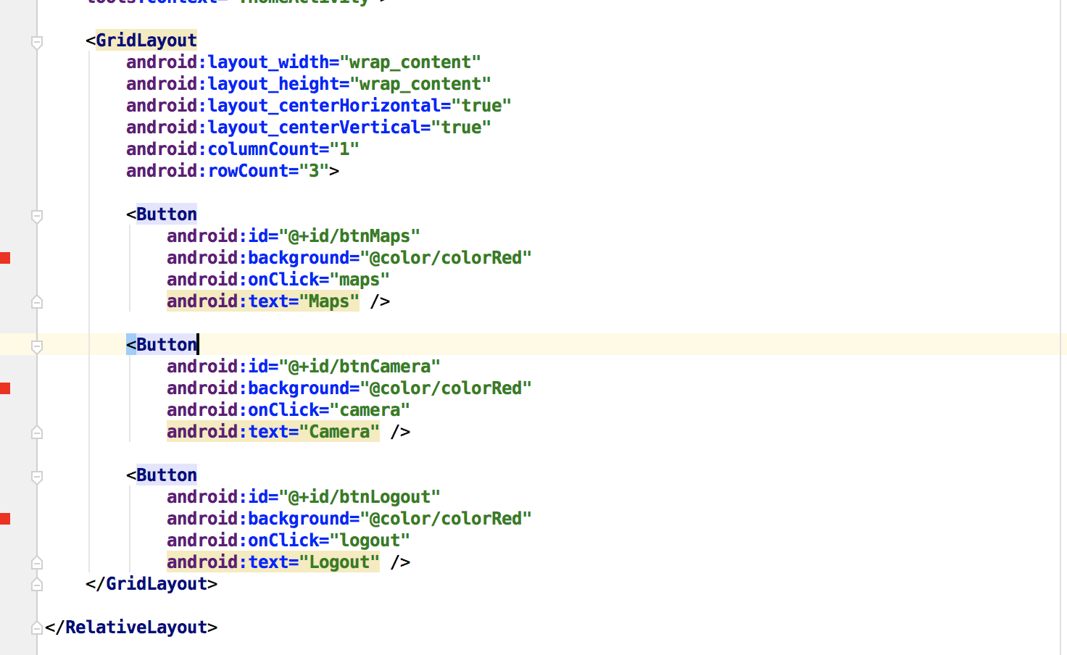

Code of java:

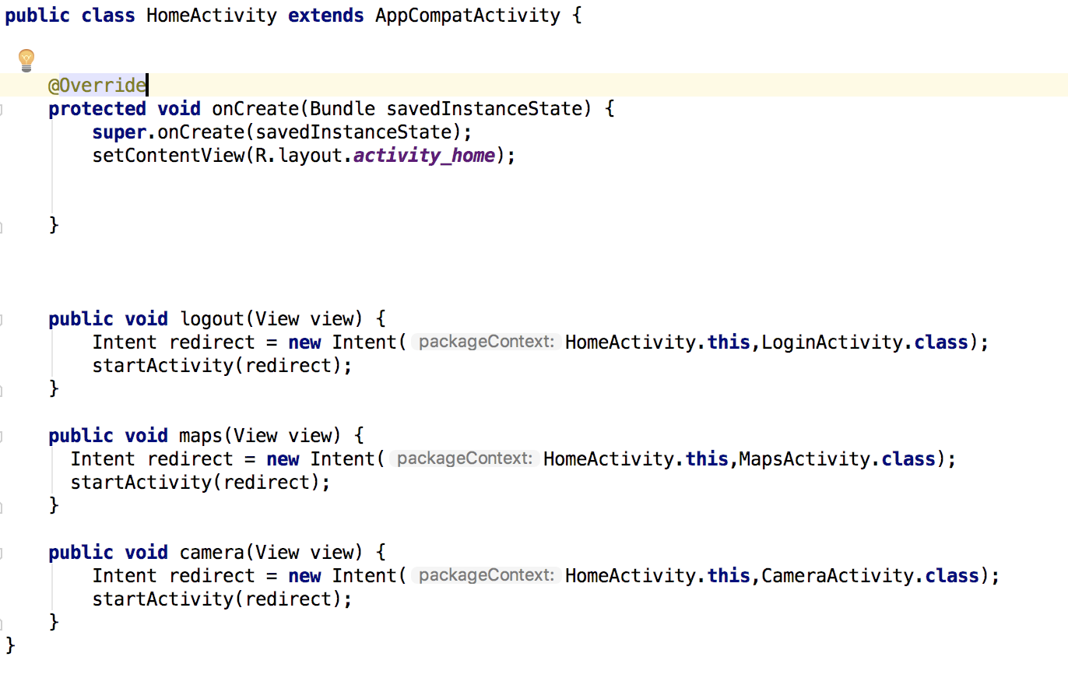
Login and Register process through email and passwords.

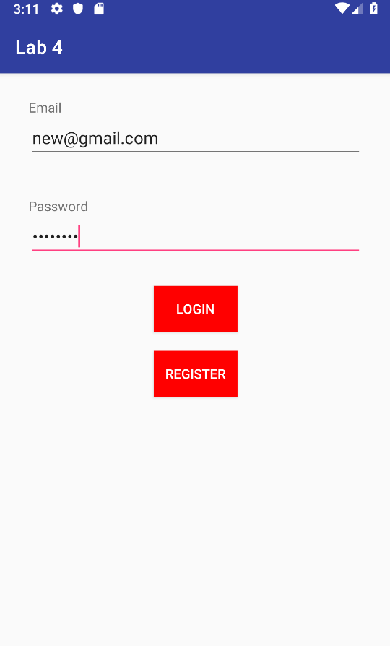
Java code for login activity.

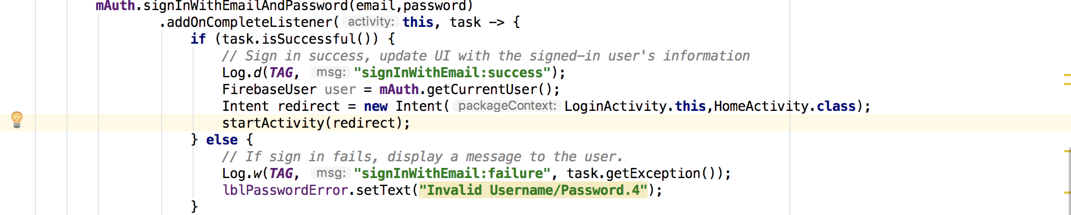

Register page , we can register by email and password:
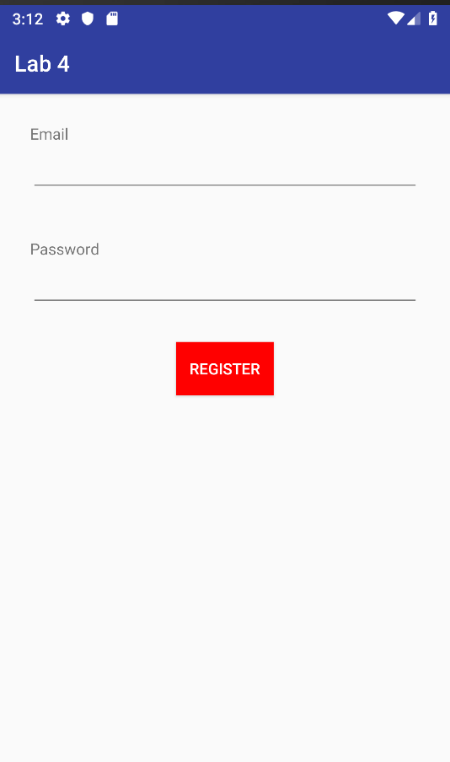

Camera Layout:

Functioning of Camera:

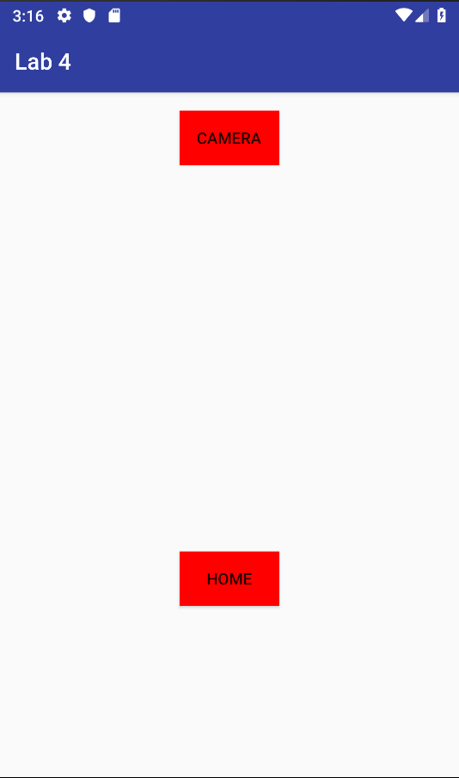

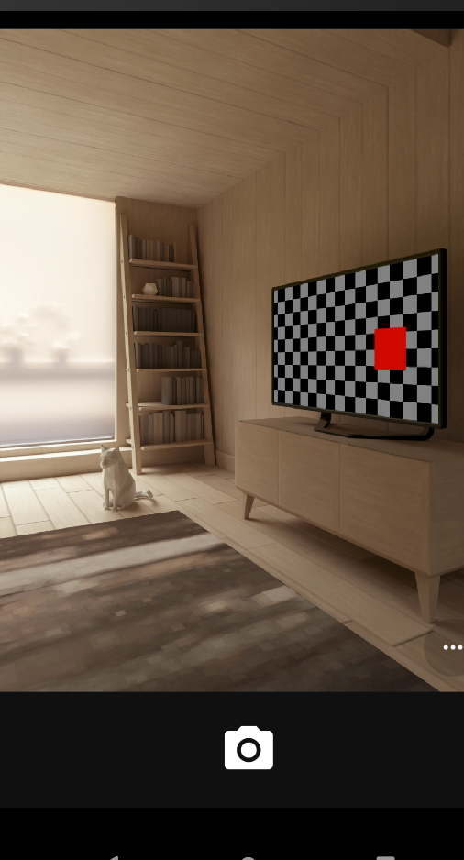

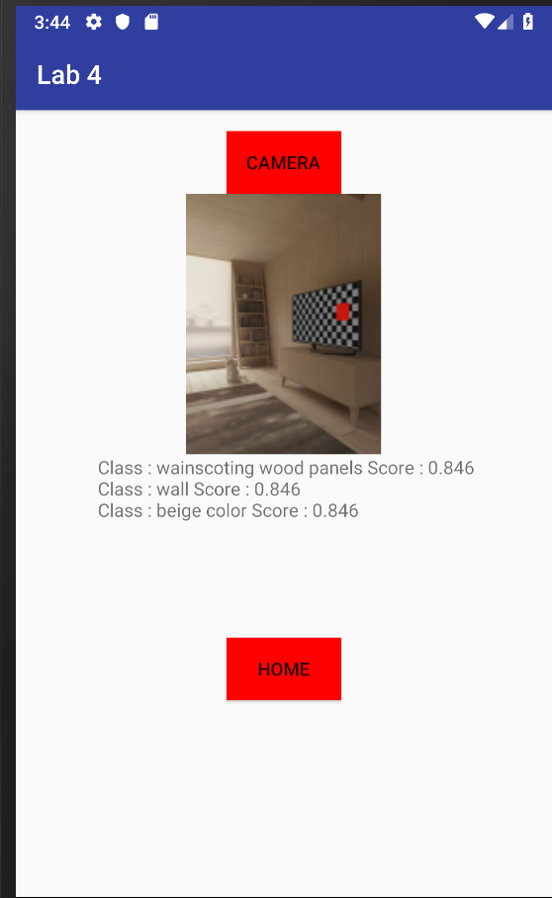

Functioning of Location.

