Comprehensive PRD – AI Real Estate Platform (Dubai/UAE)

# Executive Summary

Comprehensive product requirements for an AI-powered Dubai/UAE real estate platform. Scope includes backend services (AI/MLOps, data, compliance), public website UX/UI, mobile, and operations. All content is bilingual-aware (English/Arabic), PDPL-compliant, and aligned with RERA/DLD Trakheesi and TDRA rules.

# Objectives

- AI-assisted operations: lead scoring, nurture, listing generation, virtual staging, AVM, chatbot, doc AI.  
- Best-in-class GCC UX for buyers/tenants and international investors.  
- Data residency in UAE, audited security, high availability, and observability.  
- Modular microservices and model lifecycle to evolve with AI progress.

# Users & Roles

|  |  |
| --- | --- |
| Role | Primary Goals |
| Agent/Broker | • Prioritize and contact high-probability leads quickly • Publish compliant listings with minimal manual effort • Use AI staging and content tools to improve marketing |
| Marketing | • Bulk generate ad copy and assets with permits embedded • Run experiments and analyze funnels • Coordinate WhatsApp/SMS with consent and time windows |
| Compliance | • Enforce Trakheesi/ADGM permits on every listing • Audit outbound messaging vs TDRA windows and consent • Respond to PDPL data subject requests |
| Buyer (Local) | • Search by community, developer, price, payment plans • Contact via WhatsApp/Call instantly • Receive alerts for new relevant projects |
| Investor (International) | • Analyze ROI/yields, visa eligibility • Compare communities and developers • Remote scheduling in local time zones |

# Compliance & Official Data Sources

• PDPL privacy with consent ledger and DSR endpoints.  
• RERA/DLD Trakheesi: permit must be validated and displayed on all public listings.  
• TDRA: SMS only 07:00–21:00 UAE; WhatsApp only with explicit opt-in and approved templates.  
• Datasets: DLD API Gateway, Dubai Pulse, Mo’asher index, ADREC/DARI (Abu Dhabi).

# Detailed Workflows

## Lead Intake & Nurture

* Ingest leads from website, portals, WhatsApp, calls.
* Score via ML; route high-score to agents; low-score to nurture.
* Nurture obeys consent flags and TDRA/WhatsApp policies.

## Listing Creation & Publishing

* Agent inputs core attributes; system drafts description with Trakheesi injected.
* Optional virtual staging; labeled and originals retained.
* Permit validation service blocks publish if invalid/expired; audit logged.

## Buyer Journey

* Homepage search → responsive filters → map + grid/list.
* Property detail shows media carousel, payment plan visualization, neighborhood info.
* Sticky CTA bar with Call/WhatsApp/Schedule; confirmation and SLA notice.

## Investor Flows

* Dashboard with saved projects, ROI calculator, visa eligibility checks.
* Community comparison (yield, liquidity, developer reputation).
* Alerts for new launches, price drops, handover updates.

## Compliance & Privacy

* Consent ledger with immutable audit trail (QLDB).
* DSR portal for access/delete/export within SLA.
* Outbound content moderation and permit compliance pre-publish.

# Data Model (Core Entities)

|  |  |
| --- | --- |
| Entity | Fields |
| Person | person_id, name, email, phone, consent_flags, locale, roles |
| Lead | lead_id, person_id, source, campaign, score, status, timestamps |
| Property | property_id, location, community, developer, bed/bath, area_sqft, price_aed, status |
| Permit | permit_id, type, trakheesi_number, issuer, issue_date, expiry_date, status |
| Listing | listing_id, property_id, description, media_refs, badges, permit_id, language, channels |
| Conversation | conv_id, person_id, channel, messages, consent_required, send_window_ok |
| Deal | deal_id, listing_id, agent_id, stage, offer_amount, close_date |
| Doc | doc_id, type, source, extracted_fields, validation_status |

# API Endpoint Schemas (Expanded)

## POST /permits/check

Request:  
{ "property_id":"string","market":"Dubai","trakheesi_number":"string" }  
200: { "valid":true,"issuer":"DLD","expiry_date":"YYYY-MM-DD","errors":[] }

## GET /permits/status?trakheesi=654321

200: { "status":"valid|expired|not_found","expiry_date":"YYYY-MM-DD" }

## POST /ml/lead-score

Request:  
{ "lead_id":"string","features":{...} }  
200: { "score":0.0-1.0,"tier":"High|Med|Low","reasons":["budget_fit","engagement_high"] }

## POST /ml/avm

Request:  
{ "property_id":"string","features":{ "community":"Palm Jumeirah","beds":3,"area_sqft":2100 } }  
200: { "estimate_aed": 5400000, "low_aed": 5200000, "high_aed": 5600000, "mae_pct": 9.2 }

## POST /nlp/listing-writer

Request:  
{ "property_id":"string","inputs":{...,"trakheesi_number":"654321","language":"en|ar"} }  
200: { "description":"...", "toxicity_flag":false, "reading_level":9 }

## POST /vision/stage

Request: { "image_url":"https://...","style":"modern|minimal|luxury","room_type":"living|bedroom" }  
200: { "staged_image_url":"https://...","label":"AI-staged" }

## POST /msg/whatsapp/send

Request: { "lead_id":"L123","template":"new_listing","language":"en","placeholders":{...},"send_at_iso":"..." }  
200: { "status":"queued|sent|blocked","reason":"outside_TDRA_window|missing_consent|null","id":"uuid" }

## POST /msg/sms/send

Request: { "to":"+971...","template_id":"...","language":"en|ar","send_at_iso":"..." }  
200: { "status":"queued|blocked","reason":"outside_TDRA_window|missing_consent|null" }

## POST /consent/update

Request: { "person_id":"P1","optin_whatsapp":true,"optin_email":true,"optin_sms":false }  
200: { "ok":true,"version":"v3","timestamp":"..." }

## POST /investor/roi-calc

Request:  
{ "price_aed":2000000,"annual_rent_aed":120000,"service_charges_aed":20000,"vacancy_rate_pct":5 }  
200: { "gross_yield_pct":6.0,"net_yield_pct":4.9,"cap_rate_pct":4.9 }

## POST /visa/check

Request: { "purchase_price_aed":2200000,"property_status":"ready|offplan","mortgage_ratio_pct":40 }  
200: { "eligible":true,"basis":"≥ AED 2m","notes":"Subject to policy" }

## GET /analytics/funnel?range=30d

200: { "search":15234,"listing":11222,"detail":7641,"contact":1894,"ctr":0.17 }

## POST /search/listings

Request: { "filters":{ "community":["Palm","Downtown"],"price_lte":6000000,"payment_plan":true }, "sort":"price_desc","page":1 }  
200: { "results":[...], "total": 4312 }

# Acceptance Criteria & Test Cases

|  |  |  |
| --- | --- | --- |
| ID | Test Case | Expected Result |
| TC-001 | Permit Validation – Expired | Given expired Trakheesi, when /permits/check, then valid=false and publish blocked; UI shows error banner; audit log created. |
| TC-002 | Permit Validation – Valid | Given valid number, system stores expiry_date; publish permitted; audit log entry created. |
| TC-003 | Lead Scoring SLA | On lead creation, scoring completes p95 < 2s; score and reasons attached; routing executed. |
| TC-004 | Nurture Guardrails | Outbound at 22:00 UAE blocked; reason=outside_TDRA_window; no vendor call fired. |
| TC-005 | Consent Required | If consent=false, all outbound blocked; opt-in flow displayed; log written. |
| TC-006 | Listing Writer Injection | Generated description always contains Trakheesi; language matches; toxicity=false. |
| TC-007 | Virtual Staging Label | All AI images labeled; originals preserved; toggle comparison available. |
| TC-008 | ROI Calculator | AED 2m, 120k rent, 20k charges, 5% vacancy → net≈4.9%; rounding tolerance ±0.05%. |
| TC-009 | Visa Eligibility | ≥ AED 2m → eligible=true; off-plan printed caveats; below → eligible=false. |
| TC-010 | Search Performance | Search API p95 < 800ms for common filters; infinite scroll stutter-free on mid-range Android. |
| TC-011 | RTL Layout | Arabic pages mirrored; icons flipped; no clipping; manual QA checklist passed on three devices. |
| TC-012 | Accessibility | WCAG AA; keyboard nav across forms; alt text EN/AR; focus rings visible. |
| TC-013 | Analytics | Funnel logs: search→listing→detail→contact; daily dashboard; anomaly alerts. |
| TC-014 | Security/RBAC | Agent cannot modify permits; compliance can read/write; attempts logged and alerted. |

# UI/UX Audit Checklist for Dubai / GCC Real Estate Platforms

## 1. Market-Specific Considerations

* English + Arabic toggle; flawless RTL mirroring.
* AED default; toggle to USD/GBP/EUR; area in sqft/m².
* Luxury visuals: video, drone, 3D tours.
* Investor flows: ROI calculator, rental yield, visa info.
* Compliance: RERA badges, agent licensing, gov data integration.

## 2. Homepage / Entry

* Search-first hero with location/type/price.
* Optimized hero visuals of key communities.
* Visible multilingual switch on top bar.
* Quick links: Off-plan, Luxury, Ready to move.

## 3. Search & Discovery

* Live filters: price, community, developer, handover year, payment plan.
* Community map overlays for Palm, Downtown, JVC, etc.
* Investment filters: yields, payment plans, developer reputation.
* Mobile UX: sticky filter icon, collapsible panels.

## 4. Property Listings / Results

* Grid + list toggle; infinite scroll with lazy load.
* Card fields: price, size, location, payment plan badge, agent thumbnail.
* Badges: Hot deal, New launch, Off-plan, Ready to move.
* Synchronized map + list; cluster hotspots.

## 5. Property Detail Page

* Hero media carousel: drone/video/high-res.
* Tabs: Overview | Floorplans | Location | Payment Plan | Agent.
* Payment plan visualization timeline.
* Trust: RERA number, developer profile.
* Neighborhood: metro, malls, schools, beaches.
* Sticky CTA on mobile: Call, WhatsApp, Schedule.

## 6. Conversion Flows

* Channels: call, WhatsApp, chat, callback.
* Minimal initial form; progressive fields.
* WhatsApp deep linking; 07:00–21:00 guard.
* Confirmation text with follow-up SLA.

## 7. Personalization & Accounts

* Save searches; alerts for Dubai Marina, Palm, etc.
* Investor dashboard: ROI, comparisons.
* Notifications for handovers and launches.

## 8. Visual Design (UI)

* Bold type, clear hierarchy, white space.
* Luxury palette + dark mode.
* Responsive on mid-range Android devices.
* Arabic UI mirrored; icon flipping.

## 9. Performance & Accessibility

* WebP + CDN; Lighthouse >90 mobile.
* WCAG AA in EN/AR; keyboard nav.
* Alt text and accessible forms.

## 10. Analytics & Optimization

* Funnels: Search→Listing→Detail→Contact.
* Filter drop-offs tracked.
* A/B test payment plan visuals and CTAs.
* Session recordings on mobile.

## 11. GCC Differentiators

* Lifestyle storytelling: marinas, malls, golf.
* Golden Visa guidance.
* International flows: country code detect, TZ-aware scheduling.
* Developer branding: Emaar, DAMAC, Nakheel.

## Audit Scorecard Template (0–5 per item)

|  |  |  |
| --- | --- | --- |
| Checklist Item | Score (0–5) | Notes |
| English + Arabic toggle; flawless RTL mirroring. |  |  |
| AED default; toggle to USD/GBP/EUR; area in sqft/m². |  |  |
| Luxury visuals: video, drone, 3D tours. |  |  |
| Investor flows: ROI calculator, rental yield, visa info. |  |  |
| Compliance: RERA badges, agent licensing, gov data integration. |  |  |
| Search-first hero with location/type/price. |  |  |
| Optimized hero visuals of key communities. |  |  |
| Visible multilingual switch on top bar. |  |  |
| Quick links: Off-plan, Luxury, Ready to move. |  |  |
| Live filters: price, community, developer, handover year, payment plan. |  |  |
| Community map overlays for Palm, Downtown, JVC, etc. |  |  |
| Investment filters: yields, payment plans, developer reputation. |  |  |
| Mobile UX: sticky filter icon, collapsible panels. |  |  |
| Grid + list toggle; infinite scroll with lazy load. |  |  |
| Card fields: price, size, location, payment plan badge, agent thumbnail. |  |  |
| Badges: Hot deal, New launch, Off-plan, Ready to move. |  |  |
| Synchronized map + list; cluster hotspots. |  |  |
| Hero media carousel: drone/video/high-res. |  |  |
| Tabs: Overview | Floorplans | Location | Payment Plan | Agent. |  |  |
| Payment plan visualization timeline. |  |  |
| Trust: RERA number, developer profile. |  |  |
| Neighborhood: metro, malls, schools, beaches. |  |  |
| Sticky CTA on mobile: Call, WhatsApp, Schedule. |  |  |
| Channels: call, WhatsApp, chat, callback. |  |  |
| Minimal initial form; progressive fields. |  |  |
| WhatsApp deep linking; 07:00–21:00 guard. |  |  |
| Confirmation text with follow-up SLA. |  |  |
| Save searches; alerts for Dubai Marina, Palm, etc. |  |  |
| Investor dashboard: ROI, comparisons. |  |  |
| Notifications for handovers and launches. |  |  |
| Bold type, clear hierarchy, white space. |  |  |
| Luxury palette + dark mode. |  |  |
| Responsive on mid-range Android devices. |  |  |
| Arabic UI mirrored; icon flipping. |  |  |
| WebP + CDN; Lighthouse >90 mobile. |  |  |
| WCAG AA in EN/AR; keyboard nav. |  |  |
| Alt text and accessible forms. |  |  |
| Funnels: Search→Listing→Detail→Contact. |  |  |
| Filter drop-offs tracked. |  |  |
| A/B test payment plan visuals and CTAs. |  |  |
| Session recordings on mobile. |  |  |
| Lifestyle storytelling: marinas, malls, golf. |  |  |
| Golden Visa guidance. |  |  |
| International flows: country code detect, TZ-aware scheduling. |  |  |
| Developer branding: Emaar, DAMAC, Nakheel. |  |  |

# Non-Functional Requirements & SLOs

• API latency p95 < 300 ms  
• Search response p95 < 800 ms  
• Image TTI < 2.5 s on 4G  
• Availability 99.95%  
• Error budget policy enforced via SLOs

# Security Architecture & Key Management

All services use TLS in transit and KMS-backed encryption at rest. IAM least-privilege, VPC endpoints, private subnets. Consent ledger immutable via QLDB; DLP scanning on S3 via Macie. WAF + Shield front CloudFront.

KMS Key Policy: CMKs scoped to service roles, rotation every 365 days, CloudTrail logs on all key usage.

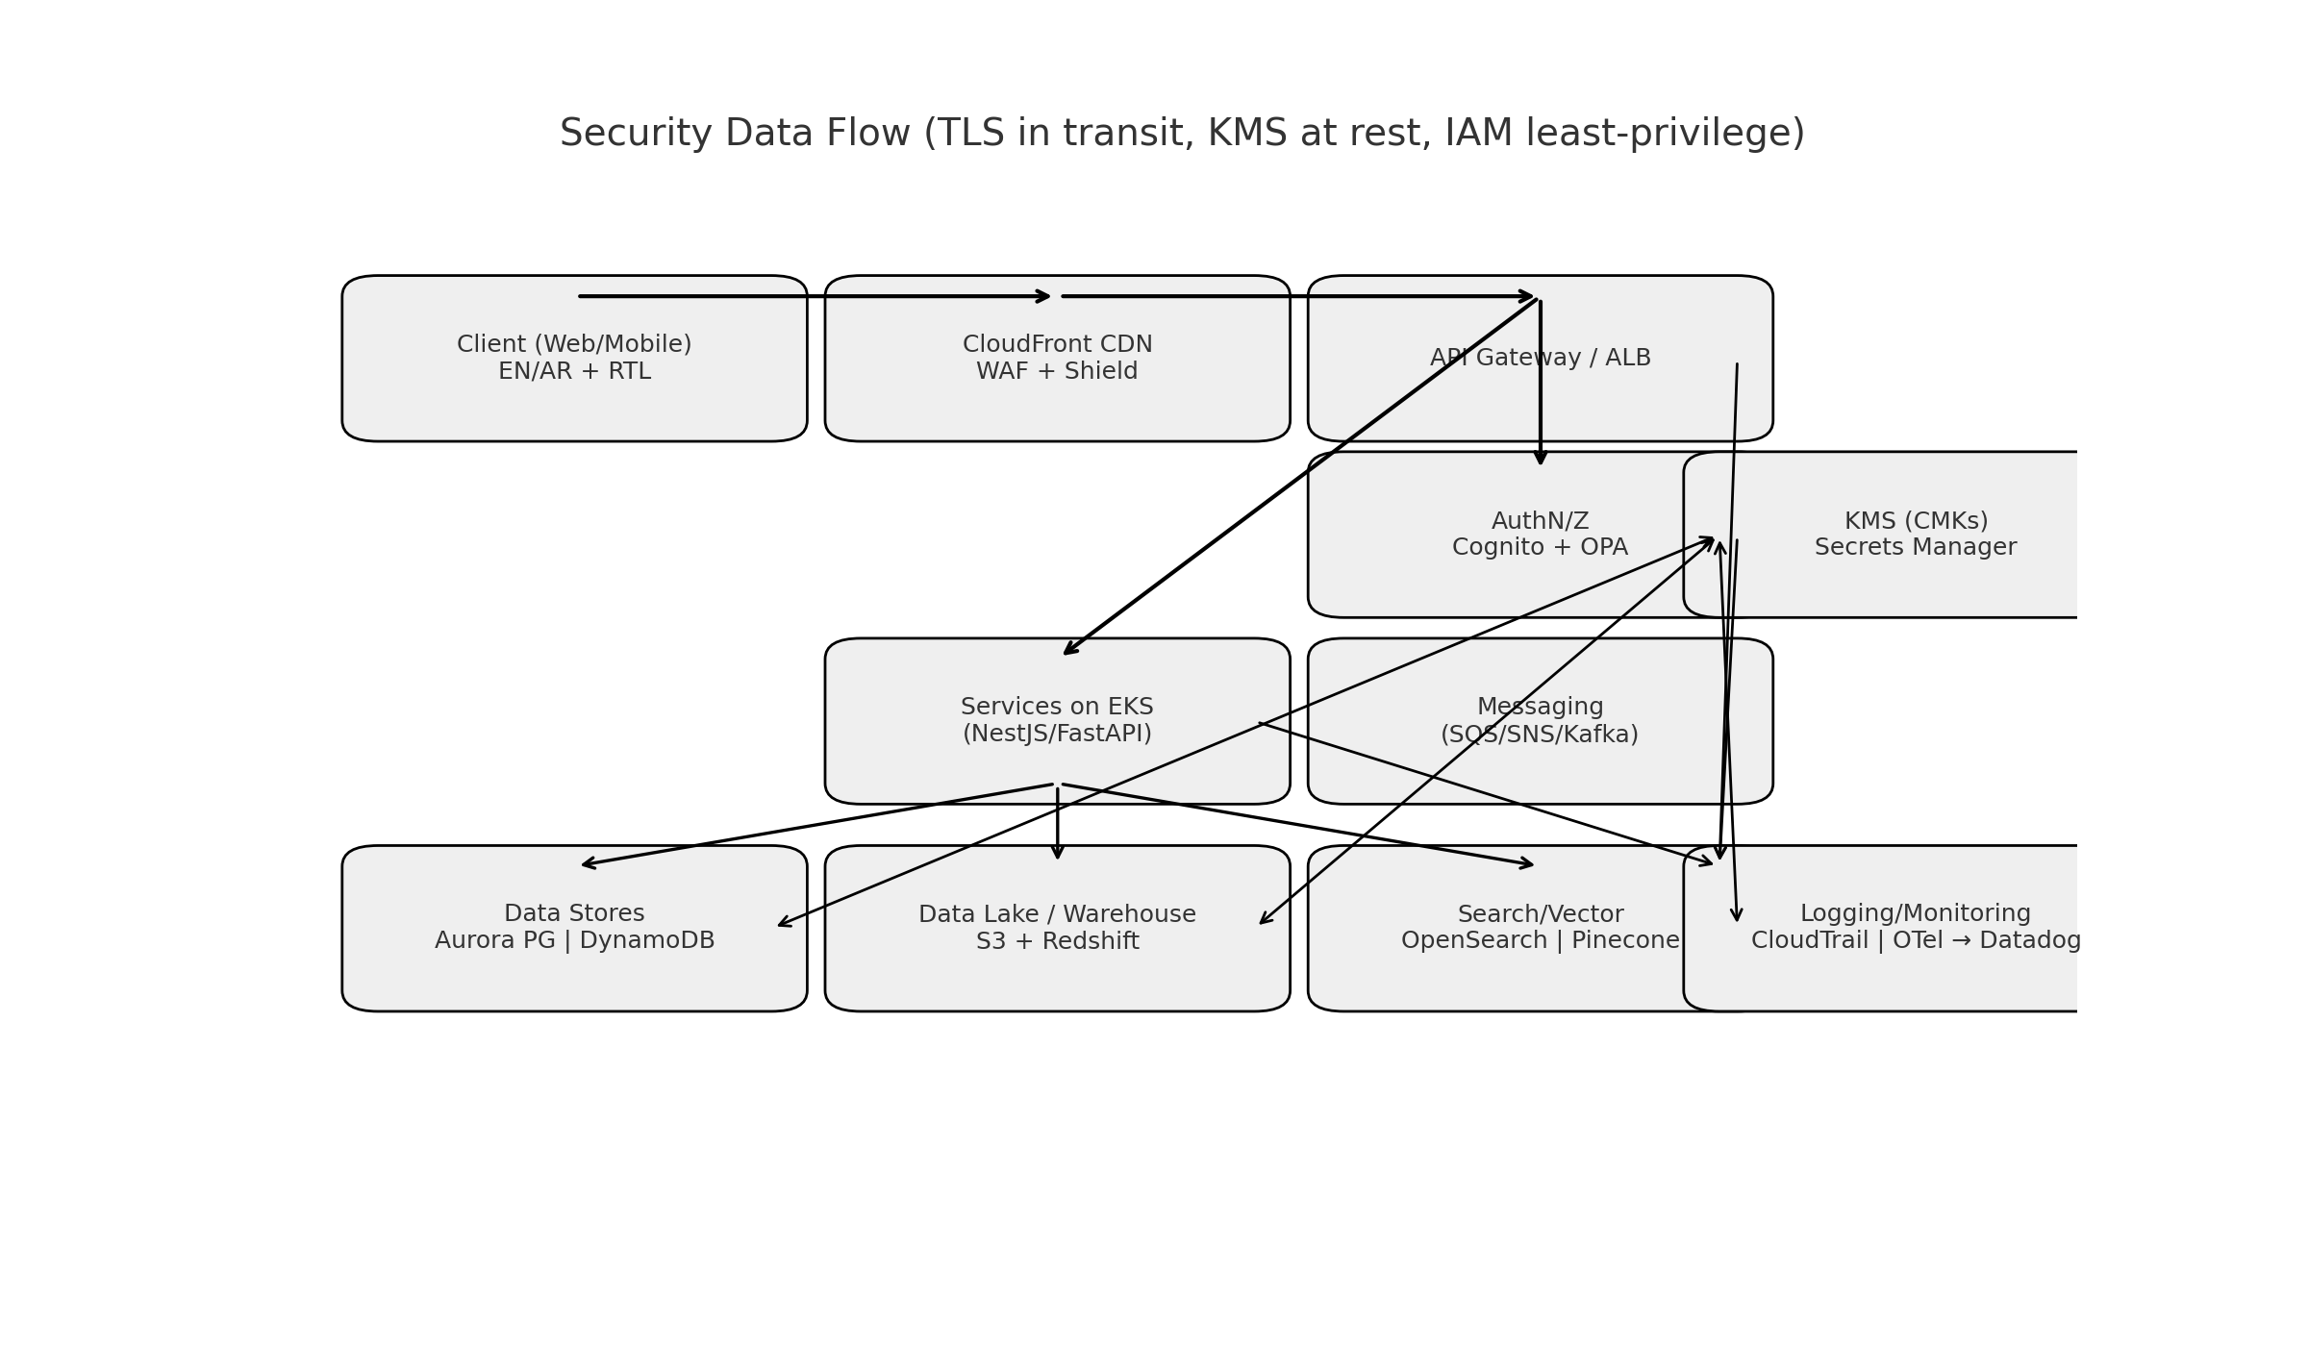

# Technology Choices & Rationale

## Cloud & Infra

* AWS me-central-1 for UAE residency; EKS for portability; Fargate for burst; Lambda for glue; Terraform for reproducibility.

## Data Platform

* MSK (Kafka) for events; Redshift for warehouse; S3 + Delta Lake for lakehouse; Great Expectations for quality.

## AI/ML & MLOps

* SageMaker + MLflow for lifecycle; vLLM/TensorRT-LLM for fast LLM inference; Pinecone/Qdrant for vectors; KServe/Argo for serving/pipelines.

## Search & Recommendations

* OpenSearch hybrid (BM25+vector) with EN/AR; Meilisearch for autosuggest; simple GBM ranker initially.

## Application Backend

* NestJS/Node for business APIs; FastAPI for ML bridges; Aurora PG for OLTP; DynamoDB for consent/ledgers; SQS/SNS for async.

## Frontend

* Next.js 14 + React 18 + TypeScript; Tailwind + shadcn/ui; next-intl and rtlcss; Mapbox GL; image optimization via CloudFront.

## Mobile

* React Native + Expo; deep-links for WhatsApp; push via SNS/APNs/FCM.

## CMS & Content Ops

* Sanity as headless CMS; Lokalise for EN/AR localization workflow.

## Security & Compliance

* Secrets Manager + KMS; QLDB for immutable audit; Macie, WAF, Shield.

## Observability

* OpenTelemetry to Datadog/Grafana; Sentry for app errors; SLOs monitored.

## Analytics & Experimentation

* RudderStack + Amplitude; GrowthBook for feature flags and A/B tests.

# Incident Runbooks

## Permit API Outage

* Detect via health checks and upstream status.
* Exponential backoff with jitter.
* Fallback to cached valid permits (TTL).
* Notify Compliance and Marketing; banner on CMS to pause new publishes.
* Postmortem within 48h.

## WhatsApp BSP Failure

* Fail over to secondary BSP automatically.
* Queue messages in SQS; replay after recovery.
* Pause non-critical campaigns; show in-app banner.
* Vendor escalation runbook.

## Vector Index Corruption

* Immediate search read-only mode.
* Restore from S3 snapshot; rebuild embeddings for last 24h.
* Run golden set QA; re-enable writes after diff <1%.

## Model Drift

* Monitor AUC/MAE weekly; thresholds alert at 10% degradation.
* Trigger retraining pipeline; champion–challenger evaluation.
* Compliance review of lead scoring fairness; roll back if needed.

# Diagrams

System Architecture

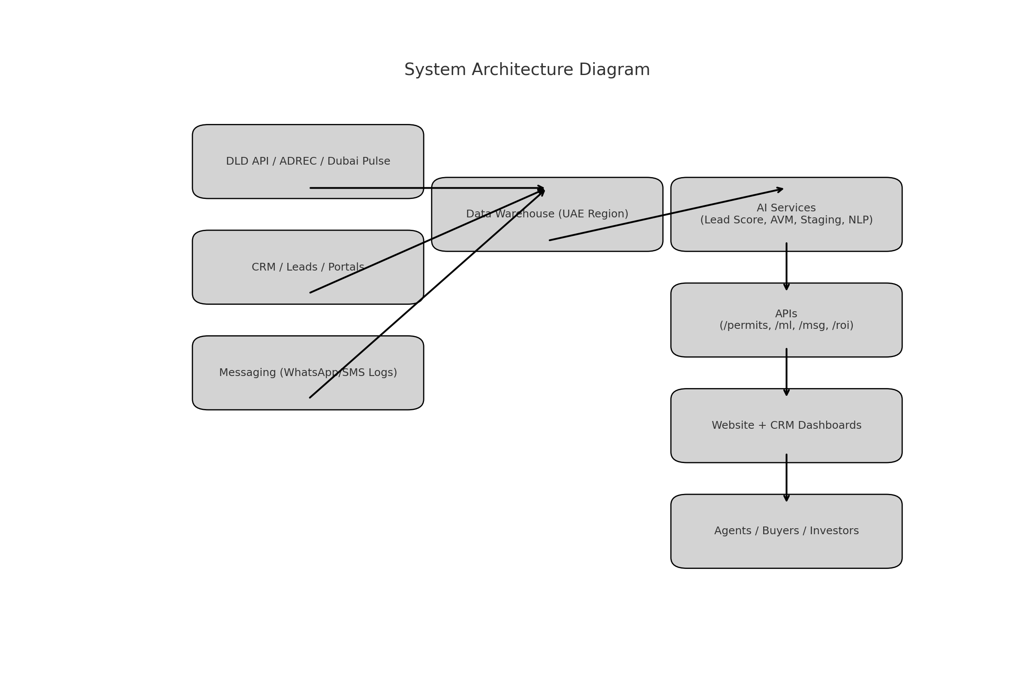

Buyer Journey Flow

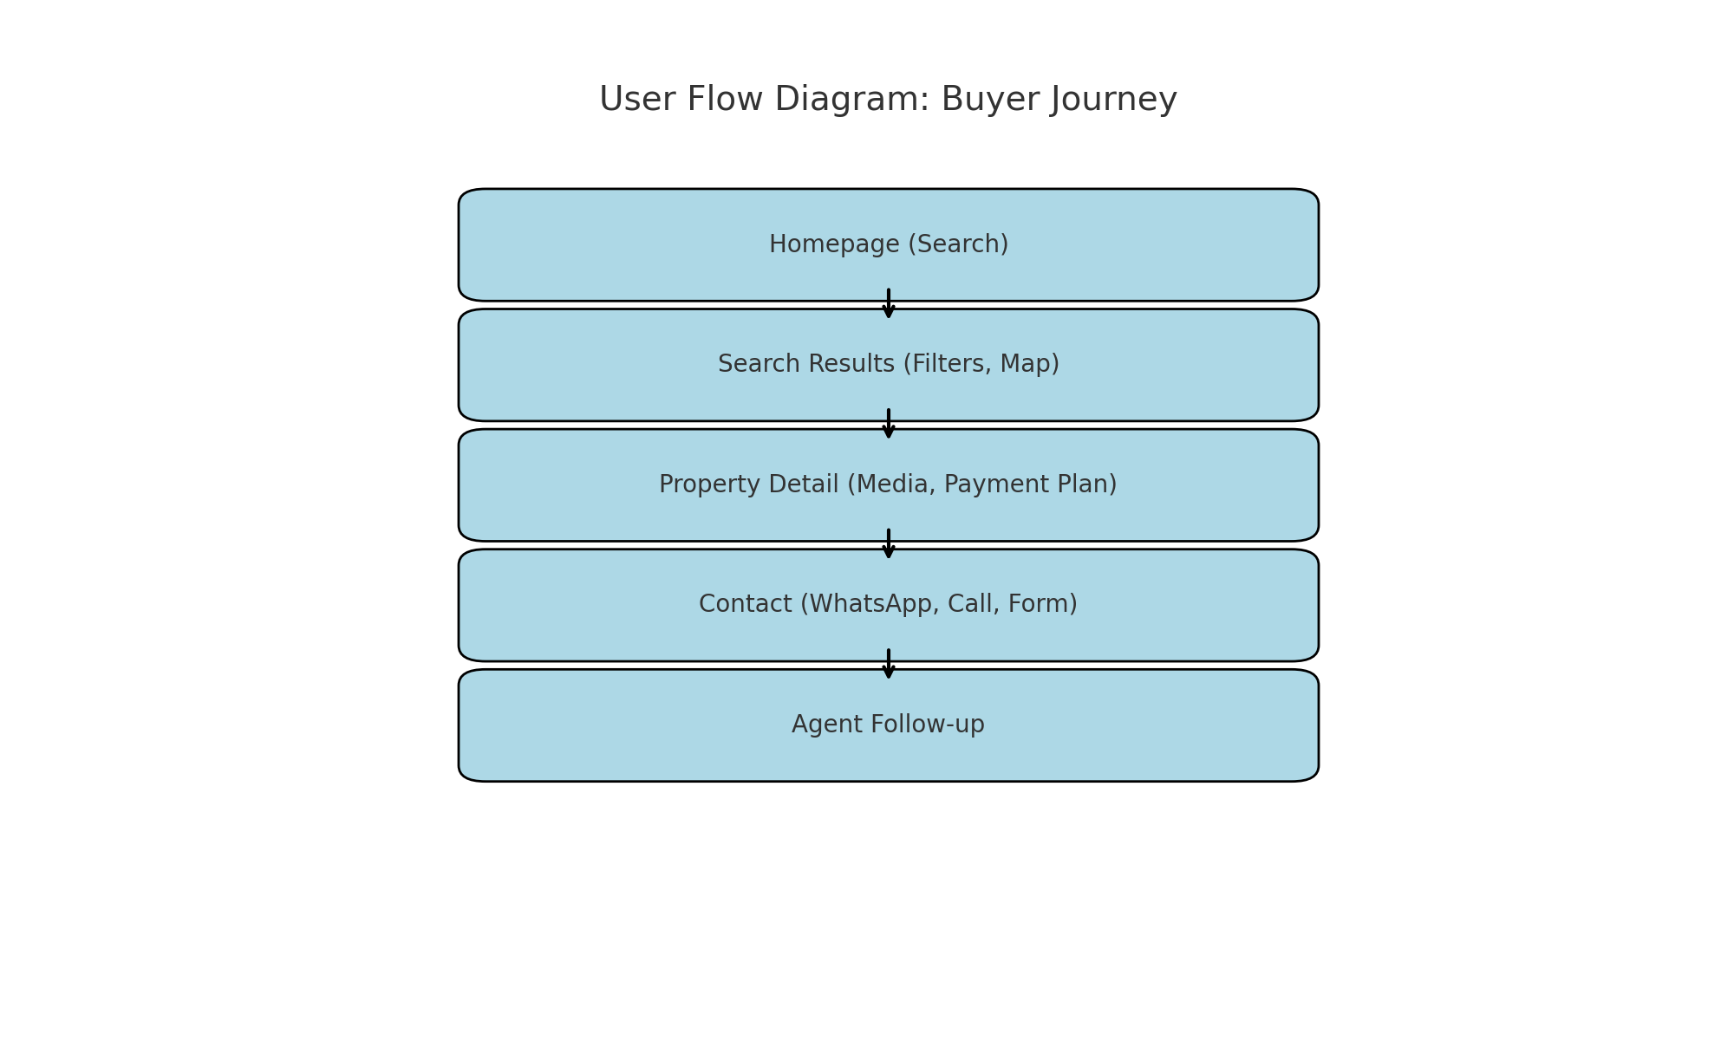

Listing Creation & Compliance Flow

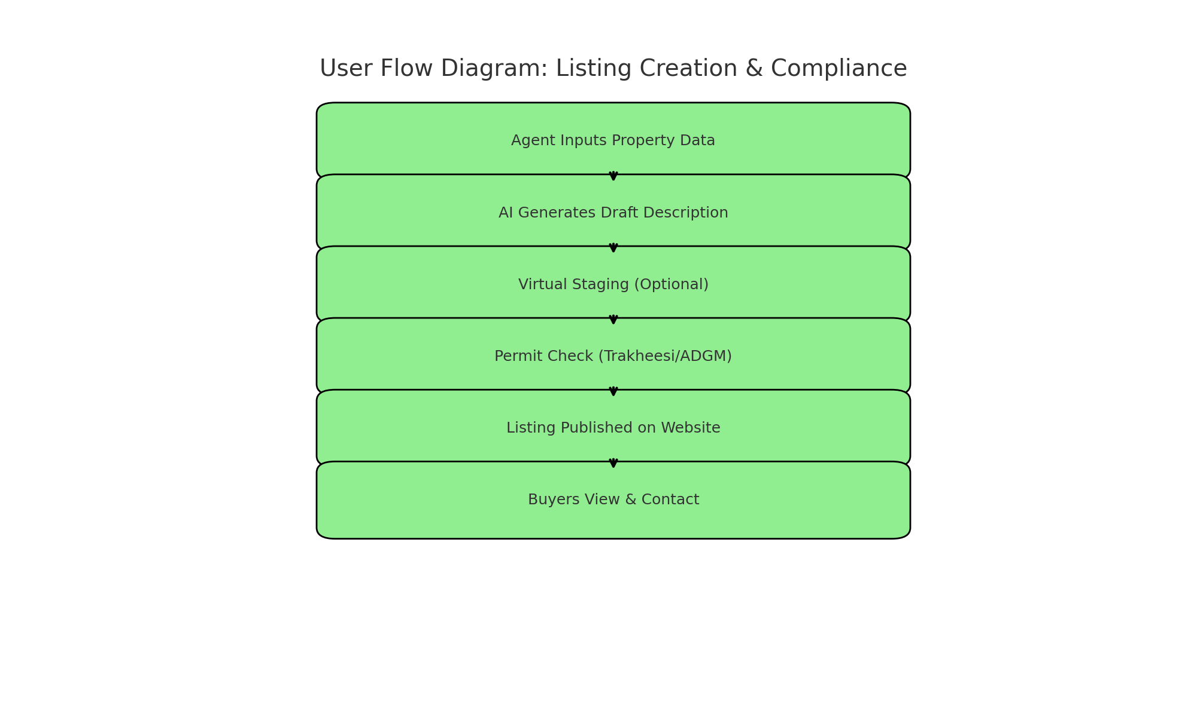

Investor Dashboard Flow

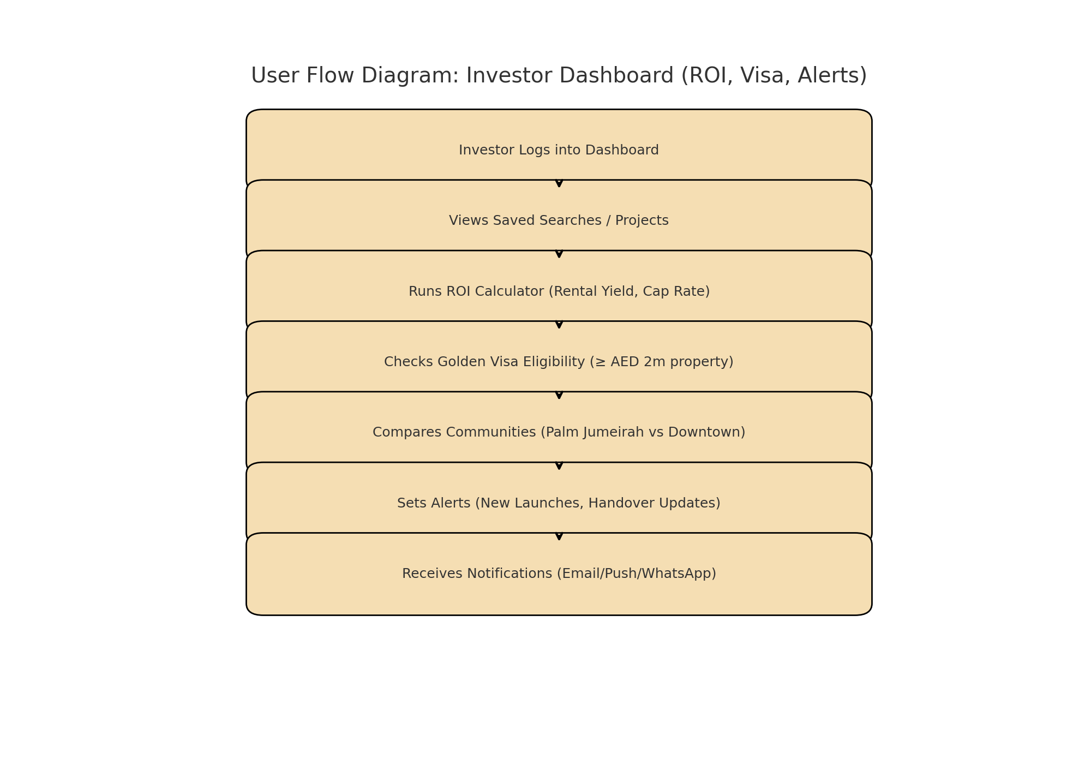

# Architecture Bill of Materials (BOM)

|  |  |
| --- | --- |
| Layer | Service/Tool |
| Cloud | AWS (me-central-1, UAE) |
| Compute | EKS, Fargate, Lambda |
| Data Warehouse | Redshift RA3 |
| Streaming | MSK (Kafka) |
| Databases | Aurora PostgreSQL, DynamoDB |
| Lakehouse | S3 + Delta Lake |
| AI/ML | SageMaker, MLflow, KServe, Argo |
| Vector DB | Pinecone or Qdrant |
| Search | OpenSearch, Meilisearch |
| Frontend | Next.js 14, React 18, Tailwind |
| Mobile | React Native + Expo |
| CMS | Sanity |
| Messaging | Infobip/Meta (WhatsApp), Unifonic (SMS) |
| Maps/Media | Mapbox GL, Matterport, Mux |
| Analytics | RudderStack, Amplitude |
| Observability | OpenTelemetry, Datadog, Sentry |