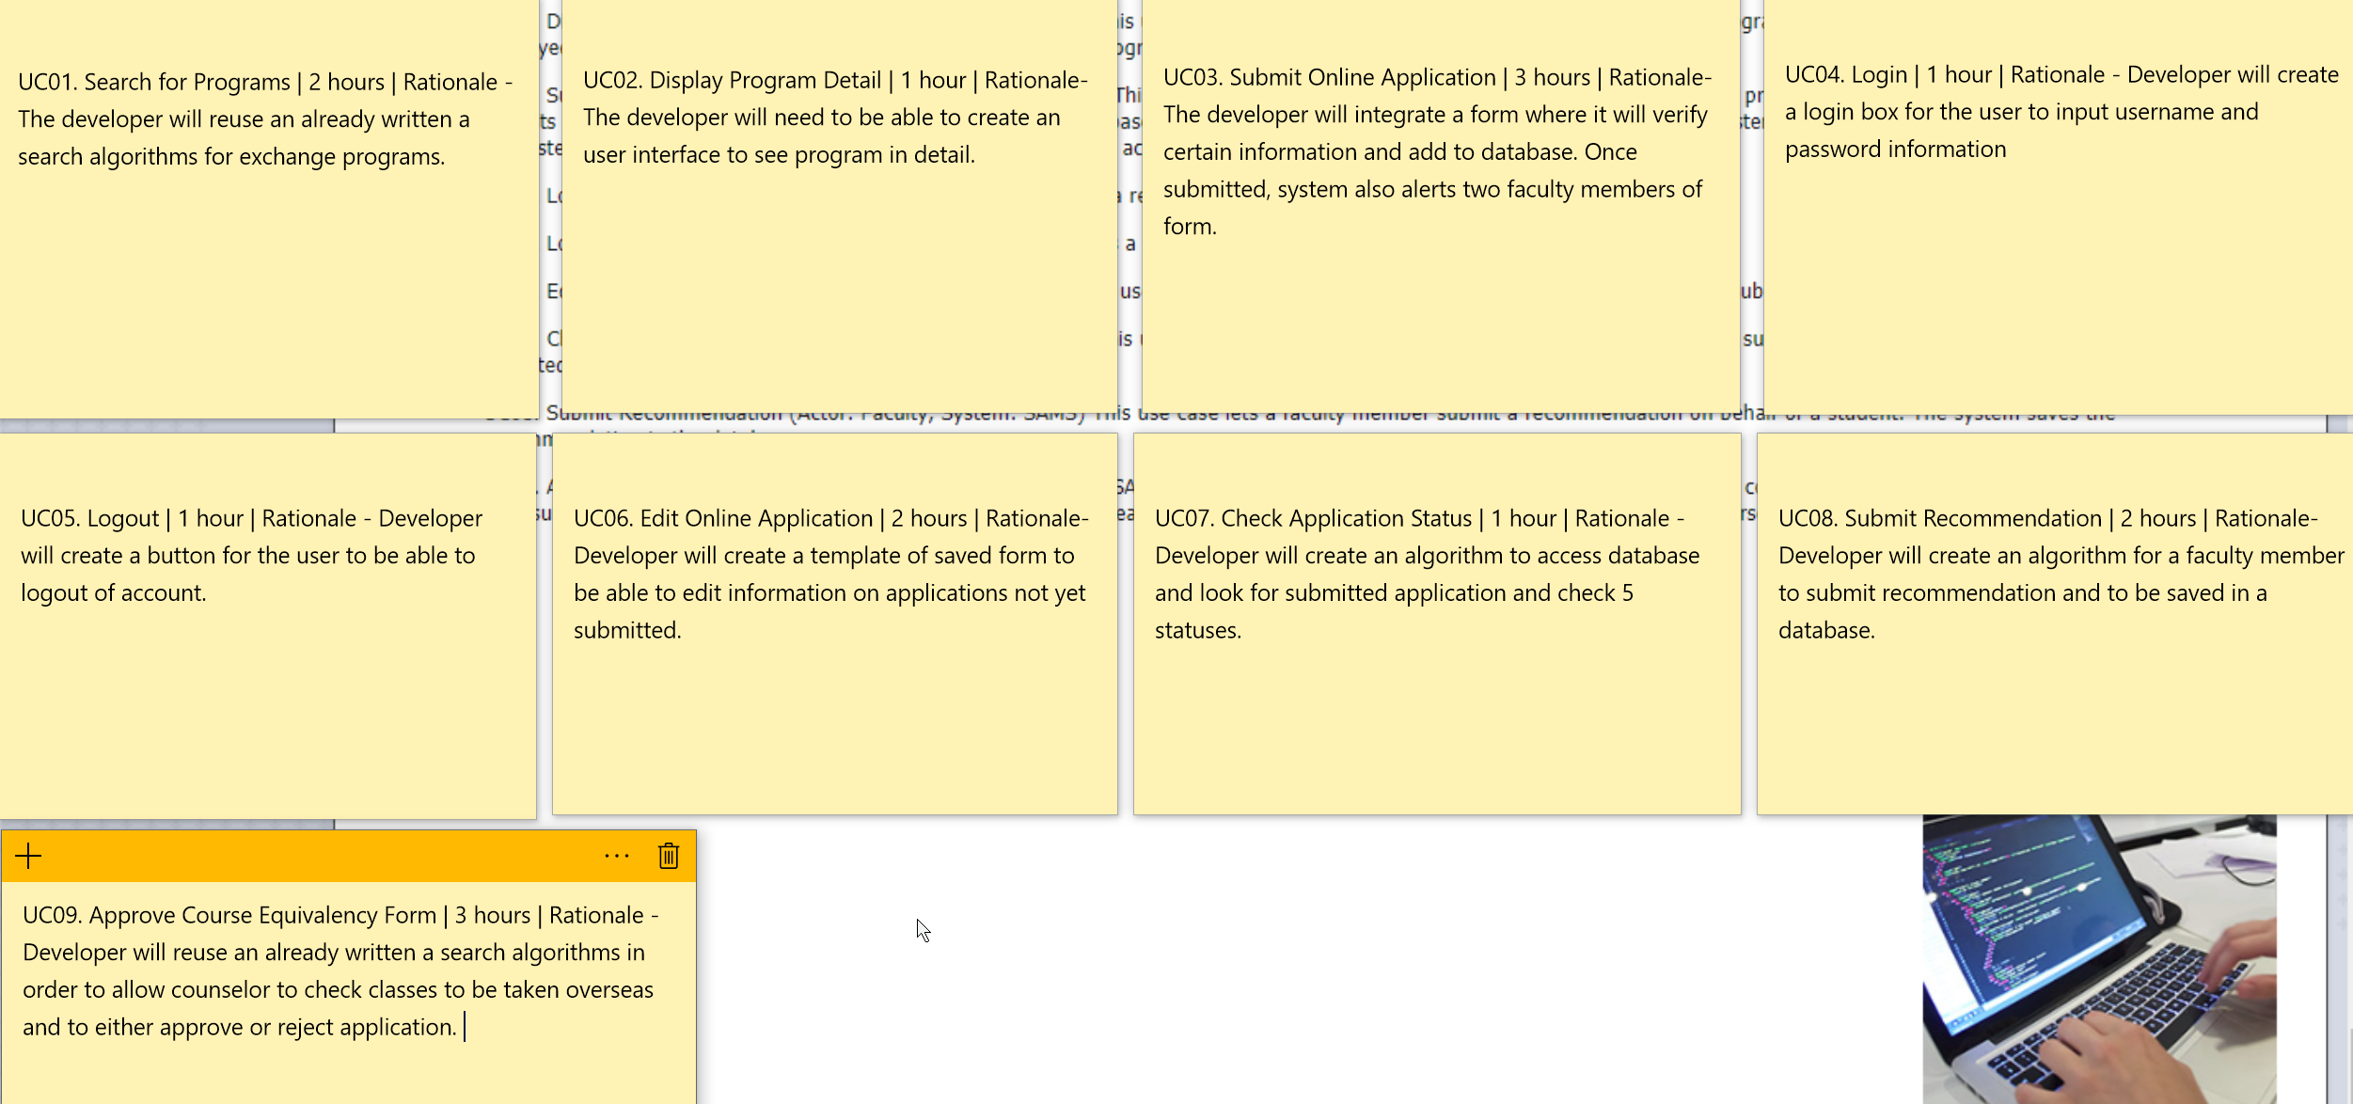

The total hours for this project will 17 hours base on use cases.