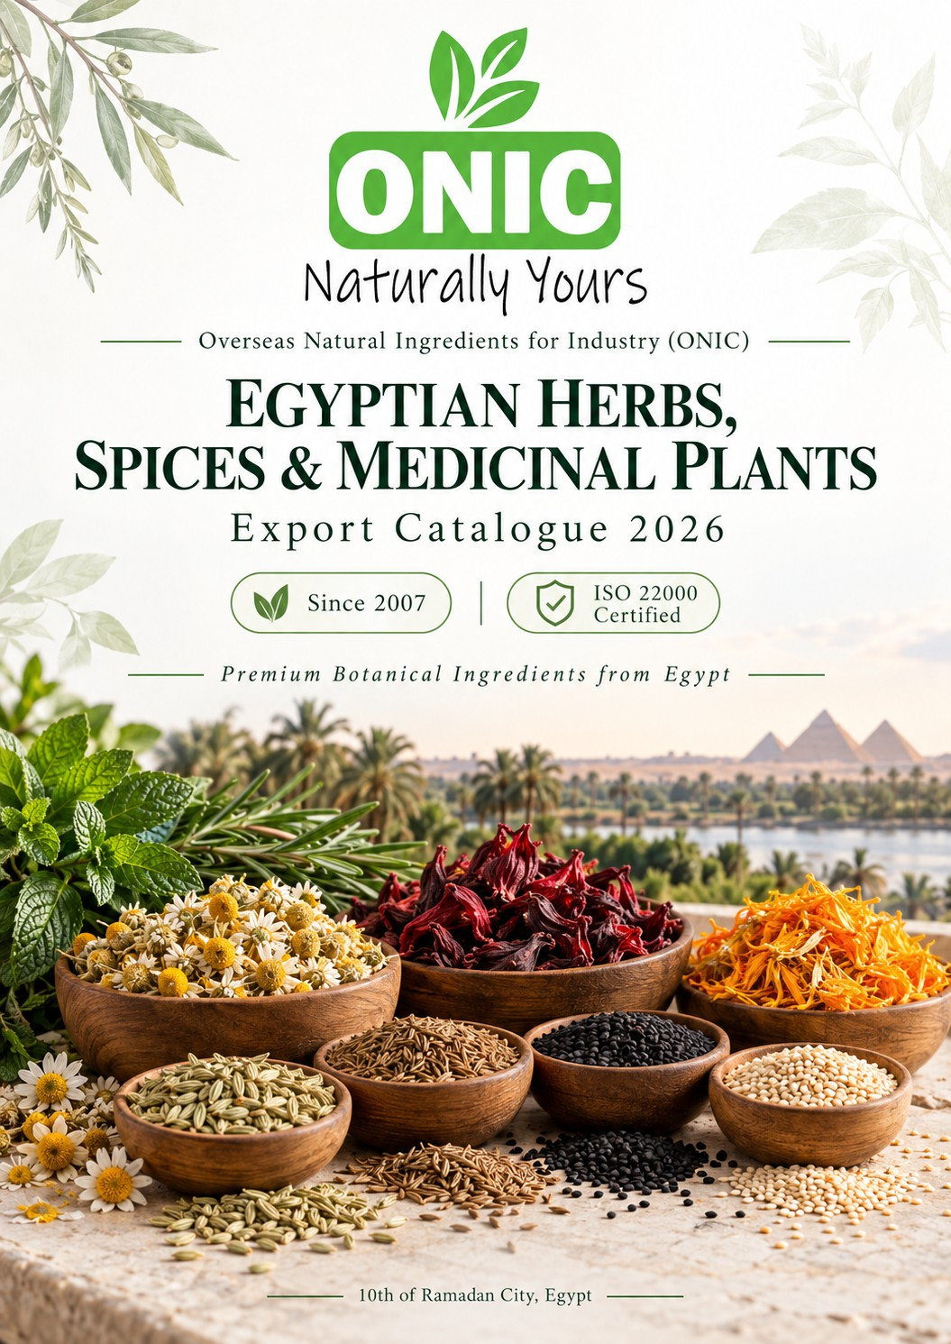

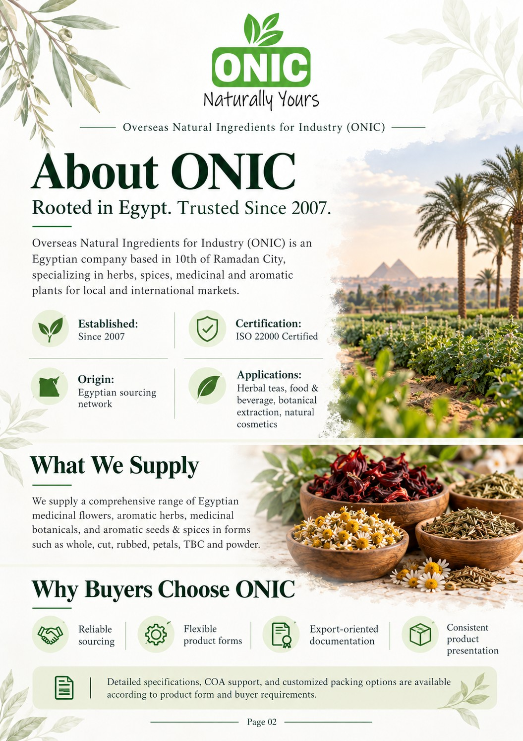

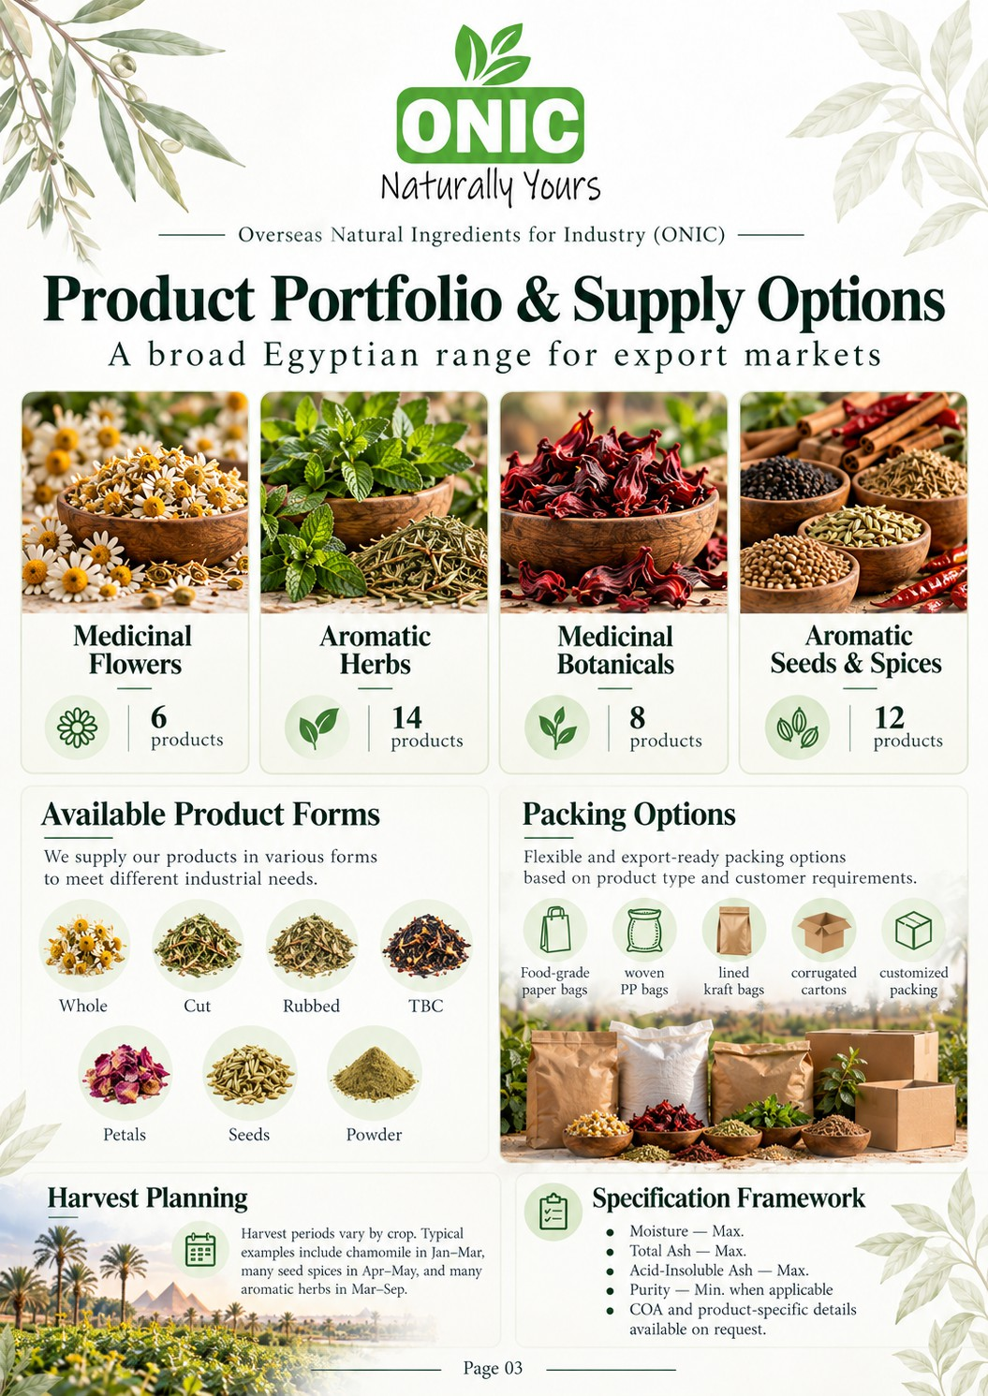

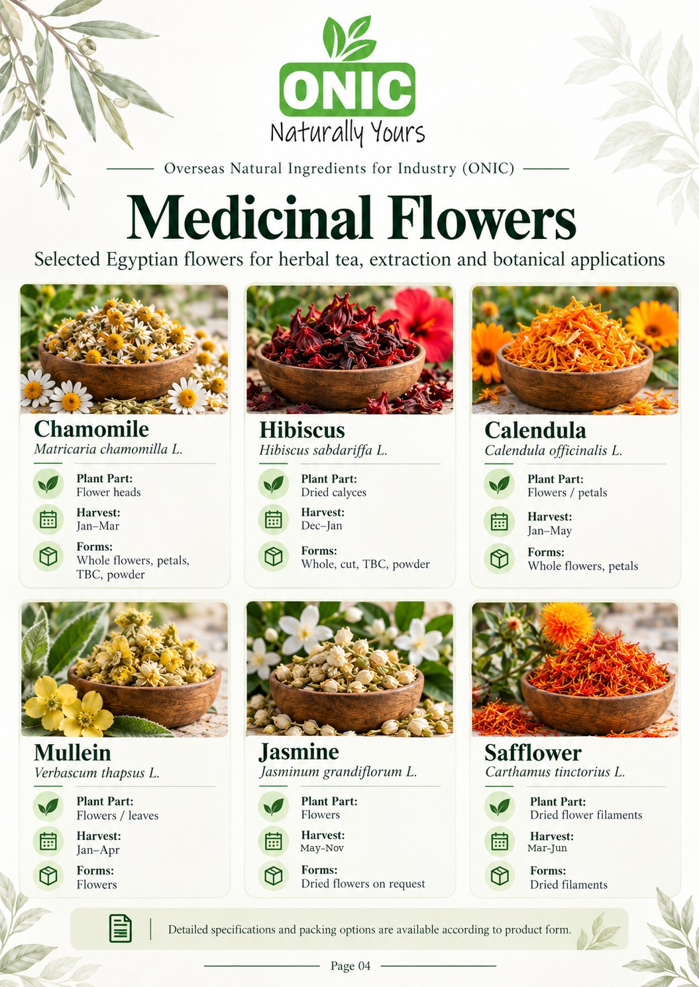

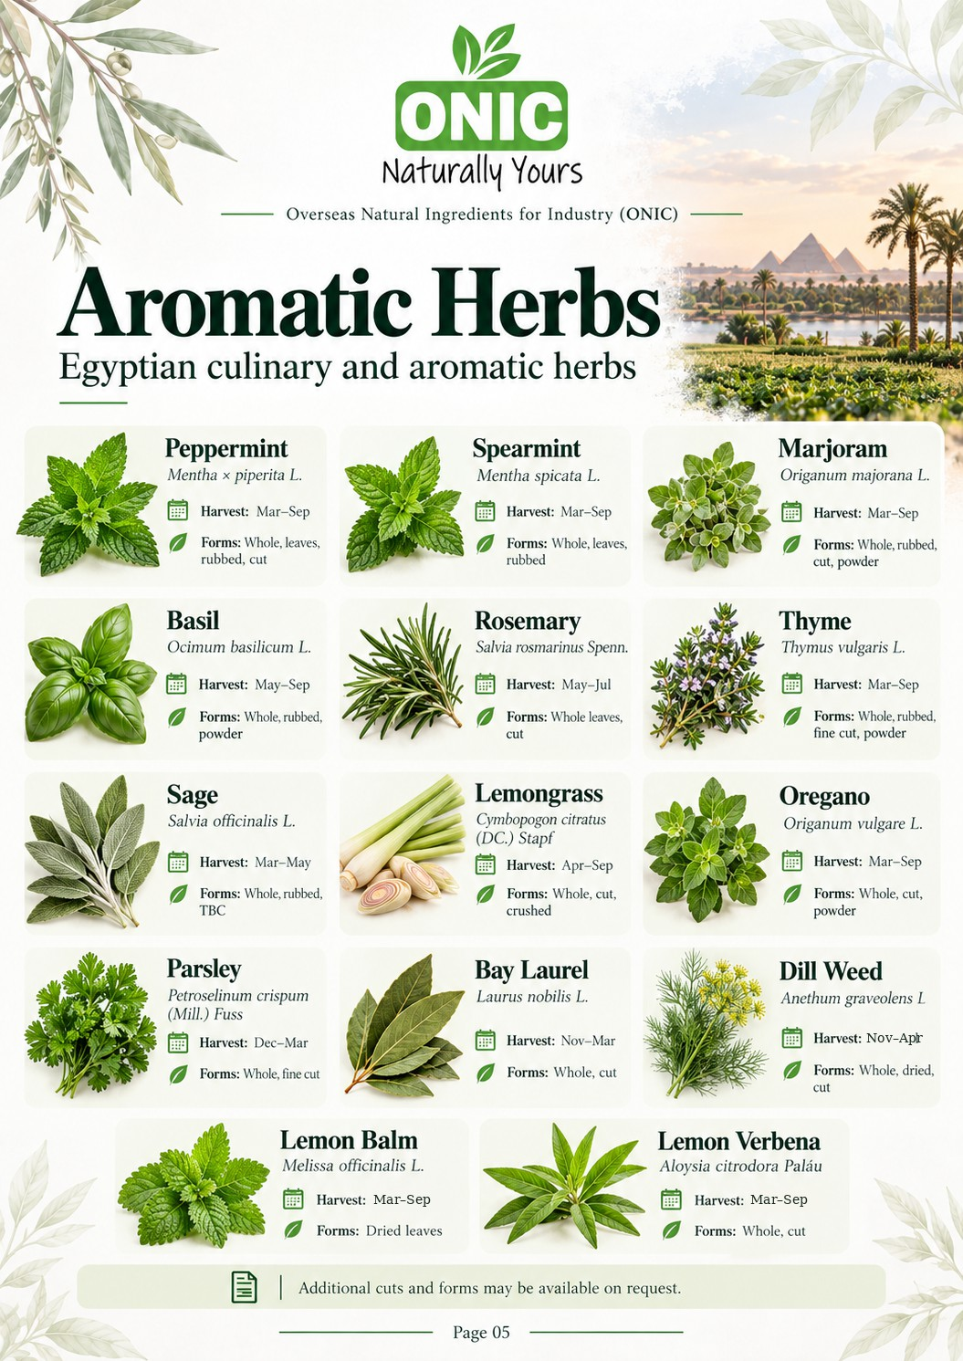

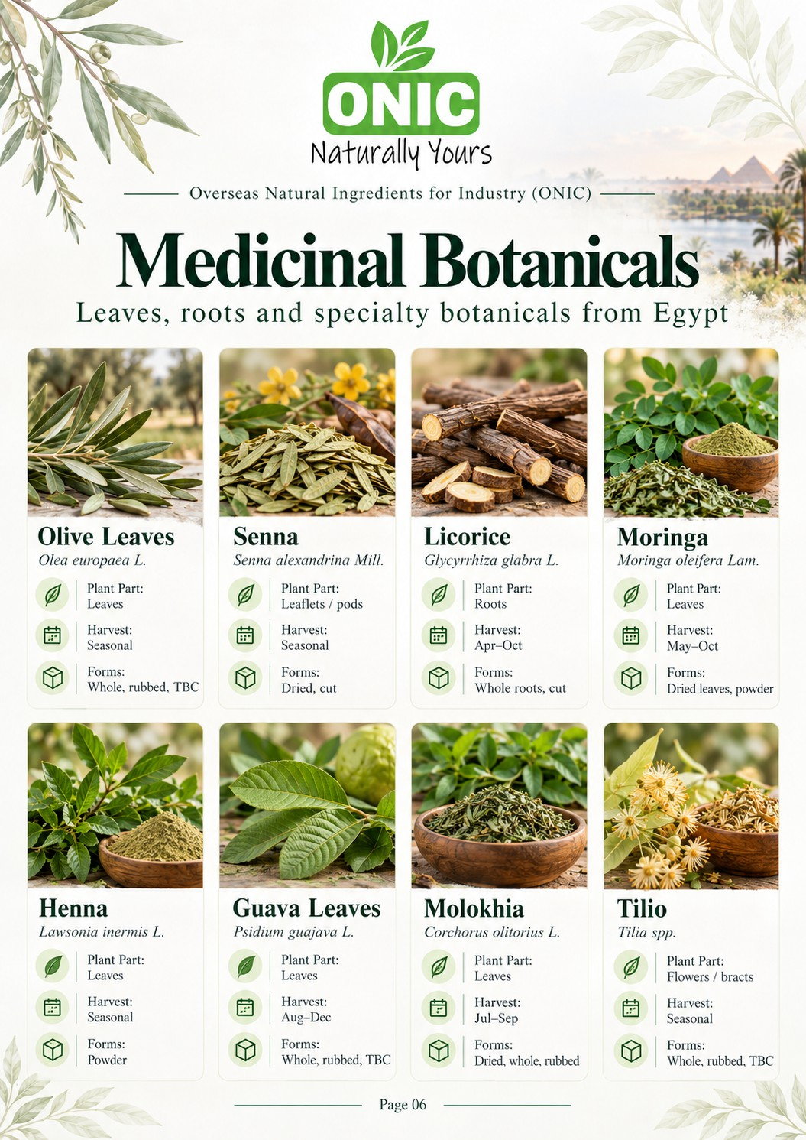

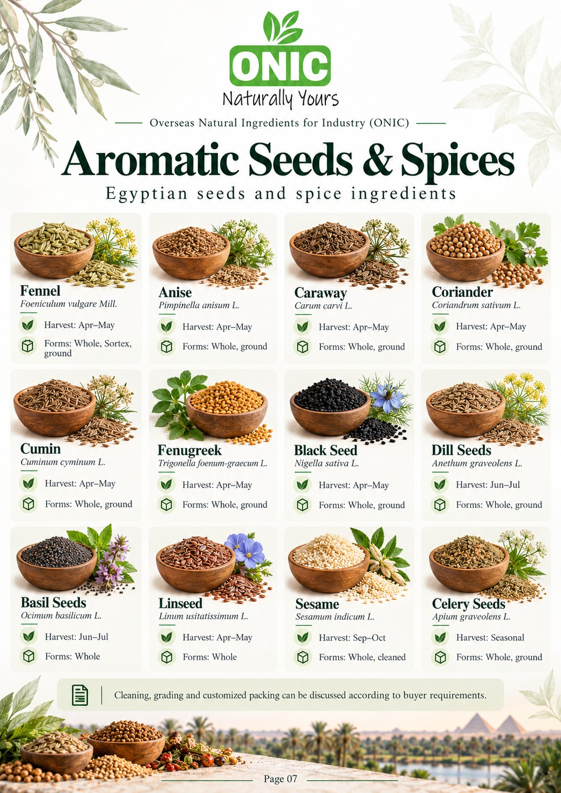

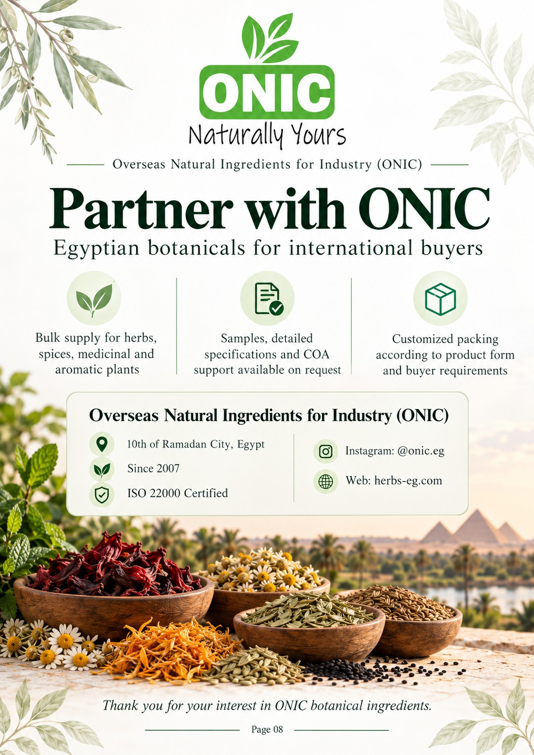

TECHNICAL REFERENCE | PROPOSED LIMITS — SUBJECT TO ONIC QC APPROVAL
Chamomile
Matricaria chamomilla L.
Product ID
ONIC-HS-001
Plant part
Flower heads
Harvest
Jan–Mar
Forms
Whole flowers; petals; TBC; po…
Moisture max.
12%
Total ash max.
10%
Acid-insol. ash max. 1.5%
Purity min. (ref)
99%
Mercury moisture (202—4)
Codex ref.
Not mapped
— No reference limit = no published guarantee
Hibiscus
Hibiscus sabdariffa L.
Product ID
ONIC-HS-002
Plant part
Dried Flowers, TBC Cut of Flow…
Harvest
Dec–Jan
Forms
Whole; cut; TBC; powder
Moisture max.
12%
Total ash max.
10%
Acid-insol. ash max. 1.5%
Purity min. (ref)
99%
Mercury moisture (202—4)
Codex ref.
Not mapped
— No reference limit = no published guarantee
Calendula
Calendula officinalis L.
Product ID
ONIC-HS-003
Plant part
Flowers / petals
Harvest
Jan–May
Forms
Whole flowers; petals
Moisture max.
10%
Total ash max.
8%
Acid-insol. ash max. 2%
Purity min. (ref)
—
Mercury moisture (202—4)
Codex ref.
Not mapped
— No reference limit = no published guarantee
Mullein
Verbascum thapsus L. (verify traded species)
Product ID
ONIC-HS-004
Plant part
Flowers / leaves — verify
Harvest
Jan–Apr
Forms
Flowers
Moisture max.
—
Total ash max.
—
Acid-insol. ash max. —
Purity min. (ref)
—
Mercury moisture (202—4)
Codex ref.
Not mapped
— No reference limit = no published guarantee

Limits marked as reference are indicative third-party benchmarks, not an approved ONIC batch COA.

TECHNICAL REFERENCE | PROPOSED LIMITS — SUBJECT TO ONIC QC APPROVAL
Jasmine
Jasminum grandiflorum L. — confirm
Product ID
ONIC-HS-039
Plant part
Flowers
Harvest
May–Nov
Forms
Fresh/dried — confirm
Moisture max.
—
Total ash max.
—
Acid-insol. ash max. —
Purity min. (ref)
—
Mercury moisture (202—4)
Codex ref.
Not mapped
— No reference limit = no published guarantee
Safflower
Carthamus tinctorius L.
Product ID
ONIC-HS-040
Plant part
Dried flower filaments
Harvest
Mar–Jun
Forms
Dried filaments; cut (per Merc…
COA)
Moisture max.
—
Total ash max.
—
Acid-insol. ash max. —
Purity min. (ref)
—
Mercury moisture (202140)%
Codex ref.
Not mapped
— No reference limit = no published guarantee

Limits marked as reference are indicative third-party benchmarks, not an approved ONIC batch COA.

TECHNICAL REFERENCE | PROPOSED LIMITS — SUBJECT TO ONIC QC APPROVAL

Peppermint |  |  | Spearmint
Mentha × piperita L. |  |  | Mentha spicata L.
Product ID Plant part Harvest Forms | ONIC-HS-005  Leaves / aerial parts Mar–Sep  Whole; leaves; rubbed; cut |  | Product ID Plant part Harvest Forms | ONIC-HS-006  Leaves / aerial parts Mar–Sep  Whole; leaves; rubbed
Moisture max. | — |  | Moisture max. | 10%
Total ash max. | — |  | Total ash max. | 10%
Acid-insol. ash max.  Purity min. (ref) | —  — |  | Acid-insol. ash max.  Purity min. (ref) | 1.5%  —
Mercury moisture (202140)%  Codex ref. Not mapped  — No reference limit = no published guarantee |  |  | Mercury moisture (202140)%  Codex ref. Not mapped  — No reference limit = no published guarantee

Marjoram |  |  | Basil
Origanum majorana L. |  |  | Ocimum basilicum L.
Product ID Plant part Harvest Forms | ONIC-HS-007  Aerial parts / leaves Mar–Sep  Whole; rubbed; cut; powder |  | Product ID Plant part Harvest Forms | ONIC-HS-008  Leaves / aerial parts May–Sep  Whole; rubbed; powder
Moisture max. | 10% |  | Moisture max. | 10%
Total ash max. | 10% |  | Total ash max. | 10%
Acid-insol. ash max. | 1.5% |  | Acid-insol. ash max. | 1.5%
Purity min. (ref) | 99% |  | Purity min. (ref) | —
Mercury moisture (202—4)  Codex ref. Draft: sweet marjoram  — No reference limit = no published guarantee |  |  | Mercury moisture (202—4)  Codex ref. CXS 345-2021  — No reference limit = no published guarantee
Limits marked as reference are indicative third-party benchmarks, not an approved ONIC batch COA.

Rosemary
Salvia rosmarinus Spenn.
Thyme
Thymus vulgaris L.
TECHNICAL REFERENCE | PROPOSED LIMITS — SUBJECT TO ONIC QC APPROVAL

Product ID | ONIC-HS-009 |  | Product ID | ONIC-HS-010
Plant part | Leaves |  | Plant part | Leaves / aerial parts
Harvest | May–Jul |  | Harvest | Mar–Sep
Forms | Whole leaves; cut |  | Forms | Whole; rubbed; fine cut; powder
Moisture max. | — |  | Moisture max. | 12%
Total ash max. | — |  | Total ash max. | 12%
Acid-insol. ash max. | — |  | Acid-insol. ash max. | 3.5%
Purity min. (ref) | — |  | Purity min. (ref) | 99%
Mercury moisture (202<4)11% Codex ref. Not mapped  — No reference limit = no published guarantee |  |  | Mercury moisture (202—4)  Codex ref. CXS 328-2017  — No reference limit = no published guarantee

Product ID | ONIC-HS-011 |  | Product ID | ONIC-HS-012
Plant part | Leaves |  | Plant part | Leaves
Harvest | Mar–May |  | Harvest | Apr–Sep
Forms | Whole; rubbed; TBC |  | Forms | Whole; cut; crushed
Moisture max. | — |  | Moisture max. | 12%
Total ash max. | — |  | Total ash max. | 10%
Acid-insol. ash max. | — |  | Acid-insol. ash max. | 1.5%
Purity min. (ref) | — |  | Purity min. (ref) | —
Mercury moisture (202—4)  Codex ref. Not mapped  — No reference limit = no published guarantee |  |  | Mercury moisture (20284%)  Codex ref. Not mapped  — No reference limit = no published guarantee
Limits marked as reference are indicative third-party benchmarks, not an approved ONIC batch COA.
Sage
Salvia officinalis L.
Lemongrass
Cymbopogon citratus (DC.) Stapf

Oregano
Origanum vulgare L.
Parsley
Petroselinum crispum (Mill.) Fuss
TECHNICAL REFERENCE | PROPOSED LIMITS — SUBJECT TO ONIC QC APPROVAL

Product ID | ONIC-HS-013 |  | Product ID | ONIC-HS-014
Plant part | Leaves / aerial parts |  | Plant part | Leaves
Harvest | Mar–Sep |  | Harvest | Dec–Mar
Forms | Whole; cut; powder |  | Forms | Whole; fine cut
Moisture max. | — |  | Moisture max. | 8%
Total ash max. | — |  | Total ash max. | 14.5%
Acid-insol. ash max. | — |  | Acid-insol. ash max. | 1.5%
Purity min. (ref) | — |  | Purity min. (ref) | —
Mercury moisture (202140)%  Codex ref. CXS 342-2021  — No reference limit = no published guarantee |  |  | Mercury moisture (20274%)  Codex ref. Not mapped  — No reference limit = no published guarantee

Bay Laurel |  |  | Dill Weed
Laurus nobilis L. |  |  | Anethum graveolens L.
Product ID Plant part Harvest Forms | ONIC-HS-015  Leaves Nov–Mar Whole; cut |  | Product ID Plant part Harvest Forms | ONIC-HS-016  Leaves Nov–Apr  Whole; dried; cut
Moisture max. Total ash max.  Acid-insol. ash max.  Purity min. (ref) | —  —  —  — |  | Moisture max. Total ash max.  Acid-insol. ash max.  Purity min. (ref) | —  —  —  —
Mercury moisture (202—4)  Codex ref. Not mapped  — No reference limit = no published guarantee |  |  | Mercury moisture (202—4)  Codex ref. Not mapped  — No reference limit = no published guarantee
Limits marked as reference are indicative third-party benchmarks, not an approved ONIC batch COA.

Lemon Balm
Melissa officinalis L.
Lemon Verbena
Aloysia citrodora Paláu
TECHNICAL REFERENCE | PROPOSED LIMITS — SUBJECT TO ONIC QC APPROVAL

Product ID | ONIC-HS-017 |  | Product ID | ONIC-HS-018
Plant part | Leaves |  | Plant part | Leaves
Harvest | Mar–Sep |  | Harvest | Mar–Sep
Forms | Dried leaves — confirm |  | Forms | Whole; cut — confirm
Moisture max. | — |  | Moisture max. | —
Total ash max. | — |  | Total ash max. | —
Acid-insol. ash max. | — |  | Acid-insol. ash max. | —
Purity min. (ref) | — |  | Purity min. (ref) | —
Mercury moisture (202—4)  Codex ref. Not mapped  — No reference limit = no published guarantee |  |  | Mercury moisture (202—4)  Codex ref. Not mapped  — No reference limit = no published guarantee

Limits marked as reference are indicative third-party benchmarks, not an approved ONIC batch COA.

TECHNICAL REFERENCE | PROPOSED LIMITS — SUBJECT TO ONIC QC APPROVAL
Olive Leaves
Olea europaea L.
Product ID
ONIC-HS-019
Plant part
Leaves
Harvest
Not verified
Forms
Whole; rubbed; TBC
Moisture max.
—
Total ash max.
—
Acid-insol. ash max. —
Purity min. (ref)
—
Mercury moisture (202—4)
Codex ref.
Not mapped
— No reference limit = no published guarantee
Senna
Senna alexandrina Mill.
Product ID
ONIC-HS-020
Plant part
Leaflets / pods — verify
Harvest
Not verified
Forms
Dried / cut — confirm
Moisture max.
—
Total ash max.
—
Acid-insol. ash max. —
Purity min. (ref)
—
Mercury moisture (202—4)
Codex ref.
Not mapped
— No reference limit = no published guarantee

Licorice |  |  | Moringa
Glycyrrhiza glabra L. |  |  | Moringa oleifera Lam.
Product ID Plant part Harvest Forms | ONIC-HS-021  Roots Apr–Oct  Whole roots; cut — confirm |  | Product ID Plant part Harvest Forms | ONIC-HS-022  Leaves May–Oct  Dried leaves; powder — confirm
Moisture max. | 10% |  | Moisture max. | —
Total ash max. | 6% |  | Total ash max. | —
Acid-insol. ash max.  Purity min. (ref) | 1%  — |  | Acid-insol. ash max.  Purity min. (ref) | —  —
Mercury moisture (202140)%  Codex ref. Not mapped  — No reference limit = no published guarantee |  |  | Mercury moisture (202—4)  Codex ref. Not mapped  — No reference limit = no published guarantee
Limits marked as reference are indicative third-party benchmarks, not an approved ONIC batch COA.

TECHNICAL REFERENCE | PROPOSED LIMITS — SUBJECT TO ONIC QC APPROVAL
Henna
Lawsonia inermis L.
Product ID
ONIC-HS-023
Plant part
Leaves
Harvest
Not verified
Forms
Powder
Moisture max.
—
Total ash max.
—
Acid-insol. ash max. —
Purity min. (ref)
—
Mercury moisture (202—4)
Codex ref.
Not mapped
— No reference limit = no published guarantee
Guava Leaves
Psidium guajava L.
Product ID
ONIC-HS-024
Plant part
Leaves
Harvest
Aug–Dec
Forms
Whole; rubbed; TBC
Moisture max.
12%
Total ash max.
10%
Acid-insol. ash max. 1.5%
Purity min. (ref)
—
Mercury moisture (202—4)
Codex ref.
Not mapped
— No reference limit = no published guarantee

Product ID | ONIC-HS-025 |  | Product ID | ONIC-HS-026
Plant part | Leaves |  | Plant part | Flowers / bracts — verify
Harvest | Jul–Sep |  | Harvest | Not verified
Forms | Dried; whole; rubbed |  | Forms | Whole; rubbed; TBC
Moisture max. | — |  | Moisture max. | —
Total ash max. | — |  | Total ash max. | —
Acid-insol. ash max. | — |  | Acid-insol. ash max. | —
Purity min. (ref) | — |  | Purity min. (ref) | —
Mercury moisture (202—4)  Codex ref. Not mapped  — No reference limit = no published guarantee |  |  | Mercury moisture (202—4)  Codex ref. Not mapped  — No reference limit = no published guarantee
Limits marked as reference are indicative third-party benchmarks, not an approved ONIC batch COA.
Molokhia
Corchorus olitorius L.
Tilio
Tilia spp. — identification required

Fennel
Foeniculum vulgare Mill.
Anise
Pimpinella anisum L.
TECHNICAL REFERENCE | PROPOSED LIMITS — SUBJECT TO ONIC QC APPROVAL

Product ID | ONIC-HS-027 |  | Product ID | ONIC-HS-028
Plant part | Fruits (trade: seeds) |  | Plant part | Fruits (trade: seeds)
Harvest | Apr–May |  | Harvest | Apr–May
Forms | Whole; Sortex; ground |  | Forms | Whole; ground
Moisture max. | — |  | Moisture max. | —
Total ash max. | — |  | Total ash max. | —
Acid-insol. ash max. | — |  | Acid-insol. ash max. | —
Purity min. (ref) | — |  | Purity min. (ref) | —
Mercury moisture (202—4)  Codex ref. Not mapped  — No reference limit = no published guarantee |  |  | Mercury moisture (20294%)  Codex ref. Not mapped  — No reference limit = no published guarantee

Caraway |  |  | Coriander
Carum carvi L. |  |  | Coriandrum sativum L.
Product ID Plant part Harvest Forms | ONIC-HS-029  Fruits (trade: seeds) Apr–May  Whole; ground |  | Product ID Plant part Harvest Forms | ONIC-HS-030  Fruits (trade: seeds) Apr–May  Whole; ground
Moisture max. Total ash max.  Acid-insol. ash max.  Purity min. (ref) | —  —  —  — |  | Moisture max. Total ash max.  Acid-insol. ash max.  Purity min. (ref) | —  —  —  —
Mercury moisture (20294%)  Codex ref. Not mapped  — No reference limit = no published guarantee |  |  | Mercury moisture (202—4)  Codex ref. CXS 369-2026  — No reference limit = no published guarantee
Limits marked as reference are indicative third-party benchmarks, not an approved ONIC batch COA.

Cumin
Cuminum cyminum L.
Fenugreek
Trigonella foenum-graecum L.
TECHNICAL REFERENCE | PROPOSED LIMITS — SUBJECT TO ONIC QC APPROVAL

Product ID | ONIC-HS-031 |  | Product ID | ONIC-HS-032
Plant part | Fruits (trade: seeds) |  | Plant part | Seeds
Harvest | Apr–May |  | Harvest | Apr–May
Forms | Whole; ground |  | Forms | Whole; ground
Moisture max. | — |  | Moisture max. | —
Total ash max. | — |  | Total ash max. | —
Acid-insol. ash max. | — |  | Acid-insol. ash max. | —
Purity min. (ref) | — |  | Purity min. (ref) | —
Mercury moisture (202—4)  Codex ref. CXS 327-2017  — No reference limit = no published guarantee |  |  | Mercury moisture (202—4)  Codex ref. Not mapped  — No reference limit = no published guarantee

Black Seed |  |  | Dill Seeds
Nigella sativa L. |  |  | Anethum graveolens L.
Product ID Plant part Harvest Forms | ONIC-HS-033  Seeds Apr–May Whole; ground |  | Product ID Plant part Harvest Forms | ONIC-HS-034  Fruits (trade: seeds) Jun–Jul  Whole; ground
Moisture max. Total ash max.  Acid-insol. ash max.  Purity min. (ref) | —  —  —  — |  | Moisture max. Total ash max.  Acid-insol. ash max.  Purity min. (ref) | —  —  —  —
Mercury moisture (202—4)  Codex ref. Not mapped  — No reference limit = no published guarantee |  |  | Mercury moisture (202—4)  Codex ref. Not mapped  — No reference limit = no published guarantee
Limits marked as reference are indicative third-party benchmarks, not an approved ONIC batch COA.

TECHNICAL REFERENCE | PROPOSED LIMITS — SUBJECT TO ONIC QC APPROVAL

Basil Seeds |  |  | Linseed
Ocimum basilicum L. |  |  | Linum usitatissimum L.
Product ID Plant part Harvest Forms | ONIC-HS-035  Seeds Jun–Jul Whole |  | Product ID Plant part Harvest Forms | ONIC-HS-036  Seeds Apr–May Whole
Moisture max. Total ash max.  Acid-insol. ash max.  Purity min. (ref) | —  —  —  — |  | Moisture max. Total ash max.  Acid-insol. ash max.  Purity min. (ref) | —  —  —  —
Mercury moisture (202—4)  Codex ref. Not mapped  — No reference limit = no published guarantee |  |  | Mercury moisture (202—4)  Codex ref. Not mapped  — No reference limit = no published guarantee

Sesame |  |  | Celery Seeds
Sesamum indicum L. |  |  | Apium graveolens L.
Product ID Plant part Harvest Forms | ONIC-HS-037  Seeds Sep–Oct  Whole; cleaned / graded — co… |  | Product ID Plant part Harvest Forms | ONIC-HS-038  Fruits (trade: seeds) Not verified  Whole; ground — confirm
Moisture max. Total ash max.  Acid-insol. ash max.  Purity min. (ref) | —  —  —  — |  | Moisture max. Total ash max.  Acid-insol. ash max.  Purity min. (ref) | —  —  —  —
Mercury moisture (202—4)  Codex ref. Not mapped  — No reference limit = no published guarantee |  |  | Mercury moisture (202—4)  Codex ref. Not mapped  — No reference limit = no published guarantee
Limits marked as reference are indicative third-party benchmarks, not an approved ONIC batch COA.

