# 1 General

## 1.1 Overview

All words and phrases that are inserted by a user are stored in the database. Each word has some  
 additional information as for example the variety of English, its regular usage etc. and belongs to a   
 certain user.

Phrases can be stored as well and act as examples for previously stored words. Each word and   
phrase has an accuray that decreases with time. Those accuracies are stored in two tables named *OWNS_PHRASE* and *OWNS_WORD*. Additionally, the date of the last revision is stored there as well.

## 1.2 ER-Diagram

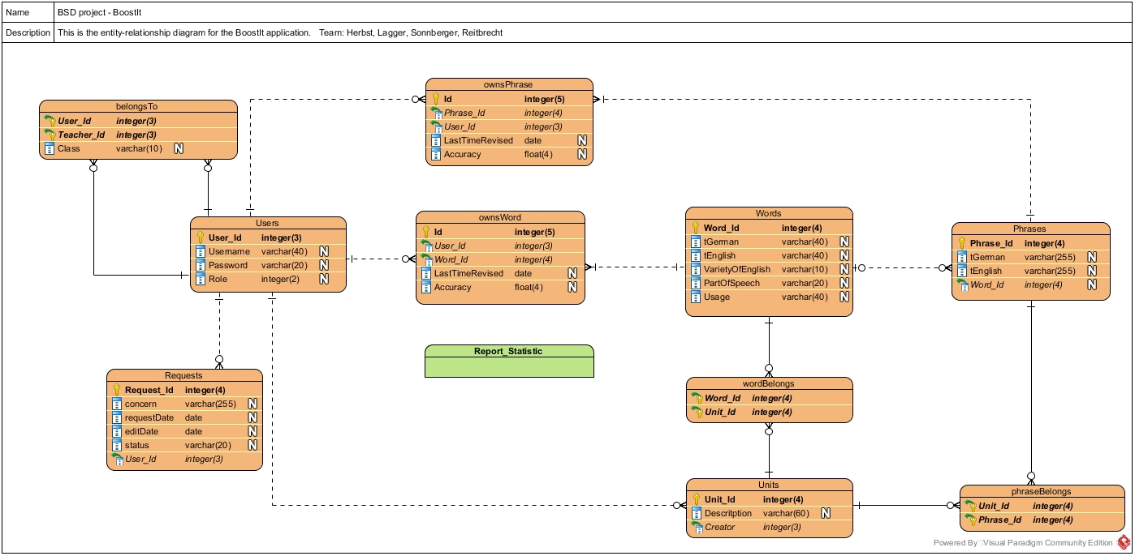

# 2 Triggers

## 2.1 TRI_SAVE_STATISTIC_PHRASE

In order to create statisitcs for each phrase, the change of accuracy of each phrase has to be   
saved in a separate table. Thus, this trigger saves the date and accuracy of the corresponding phrase in a seaprate table before it is updated to its new state.

It is called before an update on the *OWNS_PHRASE* table, which means either by the trigger event itself or by the procedure *PRO_SET_ACCURACY_PHRASES*.

## 2.2 TRI_SAVE_STATISTIC_WORD

In order to create statisitcs for each word, the change of accuracy of each word has to be   
saved in a separate table. Thus, this trigger saves the date and accuracy of the corresponding word in a seaprate table before it is updated to its new state.

It is called before an update on the *OWNS_WORD* table, which means either by the trigger event itself or by the procedure *PRO_SET_ACCURACY_PHRASES*.

# 3 Procedures

## 3.1 PRO_LOG

This procedure is used to add a log entry to the log table and later to a datawarehouse.

A timestamp is added automatically.

**Parameter** MESSAGE VARCHAR2 the text of the log message

## 3.2 PRO_SET_ACCURACY_PHRASES

This procedure is used to decrease the accuracy of all phrases. All records of which the date of the

last revision is older than the difference between today’s date and the given value in *days* are selected and the accuracy is decreased by the value given in *decrease*.

In order to have the opportunity of fully knowing a word (100 per cent of accuracy),

**Parameter** days INTEGER days after which the accuracy is

decreased

decrease INTEGER deacrease in per cent

## 3.3 PRO_SET_ACCURACY_WORDS

This procedure is used to decrease the accuracy of all words. All records of which the date of the

last revision is older than the difference between today’s date and the given value in *days* are   
selected and the accuracy is decreased by the value given in *decrease*.

In order to have the opportunity of fully knowing a phrase (100 per cent of accuracy),

**Parameter** days INTEGER days after which the accuracy is

decreased

decrease INTEGER deacrease in per cent

# 4 Jobs

## 4.1 JOB_ACC_WORDS

This job calls the procedure PRO_SET_ACCURACY_WORDS. It is invoked each day at 4 a.m. by   
default.

## 4.2 JOB_ACC_PHRASES

This job calls the procedure PRO_SET_ACCURACY_PHRASES. It is invoked each day at 4 a.m. by   
default.

# 5 Sequences

There are several sequences which are used for generating the primary keys for each entry.

# 6 Reports

A